Moreno, Melissa

September 16, 2019

FAS5901- Essay #1

Write an essay that answers the question, "What is science and critical thinking?"

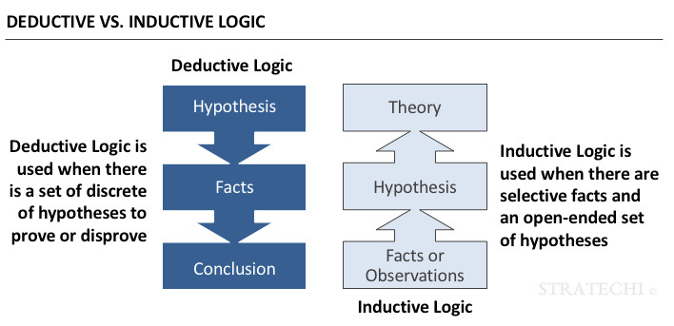Science is a way to understand our surroundings and the observations we make about our surroundings. Science is also a straightforward, rational process following a set of rules embodied in the "scientific method" (Russell, 1931). However, science can range from a very strict and restrictive methodology to a looser scientific methodology. Science normally requires testing hypothesis from inductive or deductive logic. Induction is also known as “informal logic” and it involves drawing uncertain inference, which is based on probabilistic reasoning. The induction conclusions reached are probable and believable. Deduction could be considered “formal logic” and it involves creating reasoning from known and true premises. The conclusions reached with deduction are inevitable and inescapable. Depending on what science is being studied, it might be useful to use deductive or inductive logic. It really does depend on what information is already available on the research topic and what is the experiment.

Figure 1 – Visualization of deductive and inductive logic (https://www.stratechi.com/deductive-inductive-logic/)

Science is also considered how well the process of experimentation and testing is followed and created. Science can be narrow with a structure, or broader with general concepts. It can really depend on the science. Many “hard sciences” like physics or chemistry have a narrow view of science, but other “soft sciences” like social science and anthropology often deal with intangible interactions, thoughts or feelings that are more general. In my opinion all forms of study can be considered science, but the methodology will determine if it is “good science”. “Good science” is science with precise and thoughtful planning and consideration. Of course in natural sciences with even the best planning efforts fail, but spending the time in trying to predict the obstacles can go a long way for “good science”.

Critical thinking, in my opinion, is a difficult habit to continuously use and keep up with. It’s easy to fall back on already existing knowledge you have and not use critical thinking to make science based decisions. In reality, critical thinking can be used in everyday life and not just in science. The “Elements of Thought” interactive website wheel (<http://www.criticalthinking.org/ctmodel/logic-model1.htm>) goes through the process of critical thinking and how a person should try to formulate their thought process. In the oyster reef restoration project that I am working on, I would say a good amount of critical thinking was put into the data management aspect of the project. I and the UF LARCS team worked together to assess the data we wanted to collect, and what could be the issues with the data during collection or managing. This process was lengthy, about eight months, and required constant back and forth. I would say, however, that despite how long the process was, and it was very beneficial to think about our purpose, question at issues, information, concepts, assumptions, implications, and points of view in a critical thinking perspective. Everyone is different, and some people might struggle with some elements that I might not have issues with. Part of science is knowing who your team is and what their strengths and weaknesses are when it comes to critical thinking. Acknowledging that not everyone knows everything and can know everything can be beneficial to any science project because people will be inclined to view their reasons and methodology through another point of view, which is part of the “Elements of Thought”.

Overall, it can be difficult to pinpoint exactly what science is and how to use everyone’s critical thinking strength’s to better science. Trying your best and taking the time to use critical thinking at the beginning of a science project can lead to “good science”.

References

Russell, E. S. (1931). Some theoretical considerations on the “overfishing” problem. ICES Journal of Marine Science, 6(1), 3-20.

Stratechi. (2019). DEDUCTION & INDUCTION, <https://www.stratechi.com/deductive-inductive-logic/>

Foundation for Critical Thinking. (2007). To Analyze Thinking We Must Identify and Question its Elemental Structures. <http://www.criticalthinking.org/ctmodel/logic-model1.htm>