Answer Sheet

1. What is the reference system/projection of the bathymetric data? __ WGS_1984_UTM_Zone_19N __________________

2. What is the spatial resolution of the bathymetric data? ______50 meter by 50 meter_

3. What does aspect represent? __ **Aspect** identifies the downslope direction of the maximum rate of change in value from each cell to its neighbors. **Aspect can** be thought of as the slope direction. The values of the output raster **will** be the compass direction of the **aspect**. The input for this function **is** Input Raster.

4. What does curvature represent? The **Curvature** function displays the shape or **curvature** of the slope. A part of a surface **can** be concave or convex; you **can** tell that by looking at the **curvature** value. The **curvature is** calculated by computing the second derivative of the surface.

5. Are your different terrain attributes impacted by edge effect? How can you tell?

6. Are your different terrain attributes impacted by artifacts? How can you tell?

It doesn’t look like it because I’m not seeing lines or specific objects that could have been contributed by the sonar

7. Submit this first map.

8. Which type of map did you make? ____________________________________________

9. Which pairs of variables are highly correlated? ____1 and 9, bathemtry and rel_position, and 5 and 6 curvature and pr_curvature

10. What is the test data AUC of your first MaxEnt model? Test AUC is 0.684, standard deviation is 0.008 (calculated as in DeLong, DeLong & Clarke-Pearson 1988, equation 2).

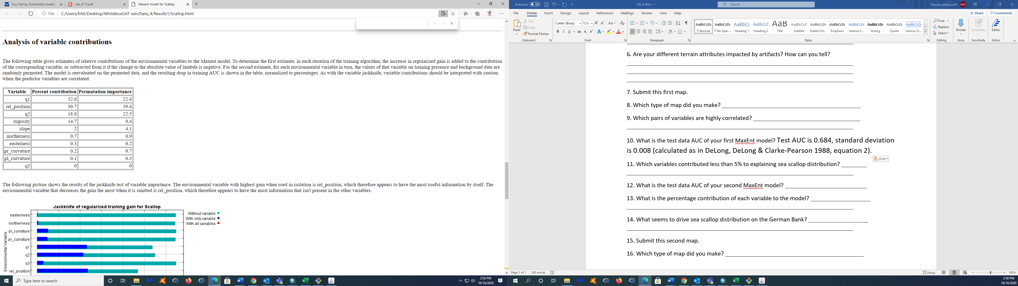

11. Which variables contributed less than 5% to explaining sea scallop distribution?

easterness, pr_curvature, pl_curvature, q3

12. What is the test data AUC of your second MaxEnt model? Regularized training gain is 0.322, training AUC is 0.741, unregularized training gain is 0.391.

Unregularized test gain is 0.263.

Test AUC is 0.682, standard deviation is 0.008 (calculated as in DeLong, DeLong & Clarke-Pearson 1988, equation 2).

Algorithm terminated after 500 iterations (18 seconds).

13. What is the percentage contribution of each variable to the model?

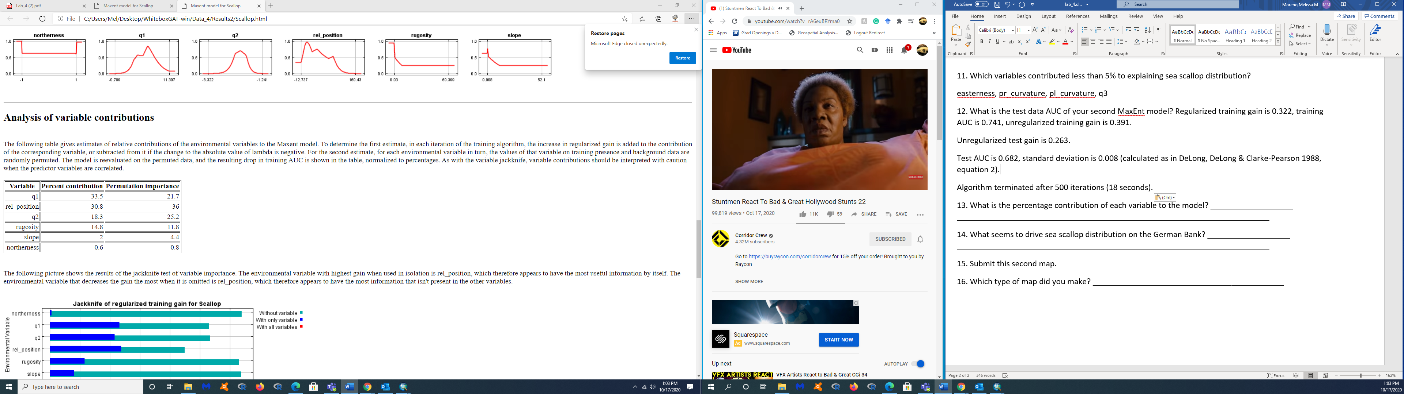

14. What seems to drive sea scallop distribution on the German Bank? ___________________ ________________________________________________________________________

15. Submit this second map.

16. Which type of map did you make? ____________________________________________