Melissa Moreno

October 21, 2020

Project proposal

Topic- Algal bloom impacts on fish species

**Rationale:**

Algal blooms (*Karenia brevis*) are dinoflagellates where which clusters are typically referred to as “red tides”. When algal blooms become massive the clusters release a neurotoxin called brevetoxin (Perryman et al., 2020). Direct exposure to large amounts of brevetoxin can change the sodium- potassium channels of fish, ultimately leading to fish mortality (Kirkpatrick et al., 2004). Algal blooms can also indirectly impact marine fauna by triggering hypoxia (depravation of oxygen) (Landsberg et al., 2009). Several studies focus on red tide impacts on human health (Fleming et al., 2005) and tourist economy (where red tides can prevent humans from touring beach front properties). This study will focus on whether an occurrence of red tides has an impact on fish species distribution. The rationale for this habitat analysis is to determine if historic and/or recent algal bloom records indicate how blooms are affecting imperiled fish distribution in Florida (as per FWC classification).

**Objectives:**

1. To conduct a spatial analysis on historic and recent red tide events and compare imperiled fish distributions.

2. To determine when and how imperiled fish species distributions have been impacted.

**Approach:**

The red tide data comes in a point vector layer and the imperiled fish species is also available in the same format. The red tide and imperiled fish data are provided by FWC (<https://geodata.myfwc.com/>). The imperiled fish data contains location information on multiple fish species. I will determine the exact fish species with more research. The approach to conduct this analysis will be to use fish distribution data and compare the data in MaxEnt to the different time periods of historical and recent red tide occurrences. Afterwards, the positive algal bloom points could be used in a species distribution model. The positive points might also be analyzed in a hot spot analysis in ArcGIS. Both of those types of analysis can then be compared to the fish species models. Using MaxEnt has been used in many species distribution model analysis and ESRI ArcGIS products have been used extensively in federal and state organizations.

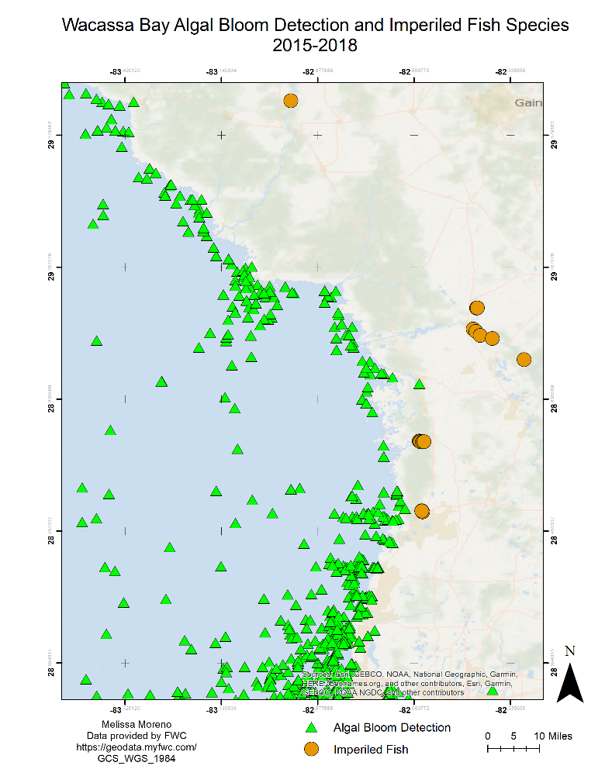

Figure 1- Map of Waccasassa Bay algal bloom detection and imperiled fish locations form 2015- 2018.

**Expected Benefits:**

The impacts of this project are to further understand the ecological impacts of red tide events. One expected benefit of this analysis is that it will provide supporting documentation to help state and local officials manage red tide areas affecting fish species distribution. In these areas, officials might be able to focus their efforts in reducing red tide events to help fish species feed and reproduce. Another expected benefit of this analysis is that it can be used to help the public understand some of the impacts red tide has not only on humans but also on fish species.

**References:**

Perryman, H. A., Tarnecki, J. H., Grüss, A., Babcock, E. A., Sagarese, S. R., Ainsworth, C. H., & DiLeone, A. M. G. (2020). A revised diet matrix to improve the parameterization of a West Florida Shelf Ecopath model for understanding harmful algal bloom impacts. Ecological Modelling, 416, 108890.

Kirkpatrick, B., Fleming, L. E., Squicciarini, D., Backer, L. C., Clark, R., Abraham, W., ... & Zaias, J. (2004). Literature review of Florida red tide: implications for human health effects. Harmful algae, 3(2), 99-115.

Landsberg, J. H., Flewelling, L. J., & Naar, J. (2009). Karenia brevis red tides, brevetoxins in the food web, and impacts on natural resources: Decadal advancements. Harmful Algae, 8(4), 598-607.

Fleming, L. E., Backer, L. C., & Baden, D. G. (2005). Overview of aerosolized Florida red tide toxins: exposures and effects. Environmental Health Perspectives, 113(5), 618-620.

**Raster/shapefile links:**

<https://geodata.myfwc.com/datasets/shallow-banks-in-florida-bay-and-florida-keys>

<https://geodata.myfwc.com/datasets/recent-harmful-algal-bloom-hab-events>

<https://geodata.myfwc.com/datasets/rare-and-imperiled-fish/data>