Moreno, Melissa

September 8, 2020

Summary 1

Paper 1- Costa et al. (2009) Comparative evaluation of airborne LiDAR and ship-based multibeam SoNAR bathymetry and intensity for mapping coral reef ecosystem. Remote Sensing of Environment, 113, 1082-1100.

**1) State the research question and explain why it is interesting**

The research question is trying to determine which seafloor mapping method (LiDar, MBES, and SoNAR) has the best performance and the most cost effective.

**2) State the hypotheses tested and/or specific objectives**

The paper states that LiDAR surveys may provide and alternative to MBES surveys for collection datasets such as coral reef data. MBES can be dangerous work since it has to be conducted on a vessel, might not be able to make in waters shallower than 15m, and its inability to create seamless mapping. LiDAR might be better suited to map shallower waters in that it can collect seamless mapping.

**3) Describe the methods**

LiDAR was collects between on April 7th and May 15th, 2006 and with MBES between April 17th and April 21st, 2007. Both the LiDAR and MBES collected bathymetry which was per International Hydrographic Organizations requirements. The LiDAR acquired data at elevations between 50 m above the sea level and 70 m below the sea level using a LADS Mk II Airborne System. The aircraft flew at different altitudes, above and below cloud ceilings. For the MBES system the data were collected at depths from 10 to 55 m using a Seabat Reason 8124 on the NOAA ship *Nancy Foster*. The MBES was able to achieve seafloor coverage of 3.5c water depths to around 75 m. They collected the all of the data, processed and compiled into their respected gear types. The MBES was corrected for sensor offsets, latency, roll, pitch, yaw, static, and the changing speed of sounds in the water columns.

The team used the 8 metrics to determine which gear type was more time effective:

1) total area mapped

2) spatial resolutions of the bathymetry and intensity surfaces

3) total number of soundings

4) estimated the total time on survey lines

5) total number of survey lines

6) total length of survey lines

7) average swatch width of survey lines

8) average vessel speed on survey lines

The team used the 3 metrics to determine which gear type was more cost effective:

1) mobilization and demobilization

2) data acquisition, processing and delivery of tidal data

3) data acquisition, processing and delivery of bathymetric and intensity data

**4) Describe the results**

The results concluded that the LiDAR data cost 6.6% less than the MBES data. The MBES systems were also to collect approximately 172 times more soundings, and the spatial resolution was 2-5 times higher than LiDAR results. With the MBES the shallower the water the narrower the swatch and the less the gear type is able to map a single survey line.

**5) Explain the key implications of the results**

Ultimately the LiDAR system was more time and cost effective in shallower systems, even though the MBES system took high spatial resolution bathymetry. The LiDAR was able to do this because it has faster survey times, and the situ width was twice as wide as MBES. LiDAR was also found to identify similar seafloor such found in MBES systems. However, LiDAR systems were noted to be inhibited by turbidity in water > 35 m.

Paper 2- Knudby et al. (2010) Predictive mapping of reef fish species richness, diversity and biomass in Zanzibar using IKONOS imagery and machine-learning techniques. Remote Sensing of Environment, 114(6), 1230-1241.

**1) State the research question and explain why it is interesting**

The research question is basically asking if the IKONOS imagery data and machine-learning techniques are useful in predicting species richness, biomass, and diversity of fish community around two reefs in Zanzibar.

**2) State the hypotheses tested and/or specific objectives**

The hypothesis is that satellite data might be informative to predictive models.

**3) Describe the methods**

The study required fish data, habitat data, and IKONOS satellite imagery. The data were collected from mid-September to mid-December 2007. The fish community data was surveyed at a total of 144 sites along the reeds. The two sites were stratified by geomorphologic zones and substrate types. At these sties an observer would wait passively for 5 minutes, afterwards they would user point method to survey the fish community, with a 5 m limitation. The observations were divided into two five- minute intervals. In the first five-minutes the observer slowly rotated and counted all of the fish species with individuals of > 5 cm fork length. In the following five-minutes the number and average fork length of the fish was noted. These data were used to calculate the species richness, biomass, and diversity at each site. The researchers used R and packages such as ‘gams’ and ‘stats’ to do the predictive modeling.

For the satellite imagery they used two images, one from October 2005, and another from October 2007. The imagery was corrected and processed in the same way. In the imagery, substrate classifications were implemented based on input bands and field observations. The substrate classifications were:

1) Deep Water

2) Dense Coral

3) Sparse Coral

4) Pavement

5) Dense Seagrass

6) Macroalgae

7) Sand

8) Deep Sand

**4) Describe the results**

The results showed that the average biomass values on Chumbe were 2x that of Bawe. This was also the same pattern for individual fish. On Chumbe the average values for live coral cover, depth and depth range were also higher than on Bawe.

**5) Explain the key implications of the results**

The implications suggest that using IKONOS data and machine-learning (e.g., tree-based ensemble techniques) can produce predictive maps of reef fish species richness, diversity and biomass. The IKONOS imagery on it’s own can help users derive rugosity and course spatial scales. But using the IKONOS imagery to calculate statistical relationships between habitat variables and fish community is weak because of the noise in the imagery.

Then answer these questions:

**1) How does the material presented in this paper relate to you (your interests/research/field of study/future career): could it be transferred into a context relevant to you?**

In this case, not necessarily. I am doing a shoreline analysis, and I am using aircraft imagery. I am unaware of consistent LiDAR imagery near my study site, Deer Island Cedar Key, FL. If I had LiDAR data, I might be able to create a more accurate shoreline analysis.

**2) Which figure do you think is the most important? Why?**

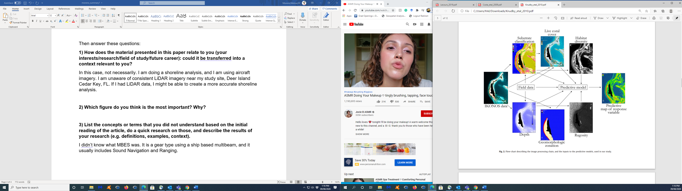

I think this figure is the most important out of the ones I have seen, because it breaks down the study sites in the image processing chain, and the inputs needed for the predicted model (Knudby et al., 2010). I think this is a good way to visualize what goes in a model, and it conveys to the audience the intent of the authors.

**3) List the concepts or terms that you did not understand based on the initial reading of the article, do a quick research on those, and describe the results of your research (e.g. definitions, examples, context).**

I didn’t know what MBES was. It is a gear type using a ship based multibeam, and it usually includes Sound Navigation and Ranging. I also didn’t know about the IKONOS imagery in Knudby et al., 2010. IKONOS is a satellite type that archives global imagery data. Most of the models and statistical predictions I understood in the papers. I also understood the workflow described in both papers.