Moreno, Melissa

August 2, 2019

FNR 6061

Conflict Assessment Plan Paper

**Introduction**

In March 2019, the Florida Senate passed a bill where cities and local governments could decide if they wanted to ban single- use plastic straws, but this was bill was shortly overturned. In a mostly Republican vote, the Florida Senate passed HB 771, which prohibits county and city governments from enforcing regulations on plastic straws for the next five years. The bill that was passed will also require that cities or counties will need to provide “data and conclusions” to support passing a single- use plastic straw ban in the future. Some cities, before this bill was passed, have already adopted straw regulations including Miami Beach in 2012. Regardless if the locals support a straw ban, the city officials will not be in a position to enforce the ban on restaurants according to the Florida Senate. The debate of this issues is giving back power to cities and counties to make their own decisions on whether they can or cannot ban straws if they so choose to. This ban also takes away power from the residents because they will not be able to voice their concerns to their local governments effectively, since their local governments will not be able to pass any laws or policy changes.

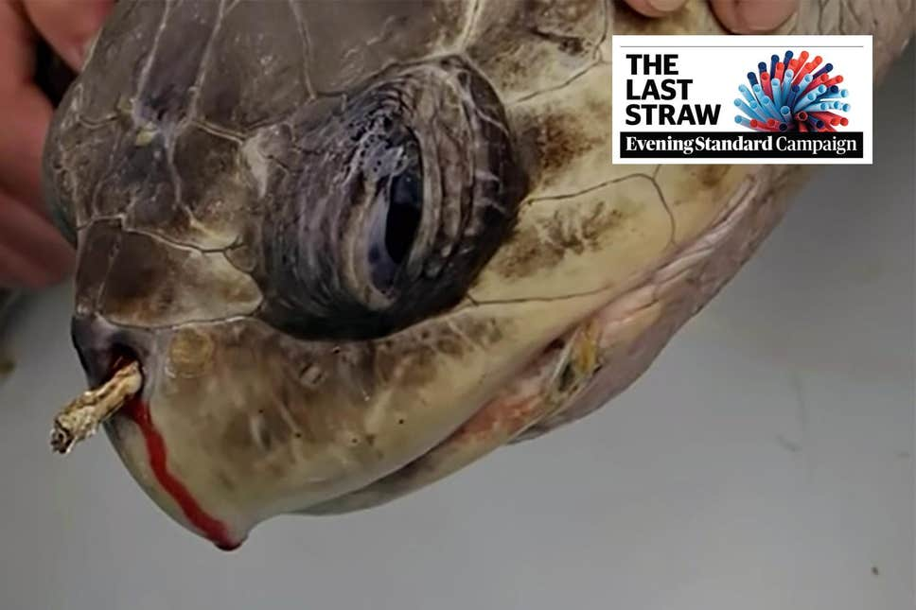 The major environmental implications in implementing a straw ban in Florida are found to be positive. Several videos of sea turtles, birds, and other marine mammals that are impacted by single- use plastic straws are surfacing, which is generating a lot of publicity for conservation action. Over 8.8 million tons of plastic are spilling into the ocean every year, and plastic straws are a small percentage of that, but that is still millions new of straws in the ocean every year. Environmentalists are pushing for more countries to ban straws, especially in Asian countries.

Figure 1- Image of turtle with straw in its nose video that went viral on YouTube and Facebook.

(<https://www.standard.co.uk/news/uk/the-last-straw-footage-of-a-turtle-with-a-12cm-plastic-straw-stuck-up-its-nose-highlights-the-a3740136.html>)

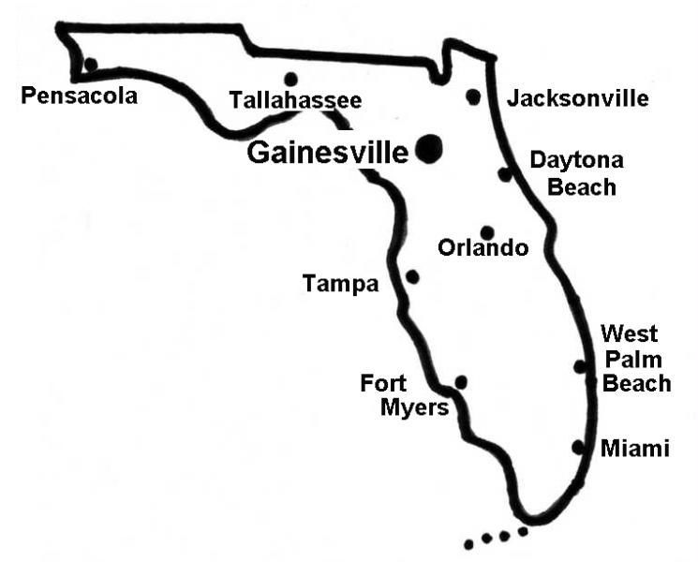 For my case selection my focus will be on how the City of Gainesville is reacting to the single- use plastic straw ban, ban. Restaurants in Gainesville can elect to not present a straw with every drink, but there is no mandate or enforcement for all restaurants to follow this. As the University of Florida supports the research of many biologists and conservationists, it is safe to say that there is a strong population of residents that are interested in having the straw ban enforced. My research on this case will interview city officials and residents of Gainesville to record their viewpoints and their opinions on the straw ban. From these interviews I will have a clear understanding of how this ban is affecting the residents and local government.

Figure 2- Map of Florida, with an emphasis of Gainesville. (<http://www.gainesvillefloridahomes.com/>)

The methods to which this case study is being evaluated on in investigating who represents the stakeholders, what the concerns of the stakeholders are, the points of views on the stakeholders, and ultimately a summary and analysis of the interviews.

**Analysis**

The reason for an analysis on this case study is to pinpoint areas of improvement to leave all the stakeholders satisfied with the result. In the analysis section we review several aspects of the stakeholder analysis. The aspects reviewed are the issues presented as they are, the constraints opportunities for collaboration between the stakeholders, areas of agreement and disagreement, and a conclusion and summary of the interviews conducted.

**Description of History in Florida**

Concern regarding single-use plastics has been on the rise since the 1990s, especially regarding plastics in the ocean. Ye and Andrary (1991) suggest that plastic waste in marine environments is a relatively recent phenomenon and is attributed to commercial fishing and gear. They also concluded that floating plastic debris are normally held in the water column where larger marine mammals and fish can be affected. Even though commercial fishing does produce plastics in the ocean, another major contributor to this plastic pollution are individual and household single use plastics. Some household single-use plastics that end up in the ocean regularly are plastic straws. Schnurr et al. 2018, mentions that both legislative and non-legislative interventions could help prevent single-use plastics, such as drinking straws, in the marine environment. Schnurr’s (2018) research was testing out non-legislative methods. The purpose of this analysis, however, will be to focus on legislative policies that impact single-use straws, which are still in due process. There is a large concern about the cleanliness of the Florida coastlines, as Florida’s economy relies heavily on beach tourism; as such, the straw ban has been a very popular topic. People are also concerned over single- use plastics affecting marine life and threatening their overall existence (Derraik 2002). Beck (1991) describes the growing interest on the impact of single-use plastic debris on Florida manatees, basically concluding that the debris are from local sources.

In 2008, the Legislature enacted a similar law requiring the Department of Environmental Protection to analyze “the need for new or different regulation of auxiliary containers, wrappings, or disposable plastic bags used by consumers to carry products from retail establishments (Gross, 2010).

*The Passage of Time*

The concern of single-use plastics has been an ongoing issue, but the specificity of a law banning straws is relatively new. The passage of time for the City of Gainesville started around March 2019 (Eldwood 2019).

**Description of Current Status in Gainesville, FL**

On May 10, 2019 Governor Ron DeSantis used his veto power, for the first time since his appointment, declining to sign an environmental bill that would have prohibited local governments from banning plastic straws for the next five years. “The state should simply allow local communities to address this issue through the political process,” DeSantis wrote. “Citizens who oppose plastic straw ordinances can seek recourse by electing people who share their views, (Gross, 2010).”

There has been a flip-flop over this bill for the past several months. Due to Governor Ron DeSantis using his veto power, local governments can now make their own decisions about the matter. Other cities have passed straw bans such as St. Petersburg, Miami Beach, and Ft. Myers. On May 17, 2019 Gainesville, FL began voting on the plastic straw ban, and there is expected to be a final result in sometime in June sometime. As of yet, there is no news on the final verdict. Even though the plastic straw ban has not been formally added as a policy, there have been many restaurants that have started to practice a single- use straw ban policy.

Depending on what the City of Gainesville decides, this choice could lead to a different conflict. The original conflict was that the local governments wanted to choose whether or not they wanted to implement their own straw ban. The conflict that could now arise is if the people are on board for the decisions made by the city officials.

*Incomplete Information*

The State of Florida is allowing for local governments to make their own decisions about the straw ban currently. However, there is still a lengthy process to allow for each county or city to make the regulation stick. Many local governments will need to conduct surveys and investigations to see if the straw ban will be beneficial to their community before they can request a regulation be implemented.

“The study would focus on the “data and conclusions” used in adopting local ordinances instead of the environmental impacts, which had irked environmental groups that argue that there’s enough evidence of the effect of plastic pollution” (Gross, 2010).

There are no true scientific studies on the effects of only single- use plastic straws in Gainesville, FL. Since there is no published study, there is lack of information for both the city officials, the residents of Gainesville, and the State of Florida.

**Possible Solutions**

*The focus is on solving a problem*

It looks like there is a solution currently for the people that wanted the straw ban to be implement by local governments, because the bill was recently overturned. Other people that are concerned about the ban are the elderly and disabled not wanting their freedoms infringed upon, by having to ask or not being able to obtain a plastic straw. Some small restaurants are concerned about the straw ban because they have limited resources, and change can be difficult, i.e switching over to paper straws. Larger chain restaurants, like Starbucks, are onboard with the straw ban and are regulating some changes such as not providing a straw with every beverage automatically. The issue is ongoing, and the conflict may between stakeholders change in the near future.

*Parties meet face to face to work out differences*

Since the City of Gainesville is still waiting on the final vote to the single-use plastic straw ban, there is not a timeline yet on whether the city officials will meet face to face with the residents. However, it would be useful if they do meet with the residents and local business owners, after the verdict sometime this month, to go over concerns about the straw ban and how it will impact the community.

**Stakeholder Analysis**

Stakeholders are defined as “any group of people, organized or unorganized, who share a common interest or stake in a particular issue or system” (Grimble & Wellard 1997).

Primary Stakeholder- parties that have unharmonious goals and/or have a direct stake and reaching those goals

Secondary Stakeholders- indirect stake in the pursue of goals and are not directly involved

Peripheral Stakeholders- parties that are interested in the conflict, have an opinion about the issue, not directly involved or affected

Positions- what people want to happen

Interest- why they want this to happen

Values- what they believe is worth the conflict

***Primary Stakeholders***

*A. State of Florida*

*Position:* Because of the veto, the State of Florida wants the cities and counties to provide evidence, to support a single-use plastic straw ban, when the local government is applying to regulate the ban to the state government.

*Interest:* The State of Florida wanted this new bill to happen so that they can have the ultimate decision on whether a city or county can enforce a plastic straw ban would rely on the city or county and not the state.

*Values:* Now Florida believes that cities and counties should have the power to make their own single-use plastic straw ban bill.

*B. City of Gainesville*

*Position:* The City of Gainesville is currently voting on their position. It is not certain, at this present time, if the city will be in support or not of the plastic straw ban.

*Interest:* The reason why the City of Gainesville is voting on enforcing a straw ban is because it is a very hot topic. Residents of Gainesville are adamant and passionate about this ban and have voiced their concerns to the City of Gainesville government, so the city feels like they must take action on this subject.

*Values:* This value is not yet determined. Voting still in process.

*C. Residents of Gainesville opposed to the straw ban*

*Position:* Many disabled people and elderly people do not want this straw ban to be enforced and for the City of Gainesville to vote no on the straw ban.

*Interest:* They do not want the straw ban to be enforced because they feel that their rights are being infringed upon and do not want to go through a hassle in looking for a readily available straw. They also believe that a strong plastic straw ban will mean straws will not be guaranteed in every restaurant. Restaurants not having straws readily available will impact this stakeholder group directly, specifically their mobility to consume beverages and comfort while dining out. Local restaurant owners are not interested because some might not be willing to change suppliers or add additional costs by choosing to purchase in bulk a more expensive straw type.

*Values:* Believes that every resident should have the right to a plastic straw if they required it. This group believes that a straw ban bill should not be passed because it infringes on the rights of some minority groups. This group believes in the equality of all people’s group.

***Secondary Stakeholders***

*D. Residents of Gainesville for the straw ban*

*Position:* Gainesville, Florida has a large population of conservationists. There are many state parks in Alachua County, which is the county of Gainesville, and the interest is there with many residents who are concerned about single-use plastic pollution.

*Interest:* The reason why the residents of Gainesville are passionate about the straw ban is because they are interested in protecting marine species, water ways, and overall be a more consciousness city. Whether or not the straw ban is enforced will not impact these residents directly, however.

*Values:* The values of this group are for the protecting and conservation of the environment for its intrinsic value. This group believes that the protection of the environment is above the rights of groups of people (i.e elderly and disabled).

**Realms and Concepts of Value**

Realms of values are “categories or a classification of ways in which the environment or natural resources are valued” (Tainer 2006). Each realm of value has an equivalent concept of the value process. The different stakeholders will view the natural resource by the each of distinct realms.

The first realm of value that is identified is the **ecosystem value**. “Ecosystem values are assed in terms of ecological health or ecosystem integrity and reproduced within the scientific discipline of ecology (Tainer, 2006)”. The concept of the value resides with the residents of Gainesville wanting a straw ban to be enacted so that the ocean and beach environments can have health and ecosystem integrity. Many viral videos have surfaced showing marine animals impacted by single-use plastic straws. The residents that are for the straw ban value the ocean for its ecosystem services and its intrinsic values, meaning that they value a clean ocean just for the sake of having a clean ocean.

The second realm of value is the **recreational value**. “Recreational values are judged on the potential for a quality recreational experience and are also reproduced via cultural and social processes (Tainer, 2006)”. The State of Florida has shown that is does value clean beaches because it attracts tourism, and thus more revenue for the state. The original bill prohibition of a straw ban for cities and counties to make their own regulation decisions, seemed to oppose this notion of recreational value. Since the bill has been vetoed, this shows a strong interest in the State of Florida have a recreational value its people and tourists. If there is a potential for clean ocean and beaches, the State of Florida will mostly go on the side of that regulation. This is a political action, that considers the political and also cultural viewpoints of the State Senate.

The third realm that is observed in this conflict is the **social realm**. We attribute social value to entities that promote and strengthen social relationships or institutions (Tainer, 2006)”. The residents of Gainesville that are for the straw ban value a concept of being able to voice their opinions and use their numbers to strengthen their social stance on single-use plastic straws. The expression for the residents is to use their voting rights and social influence to display their passion on this conflict. What residents’ value is the ability to have their voices hear and for their to be a call to action that the City of Gainesville can address.

The last realm in this conflict is the **moral realm**. Residents of Gainesville that do now want the straw ban to be enforced are concerned that their rights are not being represented. They feel that their right to mobility to drinking and comfort dining out is not being represented with a straw ban. “Moral value taking the form of normative judgments and are reproduced via moral and cultural education (Tainer, 2006)”. Disabled and elderly people believe that people should have more moral standards and consider their needs as well before single-use plastic straws are banned. The overall feeling of this stakeholder group is that they should have the same rights as everyone else, and that with a straw ban their lives will be generally impacted in a negative way.

|  |  |  |  |  |  |
| --- | --- | --- | --- | --- | --- |
| Realm of Value | Concept of Value | Stakeholder | Expression of Value | Mode of Value Reproduction | Entities that are valued |
| Ecosystem | Ecosystem health and integrity | Residents of Gainesville for the straw ban | Enacting the straw ban | Science of ecology and ecological processes | Oceans are cleaner because there is limited availability of single-use plastic straws |
| Recreational | Potential for cleaner quality of recreational experience in beaches | State of Florida | Political action | Cultural and political processes | Tourists and locals and enjoying cleaner beaches free from single- use plastic straws |
| Social | People unifying against a cause they will strongly about will strengthen the social political climate | Residents of Gainesville for the straw ban | Political action and voting | Cultural and social process | The ability for residents to voice their opinions governments take action actions happen |
| Moral | People who do not want their rights taken away | Residents of Gainesville opposed to the straw ban | Remove the straw ban | Moral education,  Cultural and social processes | All people should have the same rights for mobility and comfort |

Table 1- Realms of Value in the City of Gainesville Straw Ban Conflict with the State of Florida

**Issues Analysis**

**Primary Generating Factors**

Facts-based: disagreement over what is because of how parties perceive what is. Judgment and perception are the primary conflict generators here. disagreement over what the “facts” of the issue are; what is true or accurate; what is “reality”

* Between the stakeholders State of Florida and City of Gainesville, there is a fact-based disagreement. The State of Florida is requiring for all cities and counties to show proof that there is evidence that a single-use plastic straw ban will be a positive influence on the residents and the environment. The State of Florida has stated that there is no scientific or actual proof that a single-use plastic straw ban will cause a positive impact. Some of residents of the City of Gainesville believe that there is enough evidence through subjective experiences in beaches and bodies of water that are littered by single-use plastic straws. That evidence is subjective and not fact-based or scientific. The reality for the residents in Gainesville is that single-plastic straws are polluting the environment and there should be ban.

Values-based: disagreement over what should be the determinants (criteria, bases, priorities) of a policy decision, a relationship, or some other issue in conflict

* The value-based disagreement in this case could be between the residents of Gainesville that are for the single-use plastic straw ban and the City of Gainesville’s voting outcome. Currently, the City of Gainesville has not reported if they will proceed with a single-use plastic straw ban, but there are many residents of Gainesville that are conservationists and they are passionate about protecting and preserving the environment for the sake of simply keeping the environment pristine. If the City of Gainesville proceeds to not enact a single-use plastic straw ban, a conflict will be created and escalated since many residents are for the straw ban. The City of Gainesville should have a value system to represent the interest of its residents, which the majority do want a plastic straw ban, but sometimes that doesn’t show through in the policies and bills passed and the public is ignored.

Interests-based: disagreement over who will get what in the distribution of scarce resources, whether tangible or intangible (e.g., land, economic benefits, rights, privileges, control, respect).

* There could be interest-based disagreement between the residents that do not want the plastic straw ban passed and the City of Gainesville voting outcome. It the City of Gainesville chooses to pass the straw ban bill, the residents that do not want the bill to be passed will have a conflict. This group believes that a straw ban bill is overstepping their rights of comfort and mobility to drink a beverage.

Jurisdiction-based: disagreement over who has authority or jurisdiction over the problems and issues of the conflict

* Jurisdiction- based disagreements have been recently resolved. This issue was resolved between the cities and counties and the State of Florida. The State of Florida has given back the decision-making power back to the cities and counties.

Person-based: disagreement pertaining to personal factors, such as interaction styles, idiosyncratic actions, personality-related behaviors, effects of the physical setting, etc.

* In this case study there is no person-based conflict biased. No one person is disagreeing with another single one person.

History-based: disagreement related to the history of the issue(s), the conflict, and the conflict relationship, as perceived by the parties in conflict.

* In this case study there is not a history-based primary generating conflict factor because the conflict is relatively new.

Culture-based: disagreements emerge that pertain to cultural orientations, worldviews, and identities. Parties’ different cultural foundations, when not addressed, may contribute to misunderstanding.

* 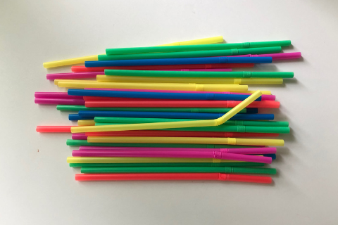In this case study there is no culture-based disagreements that are identified. The residents of the Gainesville do have different cultures, but that doesn’t play into this case study.

Figure 3- Image of single-use plastic straw ban.

**BATNAS- Principled Negotiation**

1. **Separate the People from the Problem**

People- separate the people from the problem. The participants should see themselves as working side by side attacking the problem, not each other

This is a very useful principled negotiation. If the City of Gainesville separated people’s feelings from the problem, they might be better to able to work together. Each side will feel that they are not being attacked, and each side will have their concerns aired out without judgement.

1. **Focus on Interests, not Positions**

The interest of the stakeholders might overlap in areas of keeping sustainability in Florida. All the parties have an interest in keeping beaches and public places free of single-use plastic straw pollution. It is better for all the parties to focus on their main interests, instead of their positions. Until I receive all of the interviews, I won’t know the level of interest that the environment has exactly on each stakeholder, but in general there is an interest in keeping pollution out of public areas.

1. **Invent Options for Mutual Gain**

Options- Generate a variety of possibilities for mutual gain before deciding what to do

For the City of Gainesville, there might be a way to create mutual gain with the residents that are against the straw ban, by creating programs to access straws. Maybe some options they could give is for any disabled person, to send them a reusable straw. For restaurants it might be beneficial if the City of Gainesville offered a tax incentive to have compostable straws instead of single-use plastic straws. This could help create a mutual gain for all parties interested in the straw ban.

1. **Insist on Using Objective Criteria**

Criteria- Insist that the result be based on some objective standard

Aside from taking people’s feeling out of the equation, it would also be beneficial to use objective evidence for the single-use plastic straw ban. If the City of Gainesville, if they vote that they are for the straw ban, provides some statistics or information materials so that people can know the full impact that the straw ban will have on restaurants, residents, and the environment.

**Barriers to agreement**

1. **One side having more money or power than the other**

This can be especially true for residents of Gainesville that are for the straw ban. These residents are environmentalists and might be associated with the University of Florida that can have quite a lot of power. The residents of Gainesville that are against the straw ban are likely elderly or disabled and might not have the same campaigning resources that the residents for the straw ban have.

**Mutual Gains**

“There is power in developing a good working relationship between the people negotiating.” (Fisher and Ury)

1. **If the parties were to enter negotiations**

If the parties were to enter negotiations, it is important to establish a good working relationship. As long as the parties respect each other’s concerns and put aside people’s emotional feelings, they should be able to find a resolution.

1. **Parties Incentives to collaborate, to compete, to learn**
2. Expanding the pie - identifying additional value to add to the deal, additional to the initial target or desire

If the City of Gainesville, if they vote for the straw ban, adds additional value to the straw ban, more people will be inclined to be for the straw ban. Some additional value to the straw ban could be how residents will be helping with keeping Gainesville the forefront of being “green”, or environmentally conscious. This might be appealing to a lot of residents since it will boost the value of the city in the eyes of tourists and other Florida residents. If the City of Gainesville advertised this perspective more people will likely be shifted to approve of the straw ban.

1. Nonspecific compensation

I did mention a nonspecific compensation earlier in the paper, on how the City of Gainesville could provide free reusable plastic straws to the elderly and disabled residents. This would provide a mutual gain of knowing that people will not be complaining that they do not have access to straws, since they will have their own, and they will also not contribute to producing more plastic waste.

1. Logrolling – the practice of exchanging favors, especially in politics by reciprocal voting for each other's proposed legislation

I’m not sure if this will be something that will come up on this issue. There are some politics involved, but I don’t know is this is applicable to my case study.

1. Cost Cutting

Some cost cutting that could ultimately happen would be if the straw ban is implemented the City of Gainesville will not have to spend as much money cleaning public areas. If the City of Gainesville gives a tax incentive to the restaurants, this will also provide cost cutting services for going “green”, that will allow restaurants to stay afloat.

**Mapping Areas of Agreement and Disagreement**

Across this conflict, there are stakeholder groups that that have incompatible and compatible interests. Table 2 displays that there is overlap between stakeholder groups but that some groups have higher priorities than other groups. An example of the differences in priorities is how the State of Florida and the City of Gainesville are going to do what is best for them business wise, even if it means upsetting other groups. Residents of Gainesville, for the straw ban, might not be as heavily invested into money or business dealings because they more interested in the environmental benefits from enacting a straw ban. Residents of Gainesville that are against the straw ban might also be have interest in business because residents that own restaurants will have to invest more money on paper straws. Of course, these restaurant owners could decide to just not to provide any straws, thus saving them money. Either way, restaurant owners are interested into the business aspect of the straw ban and take that into a high priority.

Residents of Gainesville, for the straw ban, mostly prioritize the environment and protecting the environment. Even if the residents of Gainesville for the straw ban regard the environment as a high priority, the City of Gainesville and the State of Florida might not consider the environment as the highest priority.

For individual rights, it seems as though the State of Florida is trying to give people more rights, and the residents of Gainesville ae also concerned about their rights. It seems as though the City of Gainesville doesn’t seem too interested in the individual rights of people, or at least that is the perception.

Both categories of residents are not really interested in tourism, since it doesn’t impact them directly. Even though tourism can lead to more traffic, but the State of Florida and City of Gainesville are more interested in tourism because of the revenue it provides.

Some of the mutual gains include Business and Tourism revenue for the State of Florida and City of Gainesville. Some of the other mutual gains involve the two categories of the residents of Gainesville that are interested and have a high priority for the environment.

|  |  |  |  |  |
| --- | --- | --- | --- | --- |
| Stakeholder | Environment | Individual Rights | Tourism | Business |
| State of Florida (responses from interviewed not yet received) | 3-4 | 3-4 | 5X | 5X |
| City of Gainesville (responses from interviewed not yet received) | 2-3 | 2-3 | 3-4 | 5X |
| Residents for the straw ban | 4X | 2 | 2 | 3 |
| Residents against the straw ban | 3 | 4X | 2 | 4X |

Table 2- Areas of agreement and disagreement matrix. 1 to 5 represent the level of priority, where 1 is the lowest and 5 is the highest.

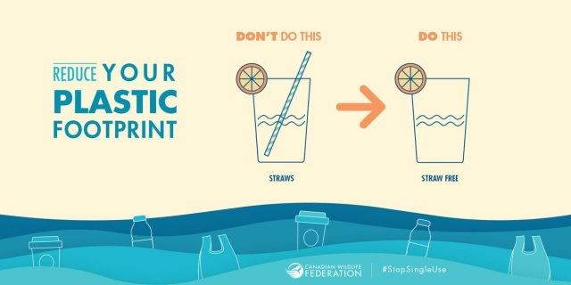

Figure 4- Example of marketing against the single-use plastic straw ban.

**Summary of Meetings and Interviews**

1. *Summary of a meeting where conflict is discussed*(e.g., city council meeting, organization meeting on issue, protest, etc.)

<https://www.gainesville.com/news/20190517/gainesville-to-vote-on-plastic-straw-ban>

On May 27, 2019, the City of Gainesville Commissioners agreed to schedule a vote in June on whether they should ban single use plastic straws. It is July now, and the meeting still wasn’t scheduled. Once the meeting takes place, the City of Gainesville will decide if the straw ban will be enforced along with the city’s plastic bag and Styrofoam ban. Those bans are to be enforced by January 2020. There is still no news on when the meeting to discuss this.

After the reviewing the captions and videos for the meetings in June, the single use plastic straw ban was mentioned (<http://gainesville.granicus.com/TranscriptViewer.php?view_id=9&clip_id=3717> ), but it was to discuss this at a later time. I had read almost all of the meetings for June 2019, and it seems as though it kept getting pushed back.

On the meeting of mentioned above, on June 24, 2019, the straw issue was addressed and the conversation goes as follows:

>>start

**Mayor:** All right.

**Commissioner Ward:** And then ordinances on second reading, the finley woods cdd and then the clarification and new enforcement date for the prohibition on plastics and polystyrene. And then ordinances on first reading, you continued this one from your last meeting, the prohibition on single-use plastic straws and stirrers. And then there's a voluntary annexation ordinance for 11.18 acres that's south of East University and west of southeast 38th street.

**Mayor:** okay, thank you. We have a couple of questions.

**Commissioner Ward:** Thank you, Mr. Mayor. What do we think about -- since I think there will be some interest in the prohibition of the single-use plastic straws and stirrers, that we make it a time certain.

**Mayor:** We can. I actually don't expect a big group for that. I think we have kind of done the heavy lifting on that. But if you have received information otherwise, I'm happy to do that at like 6:00.

>>end

I would say from reading these comments in the captions, and watching the video, it looks as though the main points are:

1. The single- use plastic straw ban vote is still being pushed back.
2. The City of Gainesville doesn’t believe they have a big group of people that are pushing for a final date on the vote.

* Summarize these major points

The summary of the major points are that the City of Gainesville is not taking the single-use plastic straw ban very seriously. They are taking the issue seriously to an extent, but they are pushing the voting, for whatever reason, until probably the last possible date to get the vote in. Also, it seems as though, people who are really interested in the ban are not speaking up, or at least not to the City of Gainesville, because Gainesville does not think there will be a push for this ban vote.

1. *Summary of two interviews with stakeholders from differing sides*

**First Interview:**

Interview in person on 6/30/2019:

Martin Noguera, resident for the Straw Ban

Clinical Research Coordinator II, University of Florida

email: mnoguera@ufl.edu

What do you know about the single-use plastic straw ban for the City of Gainesville?

**I haven’t seen or heard much advertisement, but it is something that can be beneficial to the environment.**

What is it important to have/ or not have a single-use plastic straw ban for the City of Gainesville?

**It is important to have a single-use plastic straw ban for the city in order to create less waste. Every now and then I see plastic waste on our streets and neighborhoods. Plastic straws being among the most common observation.**

What other individuals or stakeholders do you believe have a stake in the single-use plastic straw ban for the City of Gainesville?

**The residents of the city of Gainesville, restaurant/bar owners, the University of Florida, Alachua County.**

What is your perspective of the interest and concerns of the different stakeholders?

**The residents of Gainesville will experience less waste on the streets and neighborhoods, restaurant/bar owners will have less expenses, the University of Florida will experience less waste around campus especially during major sporting events, the county will have less waste to clean up.**

Is there anything that you think you can do to support your perspective on the single-use plastic straw ban for the City of Gainesville?

**Attend town hall meetings and express the need to pass legislation for single-use straw ban. Also, writing letters of support to city council workers.**

What are your main concerns about the single-use plastic straw ban for the City of Gainesville?

**My main concern is the preservation of the environment and ecosystem. Plastic straws are not biodegradable and can be a potential health hazard to different species of animals that call Gainesville home.**

What is your involvement in the single-use plastic straw ban for the City of Gainesville?

**As a resident of this beautiful city, I am raising awareness and setting an example in the community by using a multiple use straw whenever I am dining at a restaurant.**

What do you think is the main pushback for the single-use plastic straw ban for the City of Gainesville?

**I think a major pushback is individuals that are not open to change and/or care for the preservation of the environment.**

What do you think your perspective is for the majority of the residents of Gainesville?

**I think most residents of Gainesville are open to this change. If it improves our city and our neighborhoods, they are for it.**

Do you think that the media is playing a role in single-use plastic straw ban for the City of Gainesville? I would not know.

**I do not use social media, so I am not aware in this format. I have not heard NPR express interest on this, although it might come on during a time where I am not able to listen.**

Do you think Gainesville can support enough scientific evidence to the Florida Senate to show that there will be a positive impact from banning single-use plastic straws?

**Yes, I do believe this is possible. There are a lot of environmental scientists in the community that can provide enough scientific evidence to the Florida Senate to show positive impact from the ban.**

Summary of interview:

This resident of Gainesville is aware of the environmental need for a single-use plastic straw ban, but they feel that there is not enough media coverage of the issue. I believe that the resident believes that the media is not doing a good job representing this conflict over the radio on NPR. They also believe that they could attend meetings and write letters to get conflict some more advertisement.

**Second Interview:**

Interview in person on 7/1/2019:

Scott Borsum, resident against the Straw Ban

University of Florida Ph.D candidate

email: jscott.borsum@ufl.edu

What do you know about the single-use plastic straw ban for the City of Gainesville?

**I did not even know that there was a single use plastic straw ban for the City of Gainesville. I assuming that it is planned because I still see plastic straws everywhere. I have noticed that more businesses do have paper straws so perhaps they are planning for the change.**

What is it important to have/ or not have a single-use plastic straw ban for the City of Gainesville?

**I don’t really see why it is important for Gainesville. My guess is that the straws will cost more and that cost will just get passed down to the consumers. Also, we are an hour from the coast and my guess is not many plastic straws actually makes it to the coast from runoff due to all the vegetation where it could be stopped. This also seems like a band aide on a much bigger issue of single use plastics. People will feel like this is enough to save the world and this makes them feel like they are doing their part**

What other individuals or stakeholders do you believe have a stake in the single-use plastic straw ban for the City of Gainesville?

**I really think this will be bad news for the smaller local restaurants.**

**Environmental groups are probably pushing to save sea turtles and other wildlife.**

**I’m not certain there is any manufactures of plastic or paper straws in Gainesville but I’m guessing not.**

**Residents (which includes me)**

What is your perspective of the interest and concerns of the different stakeholders?

**The food industry is hard work, with high overhead, and low margins so even little changes may force them to raise prices or make life tougher. My guess is the paper straw makers will not be able to meet demand consistently which could create a volatile, unpredictable supply. This creates inconsistent prices and makes budgeting more difficult.**

**I think environmental groups want to prevent any sort of issues with wildlife like the infamous turtle video. I think the thought is well minded but do we really use that many straws anyway? What about all the other single use plastics and the continued expansion of human developments on natural areas. Seems like a more comprehensive ban would be needed to make actual change and not just make some people and politicians feel good about themselves.**

**The same goes for residents. This seems like a feel-good initiative more than one that is actually seeking to reduce plastic use. Straws are relatively small, thin pieces of plastic compared to say bottles which people use way more of or plastic utensils. I think this creates a bigger problem, complacency. People will begin to feel like they are doing enough to help and stop looking to reduce in other way. They think “I recycle, my city doesn’t have straws, I am doing my part.” Most people don’t even recycle properly and is still just a band aide to a much larger issue.**

Is there anything that you think you can do to support your perspective on the single-use plastic straw ban for the City of Gainesville?

**I think the city could try to take a bigger stand on single use plastics in general. This plastic straw ban seems like a low hanging fruit for a positive political view and jumping on the bandwagon. I think they could do more to educate people or enforce littering fines or taxes. Perhaps putting pressure on the bigger companies which can more easily afford to make environmental friendly changes to their business plans.**

What are your main concerns about the single-use plastic straw ban for the City of Gainesville?

**My main concern is that it will hurt the bottom line of smaller local restaurants by raising their costs, forcing them to pass on to consumers which may affect their decision to go there.**

**I also fear that this will not lead to future legislation to remove other single use plastics which I call the complacency effect.**

What is your involvement in the single-use plastic straw ban for the City of Gainesville?

**I have no real involvement other than as a consumer but I simple chose not to use straws because they aren’t really necessary for most people. They are a convenience that we have become accustom to. How bout this just a straw ban in general.**

**I also consider myself an environmentalist and want to see a healthy environment but I can’t even remember the last time a saw a straw trash on the ground. Usually it is some paper bag, wrapper, or bottle. I want to see bigger more fundamental changes not some pushover weak policy that everyone else is doing.**

What do you think is the main pushback for the single-use plastic straw ban for the City of Gainesville?

**I think the economic argument is the most sound and logical opposition. However, I wasn’t even aware and I’m guessing most people would notice till after it already happens.**

What do you think your perspective is for the majority of the residents of Gainesville? ( the wording is weird here)

**I think most residents are probably for the ban and my perspective is only shared by small business owners**

Do you think that the media is playing a roll in single-use plastic straw ban for the City of Gainesville?

**100% the media and the turtle are responsible for straw bans specifically. It has been fascinating to watch how quickly the responses to this turtle thing happened. I think it says a lot about the state of our society and should be studied by people because it was brilliant environmental marketing.**

Do you think Gainesville can support enough scientific evident to the Florida Senate to show that there will be a positive impact from banning single-use plastic straws?

**I don’t know what evidence they have but I wouldn’t buy it. It seems so trivial amongst a much bigger issue. Straws are such and insignificant part of the plastic trash that I don’t see how any benefit can outweigh the logistical and economic negatives associated with it. The only real argument is that it will help people use less by removing options and be more conscious about plastic use, but obviously I don’t think it will and is difficult to understand how people will behave from a scientific perspective.**

Summary of interview:

This resident feels that the single-use plastic straw ban is a “feel good initiative” because Gainesville is not near the coast, and the straw pollution will never reach the ocean. The resident believes that the turtle video with the straw in its nose (<https://www.youtube.com/watch?v=4wH878t78bw>) is one of the video that is causing the uproar to ban plastic straws. The resident also believes that the straw ban will come at a big expanse for the local restaurants and ultimately the price will come down to the consumers, so it might not be worth it to enact the straw ban.

**Findings and Recommendations**

**After all of the analysis and interview summaries, I found that the City of Gainesville is not as passionate as the residents when it comes to this case study. After reviewing the last meeting that the City of Gainesville officials kept pushing back the single-use plastic straw ban meeting. The City of Gainesville is setting a formal meeting and continues to push the topic into the next city meetings, and it has been going on for the past several months. The media articles have reported that the City of Gainesville should be making a final decision on the single-use plastic straw ban in June, but it’s August, and there is still no official meeting date yet. I believe they might not even get to the meeting until next year.**

**Compared to the city officials, the Residents of Gainesville are motivated and passionate about the single-use plastic straw ban. Both types of residents that are for or against the single-use plastic straw ban do consider this a serious topic that should be addressed. The Residents of Gainesville do have strong opinions about the single-use plastic straw ban, and they believe that their opinions should be heard.**

**I would recommend for the City of Gainesville to hold a public meeting about the single-use plastic straw ban and allow the Residents to voice their concerns. The Residents, going through the interviews with them, are interested in this issue being resolved and they do not like waiting for the City of Gainesville to have a meeting to make up their mind. The Residents of Gainesville would like to know the outcome of the voting meeting.**

**I would also recommend that the Residents of Gainesville send letters to the City of Gainesville to address their concerns to have the meeting be formally scheduled. Once the City of Gainesville sticks to their schedule to have the single-use plastic straw ban meeting, and seriously discuss the issue, they should be able to come to a final vote.**

**Conclusion**

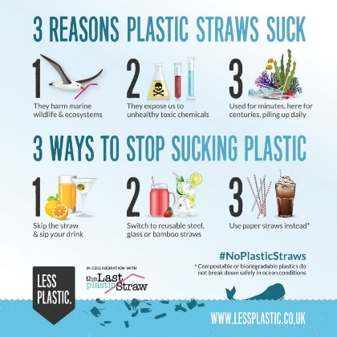My conclusion is that there is still a lot of work needed to be done to resolve this issue and leave the stakeholders feeling satisfied or at least heard. The City of Gainesville needs to schedule a meeting to resolve this issue before the Residents of Gainesville start to become very impatient to get a resolution.

Figure 5- Example of single-use plastic straw ban marketing.

**References**

1. Plastic Straws Are Out: Ron Desantis Vetoes Prohibition Of Local Straw Bans,

Samantha Gross - <https://www.tampabay.com/florida-politics/buzz/2019/05/10/plastic-straw-are-out-ron-desantis-vetoes-prohibition-of-local-bans/> , May 10, 2019

1. Senate Panel Approves 5-year Delay on Plastic Straw Bans

Ryan Nicol - <https://floridapolitics.com/archives/289919-senate-panel-plastic-straw-ban>, March 4, 2019

1. Beck, Cathy A. and Nélio B. Barros. "The impact of debris on the Florida manatee." Marine Pollution Bulletin (1991).
2. Derraik, José G B. "The pollution of the marine environment by plastic debris: a review." Marine pollution bulletin (2002).
3. Schnurr, Riley E.J., et al. "Reducing marine pollution from single-use plastics (SUPs): A review." Marine Pollution Bulletin (2018).
4. Ye, Song and Anthony L. Andrady. "Fouling of floating plastic debris under Biscayne Bay exposure conditions." Marine Pollution Bulletin (1991).
5. Gainesville Commission plans to oppose the bill, Karina Eldwood, <https://www.alligator.org/news/a-new-bill-might-ban-city-straw-bans/article_d77df52a-43b1-11e9-aecb-476dae2909e7.html>, March 10, 2019