**Case Study - Spatial Analysis of Deer Island**

**Introduction and Background**

Restoration efforts in coastal zones may be strongly influenced by landscape level processes. The Gulf of Mexico coastline, with its low relief geomorphology, especially in Florida, is also vulnerable to coastal erosion (Geselbracht et al., 2011). Much of the Florida coastline consists of a 1-meter elevation contour that extends inward anywhere from 3 to 10 kilometers. This low elevation leaves the Florida coastline susceptible to frequent coastal changes. Other types of landscape changes occur at different time scales and may have different (and unknown) effects including conversion from wetlands to shallow shores.

The Big Bend coastline is 60 miles west of Gainesville Florida and is located in the Gulf of Mexico. The Big Bend is largely undeveloped, which is usual considering that most of the Gulf of Mexico coastline is fully developed. Around 30% of the Big Bend land area and over 60 miles of coastline are under conservation protection (Main & Allen 2007). Human population density around the Big Bend is the lowest of any other coastal Florida city and the percentage of intact natural habitat is considerably high (Geselbracht 2007). Due to, in part, low human densities, coastal areas have not been heavily impacted by boat traffic, dredging, heavy industrial pollution, eutrophication, or other anthropogenic impacts (Seavey et al. 2011). Despite the lack of human influence, many observable declines in ecosystem and habitats have been documented (Seavey et al. 2011).

**Objectives**

Analyzing trends of landscape level change over time can provide basic information on how systems may be changing. These quantified trends can motivate actions to improve management and protection of coastal and inland habitats.

I will conduct a geospatial analysis on coastal changes, gained and/or lost, from the earliest appropriate mapping imagery of Deer Island to the most recent appropriate mapping imagery.

**Study Area – Deer Island**

The area of study that will be analyzed is the coastline of Deer Island, which is off the coast of the Big Bend coastline. Deer Island is a barrier island consisting of 90 acres in total area, which comprises of 25 acres of upland habitat and 20 acres of wetland habitat (https://www.privateislandsonline.com/united-states/florida/deer-island). The island coastline features a sandy beach facing the open Gulf of Mexico. Deer island is not inhabited, but there are some man-made structures still remaining from the late 1800s. Deer Island is located 8 miles north of Cedar Key, Florida. The surrounding islands will be observed for coastline trends but these changes will not be quantified.

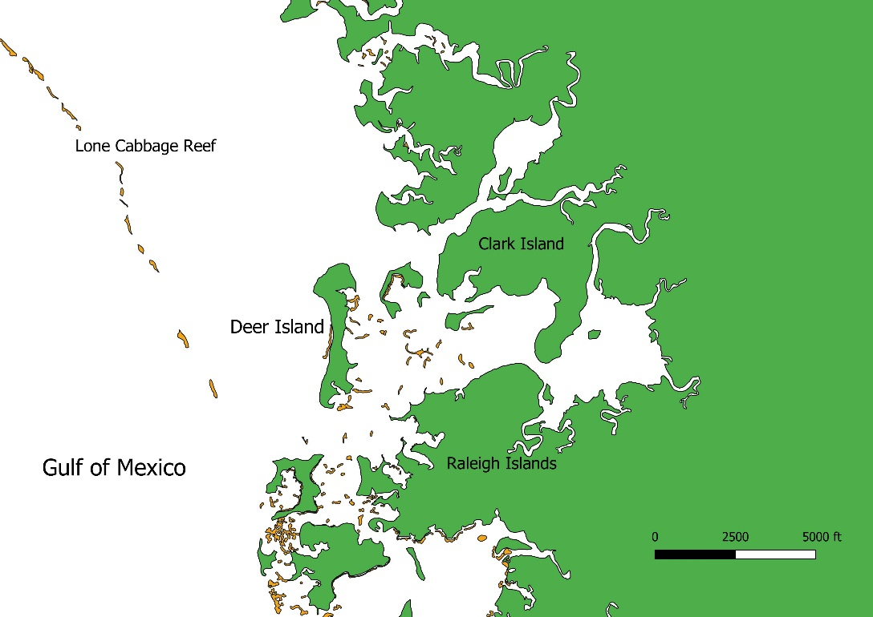

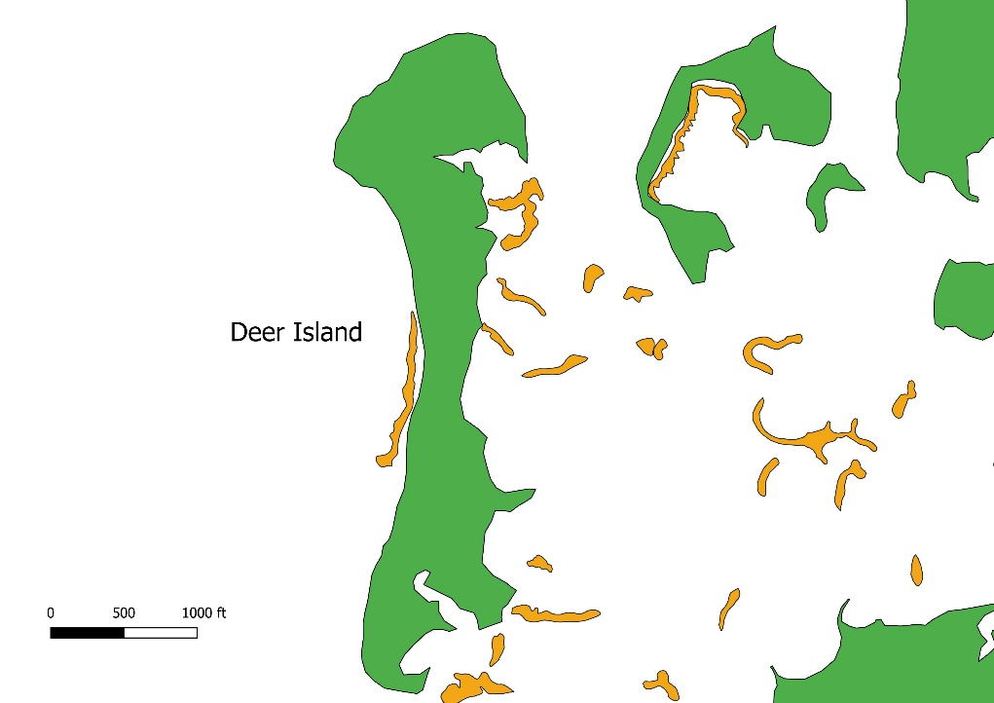Figure 1- Zoomed out view of study area, Deer Island, for spatial context in relation to Lone Cabbage Reef. Land mass is colored in green, and oyster clusters are colored in orange, for reference.

Figure 2- Zoomed in view of study area, Deer Island. Land mass is colored in green, and oyster clusters are colored in orange, for reference.

**Methods**

Defined methods for this case study are not set. Many software programs and packages are available through the University of Florida and open source resources.

*Geospatial Analysis*

There are many online database repositories that offer mapping imagery. Some of the available mapping resources that will be scoured for relevant data are:

* Florida Geographic Data Library (FGDL) - <https://www.fgdl.org>
* LABINS - labins.org
* NOAA - https://maps.ngdc.noaa.gov/
* Digital Orthophoto Quarter Quads (DOQQs) - https://catalog.data.gov/dataset?tags=doqq
* Google Earth Engine - https://earthengine.google.com/
* George A. Smathers Libraries (digital collection) - https://cms.uflib.ufl.edu/
* Ellen Raabe imagery - https://www.usgs.gov/centers/spcmsc/maps

These mapping images will have associated metadata to ensure that the map analysis will be compatible between all maps. It is unsure how many maps at this time will be used to produce the final analysis, but I propose that each decade, ranging from two to four decades, will have at least one selected map, to show the greatest date range of coastline change of Deer Island.

Skills and techniques are still being learned and solidified through recommended GIS courses. Geospatial analysis will be accomplished by using ESRI software products such as ArcMap. ArcMap tools such as “create features”, will allow the user to construct points, polylines, and polygons at on the spatial imagery, allowing for digitization of any area of the map. These features can then be compared and analyzed to observe short-term or long-term trends between spatial imagery of Deer Island. I propose to evaluate if this method can be easily reproduced for future available mapping needs for this restoration effort.

**Expected Outcomes**

The results I intend to find are a decline in land mass of Deer Island in the recent decades, despite lack of much human influence. At this time, there are only story accounts, from local residents, of smaller islands existing around Deer Island, that are no longer visible or available, which suggests that shoreline changes have occurred since at least one generation. There is no in-depth analysis of any particular coastal area of the Big Bend, so this case study will provide a good starting ground for future spatial analysis in the region.

## Bibliography

Geselbracht, L., Freeman, K., Kelly, E., Gordon, D. R., & Putz, F. E. (2011). Retrospective and prospective model simulations of sea level rise impacts on Gulf of Mexico coastal marshes and forests in Waccasassa Bay, Florida. Climatic Change, 107(1-2), 35-57. <https://link.springer.com/article/10.1007/s10584-011-0084-y>

Geselbracht, L. 2007. Conservation action plan for marine and estuarine resources of the Big Bend Area of Florida. The Nature Conservancy, Florida Chap-ter. conpro.tnc.org/968/big_bend_conservation_ action.../download_public

Main,M.B.andG.M.Allen.2007.Florida’ s environment: North central region. Wildlife Ecolo-gy and Conservation Department, Florida Cooper-ative Extension Service, Institute of Food and Agricultural Sciences, University of Florida, Gaines-ville, Florida, USA.

Raabe, E. A., Streck, A. E., & Stumpf, R. P. (2004). Historic topographic sheets to satellite imagery—A methodology for evaluating coastal change in Florida's Big Bend tidal marsh(No. 2002-211). US Geological Survey. <https://pubs.er.usgs.gov/publication/ofr2002211>

Seavey, J. R., Pine III, W. E., Frederick, P., Sturmer, L., & Berrigan, M. (2011). Decadal changes in oyster reefs in the Big Bend of Florida's Gulf Coast. Ecosphere, 2(10), 1-14. https://esajournals.onlinelibrary.wiley.com/doi/full/10.1890/ES11-00205.1