Moreno, Melissa

August 1, 2019

FOR5435 - Geocaching report

Team- Power Puff Girls (Melissa Moreno, Ciara Sanders, Maria Suarez)

**Gatorwalk ID- GCH7B8**

Difficulty – 3 out of 5 difficulty

Obstacle - I would recommend a flashlight to find this one, because the box is under the bridge, making it difficult to see.

GPS performance- Relatively easy to find the overall location. GPS was correct, and accurate to the overall location of geocache.

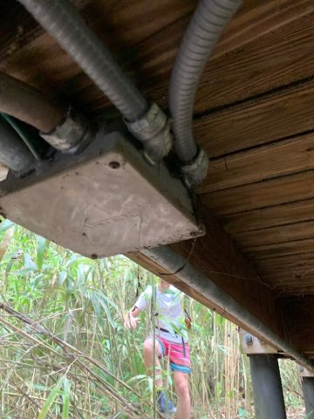

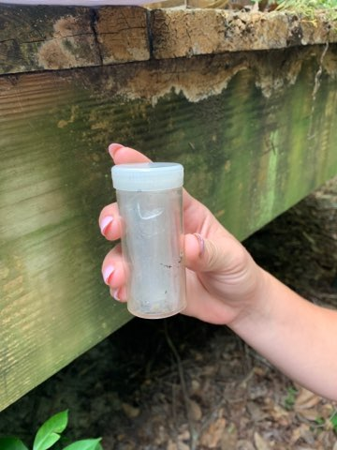

**Princess Nina Georgievna ID – GC55EG8**

Difficulty – 1 out of 5 difficulty

Obstacle – Right on the road, no obstacles.

GPS performance- Relatively easy to find the overall location. GPS was correct, and accurate to the overall location of geocache.

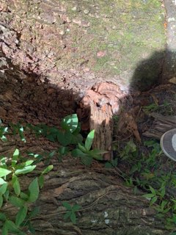

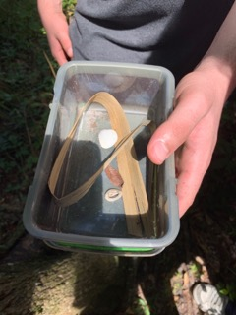

**10 Lords a Leaping ID – GC4V8WF**

Difficulty – 3 out of 5 difficulty

Obstacle – This one was tricky, it was a small black box behind a pole.

GPS performance- GPS was very accurate. The GPS almost pinpointed exactly where the geocache was.

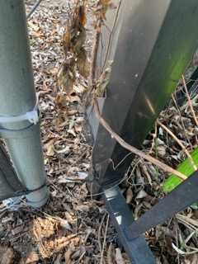

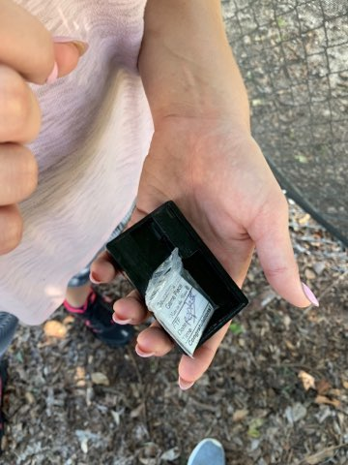

**Lakeside Memories ID – GC43TC2**

Difficulty – 4 out of 5 difficulty

Obstacle – No real obstacle. The geocache was on the ground but very hard to see, it was very lucky that we found it.

GPS performance- GPS didn’t recognize Lake Alice, so we needed to travel around the lake. The GPS adapted to walking around the lake, but overall was not very accurate.

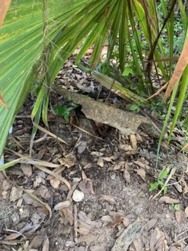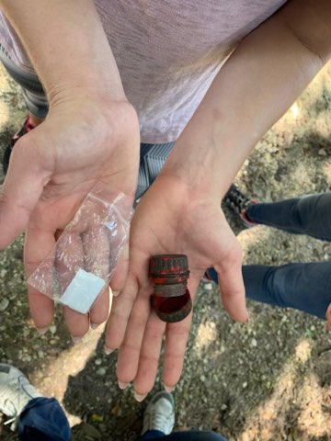

**Don’t Cross Me ID- GC1Y7XQ**

Difficulty – 2 out of 5 difficulty

Obstacle – No obstacles. Very easy to find in the fence. Not covered at all, but very small so easy to miss.

GPS performance- GPS took us exactly to where we needed to go. It almost took us exactly to where the geocache was.

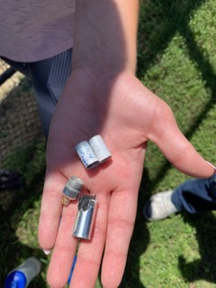

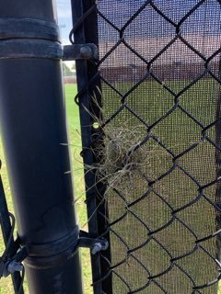

**Naturally Historic Butterflies ID – GC7M0C6**

Difficulty – 2 out of 5 difficulty

Obstacle – In wooded area, no real obstacles. Geocache was large and relatively easy to spot. Did not have to climb or go under the bridge that was near.

GPS performance- Relatively easy to find the overall location. GPS was correct, and accurate to the overall location of geocache.

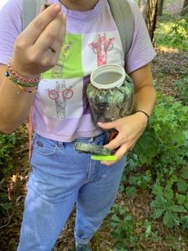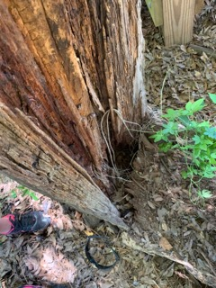

**Leaving Evidence ID – GC5ADAR**

Difficulty – 1 out of 5 difficulty

Obstacle – In wooded area, no real obstacles. Easy to find even though it was covered in moss, it was hanging and in good shape.

GPS performance- Relatively easy to find the overall location. GPS was correct, and accurate to the overall location of geocache.

