Moreno, Melissa

February 16, 2020

Assignment #2: Project Progress Statement

You will submit two items:

1) Documentation of progress on your project in whatever format makes sense for your media type.  This does not need to be a near-complete draft.  i just want to see that you are working on it.

- I have downloaded a sound editing software, Audacity.

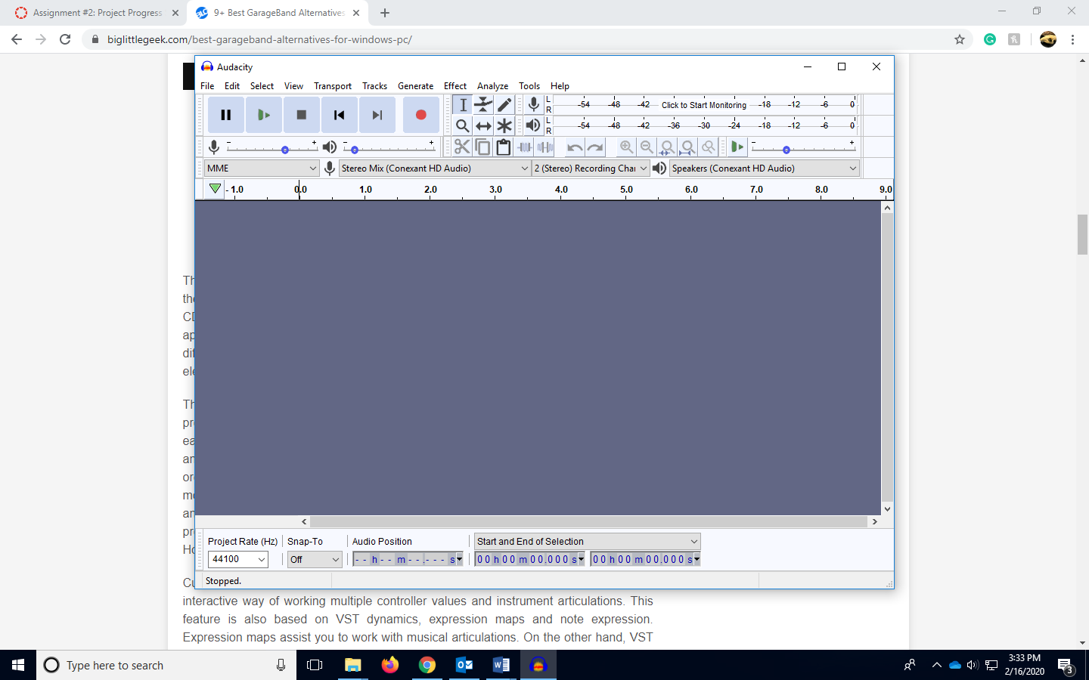

-I have stared compiling articles to talk over during the podcast, and they are stored in my Mendeley account.

- I have started to ask some of the members of my cohort to see if they are available to read and discuss climate change on the podcast. Some are interested. I will have my final members of the podcast group chose by the end of the February.

- According to my project proposal guideline I’m still on tract, since most of February is setting up the podcast, with the members, articles, and editing software.

2) A written narrative of your process to date.   Two or more peers will be assigned to provide feedback.  Keep in mind that they will not have read your Project Proposal, so start off with a**brief** explanation of your topic, audience, justification, objectives, and selected medium.   You might consider addressing the following:

A. What do you envision as your final deliverable?

My final deliverable will be an audio file with the edited podcast.

B. Has the direction of your project changed as you've gotten into working on it?

I have not changed the direction of my project. I still feel confident that I can deliver a well edited audio podcast before the due date of the project.

C. Have you run into any problems?  How have you overcome those (if you have)?

- I don’t have many problems quiet yet, but I am trying to make sure that the date I choose to record the podcast is a good date for the rest of the people might in the discussion. I need to choose a date that will give my members enough time to read the articles, and enough time to edit the podcast. I think sometime by mid to end of March should be enough time.

D.  **What feedback would you like from your peers, instructor, and TA at this time?** In past courses, students have found their peer feedback to be extremely useful in overcoming problems and determining the direction of their final project.  Take advantage of them!

I guess some feedback to the instructor and TA could be what elements in the podcast would be interesting to hear. Maybe more personal experiences rather than article information could be interesting in a podcast.