Moreno, Melissa

November 5, 2019

GEO6938, Final Proposal

1. The task you intend to accomplish.

The task I intend to accomplish is to use Google Earth Engine to do a shoreline analysis of my study area, Cedar Key, Florida. This relates directly to my graduate research, since my graduate research entails finding the easiest and more reproducible way to do shoreline analysis with available data. I plan to write a script that will allow for me to re-run at any time for the digital collection of images selected.

1. How your proposed solution will make the task easier, faster, and/or more accurate. Explain why your task could not simply be accomplished using the toolbox from Esri, or why your script gives a particular advantage over the toolbox.

I can use ArcMap do to this shoreline analysis using the extension DSAS (<https://www.usgs.gov/centers/whcmsc/science/digital-shoreline-analysis-system-dsas?qt-science_center_objects=0#qt-science_center_objects> ), but I know that Google Earth Engine is expanding so I would like to utilize the scripting features especially since Google Earth Engine has a lot faster processing than ArcMap and can compline the digital collection within itself. The task can be completed by using Esri products, like I was mentioning before, but a lot of time would have to go into locating the imagery, which I have previously done but it’s also difficult to sort through. Using Google Earth Engine would also make it easier to find and filter through the imagery instead of looking to find each image one by one via a federal website. I also think that Google Earth Engine is intuitive if you already know a coding language, so I believe that most people will be able to run the script do to analysis in the future, without having much issues.

1. The deliverables you will submit for the project. A well-documented script tool is highly encouraged. If the script requires data, describe how the instructors will be able to evaluate your script. Possible solutions are to zip a sample dataset for the instructor or make the script flexible enough that it could be used with any dataset.

The deliverables for this project will be a quantitative shoreline analysis, a well-documented script tool, and a time-series image analysis (<https://samapriya.github.io/open-impact/sfh/projects/shoreline/>). I hope I am able to complete all of the tasks I am proposing, but I at least want to have the quantitative shoreline analysis, and a well-documented script tool.

Example of a a well-documented script tool :

Sidhu, N., Pebesma, E., & Câmara, G. (2018). Using Google Earth Engine to detect land cover change: Singapore as a use case. *European Journal of Remote Sensing*, *51*(1), 486-500.(https://www.tandfonline.com/doi/full/10.1080/22797254.2018.1451782)

Defining variable colors in palette:

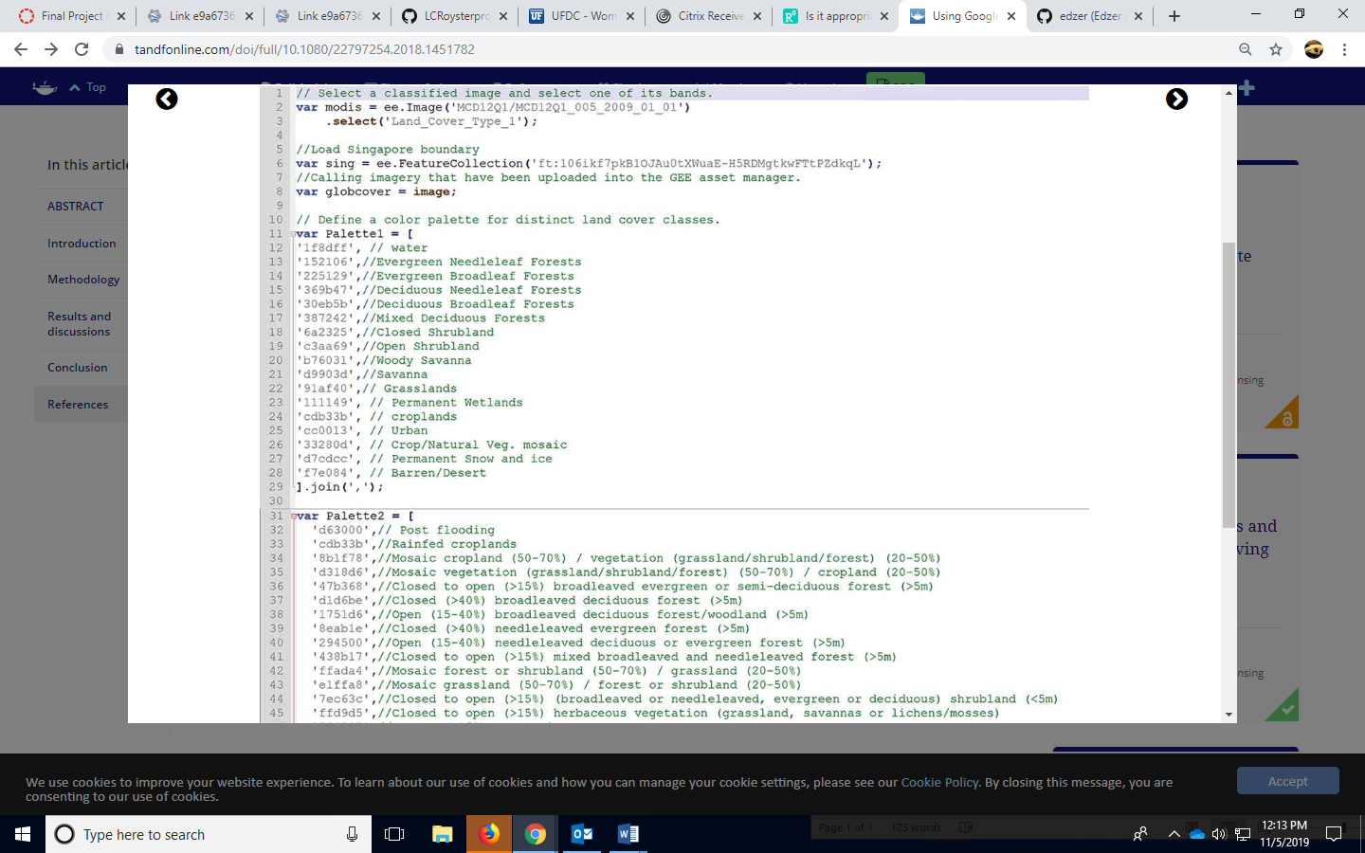

Creating another color palette for additional variables.

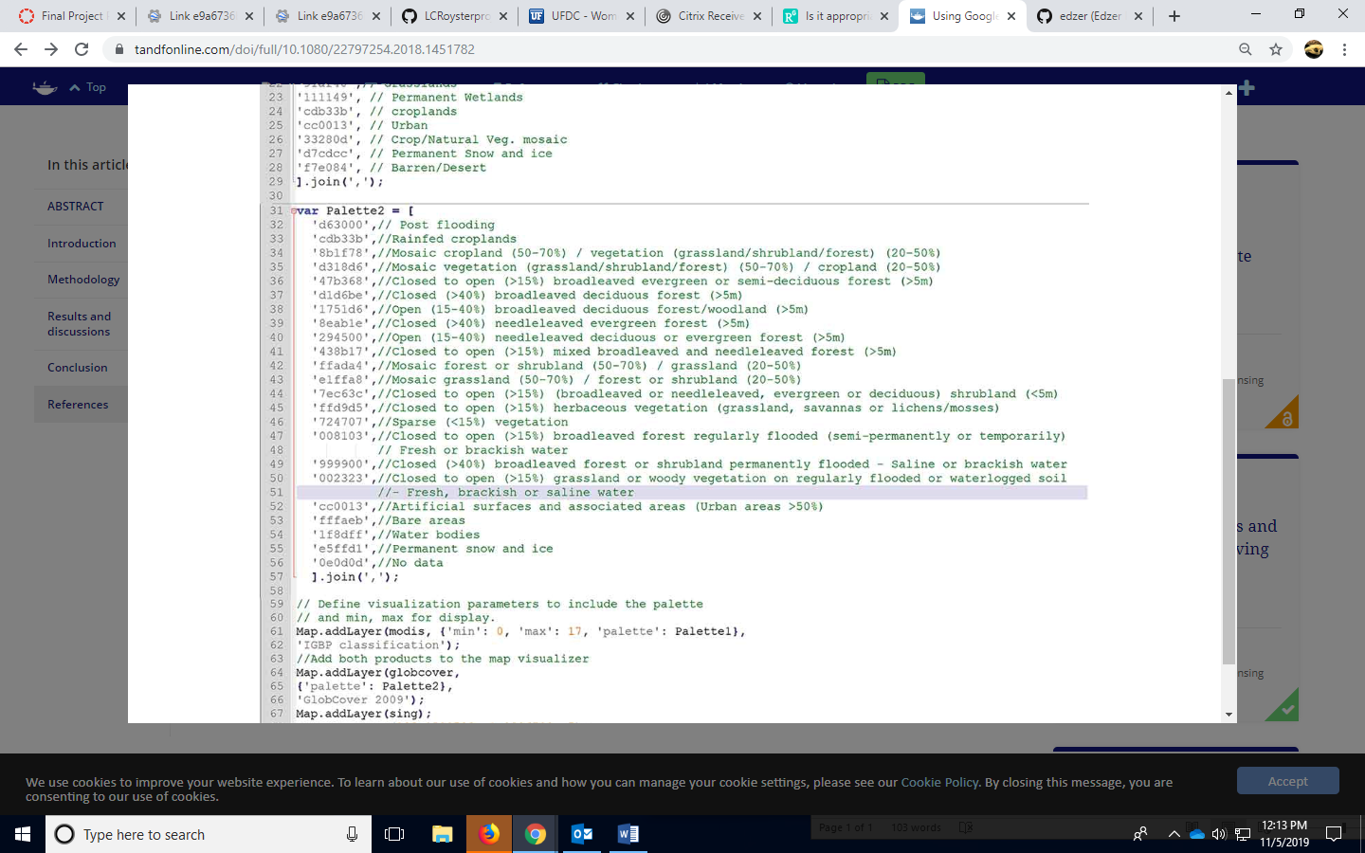

Filtering the imagery from the date ranges and then selecting then creating variables for months and years. 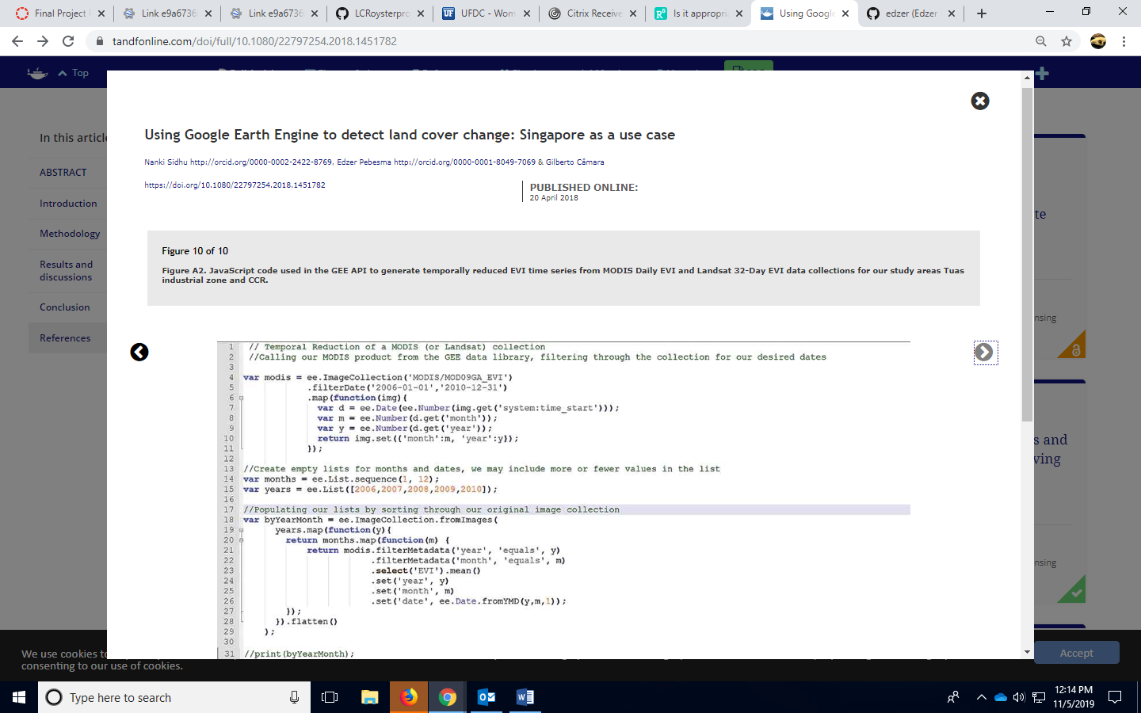

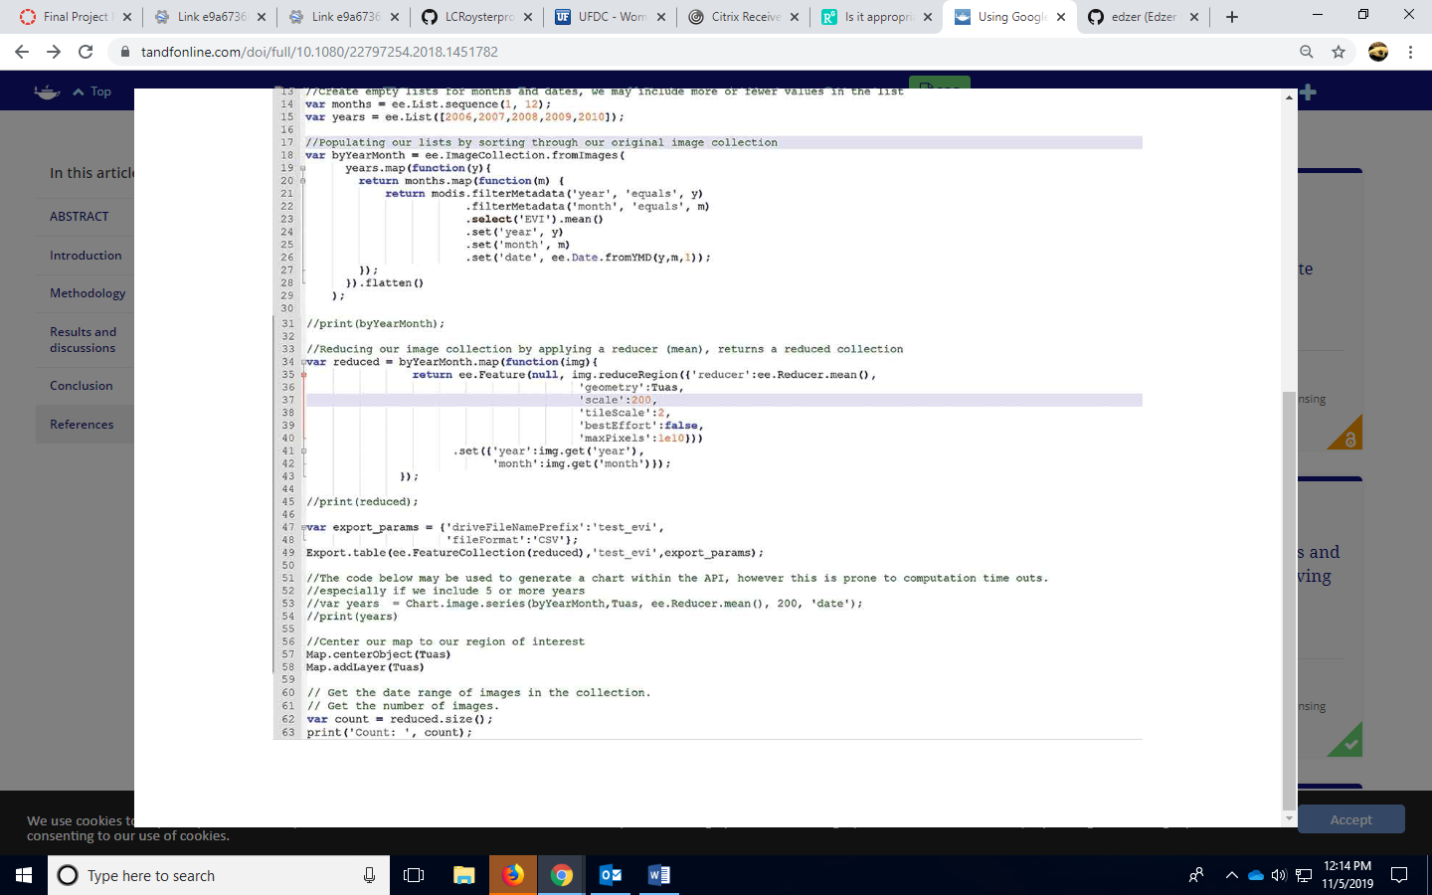

Figure A2. JavaScript code used in the GEE API to generate temporally reduced EVI time series from MODIS Daily EVI and Landsat 32-Day EVI data collections for our study areas Tuas industrial zone and CCR (Taken from Sidhu, 2018).