**Chapter 2**

**Proposal Outline**

**Introduction and Background**

Restoration efforts in coastal zones may be strongly influenced by landscape level processes, such as changes within adjacent upland watersheds or alterations to shoreline features due to erosion or development. Watersheds and shoreline habitats are naturally transient, and changes occur over both short and long time scales from storms, natural erosion, or changing sea levels. The Gulf of Mexico coastline, with its low relief geomorphology particularly along the west coast of Florida is vulnerable to coastal erosion (Geselbracht et al., 2011). As an example, much of the Florida coastline consists of a 1-meter elevation contour that extends landward from 3-10 km. This low elevation consequently leaves the Florida coastline susceptible to continual changes.

Monitoring trends for key characteristics of a coastline can provide basic information on the rate and types of changes occurring in a region at landscape scales. In this chapter I will develop a data workflow and visualization tool to compile information on to assess trends of major features in the Big Bend coastline. The goal of this chapter is to document trends in key features such as geomorphic habitat and vegetation. This information is useful to inform decision making related to restoration actions and to inform decision makers in how base-line conditions within a region have changed.

**Study Area**

The Suwannee River Basin (SRB) ranges from southern Georgia to north-central Florida. The basin is one of the largest river systems in the southeastern United States spanning 28,600 kilometers squared. At the end of the 394 km drainage is the Suwannee River Estuary, which is composed into four zones the tidal river, the intertidal marsh, Suwanee Sound, and the estuarine zones (Raabe et al., 2007). The Suwannee Sound zone is in the “Big Bend” region of the Gulf of Mexico.

The “Big Bend” coastline of Florida’s west coast spans from Crystal River to Apalachee Bay. Within this area, the Suwannee River is a major source of freshwater inputs. The Big Bend is largely a marsh-dominated coast and this coastline differs from other coastal areas in the Gulf of Mexico because it is primarily underdeveloped (Mattson et al., 2012). Over half of the entire Big Bend region is part the 1985 Big Bend Seagrass Aquatic Preserve, which is managed by the Florida Department of Environmental Protection and also includes further protection from five U.S. Fish and Wildlife Service (USFWS) national wildlife refuges (St. Marks, Lower Suwannee, Cedar Keys, Crystal River, and Chassahowitzka) and several other State conservation areas (Econfina River State Park, Cedar Key Scrub State Reserve, Waccasassa Bay State Preserve, St. Martins Marsh Aquatic Preserve, and Homosassa Springs Wildlife State Park), (Mattson et al., 2012).

My proposed study area would focus on an targeted area of the “Big Bend” coastline. The area would be selected based on level of interest by state and federal agencies, which can be assessed through a literature research. An example area of study could be the mouth of the Suwannee River, which is the center of an extended open marine marsh coastline and was investigated by Wright et al. (2003) to document the sediment changes from the Pleistocene to the Holocene (Figure 1). This same area was also evaluated by Raabe et al. (2007) to determine habitat categories using Compact Airborne Spectrographic Imager (CASI), (Figure 2).

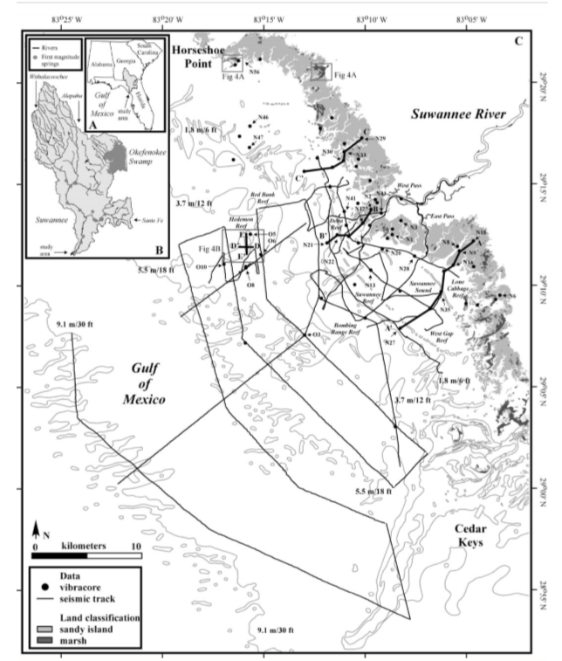

Figure 1- A, B Location map of the Suwannee River drainage basin distributaries, and location of study area. C) Location map of student area and the data collected (Wright et al., 2003).

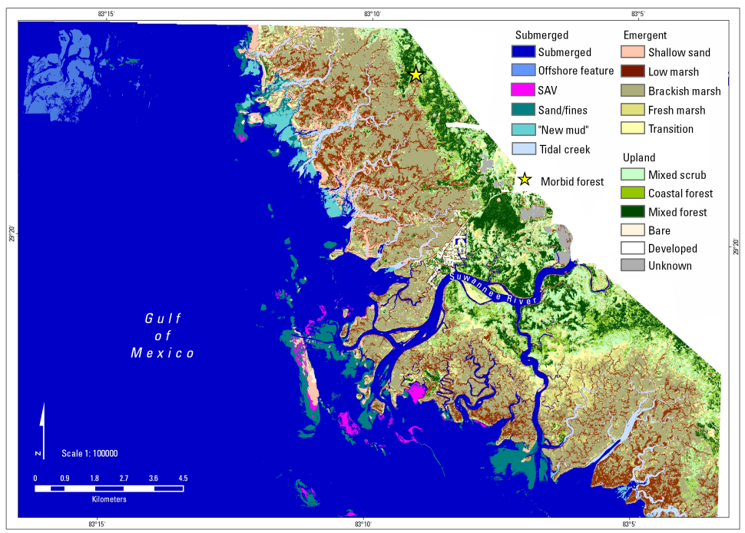

Figure 2- Habitat categories derived from CASI imagery over Lover Suwannee River and Estuary (Raabe et al., 2007).

**Reason for Effort**

The United States Geologic Survey (USGS) and other state and federal management agencies have been monitoring different aspects of water and land resources in the SRB for nearly 100 years (Katz & Raabe, 2005). This research has addressed water quality, river discharge, floodplains, and surface water exchange. Many of these studies have been done in discrete pieces with each study addressing specific objectives over short periods of time. In 2005 a group of agency and academic researchers led by USGS scientists identified a key need for the SRB to integrate the collected data information from these studies in basin-wide and inter-disciplinary frameworks and provide a supportive data framework to meet conservation management needs such as developing and applying consistent data collection methods, developing improved interaction models, and ensuring spatial distribution and environmental coverage (Katz & Raabe, 2005). These discussions led to the development of a series of documents identifying threats to the SRB and key research needs. Threats to the SRB include alteration to water supply, alteration of trophic dynamics, geographic constraints through land use, and climate change (Katz & Raabe, 2005). As an example of how researchers worked to document long-term trends in the SRB and adjacent coastal areas, Raabe (2004) digitized information from surveys of the coastline from approximately the Suwannee River mouth to Tampa Bay collected in the 1800’s and compare these surveys to satellite imagery from 1995 to characterize changes in coastal habitats between these two time periods. Research such as Raabe (2004) are useful because they provide resource managers with long-term perspective on how resources are or are not changing. This long-term perspective is important when assessing changes in resources such as coastal habitats that may be changing incrementally long-time scales that are much longer than the time that an individual manager may have been observing the system (decades vs. years). I will extend ideas introduced in Katz and Raabe (2005) as part of the USGS led assessment of the Big Bend to develop long-term assessments of coastal landform characteristics. This will be done in a reproducible framework using publicly available data tools. These results will help to characterize trends in key metrics of interest to resource managers including trends in land cover and changes in coastal land forms held as part of public lands. Details are provided below.

**Objective**

Using publicly available data and by developing a reproducible workflow I will assess changes in large-scale geographic features and land use in the Big Bend coastline.

Raabe et al. (2004) described a method using digitized 19th century topographic sheets for the Big Bend region of Florida and then compared these sheets to 1995 satellite imagery to characterize trends in large-scale geographic features for this region. I will follow methods from Raabe et al. (2004) and extend the data used beyond 1995 with more recent publicly available images. I will follow guidelines from Raabe et al. (2004) to focus on overall trends in large-scale geographic features and not focus on site specific changes due to variation in survey methods. My initial efforts will focus on a targeted geographic region surveyed as part of Seavey et al. (2011) from approximately the Waccasassa River, Florida to Horseshoe Beach, Florida with special emphasis on public lands. I will develop a data workflow for collecting and processing available imagery that is reproducible and uses publicly available resources.

**Methods**

The proposed methods of my research will produce an automized way to update key feature maps, based on satellite or aerial imagery, or also by using map data by scrapping from other public sources.

A reproducible effort could be to create a set of calculations that can automatically process new images, of the same location, using the software ENVI (Environment for Visualizing Images) + IDL (Interactive Data Language). Satellite imagery are measured using a series of calculations IDL. These calculations can also create new raster types, which can be compared in ENVI. Using a combination of calculations and spatial software analysis, an adaptive management plan could address imagery updates. This method could be reproduced but might be difficult to replicate methods, especially with other potential users or agencies. This method is not automated and must be done by the user. I propose testing this method using available imagery around Lone Cabbage Reef and document the reproducibility of this method.

Other methods that rely on the user, but also reproducible, can be to manually hand digitize imagery, which might or might have any spatial reference associated to them, and compare these digitized areas. ArcMap is a software that can allow for overlays of manual digitization. Using the tools in ArcMap “create features” from the map, will allow the user to construct polylines at certain points of the imagery. These polylines can then be compared and analyze to observe short-term or long-term trends, I propose to evaluate if this method can ensure reproducibility for future satellite imagery on this project.

Other way to create a reproducible mapping workflow is to use available online continuous data. Much of these data are provided by government agencies, and updated frequently. Government organizations such as USGS, and USDA have public APIs to access these data (https://sheilasaia.rbind.io/post/2019-01-04-nass-api/). These APIs can connect to R and allow for data to be downloaded, and then be manipulated to suit the needs of the user. I propose that spatial and temporal analysis, to support the ongoing shoreline changes along the Lone Cabbage Reef, can be created using much of these available packaged data. Using the USADA quick stats, the census and survey data (<https://quickstats.nass.usda.gov/>) for agriculture land, agricultural services, and improvement and construction might also be used to create dynamic maps. I propose to develop a workflow using available online packaged data, to create comparable mapping imagery, and record its reproducibility.

Though these methods have been used my multiple scientists and conservation efforts, it will be valuable to learn of the best reproducible workflow for creating and maintaining these compared spatial imageries for the Lone Cabbage Reef project. Satellite imagery and available continuous data differ between regions and can have impacts on analyzing spatial features in the long run. I propose to record and observe the most effective spatial analysis methods, using a section of the Suwannee Sound shoreline.

# Bibliography

Allen, R., & Iii, M. (2012). *ESTABLISHING VISUAL BASED AND DATUM BASED SHORELINES AND SHORELINE UNCERTAINTIES ON A SANDY COAST: CAPE CANAVERAL, FLORIDA.*

L., Ning, Z., Turner, R., Doyle, T., Abdollahi, K., Authors, C., . . . Liu, K. (2003). *INTEGRATED ASSESSMENT OF THE CLIMATE CHANGE IMPACTS ON THE GULF COAST REGION Gulf Coast Region.*

Desantis, L., Bhotika, S., Williams, K., & Putz, F. (2007, 11). Sea-level rise and drought interactions accelerate forest decline on the Gulf Coast of Florida, USA. *Global Change Biology, 13*(11), 2349-2360.

Epstein, J., Pine, W., Romagosa, C., Scott, M., Phillips, C., Marion, C., & Baiser, B. (2018, 11 1). State- and Regional-Scale Patterns and Drivers of Freshwater Fish Functional Diversity in the Southeastern USA. *Transactions of the American Fisheries Society, 147*(6), 1179-1198.

Geselbracht, L., Freeman, K., Kelly, E., Gordon, D., & Putz, F. (2011, 7). Retrospective and prospective model simulations of sea level rise impacts on Gulf of Mexico coastal marshes and forests in Waccasassa Bay, Florida. *Climatic Change, 107*(1), 35-57.

Katz, B., & Raabe, E. (n.d.). *Suwannee River Basin and Estuary: An Integrated Watershed Science Program White Paper Open-File Report 2005-1210.*

Keys, F. (n.d.). *Confronting Climate Change in the Gulf Coast Region Prospects for Sustaining Our Ecological Heritage Southeastern Plain South Florida Coastal Plain.*

Langston, A., Kaplan, D., & Putz, F. (2017, 12 1). A casualty of climate change? Loss of freshwater forest islands on Florida's Gulf Coast. *Global Change Biology, 23*(12), 5383-5397.

Malthus, T., & Mumby, P. (2003, 7 10). Remote sensing of the coastal zone: An overview and priorities for future research. *International Journal of Remote Sensing, 24*(13), 2805-2815.

Ning R Eugene Turner Thomas Doyle Kamran Abdollahi, Z. (2003). *Gulf Coast Region The Potential Consequences of Climate Variability and Change PREPARING FOR A CHANGING CLIMATE Findings of the Gulf Coast Regional Assessment.*

Raabe, E., Edwards, R., Mcivor, C., Grubbs, J., & Dennis, G. (n.d.). *Habitat and Hydrology: Assessing Biological Resources of the Suwannee River Estuarine System Open-File Report 2007-1382.*

Raabe, E., Streck, A., & Stumpf, R. (n.d.). *Historic Topographic Sheets to Satellite Imagery: A Methodology for Evaluating Coastal Change in Florida's Big Bend Tidal Marsh.*

Seavey, J., Pine, W., Frederick, P., Sturmer, L., & Berrigan, M. (2011, 10 21). Decadal changes in oyster reefs in the Big Bend of Florida's Gulf Coast. *Ecosphere, 2*(10), art114.

Why Reefs Decline-Local versus Global Impacts. (n.d.).

Wilson, S., & Fischetti, T. (2010). *Coastline Population Trends in the United States: 1960 to 2008 Population Estimates and Projections Current Population Reports.*

Zhang, K., Douglas, B., & Leatherman, S. (2004). *GLOBAL WARMING AND COASTAL EROSION.*