Mel Moreno Microblog

My name is Mel Moreno, and I am a graduate student at the University of Florida. Prior to becoming a graduate student I was a full-time employee working on the Lone Cabbage Reef Restoration Project at the University of Florida. This project involves restoring an oyster reef to historic conditions. The oyster reef is located in the Big Bend, near Cedar Key, Florida. You can read more information about the project here <http://www.wec.ufl.edu/oysterproject/restoration.php>. I was in charge of handling water quality data collected around the reef during my work on the project. At that time, with the help of others at the University of Florida Library, we were able to create a workflow to ensure quality control and securement of these data. Because of this effective workflow, we are able to turn around data analysis from the water quality sensors in 5 business days. You can locate the work I have managed here <https://lcroysterproject.github.io/oysterproject/>. My current research entails ensuring the workflow is as effective as it can be and documenting the final product.

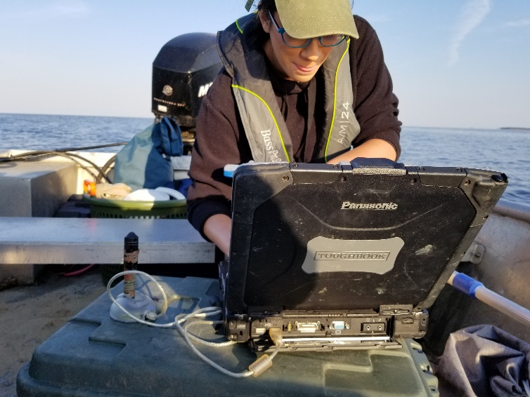

Me in the field downloading water quality data.

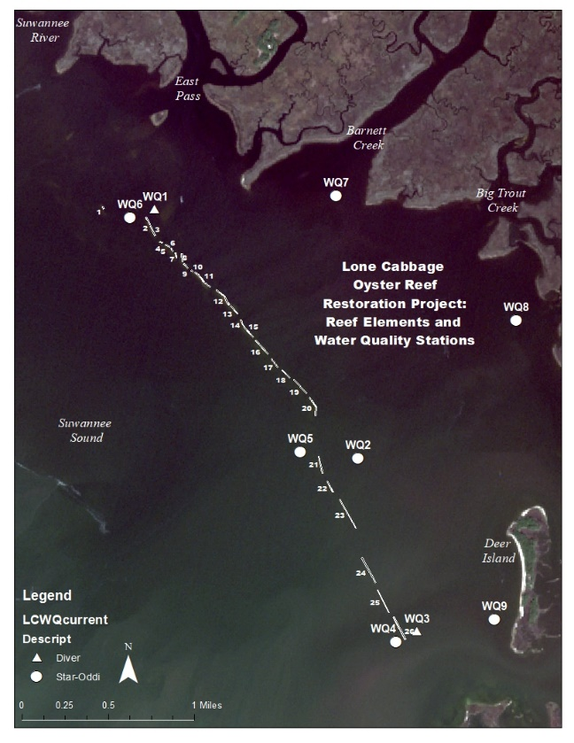

Map of oyster reef and water quality sensors.

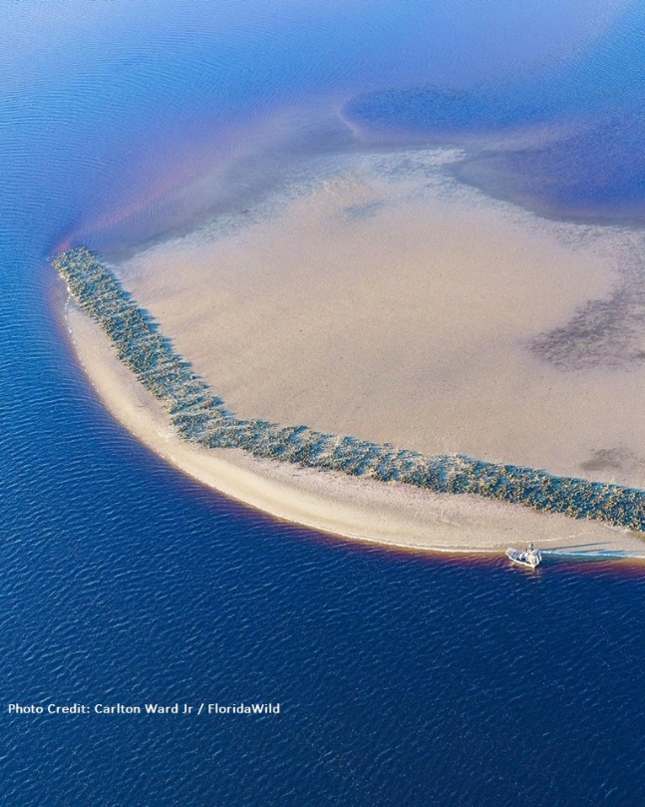

Image of constructed oyster reef, photo credit Carlton Ward Jr, FloridaWild