**Case Study: Shoreline changes in Cedar Key, Florida using Google Earth Engine API and DSAS**

**Abstract**

**Introduction**

Shorelines changes can occur due to multiple factors including anthropogenic, natural, hurricane intensity, and sea level rise (Yu et al., 2011). The combination of these processes can influence erosion and accretion. These shoreline changes may affect the resilience to storm surges including flooding and species diversity implications (Desantis et al., 2007). It was observed by USGS (US Geological Survey) that shoreline changes along the Gulf of Mexico, specifically in Florida, were relatively steady between the 1800s and 1990s (Morton et al., 2005). Since then, the Gulf of Mexico coastline, with its low relief geomorphology particularly along the west coast of Florida, has been noted to be vulnerable to coastal erosion (Geselbracht et al., 2011).

**Study Area**

Our study area is located on the west-central Florida coastline off the Cedar Key, Florida. The area includes small islands and one major island, Deer Island. Deer Island is

|  |  |  |
| --- | --- | --- |
| Direction Marker | Lat/Y | Long/X |
| NW | 29.243000° | -83.086019° |
| SW | 29.229686° | -83.087150° |
| NE | 29.241386° | -83.070575° |
| SE | 29.228114° | -83.072361° |

|  |  |  |
| --- | --- | --- |
| Day | Median River Discharge | Weather in CK |
| January 20, 1994 |  | Avg Temp (F)- 38.15 Precipitation (inches)- 0.00  Sea Level Pressure (Hg)- 30.33 |
| December 30, 1998 |  | Avg Temp (F)- 48.75 Precipitation (inches)- 0.00  Sea Level Pressure (Hg)- 30 |
| December 31, 2003 (2004) |  | Avg Temp (F)- 59.26 Precipitation (inches)- 0.00  Sea Level Pressure (Hg)- 30.19 |
| May 7, 2007 |  | Avg Temp (F)- 66.32 Precipitation (inches)- 0.00  Sea Level Pressure (Hg)- 29.97 |
| December 31, 2010 |  | Avg Temp (F)- 58.3 Precipitation (inches)- 0.00  Sea Level Pressure (Hg)- 30.04 |
| January 8, 2012 |  | Avg Temp (F)- 57.07 Precipitation (inches)- 0.00  Sea Level Pressure (Hg)- 30.09 |
| December 18, 2013 |  | Avg Temp (F)- 49.65 Precipitation (inches)- 0.00  Sea Level Pressure (Hg)- 30.15 |
| January 21, 2014 |  | Avg Temp (F)- 60.98 Precipitation (inches)- 0.00  Sea Level Pressure (Hg)- 29.86 |
| November 11, 2016 |  | Avg Temp (F)- 58 Precipitation (inches)- 0.00  Sea Level Pressure (Hg)- 29.95 |
| May 26, 2017 |  | Avg Temp (F)- 72 Precipitation (inches)- 0.00  Sea Level Pressure (Hg)- 29.9 |

wunderground.com/history/daily/us/fl/gainesville/KGNV/date/2012-1-8

Deer Island –

Deer Island is an island that can provide relief from storm events and storm surges. Briefly comparing imagery from 1984 to 2018, it can be observed that there are some shape changes to the island. Unlike Derrick Key, Deer Island is still visible and still available for use by people and habitat use by animals. Between the 34 years, between the imagery, there are some observable shoreline differences but not nearly as drastic as the shoreline differences of Derrick Key.

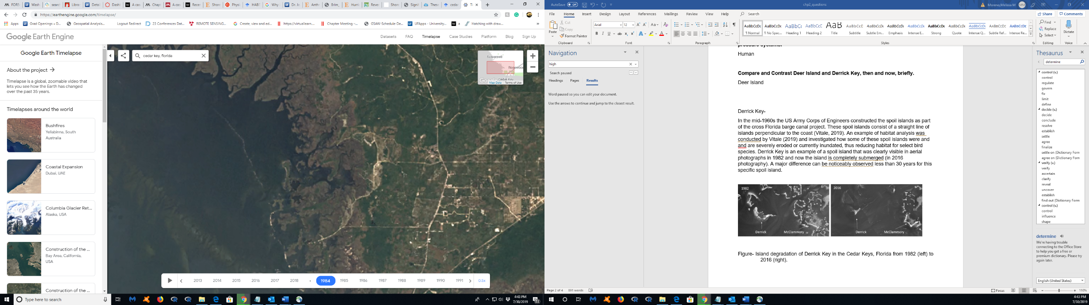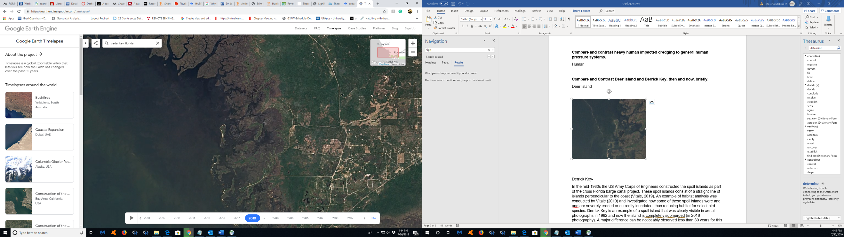

Figure- Google Earth Engine imagery of Deer Island, from 1984 (left) to 2018 (right).

Derrick Key-

In the mid-1960s the US Army Corps of Engineers constructed the spoil islands as part of the cross Florida barge canal project. These spoil islands consist of a straight line of islands perpendicular to the coast (Vitale, 2019). An example of habitat analysis was conducted by Vitale (2019) and investigated how some of these spoil islands were and and are severely eroded or currently inundated, thus reducing habitat for animals. Derrick Key is an example of a spoil island that was clearly visible in aerial photographs in 1982 and now the island is completely submerged (in 2016 photography). Major shoreline differences are noticeably observed in the 34 years, time between the imagery, for this specific spoil island.

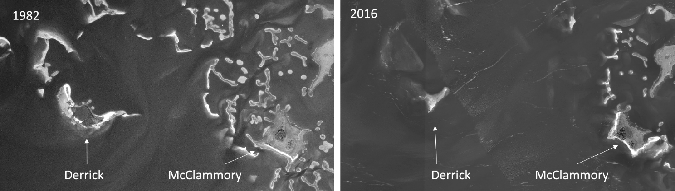

Figure- Island degradation of Derrick Key in the Cedar Keys, Florida from 1982 (left) to 2016 (right), (Vitale, 2019).