**Chapter 2**

**Proposal Outline**

**Introduction**

The Big Bend coastline spans from Crystal River to Apalachee Bay and is located on the west coast of Florida. The Big Bend is largely a marsh-dominated coast. This coastline differs from other coastal areas in the Gulf of Mexico because it is primarily underdeveloped. Over 50% of the shoreline is under conservation protection (Main and Allen 2007), which in turn cause human populations to be very low, compared to other Florida coastal regions. Due to the lack of human settlement and construction, there is very little evidence that humans have impacted the shoreline in a negative or positive way. Because of this, there is an interest in recording or observing coastline trends that are largely influenced by natural factors.

**Background**

The Comprehensive Restoration Plan for the Gulf of Mexico requires adaptive management to be implemented into its projects as part of the $8.8 billion settlement with BP (https://www.gulfspillrestoration.noaa.gov/restoration-planning/gulf-plan). These settlement funds will be used to restore ecosystems that were impacted as part of the Deep Horizon Oil Spill in 2016.

Much of the Gulf of Mexico shoreline has been requested to be studied, with much preference given to the Big Bend region (Raabe E. , 2008). The overall goal is to have a greater understanding of the changes of this local system. Spatial imagery is known to exist in the area, as well as decades worth of water quality data. Much of this data have yet to be processed or analyzed, leaving a great deal of completed ecological research to be desired.

The LCR project will use adaptive management for data collection, sampling, and evaluation. The LCR adaptive management plan is currently tailored for biological data, but the project will need to take additional steps to create a plan for spatial data. Temporal and spatial data will be integrated into the adaptive management workflow along with biological data.

**Objectives**

Using publicly available data I will assess trends in several key characteristics of the Big Bend of Florida.

(1) Using information from Raabe et al. 2004, I will use 19th century topographic sheets digitized by USGS for the Big Bend region of Florida and update the comparisons made between the 19th century assessments (Figure 2), 1995 satellite imagery used in Raabe et al. (2004), and more recent imagery available since 1995. I will follow guidelines from Raabe et al. (2004) to focus on overall trends in large-scale geographic features and not focus on site specific changes due to variation in survey methods. My initial efforts will focus on geographic region surveyed as part of Seavey et al. (2011) from approximately the Waccasassa River, Florida to Horseshoe Beach, Florida. I will develop a data workflow for collecting and processing available imagery that is reproducible and uses publicly available resources.

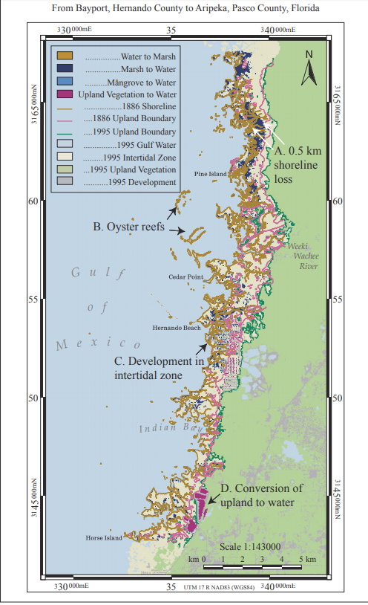(2) I will identify a set of watershed metrics for the Suwannee River basin from public data repositories that are useful for understanding trends in variables that are known to correlate with changes in river discharge, nutrient levels, or aquatic biodiversity and habitats.

Figure 2- Intertidal Zone Changes from 1886 to 1995 for Topographic Survey T-1700, (Raabe et al. 2004)

**Spatial Observational Units**

At this time, no spatial units are defined. Selecting observation units will be established before the landscape metrics can be calculated and atmospheric variables corrected. It could be possible to select shapes or predefined buffer zones (et. al Yang 2007) for the area. Other spatial units could be defined by different levels of biological or human related data, which can influence shoreline coastal patterns.

**Methods**

The proposed goal of my research is to create an automized way to update maps, based on satellite imagery, or map data scrapping from another source.

An abundant amount of ecological data can be found in many R packages. Some of these packages are ran by government agencies, and updated frequently. Government organizations such as USGS, and USDA have public APIs to access these data (https://sheilasaia.rbind.io/post/2019-01-04-nass-api/). These APIs can connect to R and allow for data to be downloaded, and then be manipulated to suit the needs of the user. I propose that spatial and temporal analysis, to support the ongoing shoreline changes along the Lone Cabbage Reef, can be created using much of these available packaged data. Using the USADA quick stats, the census and survey data (<https://quickstats.nass.usda.gov/>) for agriculture land, agricultural services, and improvement and construction might also be used to create dynamic maps.

Another way to apply another adaptive management method for this effort would be to create a set of calculations that can automatically process the same new images, using ENVI + IDL. Satellite imagery are measured using a series of calculations IDL. These calculations can also create new raster types, which can be compared in ENVI. Using the combination of calculations and spatial software analysis, an adaptive management plan can easily address imagery updates. This method can be easily reproduced but might be difficult to share with other potential users or agencies.

**Discussion**

Adaptive management plans can be applicable to all data types. Maps are one source of visual data that can be used to calculate patterns and trends. By using maps, the intended audience has a better understanding of the impact of ecological impacts in an area. Areas that are involved in monitoring programs, are the ideal candidate for spatial and temporal evaluations. Creating these series of shoreline satellite imagery, on behalf of the LCR project, will prove to be an amazing tool for both public and program needs.