**Chapter 2**

**Proposal Outline**

**Introduction**

Shorelines trends are used to conserve or manage coastal features. These features are not always properly documented or confirmed. Much of the time, these trends can go unnoticed in data collection or monitoring. Because of this, many coastline feature trends can go unnoticed including short-term and long-term trends. Short-term trends can be considered season coastal position changes, and long-term trends are physical features that have remained changed for several years.

**Study Area**

The Big Bend coastline spans from Crystal River to Apalachee Bay and is located on the west coast of Florida. The Big Bend is largely a marsh-dominated coast. This coastline differs from other coastal areas in the Gulf of Mexico because it is primarily underdeveloped. Over 50% of the shoreline is under conservation protection (Main and Allen 2007), which in turn cause human populations to be very low, compared to other Florida coastal regions. Due to the low levels of human settlement and construction along this coast, and the large amount of land in conservation, this creates opportunities to examine how the coastline has changed over time from factors that may be occurring naturally.

**Background**

The Comprehensive Restoration Plan for the Gulf of Mexico requires adaptive management to be implemented into its projects as part of the $8.8 billion settlement with BP (https://www.gulfspillrestoration.noaa.gov/restoration-planning/gulf-plan). These settlement funds will be used to restore ecosystems that were impacted as part of the Deep Horizon Oil Spill in 2016.

Much of the Gulf of Mexico shoreline has been requested to be studied, with much preference given to the Big Bend region (Raabe E. , 2008). The overall goal is to have a greater understanding of the changes of this local system. Spatial imagery is known to exist in the area, as well as decades worth of water quality data. Much of this data have yet to be processed or analyzed, leaving a great deal of completed ecological research to be desired.

The LCR project will use adaptive management for data collection, sampling, and evaluation. The LCR adaptive management plan is currently tailored for biological data, but the project will need to take additional steps to create a plan for spatial data. Temporal and spatial data will be integrated into the adaptive management workflow along with biological data.

You need some more Suwannee Basin background. Take a look at this <https://archive.usgs.gov/archive/sites/gulfsci.er.usgs.gov/suwannee/reports/KatzRaabeWP.pdf>

Note how in the executive summary it moves from a general discussion to the basin, to some of the threats. By page 11 it is listing potential sources of water quality degradation in the basin. You could maybe use these as ideas for factors to look at in terms of trends over time. USGS identifies the potential threat (as an example animal-feeding operations) and then you can plot over time how animal feeding operations have changed. This report is from 2004, I don’t know how many of these things were followed up by USGS folks. Simeon could help you figure that out perhaps.

When you get to page 15 you see a list of “gaps and opportunities” you are working to fill those gaps and address opportunities.

**Objectives**

Using publicly available data and by developing a reproducible workflow I will assess changes in large-scale geographic features and land use in the Suwannee River estuary and watershed. This will be done in two parts.

(1) Raabe et al. 2004 described a method using digitized 19th century topographic sheets for the Big Bend region of Florida and then compared these sheets to 1995 satellite imagery to characterize trends in large-scale geographic features for this region. I will follow methods from Raabe et al. (2004) and extend the data used beyond 1995 with more recent publicly available images (Figure 2). I will follow guidelines from Raabe et al. (2004) to focus on overall trends in large-scale geographic features and not focus on site specific changes due to variation in survey methods. My initial efforts will focus on geographic region surveyed as part of Seavey et al. (2011) from approximately the Waccasassa River, Florida to Horseshoe Beach, Florida with special emphasis on public lands. I will develop a data workflow for collecting and processing available imagery that is reproducible and uses publicly available resources.

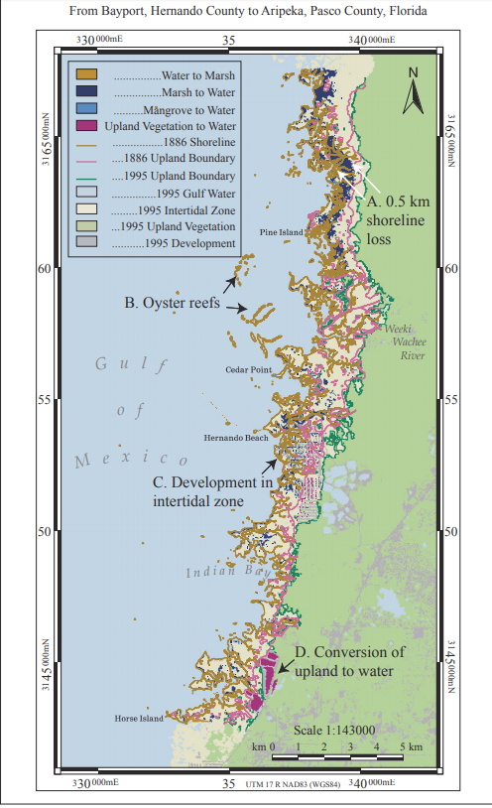(2) I will identify a set of watershed metrics for the Suwannee River basin from public data repositories that are useful for understanding trends in variables that are known to correlate with changes in river discharge, nutrient levels, or aquatic biodiversity and habitats.

Figure 2- Intertidal Zone Changes from 1886 to 1995 for Topographic Survey T-1700, (Raabe et al. 2004). As an example Raabe et al. (2004) determined that …provide an example result here to help in understanding the figure above.

**Spatial Observational Units**

At this time, no spatial units are defined. Selecting observation units will be established before the landscape metrics can be calculated and atmospheric variables corrected. It could be possible to select shapes or predefined buffer zones (et. al Yang 2007) for the area. Other spatial units could be defined by different levels of biological or human related data, which can influence shoreline coastal patterns.

**Methods**

The proposed goal of my research is to create an automized way to update maps, based on satellite imagery, or map data scrapping from another source.

An abundant amount of ecological data can be found in many R packages. Some of these packages are ran by government agencies, and updated frequently. Government organizations such as USGS, and USDA have public APIs to access these data (https://sheilasaia.rbind.io/post/2019-01-04-nass-api/). These APIs can connect to R and allow for data to be downloaded, and then be manipulated to suit the needs of the user. I propose that spatial and temporal analysis, to support the ongoing shoreline changes along the Lone Cabbage Reef, can be created using much of these available packaged data. Using the USADA quick stats, the census and survey data (<https://quickstats.nass.usda.gov/>) for agriculture land, agricultural services, and improvement and construction might also be used to create dynamic maps.

Another way to apply another adaptive management method for this effort would be to create a set of calculations that can automatically process the same new images, using ENVI + IDL. Satellite imagery are measured using a series of calculations IDL. These calculations can also create new raster types, which can be compared in ENVI. Using the combination of calculations and spatial software analysis, an adaptive management plan can easily address imagery updates. This method can be easily reproduced but might be difficult to share with other potential users or agencies.

**Discussion**

Adaptive management plans can be applicable to all data types. Maps are one source of visual data that can be used to calculate patterns and trends. By using maps, the intended audience has a better understanding of the impact of ecological impacts in an area. Areas that are involved in monitoring programs, are the ideal candidate for spatial and temporal evaluations. Creating these series of shoreline satellite imagery, on behalf of the LCR project, will prove to be an amazing tool for both public and program needs.