**Chapter 2**

**Proposal Outline**

**Introduction and Background**

Restoration efforts in coastal zones may be strongly influenced by landscape level processes such as changes within adjacent upland watershed characteristics or shoreline features due to erosion or development. Watersheds and shoreline habitats are naturally transient and changes occur over long periods of time due to natural processes including shifts in climate or effects of storms. The Gulf of Mexico coastline, with its low relief geomorphology especially in Florida, is also vulnerable to coastal erosion (Geselbracht et al., 2011). Much of the Florida coastline consists of a 1-meter elevation contour that extends inward anywhere from 3 to 10 kilometers. This low elevation leaves the Florida coastline susceptible to frequent changes. Other types of landscape change occur at different time scales and may have different (and unknown) effects including conversion from forest to agricultural lands to urban areas or development of coastal towns.

Monitoring trends in key characteristics of a watershed over time can provide basic information on how these systems may be changing, and this can motivate actions to improve management and protection of coastal and inland habitats. In this chapter I will develop a data workflow and visualization tool to compile information on to assess trends in major features of the Suwannee River Basin and adjacent coastline. The overall goal is to have a greater understanding of the changes of this local system and document trends in key resources, including agriculture, and habitat type. Examining these trends will provide information to place observed changes in this region such as increased human population density and changes in coastal forests in a broader context in terms of short-term observations or longer-term trends.

**Study Area**

The Suwannee River Basin (SRB) is region of the southeastern United States, ranging from Cordele Georgine to Cedar Key, FL. The SRB is often referred to as one of the most untouched river systems in the United States (Katz & Raabe, 2005). It holds a distinct combination of habitats including swamps, forests, and wetlands The basin also comprises of the second largest river in Florida, the Suwannee River.

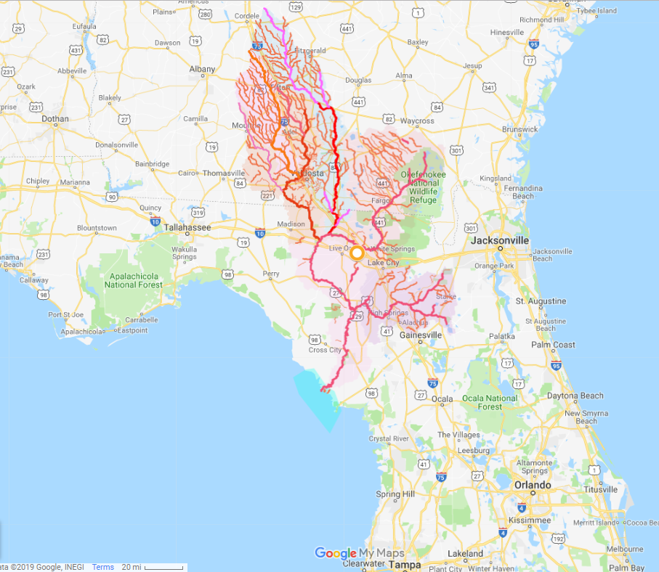

Figure 1- Google map displaying Suwannee River basin in Georgia and Florida. The basin ends in the Suwannee Sound, (turquoise area). Provided by WWALS Watershed Coalition (Suwannee RIVERKEEPER®, http://wwals.net/2017/11/14/suwannee-river-basin-maps/#basingooglemap). The Suwannee River exits on the west coast of Florida (bolded pink line).

The Suwannee River empties into the Big Bend (Figure 1). The Big Bend coastline spans from Crystal River to Apalachee Bay. The Big Bend is largely a marsh-dominated coast and this coastline differs from other coastal areas in the Gulf of Mexico because it is primarily underdeveloped. Over 50% of the shoreline is under conservation protection (Main and Allen 2007), which suggests a low percentage of urbanization, compared to other Florida coastal regions. Due to the low levels of human settlement and construction along this coast, and the large amount of land in conservation, this creates opportunities to examine how the coastline has changed over time from factors that may be occurring naturally, instead of human made impacts.

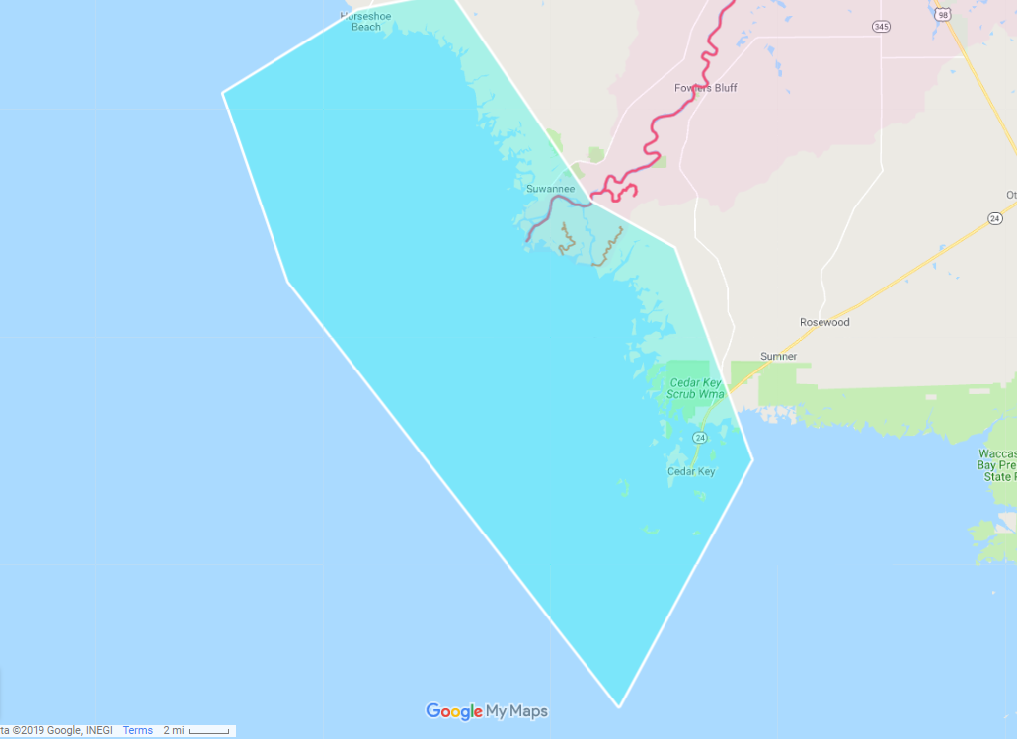

Figure 2 – Zoomed in area of Suwannee River ending at the Big Bend from Figure 1.

Significant areas of the land within the basin are protected and conserved by local, State, and Federal agencies, as well as private land owners, and non-government organizations. There are over 50 state and county recreational parks along the river. Along with recreational parks along the basin, there are also monitoring programs that protect and conduct management strategies. According to the Florida State’s Suwannee River Basin Management Action Plan (Suwannee River Basin Management Action Plan (lower suwanner pdf) the lower and middle Suwannee river basin comprises 1.13 million acres where over 750,000 of those acres are protected and designated as part of the priority focus areas for ground water nutrient level reduction as well as implementing restoration management strategies.

Much of the land use around the basin, for the lower and middle areas, are comprised of forest, agriculture, and wetlands (Figure 3). There has been very little urban development around the basin,

Figure 3- (lower suwannee pdf), 2018) Land uses for each sub-basin in The Suwannee River Basin Management Action Plan

**Reason for Effort**

The United States Geologic Survey (USGS) and other state and federal management agencies have been monitoring different aspects of water and land resources in the SRB for nearly 100 years (ref). This research has addressed water quality, river discharge, floodplains, and surface water exchange. Many of these studies have been done in discrete pieces with each study addressing specific objectives over short periods of time. In 2005 a group of agency and academic researchers led by USGS scientists identified a key need for the SRB was to integrate information from these studies in basin-wide and inter-disciplinary frameworks to provide XYZ. These discussions led to the development of a series of documents identifying threats to the SRB and key research needs (refs). As an example, Raabe (ABCD) digitized information from surveys of the coastline from approximately the Suwannee River mouth to Tampa Bay collected in the 1800’s and compare these surveys to satellite imagery from 1995 to characterize changes in coastal habitats between these two time periods. Research such as Raabe (ABCD) are useful because they provide resource managers with long-term perspective on how resources are or are not changing. This long-term perspective is important when assessing changes in resources such as coastal habitats that may be changing incrementally long time scales that are much longer than the time that an individual manager may have been observing the system (decades vs. years). The missing element that USGS identifies is the integration of both basin-wide and inter-disciplinary information.

According to the USGS Suwannee River Basin and Estuary: An Integrated Watershed Science Program Open-File Report of 2005-2010 (Brian G. Katz, 2005)the improvements to the water resources information and management of the Suwannee basin include to ensure spatial distribution and environmental covered, develop integrated a land-use and land-cover database that will offer past, present and planned information.

It is also noted that USGS has identified habitat conservation research gaps and opportunities in data collection and analysis. Some of the gaps missing are from mapping terrestrial and aquatic habitats, using data from remote sensing compatibilities for a complete spatial coverage of the area (Katz & Raabe, 2005)

**Objectives**

Using publicly available data and by developing a reproducible workflow I will assess changes in large-scale geographic features and land use in the Suwannee River estuary and watershed. This will be done in two parts.

(1) Raabe et al. 2004 described a method using digitized 19th century topographic sheets for the Big Bend region of Florida and then compared these sheets to 1995 satellite imagery to characterize trends in large-scale geographic features for this region. I will follow methods from Raabe et al. (2004) and extend the data used beyond 1995 with more recent publicly available images (Figure 2). I will follow guidelines from Raabe et al. (2004) to focus on overall trends in large-scale geographic features and not focus on site specific changes due to variation in survey methods. My initial efforts will focus on geographic region surveyed as part of Seavey et al. (2011) from approximately the Waccasassa River, Florida to Horseshoe Beach, Florida with special emphasis on public lands. I will develop a data workflow for collecting and processing available imagery that is reproducible and uses publicly available resources.

2) I will identify a set of watershed metrics for the Suwannee River basin from public data repositories that are useful for understanding trends in variables that are known to correlate with changes in river discharge, nutrient levels, or aquatic biodiversity and habitats.

**Spatial Observational Units**

At this time, no spatial units are defined. Selecting observation units will be established before the landscape metrics can be calculated and atmospheric variables corrected. It could be possible to select shapes or predefined buffer zones (et. al Yang 2007) for the area. Other spatial units could be defined by different levels of biological or human related data, which can influence shoreline coastal patterns.

**Methods**

The proposed goal of my research is to create an automized way to update maps, based on satellite imagery, or map data scrapping from another source.

A reproducible effort could be to create a set of calculations that can automatically process new images, of the same location, using the software ENVI + IDL. Satellite imagery are measured using a series of calculations IDL. These calculations can also create new raster types, which can be compared in ENVI. Using the combination of calculations and spatial software analysis, an adaptive management plan can easily address imagery updates. This method can be easily reproduced but might be difficult to share with other potential users or agencies. This method is not automated and must be done by the user. I propose testing this method using available imagery around Lone Cabbage Reef and document the reproducibility of this method.

Other methods that rely on the user, but also reproducible, can be to manually hand digitize imagery, which might or might have any spatial reference associated to them, and compare these digitized areas. ArcMap is a software that can allow for overlays of manual digitization. Using the tools in ArcMap “create features” from the map, will allow the user to construct polylines at certain points of the imagery. These polylines can then be compared and analyze to observe short-term or long-term trends, I propose to evaluate if this method can ensure reproductivity for future satellite imagery on this project.

Other way to create a reproducible mapping workflow is to use available online continuous data. Much of these data are provided by government agencies, and updated frequently. Government organizations such as USGS, and USDA have public APIs to access these data (https://sheilasaia.rbind.io/post/2019-01-04-nass-api/). These APIs can connect to R and allow for data to be downloaded, and then be manipulated to suit the needs of the user. I propose that spatial and temporal analysis, to support the ongoing shoreline changes along the Lone Cabbage Reef, can be created using much of these available packaged data. Using the USADA quick stats, the census and survey data (<https://quickstats.nass.usda.gov/>) for agriculture land, agricultural services, and improvement and construction might also be used to create dynamic maps. I propose to develop a workflow using available online packaged data, to create comparable mapping imagery, and record its reproducibility.

Though these methods have been used my multiple scientists and conservation efforts, it will be valuable to learn of the best reproducible workflow for creating and maintaining these compared spatial imageries for the LCR project. Satellite imagery and available continuous data differ between regions and can have impacts on analyzing spatial features in the long run. I propose to record and observe the most effective spatial analysis methods, using a section of the Suwannee Sound shoreline.