**What are shoreline changes?**

Coastal shorelines are naturally dynamic and are an active point between land and sea. Shorelines undergo frequent changes in long-term and short-term variations caused by seal level rise (e.g changes in wave climate) (Johnson et al., 2014), geomorphic changes (e.g island erosion) and other factors (e.g storm events and surges) (Scott, 2005).

An example of sea level rise changes can be seen in the research of Raabe and Stumpf (2015), where they concluded that mean higher high water (MHHW) had increase from 1 to 1.2 m (Figure) at Cedar Key during the tide gage record. The MHHW that was tracked is the mean sea level except for some lunar deviations (Stumpf and Haines 1998). Sea-level rise can have drastic effects on shoreline as indicated in Raabe and Stumpf (2015), where they further explained that marsh shoreline in the Big Bend exhibited some resistant to inundation retreat, but the coastal forest had succumbed to inundation, resulting in an inland expansion of marsh habitat.

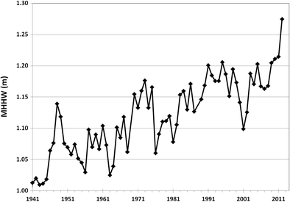

Figure -Average mean higher high water (MHHW) at Cedar Key, FL, 1941–2011, showing approximately 0.2 m increase over 70 years (NOAA [2014](https://link.springer.com/article/10.1007/s12237-015-9974-y#CR43), http://tidesandcurrents.noaa.gov/sltrends/)

Increased tidal flooding exposes coastal island vegetation to frequent salt stress due to sea level rise (Langston et al., 2017). Coastal islands are not able to escape the salt stress, resulting in lack of vegetation regeneration (Langston et al., 2017). Coastal plants have adapted to survive periodic disturbances, but it is unclear how they will survive with more frequent storm pulses and changes in sea level rise (Leonardi, Ganju, & Fagherazzi, 2016). Coastal plants adapting slowly or not quickly enough can lead to higher rates of erosion on shorelines, which will increase the rate of shoreline change.

Storm events

**Why is shoreline analysis important?**

Shoreline trend analysis is important because it can be a useful tool in future predictions of integrated coastal zone management (Maiti and Bhattacharya, 2009). Noticing shoreline trends changes can influence what management decisions can help protect coastal areas for future conservation efforts. These efforts can also help mitigate climate change related events such storm surges and also enforce protection in areas that animals might utilizes for feeding, nesting, and foraging.

**Why is shoreline analysis important in the Big Bend?**

**What are the impacts of shoreline changes/ trends?**

-Impacts to humans

- loss of area that could be utilized to fish, hunt, live, use as recreation

- harder impacts from storm surges

-Impacts to wildlife

- loss of habitat

- loss of species to hunt/fish that live in the habitat that was affected

-Impacts to potential island protection

-less protection from storm surges

- more damage to protected areas, will be harder to restore

**Compare and contrast heavy human impacted dredging to general human pressure systems.**

**Compare and Contrast Deer Island and Derrick Key, then and now, briefly.**

Deer Island –

Deer Island is an island that can provide relief from storm events and storm surges. Briefly comparing imagery from 1984 to 2018, it can be observed that there are some shape changes to the island. Unlike Derrick Key, Deer Island is still visible and still available for use by people and habitat use by animals. Between the 34 years, between the imagery, there are some observable shoreline differences but not nearly as drastic as the shoreline differences of Derrick Key.

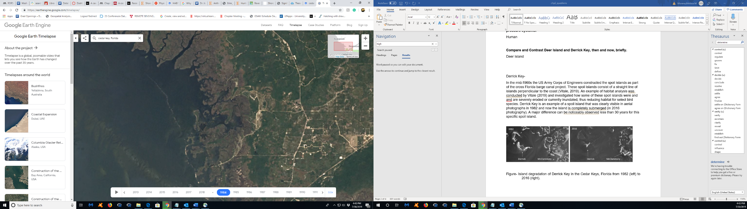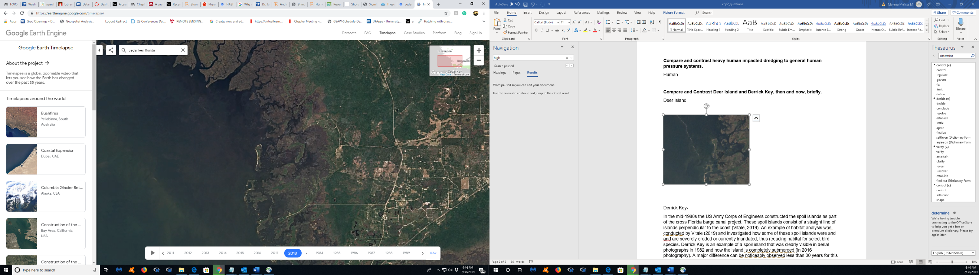

Figure- Google Earth Engine imagery of Deer Island, from 1984 (left) to 2018 (right).

Derrick Key-

In the mid-1960s the US Army Corps of Engineers constructed the spoil islands as part of the cross Florida barge canal project. These spoil islands consist of a straight line of islands perpendicular to the coast (Vitale, 2019). An example of habitat analysis was conducted by Vitale (2019) and investigated how some of these spoil islands were and and are severely eroded or currently inundated, thus reducing habitat for animals. Derrick Key is an example of a spoil island that was clearly visible in aerial photographs in 1982 and now the island is completely submerged (in 2016 photography). Major shoreline differences are noticeably observed in the 34 years, time between the imagery, for this specific spoil island.

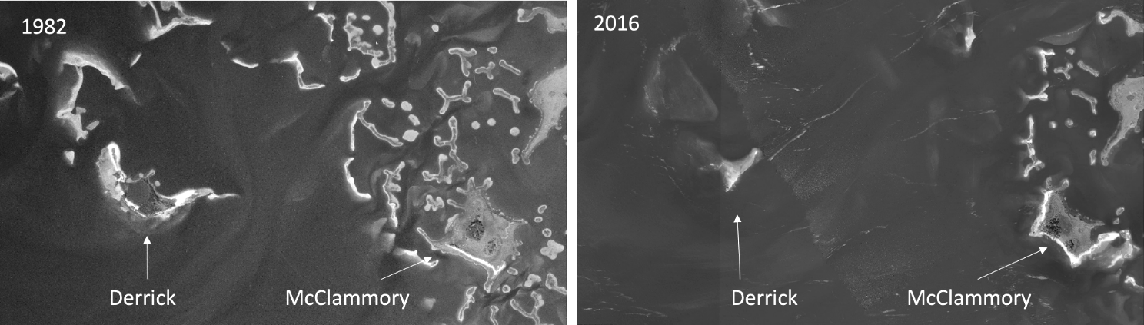

Figure- Island degradation of Derrick Key in the Cedar Keys, Florida from 1982 (left) to 2016 (right), (Vitale, 2019).

**How and why is climate change affecting those islands? What are the rates of storms, is it more frequent?**

Climate change is impacting the Big Bend islands by increasing the frequency of cyclones and hurricanes due to the recent rise of greenhouse warming, with an intensity increase of 2-11% in the next 100 years (Knutson et al., 2010). Further research conducted Lewsey (2004) explains how islands have been recently impacted by climate change with such environmental factors such as varying yearly rainfall, frequency and intensity of hurricanes, and patterns of wave action in the Caribbean. Many of these same factors can also affect Big Bend shoreline, most notably hurricanes (e.g storm surges). Frequent storm surges will cause an increase in infrastructure vulnerability (Lewsey et al., 2004) and retreat or death of vegetation due storm surges (Langston et al., 2017).

**What are key indicators of shoreline changes?**

Some of the key indicators for shoreline change includes high water line (HWL) and vegetation (Boak et al., 2005). High water line is the most common indicator, and it can be defined as a visually determined change in tone left by the maximum runup from a preceding high time (Anders and Byrnes, 1991). HWL can normally be established through aerial photographs, which could be obvious to spot a debris line or a static shoreline parallel line (Crowell, Leatherman, and Buckley, 1991). Because HWL observations can vary wildly between studies, I will propose an HWL definition specifically related to Deer Island that will consider what factors are available in the imagery to determine what constitutes an HWL. Derek key is currently inundated, but a similar HWL definition will be applied to earlier available imagery.

Vegetation is another key indicator of shoreline change because with sea level rise, it is likely that vegetation will stall in regrowth, hence a distinct more sediment will be visible through aerial and satellite imagery (Langston et al., 2017). Raabe (1997) took Landsat Thematic Mapper (TM) imagery from 1986 and 1995 evaluated for signs of vegetation change and determined that there were observable differences in vegetation with increases and decreases in vegetation indexes along the Big Bend coastline. The changes that Raabe (1997) observed indicate that vegetation index changes at the gulf edge could be attributed to water level fluctuation, which is also an indicator of shifting biomass at the gulf edge.

**What is the timeline of major hurricane events in the Gulf of Mexico?**

|  |  |  |
| --- | --- | --- |
| 1950 | September 1 - 9 | Hurricane Easy - Florida |
| 1957 | June 25 - 29 | Hurricane Audrey - Lousiana |
| 1961 | September 3 - 16 | Hurricane Carla - Texas |
| 1964 | September 28 - October 6 | Hurricane Hilda - Louisiana |
| 1965 | August 27 - September 13 | Hurricane Betsy - Louisiana |
| 1967 | September 7 - 19 | Hurricane Beulah - Texas |
| 1969 | August 14 - 20 | Hurricane Camille - Mississippi |
| 1970 | August 31 - September 5 | Hurricane Celia - Texas |
| 1974 | August 29 - September 9 | Hurricane Carmen - Louisiana |
| 1975 | September 13 - 24 | Hurricane Eloise - Alabama |
| 1977 | August 29 - September 2 | Hurricane Anita - Mexico |
| 1979 | August 29 - September 13 | Hurricane Frederic - Alabama |
| 1980 | August 1 - 11 | Hurricane Allen - Texas |
| 1983 | August 15 - 18 | Hurricane Alicia - Galveston, Texas |
| 1985 | August 28 - September 2 | Hurricane Elena - Florida, Louisiana |
| 1985 | November 15 - 23 | Hurricane Kate - Florida |
| 1988 | September 8 - 19 | Hurricane Gilbert - Mexico |
| 1992 | August 16 - 28 | Hurricane Andrew - Florida, Louisiana |
| 1993 | March 12-15 | Storm of the Century – Gulf of Mexico |
| 1995 | September 27 - October 6 | Hurricane Opal - Florida |
| 1999 | August 18 - 25 | Hurricane Bret – Texas |
| 2002 | September 21-October 4 | Hurricane Lili - Louisiana |
| 2004 | September 2-24 | Hurricane Ivan - Alabama/Florida |
| 2005 | July 4-12 | Hurricane Dennis - Alabama/Florida |
| 2005 | August 23-31 | Hurricane Katrina - Louisiana/Mississippi |
| 2005 | September 18-26 | Hurricane Rita - Texas/Louisiana |

Table – Table of major hurricane events in the Gulf of Mexico since 1950 (<http://www.wxresearch.org/family/gulfhur.htm>).

**How did these storms specifically affect islands in the Gulf of Mexico?**

Anders, F. J., and M. R. Byrnes. "Accuracy of shoreline change rates as determined from maps and aerial photographs: Shore and Beach." (1991): 17-26.