**Chapter 2**

**Case Study - Spatial Analysis of Deer Island**

**Introduction and Background**

Restoration efforts in coastal zones may be strongly influenced by landscape level processes. The Gulf of Mexico coastline, with its low relief geomorphology, especially in Florida, is also vulnerable to coastal erosion (Geselbracht et al., 2011). Much of the Florida coastline consists of a 1-meter elevation contour that extends inward anywhere from 3 to 10 kilometers. This low elevation leaves the Florida coastline susceptible to frequent coastal changes. Other types of landscape changes occur at different time scales and may have different (and unknown) effects including conversion from wetlands to shallow shores.

The Big Bend coastline is 60 miles west of Gainesville Florida and is located in the Gulf of Mexico. The Big Bend is largely undeveloped, which is usual considering that most of the Gulf of Mexico coastline is mainly developed. Around 30% of the Big Bend land area and over 60 miles of coastline are under conservation protection (Main & Allen 2007). Human population density around the Big Bend is the lowest of any other coastal Florida city and the percentage of intact natural habitat is considerably high (Geselbracht 2007). Due to, in part, low human densities, coastal areas have not been heavily impacted by boat traffic, dredging, heavy industrial pollution, eutrophication, or other anthropogenic impacts (Seavey et al. 2011). Despite the lack of human influence, many observable declines in ecosystem and habitats have been documented (Seavey et al. 2011).

In this chapter I will develop a data workflow and conduct a geospatial analysis to assess trends on a specific region of the Big Bend. Analyzing trends of landscape level change over time can provide basic information on how systems may be changing. These quantified trends can motivate actions to improve management and protection of coastal and inland habitats.

**Reason for Research**

Because of how little the Big Bend coastline has been influenced by outside forces, there is a high interest to protect the coastal areas that have not been colonized. There are several restorative and conservation projects in the Big Bend, which are funded through National Fish and Wildlife Foundation (NFWF), who have been allocating money from the 2010 Deepwater Horizon oil spill as of 2013 (https://www.nfwf.org/gulf). The agreement of the settlement is directed to fund projects benefitting the natural resources of the Gulf Coast that may have been impacted by the spill. The awards are invested into projects to conserve and enhance coastal habitats. The Lone Cabbage Restoration project (LCR) is a program funded through NWFW to restore and monitor oyster populations. The LCR project has been working with other agencies such as Florida Fish and Wildlife Conservation Commission (FWC) and Nature Coast Biological Station (NCBS) to unify available biological data including water quality and species density monitoring. These biological data are important to illustrate a larger picture of the natural impacts that have occurred in the Big Bend.

Spatial analysis in the Big Bend is a monitoring evaluation that has not been fully explored, despite large conservation interest in the area. An example of spatial analysis efforts can been seen in Raabe (2004), who digitized information from surveys of the coastline, from approximately the Suwannee River mouth to Tampa Bay, and collected topographic sheets from the 1800’s and compared these surveys to available satellite imagery from 1995 to characterize changes in coastal habitats between these two time periods. Research such as Raabe (2004) are useful because they provide resource managers with long-term perspective on how resources are or are not changing. Examining these trends will provide necessary information to the efforts in the area to , including the LCR project.

**Objectives**

Review all available mapping imagery and materials of the Big Bend coast and Suwannee Sound to A) organize and store the materials for future conservation projects as per USGS data management standards, B) conduct a geospatial analysis on coastal changes, gained and/or lost, from the earliest appropriate mapping data of Deer Island C) outline methods of geospatial analysis for future use and analyses of the LCR project for maximum reproducibility.

**Study Area – Deer Island**

The research area for this case study will be Deer Island, which is off the coast of the Big Bend Florida in Suwannee Sound, which is in the Gulf of Mexico. The area of study that will be analyzed is the coastline of Deer Island. Deer Island is a barrier island consisting of 90 acres in total area, which comprises of 25 acres of upland habitat and 20 acres of wetland habitat. The island coastline features a sandy beach facing the open Gulf of Mexico. Deer island is not inhabited, but there are some man-made structures from the late 1800s. Deer Island is located 8 miles north of Cedar Key, Florida. The surrounding islands around Deer Island will be observed for changes but will not be quantified.

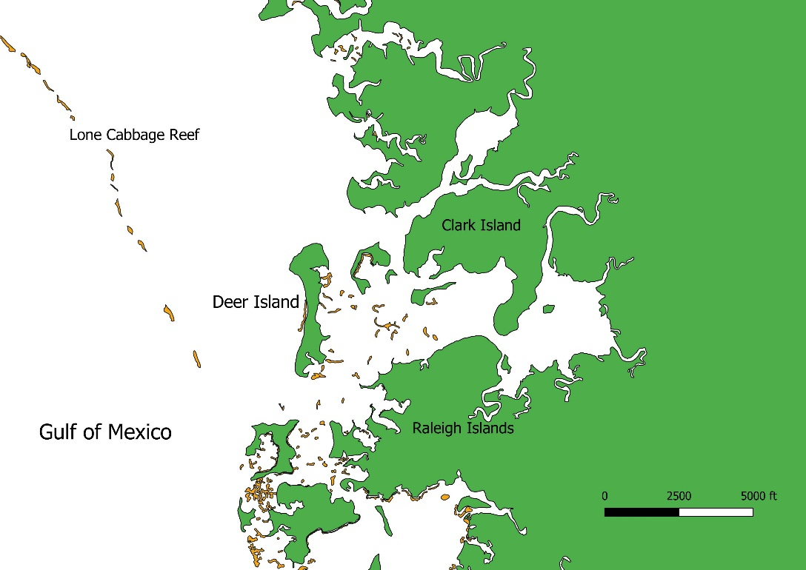

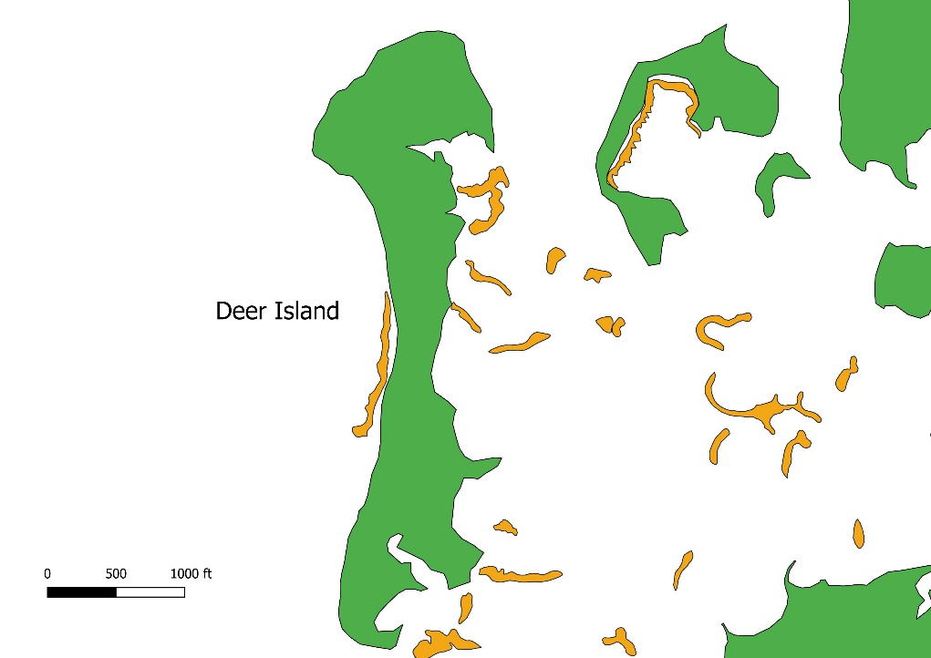Figure 1- Zoomed out view of study area, Deer Island, for spatial context in relation to Lone Cabbage Reef. Land mass is colored in green, and oyster clusters are colored in orange.

Figure 2- Zoomed in view of study area, Deer Island. Land mass is colored in green, and oyster clusters are colored in orange.

**Methods**

Defined methods for this case study are not solidified. Many software programs and packages are available through the University of Florida and open source resources. There are general methods and techniques that will be mentioned in this section.

*Organization and Storage*

USGS Data Management standards explain that some of the best practices for processing spatial data are to use open formats such as geoTIFF and use open-source solutions whenever possible. The manual also describes that adding metadata to datasets to define the who, what, where, when, why, and how is important so that data can be understood, re-used, and integrated with other datasets. In the Geological Survey Manual section SM 502.7 states:

“metadata must accompany all USGS scientific data and other information products. Metadata records are to be developed in a standardized way that enables users to understand the context and to evaluate the usefulness of the data or information product. Metadata records for scientific data must comply with standards such as the FGDC Content Standard for Digital Geospatial Metadata, the International Organization for Standardization suite of standards, or other USGS endorsed FCDC standards. A minimum of one metadata review by a qualified reviewer is required for all USGS scientific data and other information products approved for release.”

Some metadata software recommended by USGS are USGS Metadata Wizard (<https://www.sciencebase.gov/catalog/item/50ed7aa4e4b0438b00db080a>) and USDA Metavist (<https://www.nrs.fs.fed.us/pubs/2737>). These software allow to the user to create FDGC (Federal Geographic Data Committee) Metadata for geospatial datasets. USGS is pushing to have these metadata to be incorporated in published geospatial datasets to standardize ways groups are storing and recording their geospatial data sets.

As far as my graduate research analysis, I will be using the T:Drive storage of the LCR project to store my datasets. I will use practices to store and backup my geospatial datasets as per USGS Data Management standards. These details will be finalized during imagery processing and analysis. Completed analysis and geospatial datasets will be located in GitHub, a version control online software, for easability to download and reproduce.

*Geospatial Analysis*

*Documenting Workflow*

As in Chapter 1, it will be important to document the workflow of a complete and accurate product. Having a completed analysis of Deer Island with the available mapping data will be available for any biologist interested in the Big Bend area at the end of my graduate research. As previously mentioned, the Big Bend is an area of interest for many conservation groups and projects, so it is imperative to document the workflow in an easy and reproducible way that is approachable to many people with many different skill sets.

The USGS Data Management best practices for sharing data are to 1) document the process thoroughly 2) create an easy to find data storage and 3) putting the information “out there” for people to locate. Objective A, of my proposed graduate research, covers practices 2 and 3 of the USGS Data Management best practices, and Objective C covers practice 1. The recommendations for sharing datasets are to clearly define the purpose of the research, describe attributes and geography, include associated links, specify a required data citation and acknowledgements, and create a second public version containing all appropriate metadata.

Workflow documentation will contain step by step guide, screen shots, and descriptive text. Final documentation will be pushed to Github in a .doc or .pdf format.