Moreno, Melissa

March 13, 2019

SUR5386

Final Project Proposed Topic

**Statement**

The University of Florida was granted a fraction of the Deep Horizon Oil Spill from BP. With these funds, we are constructing a once historically active oyster reef. The construction has been completed as of October 2018. Part of the grant is to monitor water quality variables and spatial aspects of the Big Bend area. I will use this project to create a spatial monitoring program of the area using publicly available satellite imagery and easily accessible mapping tools.

<https://lcroysterproject.github.io/oysterproject/>

**Objectives**

In line with my research that I am doing for my master’s thesis, I would like to propose to analyze satellite imagery to determine coast line loss or gained in the Cedar Key, FL area. I may pick a small location, instead of the whole Big Bend area, but it would be an analysis of land cover change in an area that is being affected by the river discharge of the Suwannee River. I will use land satellite imagery and software to determine and measure land change trends.

**Suggested Methodology**

**Software**

* ERDAS Imagine 2018 Software
* Arc GIS Software

I will download satellite imagery from USGS Glovis online image achieve. I will pick years that are about 10 years apart. Once downloaded, and corrected, the images will be imported into ERDAS and georeferenced. Using My Digital Globe, I will find land class classifications for the images. The classifications can include vegetation, habitat type, etc. The two views will be linked and synced in ERDAS, and an AOI layer created for each satellite imagery. The imagery will be compared and a change analysis conducted.

**Proposed Study Area**

Big Bend

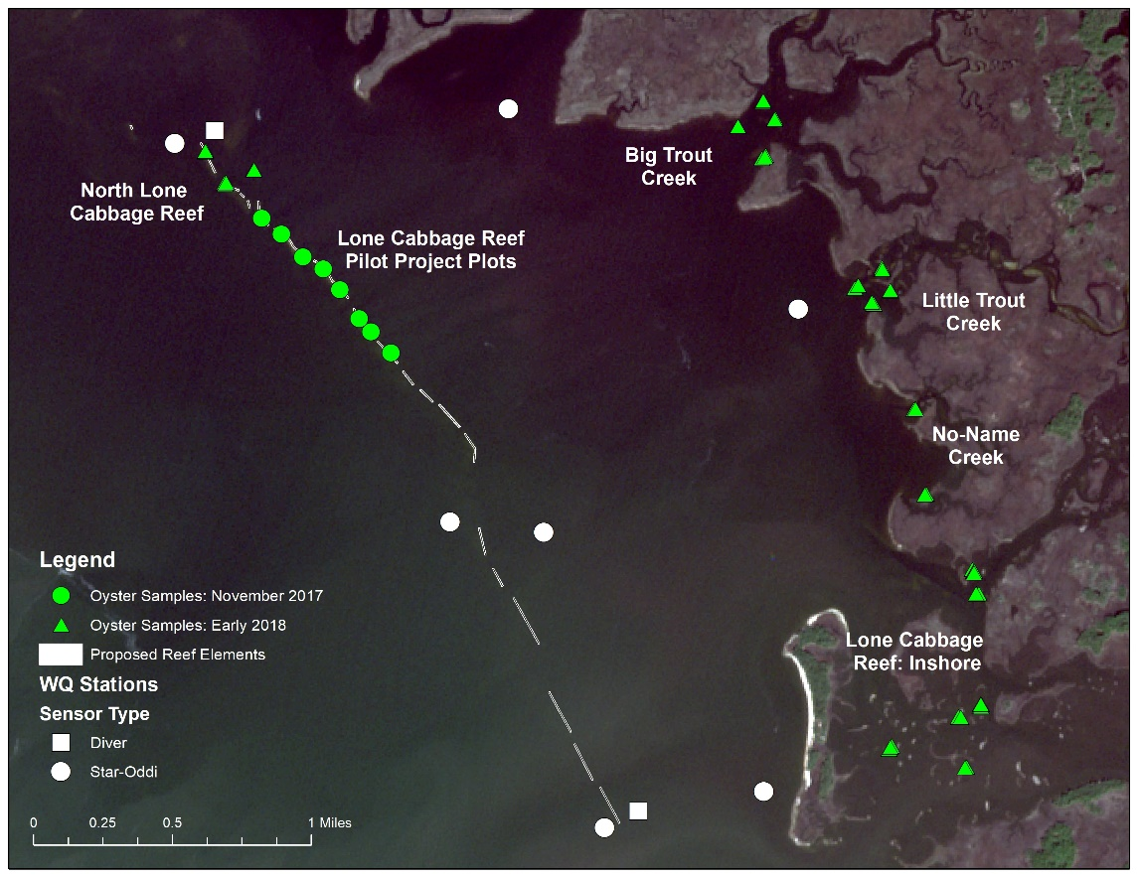Cedar Key, FL