Moreno, Melissa

January 14, 2019

SURSUR5386

Tutorial 1

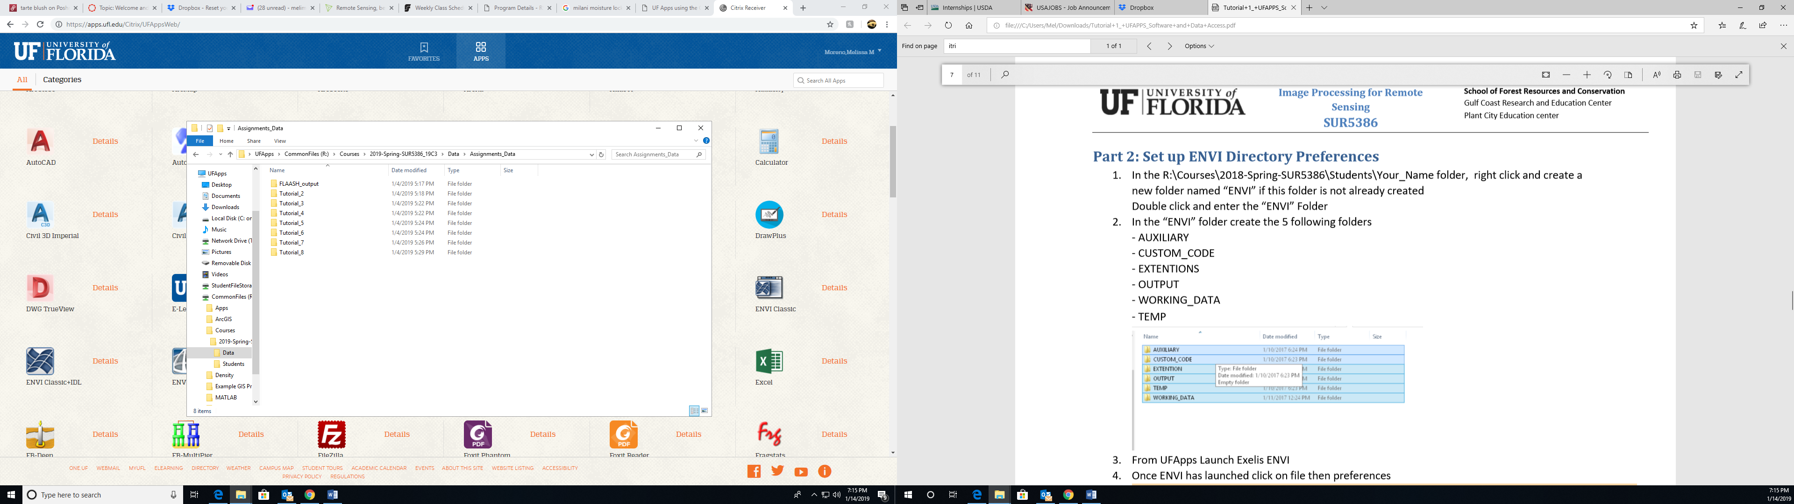Part 1: Take a snapshot showing the folder content and paste in Tutorial 1 Report.

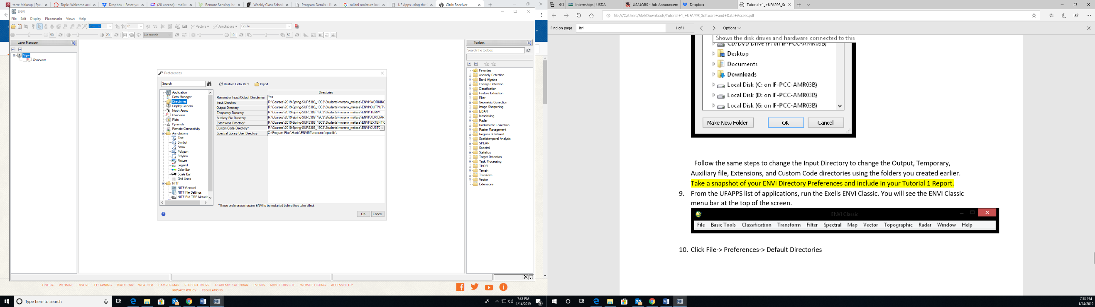Part 2: Take a snapshot of your ENVI Directory Preferences and include in your Tutorial 1 Report.

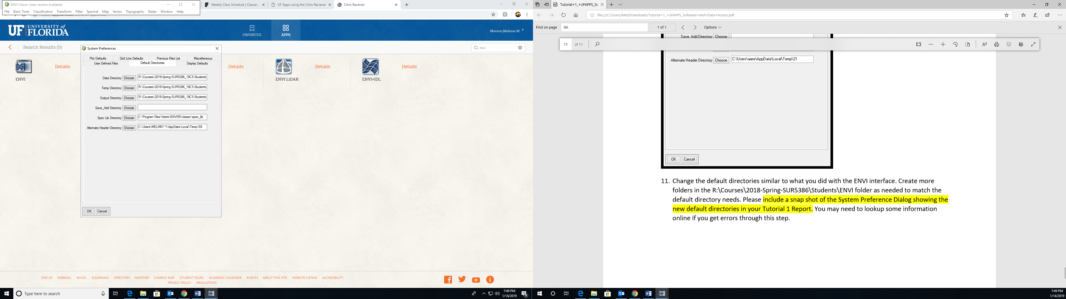Part 2: Please include a snap shot of the System Preference Dialog showing the new default directories in your Tutorial 1 Report.