Exam

Question 3.

Pieces of hypothetical deductive logic, Alternative hypothesis, Testing, methods, predictions and assumptions

5. Paradigm

6. Scientific theory

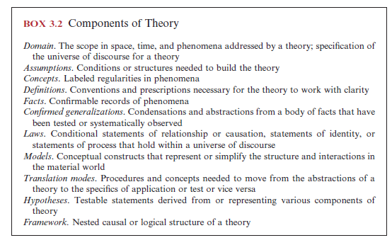

7. What exactly is a falsifiable hypothesis?

8. like Falisifibalitiy, rule things out, reduce variables, reduce the system, keep out alternatives, experimentation, testing only 1or 2 hypothesis, manipulative, take the real question and make it smaller pieces but it doesn’t explain the whole but importatnt to know

3)(a)

All laws are conditional

Pickett says there are laws

A number of objections or arguments for ecological laws have been presented by both

ecologists and philosophers of science. The debate does not appear resolved but it may be

important to the determination and pursuit of ecological questions and ultimately to the

success of ecology.

Let us begin with an assertion that the existence of emergent properties precludes

obtaining high-level ecological laws by just deducing them from those of other sciences

(Bunge 2003). Hence, ecological laws must be deduced at the appropriate levels of ecological

organization, involve ecologically based assumptions, and use logic or known ecological

relationships to organize the assumptions into a prospective law. For example, the

mechanisms by which plants or animals compete are entirely different from those by which

atoms compete. While plants process energy and matter consistent with the laws of physics,

it does not mean that the dynamics of competition are directly deducible from physical

knowledge (Marone and Del Solar, in press, Murray 2000). A simple example illustrates

this point. When lions and hyenas compete for a carcass, the outcome determines where

the energy is going to be allocated and in what quantities. However, neither the energy of

the carcass, the energy of hyenas, nor that of lions appears to be informative of the outcome

of competition. Thus, competition is a phenomenon that appears at the level of a system

that consists of at least two ecological entities (i.e., populations) and cannot be deduced

from nor rigorously linked to the principles of physics.

Having asserted that laws of ecology are not those of physics, the question arises of why

ecologists seem to have diffi culty with formulating and agreeing to what the laws are. The

most common putative cause invoked by ecologists, as well as some philosophers of science

(Shrader-Frechette 2001), is the contingency of ecological phenomena (Knapp et al. 2004,

Lawton 1999, Marone and Del Solar, in press). Sagoff (e.g., 1997) and Shrader-Frechette

and McCoy (1993) have repeatedly condemned ecology’s pretensions to nomotheticity, or

law-likeness, of some of its regularities. Ecology is too complex, they have said, to be

V. Theory and Its Derived Conceptual Content 77

78 3. The Anatomy of Theory

fruitfully characterized in terms of general laws (Mikkelson 2003). However, Simberloff

(2004) cautioned after Windelband (1894) that ecologists should not confuse the distinction

between general laws about the structure and workings of nature with idiographic

knowledge, which depicts singular events and focuses on unique aspects of particular

phenomena — the sources of complexity.

Complexity is then seen to derive from contingency, and contingency itself is seen as a

condition where any particular outcome depends on a number of contributory causes that

can act in a fairly unpredictable mix. Irrespective of the level of organization, contingency

is believed to be fundamentally different from that of physical phenomena and hence an

insurmountable obstacle to fi nding meaningful laws in ecology. However, this claim seems

to be taken on faith and, when confronted with reality, borders on absurdity. The great

majority of physical phenomena is as contingent as biological ones, and some are entirely

indeterminate. Whether one considers a fl ight trajectory of a falling object, the distribution

of rocks on the slope of a mountain, movement of air particles or air masses, locations of

lightning strikes, arrangement of matter in the universe, spread of fi re, shape of a snowfl ake,

or hundreds of other physical phenomena, contingency is pervasive. Rather, it is a matter

of abstraction and idealization (see Chapter 2), not of subject, that differentiates the

constructs of physics as compared to constructs of ecology, at the moment at least. This

means that laws of physics are usually formulated as if no other forces or modifying factors

existed. Laws of physics rely on stripping the contingency to expose an ideal relationship,

a relationship that is diffi cult to observe in nature. Consider the simplest and best known

law of physics, that of the fi rst law of mechanics. The fi rst law deals with forces and changes

in velocity. For just a moment, let us imagine that you can apply only one force to an

object — that is, you could choose to push the object to the right or you could choose to

push it to the left, but not to the left and right at the same time, and so on.

Under these conditions, the fi rst law says that if an object is not pushed or pulled, its

velocity will naturally remain constant. This means that if an object is moving along,

untouched by a force of any kind, it will continue to move along in a perfectly straight line

at a constant speed. The operative phrase is *under these conditions* (i.e., of one force only)*.*

When more forces apply, as always is the case, the fi rst law of mechanics will fail in its

predictions. However, physicists are happy with this law. Should not ecologists be able to

construct similar laws and be happy with them?

In spite of the reasons to the contrary, ecologists worry about the contingency and its

negative effect on their ability to synthesize multiple streams of observations. One attempt

to come to rescue (Knapp et al. 2004) starts by conceding to critics that laws may not be

attainable because of fuzziness of relationships among ecological entities and phenomena.

Knapp et al. (2004) postulated a scaled-back program for ecology — a program that will

focus on fi nding rules. They seem to subscribe to the collective arguments and logic of

Lawton (1999), Simberloff (2004), or Berryman (2003) and fi nd comfort in the fact that

most ecologist agree to the existence of rules. They defi ned rules as generalizations or

statements that predict the occurrence of a particular ecological phenomenon if certain

conditions are met. However, their defi nition of rule is not much different from the

defi nition of law. So what is the problem? The quality of prediction or the quality of the

formulation?

One might argue that the search for rules might be good because it could inspire fi nding

laws. One might also argue that the search for rules might hinder progress by emphasizing

empirical over conceptual work. Newton’s fi rst law of mechanics illustrates these two

possibilities. The law says that an object pushed should move at a constant speed along

a straight line. Although no object obeys this law in the natural world, the fact that most

objects tend to move in one predominant direction and continue to do so for a while might

lead a speculative observer, as it did, to the formulation of the law. Hence, empirical

observations summarized as a rule that movement occurs, at least initially, in a direction

not much different from a straight line and continues for a while at least after the force

stopped suggested a general conditional rule that would only work in an idealized

setting — a law in short. However, these same observations might lead one to a proliferation

of rules such that, for example, (1) fl uffy objects show greater trajectory variance than do

dense objects (like bullets), (2) objects whose initial speed is less that the fi rst cosmic speed

tend to fall to Earth, (3) objects whose initial speed is greater than the fi rst cosmic speed

tend to orbit Earth, (4) objects in water fl oat if their density is less than that of water or

sink to the bottom if their density is greater than that of water, and so on. All of these

rules, and many others, are useful, true, and would represent progress in recording and

understanding natural phenomena. The question ecology faces is not which of the strategies

to pursue but what is the most promising mix of strategies, all of which should be pursued.

The claim that laws cannot be found and cannot be useful in ecology (see Mikkelson 2003)

has little basis in logic and the practice of science in general.

Newtons 4 laws- covering law model

Logical positive- verifiability principle

Quinn and Dunham- multi casual hypothesis theory

Thomas bayes- ubductive probability

Lloyd- fit between model and data

Platt- Reductionism (strong inference, classic view)

Guillie- explanatory surplus

Pickeet- New Pluralism

Bacon-

Katie- research and design

Diagram in chapter 4, the stages of theory

Buzz Holling

Resilience theory

Lumps and gaps theory- plop body sizes, and birds of the same size lump together, and the gaps tells you about the ecosystem, it’s more like a notion

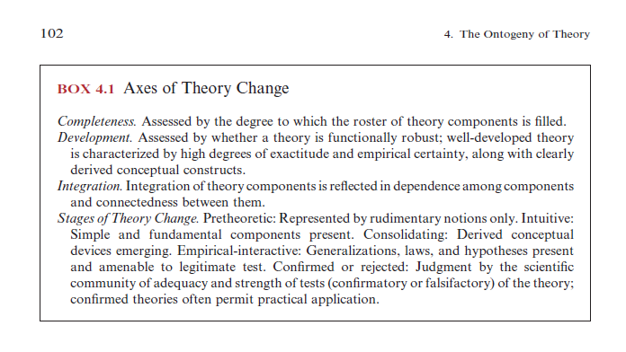

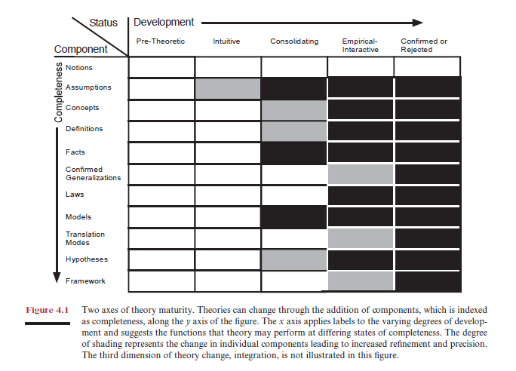

5. Quinn and Dunham hypothesis testing

Faslificaiton and strong inference, and there are weakeness if you see this way

Have to assume multi-casuality

State the hypothesis when there are a bunch of them

Interactive- say AND

Exclusive- OR

The questions

1. Define
2. Explain the key content of the question
3. Elaborate