Lloyd Reading Concepts

**Elisabeth Lloyd - Confirmation of Evolutionary Models**

Explain the three factors in evaluating evidence for hypotheses in ecology/evolution.

1) Fit between conceptual model and data

2) Independent tests of various aspects of the model

3) Variety of evidence (3 kinds)

--- variety of instances of fit

--- variety of assumptions tested

--- variety of types of support

Now (this could be on the test) - given your ability to explain Lloyd's definition of confirmation (using variety of evidence) and Gillies definition of confirmation (using 'explanatory surplus') -

- Explain how these definitions overlap.

- Explain any differences between them.  Are they semantic, or real differences?

- Now - in what way does each definition relate to the 5 main components of Hypothetical Deductive logic?

Research hypothesis(es)

Critical test

Predictions (statistical hypothesis(es))

Alternative hypotheses

Assumptions

***Make sure we discuss this fully in class!!***

**Notes for 2018/09/10**

1. Testing Criteria
   1. Modes vs criteria
   2. Testing mode- (pickett has a table with different testing modes)
      1. Via Sciencce, Via Faith, Via Art (Box 2.1)
      2. Legal knowledge, moral codes of behavior
      3. Beautiful- art
      4. True- science
         1. The idea of testing, and if we test it, it might be probably true
      5. Ethical- moral
   3. Testing criteria- (more logical)
      1. Falsification
      2. Confirmation
      3. Verifiability – (more like the first testing criteria)
         1. This would be considered Inductivism and also Logical Positivism
         2. Need to have testing criteria, that is why they moved from verifiability
   4. Testing mode- (tool, thing or process, tools used to apply the criteria)
      1. Comparison
      2. Correlation- the main mode, in testing mode
      3. Manipulation
   5. 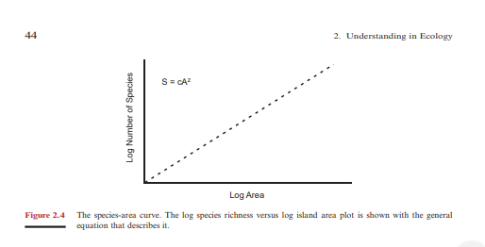
2. Confirmation (ecologists use this one the most)
   1. Gillies- explanatory surplus
   2. Lloyd- variety of evidence (model-data)
3. Exemplar -> Julie Savidge
4. Confirmation vs Falsification
   1. What is the logical difference

History timelines

1. Inductivism – 1500s to 1950s
   1. Early themes for “testing theory”
   2. We can create theories that were simple theories
   3. Possibly a law model
      1. Astronomy
   4. Covering law model (describe this)
      1. Island Biogeography (is an example)
2. Demarcation
   1. Gillies ,explanatory surplus
3. Logical Positivism
   1. Didn’t start doing testing until this time
4. Falsification – considered ther eal powerful criteria
   1. Most sciencetists can’t apply, very strict
   2. Karl Popper
5. New Plurism-

**In class questions**

1. Explain how we test statements with explanatory surplus.

Is an estimated n-s. The measure.

The principles of explanatory surplus has been designed to enable confirmation theory to be applied to actual scientific examples, where historical or present-day.

If in the practice it proves possible to estimate the size of the explanatory surplus in a sensible and natural way, and if the principle of explanatory surplus in a sensible and natural way, and if the principle of explanatory surplus leads to satisfactory results, then there is a strong case for adopting it.

Principle of confirmation, designed to be applied to confirmation theory.

An excess of facts explained over theoretical assumptions employed.

1. How do I know when I have it and what are the constraints?

Constraints- arbitrary, there might be no significance, not all facts that follow don’t support it, not all factors that follow the hypothesis support it

Limits the evidence that can be used to support the theory.

A large surplus is correspondingly strongly supported.

1. How do you know when you have it? And what is it of?

Subtract the theoretical assumptions from the number of the facts that are explained. The size of this surplus is held to be a measure of the confirmation of the theory. If there is a good measure of the surplus, it can be a good thing to create a better assumption.