NOTE: this text is written for social scientists, who can rarely apply experimental designs within ethical bounds.  So take the examples and think of ecological ones.

Descriptive versus Explanatory Research

Relationship between Correlation and Causation

Relationship between Correlation and Prediction

Relationship between theory-building and theory testing

Considering that 'proposition' and 'prediction' are equivalent ideas (pg 7) - do you see how the example relates to 'testing' alternative theories (arguably, these are hypotheses) via confirmation?

Distinguish Research Design from Research Methods

Bottom of page 11-page 15: Unfortunately, the writer of this book never read about confirmation as a testing criterion; yet the author has a good sense of what it is. You need to understand how they compensate for lack of knowledge of confirmation in their argument here concerning testing rival (alternative) hypotheses. In order to avoid the "fallacy of confirming the consequent" [If A then B; B, therefore A], they promote consideration of three things.

a) Make sure you map out all important alternative causes of a consequent,

b) Set up falsifiable tests when possible, and otherwise,

c) Apply a sceptical approach to alternative explanations by exhaustively laying out all possible predictions (propositions) that derive from all of the alternatives, then accept the hypothesis with the most confirmed predictions. [This is a decent approach to achieving explanatory surplus, simply lacking ID and testing of critical assumptions. If they had considered this last step, their design, in this case, would have been more efficient - can you see why?]

Use the questions in the beginning of Chapter 2 to focus on thinking about the **a) descriptive** aspects of **your**study design, then b) use the questions that follow to help you ID **your** explanatory and response variables.

Using boxes and arrows like they do in the next section, make a **causal model of YOUR study design**. What are the causal (research and alternative) variables and the response(s) of interest?

What do they mean by 'theoretical, substantive versus technical, methodological' rival hypotheses? **What are some examples from your system?**

Internal versus External **Validity**?  Which do you think YOU need to emphasize??? You can go for both. But which is more important (to you)?

-------------------------------------------------------------------------------------

**Nguyen et al, 2016**

I included this reading - not for the details, but - because research questions in conservation SHOULD COME from those whose work advances conservation goals every day (land managers, government biologists and policy makers, et al.).  ***Where do your research questions come from, and where will your answers go?***

To be honest, much of this paper is not very useful to you at this stage. However, for discussion - please study Table 1, and **circle** all parts that seem like they pertain to you, your project, your stakeholders and outcomes you hope to see. Then answer these questions with names of people, agencies, or other stakeholder groups:

a) Who all cares how you design your study? b) Who all cares what data you collect, and whether it will be available during or after your study is over? c) Who all cares what your results are? d) Who all cares what papers you produce or what talks you will be required to give when you are finished?

-------------------------------------------------------------------------------------

**James and McCulloch** - this is an important paper concerning causal inference and how to get it!

Finally, as an exercise, try to take factors acting within your own study system and design different causal designs (longitudinal comparative, true experimental, quasi-experimental, comparative cross-sectional) using the notation provided in this paper.  Play with X (causal) factors in your system and think about comparative, experimental, cross-sectional, longitudinal designs - even if you are not doing them; what would they look like?  How hard or easy would they be?

Be able to define and explain every term (in Table 2-1) and every design (Table 2-2) and apply the notation they use to diagram all the different causal designs they define (using the X, Y, O, R notations). Question - in Table 2-2, what columns relate to internal and external validity?

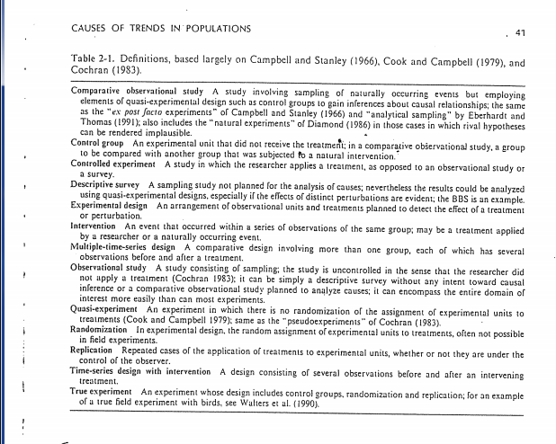

**Research design for causal analysis**

**X= exposure of a group to a treatment or event**

**O= observation**

**R= random assignment of experimental units of treatments**

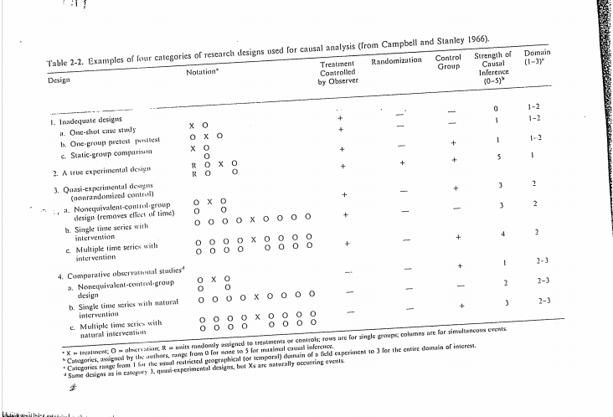

Controlled experiments, where the researcher is in control of the application of the treatment. The one shot case study us inadequate for causal inference, because they offer insufficient control.

**True experimental design**

R O X O

RO O

It is the comparison of the difference between observations before and after the treatment and differences without the treatment is a test for the effect of the treatment.

**Quasi- experiment designs**

O XO

O O

This refers to an experiment in while the full experimental control is lacking because the random assignment of experimental units to treatments was not performed. These inference are not necessarily weaker that a true experiment. The comparisons depend on non-equivalent groups that differ from each other in many ways other than the presence of a treatment whose effects are being tested.

O O O O X O O O O

This is another type of quasi-experiment design, no control group, but there are multiple observations pretest and potteest that help the researcher judge the effect of the treatment.

**Comparative Observational Studies**

Many causal hypothesis about naturally occurring events are first addressed through inadequate designs, so the question becomes how to move them forward through a progression of designs that provided stronger causal inference.

X O O O O

Y O O O O

XY O O O O

O O O O

The comparative design has been the most difficult of all, yet this is the situation in many cases of the analysis that may require quantification of status levels of hypothesized causes.

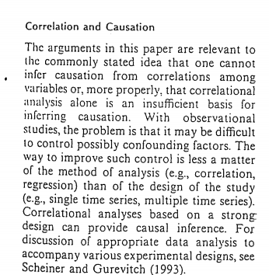

**Correlation and Causation**

-Difficult to control confounding factors

-Correlation analyses based on a strong design can provide causal inference.

**In the last section, they explain fully where causal inference about population declines comes from - be able to explain that fully.**

Tropical deforestation were interpreted as causal by some authors, correlations with forest fragmentation on the breeding grounds by others.

At least there major problems must be addressed before valid inference can be developed about what factors affect population trends.

-Accurate documentation

-How to determine the major causes of observed population trends

- Confirmed courses of mortality are not necessarily causes of population regulation

The validity of causal inference derived from experiments depends upon their design.

Until inferences can be developed about environmental factors, when modified, make a difference, conservation and movement will be inefficient. An important the development of such causal inference should be the incorporation of principles such as quasi-experimental design into broad observational attention.

-------------------------------------------------------------------------------------

**Campbell and Stanley** - This is the in depth source of the notation and designs used in James and McCulloch, and I provide it as an important clarifying resource for you if you need it.

Do not memorize this whole thing - read it for clarification as needed. In particular, the following sections may be useful; Pages 13-20 (concerning validity); pages 27-31 (concerning factorial designs); The large section on quasi-experimental designs (any parts that help you understand what makes a strong or weak one); and three interesting topics in the last section include Correlation v Causation, Retrospective Pre-testing, and Ex Post Facto studies.