* Make a list of the following KINDS of things.
  + Your species name (Eastern oyster (Crassostrea virginica))
  + Your species condition of interest (common)
  + Your habitat / ecosystem type (ocean, inter-tidal, sub-tidal)
  + Region of interest (SE USA, Cedar Key, FL)
  + Words that represent your challenge (This is the species that my database management research is based on, but I am not specifically researching this species. Some of my possible proposal drafts could contain water quality data collected 30 years ago, and relating that with current water quality data. This water quality data will give us a better picture of the conditions of Cedar Key, FL.)

Used search terms: Eastern oyster and salinity

As you catch interesting papers – look for the ‘add to marked list’ option and create a list of all the best papers in a **“marked list”.**

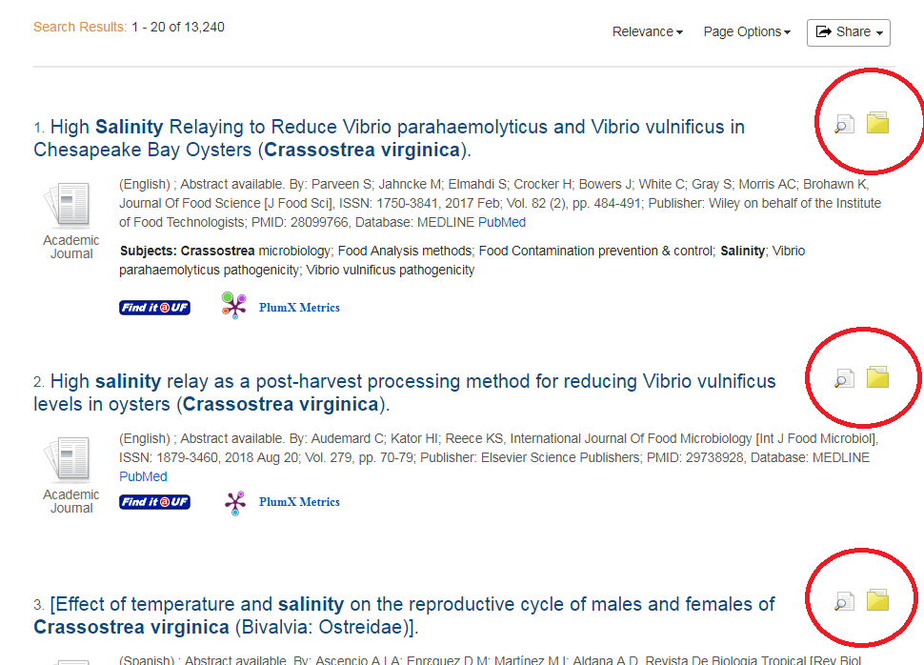

###### Comparison of hits for “Eastern oyster and salinity " - (Conducted 2018/08/29)

|  |  |
| --- | --- |
| **Table 1: Search Words and (database) Comparison** | # Hits |
| 1. “Eastern oyster **and** salinity*” (WESW) | 45 |
| 1. “Eastern oyster **and** salinity *” (WOS) | 299 |
| 1. “Eastern oyster **and** salinity ” (WOS) | 309 |
| 1. “Eastern oyster **and** salinity ” (WESW) | 43 |

1. **Follow citation trails backward and forward. Go Back to Web of Science.**

* Biocalcification in the Eastern Oyster (Crassostrea virginica) in Relation to Long-term Trends in Chesapeake Bay pH
* By: Waldbusser, George G.; Voigt, Erin P.; Bergschneider, Heather; et al.
* ESTUARIES AND COASTS Volume: 34 Issue: 2 Pages: 221-231 Published: MAR 2011
* I believe this paper was the most cited because it includes long term research, and it relatively new.

|  |  |
| --- | --- |
| **Table 2: Citation network for a chosen paper** | # |
| 1. Number of times cited (how many years since published?) | 114 |
| 1. Number of papers it cites | 54 |
| 1. Most highly cited paper that your paper cites | 263 |
| * Mollusk shell formation: A source of new concepts for understanding biomineralization processesBy: Addadi, L; Joester, D; Nudelman, F; et al. CHEMISTRY-A EUROPEAN JOURNAL Volume: 12 Issue: 4 Pages: 981-987 Published: JAN 23 2006 * This paper has more citations because it is older and because it is talking about biomineralization and is published in a well-respected journal, CHEMISTRY-A EUROPEAN JOURNAL. | |

1. **Assessing the importance of Authors, Journals, and Papers.**

* Developing success criteria and goals for evaluating oyster reef restoration: Ecological function or resource exploitation?
* By: Coen, LD; Luckenbach, MW
* ECOLOGICAL ENGINEERING Volume: 15 Issue: 3-4 Pages: 323-343 Published: JUL 2000

|  |  |  |  |  |  |  |  |
| --- | --- | --- | --- | --- | --- | --- | --- |
| **Table 3:**  **Author assessment** | Total pubs | Span of years with pubs | h-index | Average citations / item | Sum of citations with self-citations | # citing articles without self citation | Number of disciplines (colored boxes) |
| 1st author Coen, LD | 59 | 1996-2015 | 26 | 39.05 | 2304 | 2230 | 20 |
| Last author  Luckenbach, MW | 85 | 1999-2018 | 32 | 39.73 | 3377 | 3312 | 24 |
| Your advisor  Dr. Bill Pine | 60 | 1998-2017 | 19 | 18.5 | 1110 | 1005 | 11 |
| Someone else  Schmitt, EL | 14 | 1997-2016 | 7 | 22.71 | 318 | 315 | 9 |
| One of the most important columns in the h-index and also the sum of citing articles without self-citation.  The h- index is the value that is based on a list of publications ranks in descending order by the Times Cited count. An index of h means that there are h papers that have each been cited at east h times. It is based on the depth of years of the product subscription and the selected lifespan.  These values are very useful in finding a good paper for a Masters publication. The h-index is very useful because it explains the depth of the year and the publication ranks. So if the h-index is low, it means that there is not a lot of depths in the publications, and it might be superficial, to an extent.  The best author according to this table is Luckenbach, MW, because they have a higher h-index and also more publications. | | | | | | | |

* **Journal assessment in WOS:** Click on a **highly cited paper** in one of your searches (must have more than 200 citations) and a paper that is published in the same year, but **only a few citations**.
* **Searched for:** ferret (first 2 journals), honey badger (next 2 journals)

|  |  |  |  |  |  |  |  |
| --- | --- | --- | --- | --- | --- | --- | --- |
| **Table 4: journal and paper impact** | Impact factor  latest | Impact factor 5 yr average | Rank out of total in category | Mode Quartile  (most frequent) | How many research domains? | # citing articles without self citation | Number of disciplines (colored boxes) |
| Most cited paper  Airborne Transmission of Influenza A/H5N1 Virus Between Ferrets | 41.058 | 40.627 | 2 of 64 | Q1 | 1 Search Domain  Science & Technology - Other Topics | Herst, S  4361 | 14 boxes for Herst, S |
| Least cited paper PATHOLOGY OF PANDEMIC (H1N1) 2009 INFLUENZA VIRUS INFECTION IN MACAQUES, FERRETS AND CATS | 1.364 | 1.267 | 58 of 79 | Q3 | 2 Search Domains  Pathology  Veterinary Sciences | Van Den Brand, J  229 | 13 boxes for  Van Den Brand, J |
| Most cited paper  Scent-marking behaviour of the honey badger, Mellivora capensis (Mustelidae), in the southern Kalahari | 3.067 | 3.519 | 16 of 51 | Q2 | 2 Research Domain  Behavioral Sciences  Zoology | Begg, CM  673 | Begg, CM  15 |
| Least cited paper  A case of injury to the back followed by all the appearances of syringomyelia. | 53.254 | 52.665 | 2 of 154 | Q1 | 1 Research Domain  General & Internal Medicine | Begg, CM  673 | Begg, CM  15 |
| **Explain which of these columns are most helpful to you in identifying the most important journals for your thesis work?**  I think the column that is most helpful in identifying the most important journal is the Mode Quartile. If the Mode Quartile 1, I will know that the journal is on the higher tier of the publication and is considered a renowned journal.  **How might this vary among different papers you write??**  This will help me determine if the journal I’m citing in my publication is considered a higher quality journal, than some other publications. | | | | | | | |

|  |  |  |  |
| --- | --- | --- | --- |
| **Table 7 – Your book** | | | |
| **Title: MySQL Workbench: Data Modeling & Development** | | **Call number: QA76.9.D26 M35 2013** | |
| ***What floor is devoted to Graduate Students Study only?*** 5 | | | |
| ***What floor of Marston houses new issues of journals?*** 3 | | | |
| Find something that is in the UF digital repository ***Use one of your search terms here …***  [***http://ufdc.ufl.edu/ufirg***](http://ufdc.ufl.edu/ufirg)  Searched for : ferret  Ferrets develop fatal influenza after inhaling small particle aerosols of highly pathogenic avian influenza virus A/Vietnam/1203/2004 (H5N1) John A Lednicky1,4*, Sara B Hamilton1 , Richard S Tuttle1,3, William A Sosna1 , Deirdre E Daniels1 , David E Swayne | ***What kind of thing did you find of interest? – data set? Thesis? PPT?***  What I found interesting in this article is the Methods section.  I thought it was interesting on how they were using chicken eggs to propagate the virus.  Also that they used very specific 3 month old female ferret. | | ***What is the digital link to this thing?***  [***http://ufdc.ufl.edu/AA00024409***](http://ufdc.ufl.edu/AA00024409)  ***/00001?search=ferret*** |



**Go to Marston Science Library, and find the book using**

1. A librarian – tell them you are new! And know nothing…
   * I did an the librarian was very helpful in finding my book and the floors
2. Go to the floor directory and figure out what floor your book will be on and then
   * My book was on the 5th floor
3. On that floor, search the stacks until you find it.
   * HERE IS where the Dewey Decimal system is explained for locating your book <http://web.uflib.ufl.edu/instruct/orcall.html>