**A Case Study- Big Changes in the Big Bend**

**Melissa Moreno**

**SNRE Graduate Assistant**

**December 08, 2018**

1. **Project Summary**

Documenting coastline and salinity gradient fluctuations is an analysis yet to be completed on the Big Bend coastline in the Gulf of Mexico. Using capable data management and visualization workflows, the existing spatial and on-going continuous water quality data will serve to construct a “complete” up-to- date ecological picture of the area.

***Intellectual Merit***

What is hoped to be learned from this research is how to effectively manage and visualize natural spatial and continuous water quality data, using already collected data and ongoing data collection from Cedar Key, FL. Establishing and developing well-organized workflows, will ensure proper supervision of data, which will lead to an accurate representation of said data, in the form of interpretable graphics.

***Broader Impacts***

This research will have wider implications in the terms of setting a standard for ecologists to follow in their own study design. Having an accepted data management standard will ensure that time and money are not wasted in the conservation effort, and that all data collected will be examined.

***Synthesis***

The significance of this work is that it will provide a guideline on how future conservation scientists will oversee spatial and continuous water quality data, especially in this locality. With good data management practices, further collected data will not go “lost” or unanalyzed, thus ensuring that each sampling effort will be fruitful, in terms of being beneficial to the conservation cause. This completed work will also be available publicly, and aid in future conservation efforts in the area by providing a baseline of these ecological trends through legible graphics.

1. **Introduction**

Ecological data management has been long considered hand-written physical data collection sheets, which are then thrown into a binder, and analyzed only when asked to be investigated. With technological advancements, more and more of this data are expected to produce ultimate biological conclusions. There has been much debate over how much data should be collected (Marx, 2013),though many conservation efforts have increased their data collection to keep up with the frequently changing ecosystem. With more data collection, also comes the need for a good data management workflow. The issue arises when data that are continually updated, which now creates a new version of itself, needs to be analyzed by researchers, especially by different researchers. Challenges with data management and reproducibility are especially demanding with the continuous on-going data, as well as spatial data.

The Gulf of Mexico is widely considered a delicate ecosystem (Reece, 2018), with species and ecosystems that cannot be found anywhere else in the world. Despite its unique bionetwork, it is commonly used for oil drilling and harvesting, which may create unknown impacts to the coastal landscape. Much of the Gulf of Mexico shoreline has been requested to be studied, with much preference given to the Big Bend region (Raabe E. , 2008). The overall goal is to have a greater understanding of the changes of this local system. Spatial imagery is known to exist in the area, as well as decades worth of water quality data. Much of this data have yet to be processed or analyzed, leaving a great deal of completed ecological research to be desired.

My research will focus on three areas (1) create and test a thorough data management workflow, which starts at the data collection step and ends at analysis (2) assess variation in shoreline features, including islands (3) integrate multiple decades of water quality data collected by agency cooperators and integrate these data with the assessment of spatial features. My work will help to provide a guideline to shape and to inform conservation decisions such as directing mitigation efforts to protect vulnerable coastal areas and promote resources critical to the economy and ecosystems of the Big Bend.

1. **Background (not done)**

The “Nature Coast” region of the northeastern Gulf of Mexico extending generally from the Waccasassa River to St. Marks, is a low-energy coastline characterized by extensive seagrass habitats, coastal marshes and upland habitats, and limited human development. This region has large state and federal public land holdings that together place about 24% of the land area in conservation. Private land holdings in the region are primarily used for forestry and agricultural operations Unlike most coastlines in the US, the Nature Coast is not extensively developed and waterfront development is mostly concentrated in small towns (<1000 people). A recent economic assessment has shows that about 13% of the jobs in this region are dependent on natural resources, and that these jobs, and the economy of the Big Bend, is highly dependent on “healthy” forests, rivers, and coasts. In contrast to more urban coastal areas of Florida which are perceived by the public and resource managers to be at greater risk of impairment due to human development, the Nature Coast is often considered pristine. Long-time local residents in this region including commercial shellfish harvesters have alternative perspectives based on their observed changes throughout the region including changes in the abundance and distribution of oysters, the persistence of coastal landforms including islands and shorelines, and large changes in fish populations. Recent research efforts have begun to quantify changes in the vegetation and oyster populations in this region and how these changes may be related to sea-level rise, changing freshwater availability, or climate.

Cedar Key, FL is a small town with a small-town feel. Many of the residents are part of the founding families, that have built Cedar Key from the ground up by generating a stable economy through commercial harvesting. Many new reports or documentation has been on case studies on the wild harvesting and aquaculture (Colson, 2000), but aside from these reports there is very little research on ecological factors which directly impact these efforts. Furthermore, there has been intensive water quality data collected, but these attempts have been segregated and have much left to be desired in terms of a proper evolutionary analysis. Much of these data are not available, and thus must be requested from the individuals or agencies. This makes it difficult to have a broader sense of the natural fluctuations of the area. It has been topic of conversation in what way has Big Bend has gone through momentous transformations.

Mapping precise and true landscape features is usually a challenging endeavor (San & Ulusar, 2018). Multiple ways to create dynamic and informative maps, with a more accurate and complete history of an area (Guariglia, 2006), are being created with modern technological advancements. Aerial and satellite mapping are commonly used in modern charting efforts (Sesli, 2010). Small shore islands near coastlines are at a great risk of disappearing (Farbotko, 2010), which can make charting especially trying. There are current satellite imagery of the area that are available to the public but lack strong coastal presentation. Recording these expired landscape features, can prove to be problematic, but with using the correct tools, can establish a comprehensive analysis.

Commercial harvesting and aquaculture can be sensitive to salinity gradients. Salinity regimes can impact numerous species, not excluding bivalves (Christensen, et al., 1997). Many species cannot thrive with radical salinity instability, thus making areas with these features’ undesirable for any harvesting or aquaculture attempts. With the possibility of increasing occurrences in drastic fluctuations of salinity, it is very likely that harvesting will not yield a suitable product as well (Motes, et al., 1998). Species can develop illness in an inappropriate habitat. Having precise documentation of water quality changes can lead to a greater general understanding of environment differences (States National Ocean Service Strategic Environmental Assessments Division,1993). Representing these changes can have huge influence on water quality management that can impact locals and conservation agencies.

The main research question that I will be diving into is how has the Big Bend coastline

features, including islands, has changed over time. My second objective is to compile water quality data, from multiple sources, to create an inclusive analysis of salinity. Analyzing theses separate but equally important variables, will be a huge step in many conservation efforts, and the sustainability of local economy.

1. **Project Objectives**

***Objective 1- Workflow efficiency***

Create and test a thorough data management workflow, which starts at the data collection point (i.e physical data sheet if required) and ends at the visualization/ interpretation of the surveyed data.

***Objective 2- Spatial analysis***

Assess change in topographic shoreline features including small islands, by generating an analysis of physical changes through satellite imagery.

***Objective 3- Continuous water quality data***

Synthesize multiple decades of water quality data collected by agency cooperators and integrate these data with the assessment of spatial features, to produce graphics and imagery of this assessment.

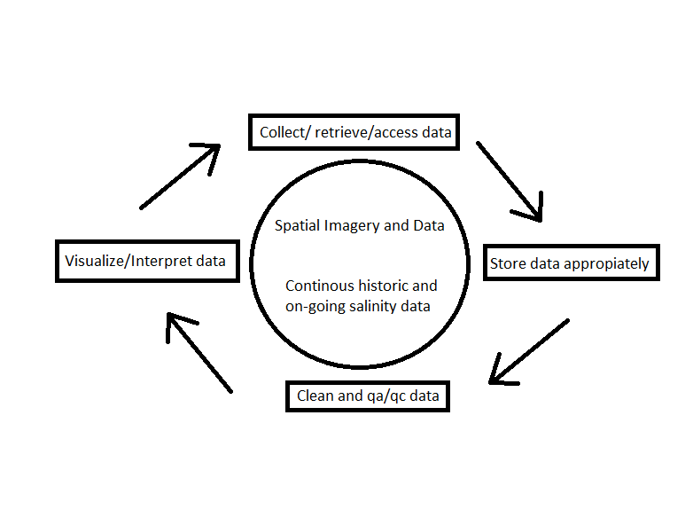

Figure 1- Diagram of objectives and logic of proposed work, including the overall workflow that influences the progression of spatial and continuous water quality data to achieve final interpretation

1. **Research Design**

***Objective 1- Workflow efficiency***

The research design for this objective is descriptive. The guideline will describe an efficient reproducible data management workflow. Please refer to the preliminary work and proposed methods of Obj 1.

***Objective 2- Spatial analysis***

The research design for this objective is descriptive. Creating a visual representation of landscape changes, in the Big Bend, will provide statistical inference of the shorelines lost or gained over time. This objective will describe how the shorelines have changed over time, without evaluating why they have changed. Please refer to the proposed methods of Obj 2.

***Objective 3- Continuous water quality data***

The ongoing water quality data for this objective is an already set up monitoring program. The historic data that will be synchronized and evaluated with the currently collected water quality data, has already been provided. Graphical representation of integrated data will be used to observe noticeable water quality trends. The research design for this objective is descriptive. The completed visual depictions will only showcase how the water quality has changed over time, without examining the predictors of this response. Please refer to the proposed methods of Obj 3.

1. **Preliminary Work**

***Objective 1- Workflow efficiency***

Research for this objective started early 2018. The initial research is with the intentions to create a data management workflow, with the expert advice of D. Maxwell, S. Meyer and J. Authmuth, from the University of Florida’s Information and Technology (UFIT) department. The introductory work started by addressing the custom data needs for the University of Florida Oyster Restoration Project’s (R.E.E.F) water quality data. Upon examining the data, it was concluded to create and subcontract a custom database using a MySQL database to store the continuous water quality data. This is due to the 1,000s of observations of water quality that are collected monthly, which is considered a large and challenging data collection series to manage. Workflow has been established to store files on a secure server, and then import these observations into the database. Once there the database performs a serious of checks, it inputs the data into its appropriate spatial locations.

Once properly stored, the workflow continues to use a version control system, Github, to “clean” the data, meaning to remove any observations that could be out of a certain range, or noticeably incorrect (i.e flatlining salinity values for multiple days). This “cleaned” data remains to create graphical representations, using a data analysis software, R. This process is currently being tried and tested, using these data.

This preliminary research for workflow efficiency is ongoing and more useful methods and techniques constantly change, which can make it a challenging endeavor to solidify a lasting guideline. These steps are recorded and screenshotted to be edited and reviewed by the UFIT advisory team. This manual is not yet available for public viewing.

***Objective 2- Spatial analysis***

There is no initial satellite imagery collected or analyzed at this time. There is, however, one preliminary historic map, that will aid in my second objective. K.A. Wilkinson has manually digitized a historical map of the Big Bend area. This map was created based on hand written records from the mid-1800s, by the U.S Navy, describing measurements and locations of the Cedar Key, FL coastline. This map is not publicly available but is accessible for my research efforts.

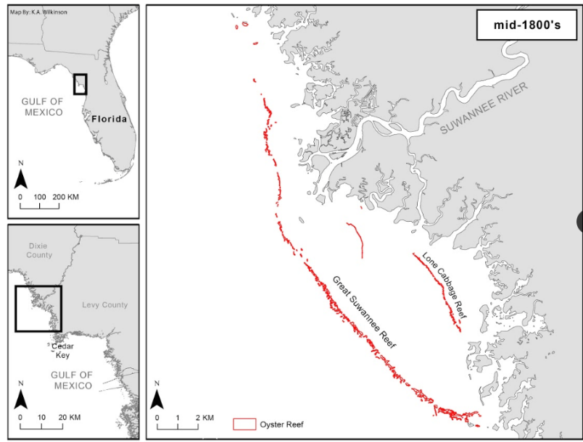

Figure 2- Historic map of the Big Bend area, digitized by K.A. Wilkinson, (not published)

***Objective 3- Continuous water quality data***

For my third objective, preliminary water quality observations have been and are currently being collected from Cedar Key, FL under R.E.E.F. These data are currently following the preliminary workflow objective, Obj 1. Many visual representations have been created and analyzed by myself, and are being updated as new water quality data are collected.

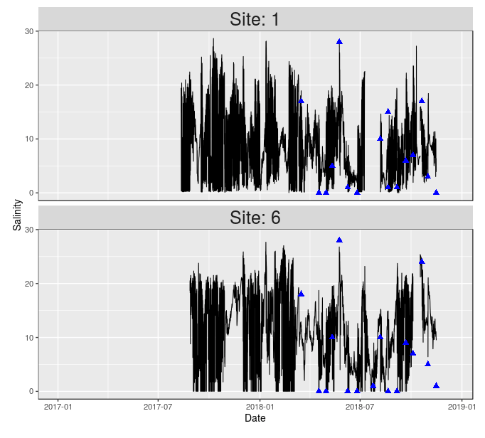

Figure 3- Example of R.E.E.F water quality analysis using R. Graphic is comparing two sites near the mouth of the Suwannee River, published online at http://www.wec.ufl.edu/oysterproject/restoration.php

Historic water quality data are also provided from the surveyed efforts of Florida Department of Agriculture & Consumer Services (FDACS), U.S. Florida Fish and Wildlife Conservation Commission (FWC), and T. Frazer. These data span from the late 1980s until 2015. These raw data values are not yet correctly “cleaned” or compiled, though there was some data “cleaning” effort by E. Christensen, done early 2018. Upon receiving this newly compiled dataset from E. Christensen, some analysis was conducted to display survey sites spatially. These data will need to be re-examined to determine the validity of their locations, before it can be synchronized with the ongoing R.E.E.F efforts.

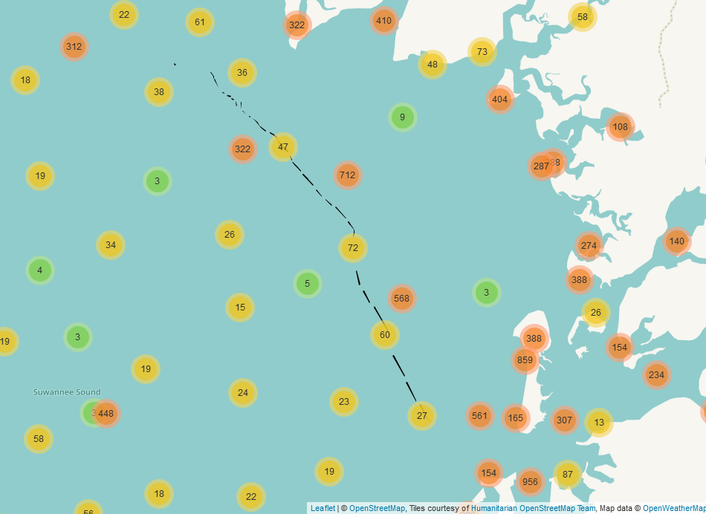

Figure 4- Preliminary mapping efforts of water quality sampling locations from FDACS, FWC, and T. Frazer, based on E. Christensen introductory dataset. Black dashed line represents Lone Cabbage reef oyster bar elements. White shading (right) is a polygonal representation of the current Big Bend shoreline, provided by OpenStreetMap.

1. **Proposed methods**

***Objective 1 – Workflow efficiency***

***Data Structure & Management*** – Data structure and management are referenced in Objective 1 preliminary work. Efficiency research will continue from the initial efforts by increasing the reproducibility of the guideline. Once completed this guideline will be available publicly through a Github repository.

***Objective 2 – Spatial data***

***Study Sites***– Satellite imagery will be accessed and collected specifically of the Gulf of Mexico Big Bend area. These maps will be provided by the University of Florida Map & Imagery Library, Smathers Library, with the help of J. Authmuth. Another source of mapping imagery are available online through USGS, and are yet to be determined if useful to this objective.

***Sampling* *Design*** – There will be no additional sampling or mapping efforts for this objective, however the measurements of the shoreline features will be quantified in meters.

***Data Structure & Management*** – It is unknown the condition or use ability of these satellite images, but all files that will be used for this objective will be stored on a secure server, provided by UFIT. These images will most likely be large in file size, and will require special naming conventions, as per ESRI restrictions.

***Data* *Analysis*** – Depending on the quality of the images, there could be additional picture quality rendering to ensure accurate shoreline measurements. It is unknown at this time what software will be used to “fix” these supposed images. Analysis to determine the loss or gain of the shoreline features will be accomplished using ESRI products, such as ArcMap and/or QGIS, and R. ArcMap provides tools in its software that can calculate georeferenced distances between points, which will provide the value measurements of this objective. R also has packages that can be used in the same manner. Determining the quality of the images, and the ease of analysis, it is unclear which software will mostly be used. Using the physical change of landscape features measured by the elected software, the rate of change can be determined. A progressive visualization of observable landscape trends will also be generated using these measurements.

***Objective 3 – Continuous water quality data***

***Study Sites*** - For the current water quality data collected, the monitoring sites are the nine locations surrounding Lone Cabbage Reef. These sites were chosen based on their spatial relation to the mouth of the Suwannee River.

|  |  |  |
| --- | --- | --- |
| Location name | Latitude | Longitude |
| WQ1 | 29.267726987600327 | -83.098221989348531 |
| WQ2 | 29.257425041869283 | -83.080270970240235 |
| WQ3 | 29.232152011245489 | -83.082710020244122 |
| WQ4 | 29.266459979116917 | -83.115749973803759 |
| WQ5 | 29.24560303799808 | -83.095912020653486 |
| WQ6 | 29.231049958616495 | -83.090120041742921 |
| WQ7 | 29.230171032249928 | -83.092115018516779 |
| WQ8 | 29.246092038229108 | -83.101499984040856 |
| WQ9 | 29.265770986676216 | -83.118119034916162 |

Table 1- Latitude and longitude of the nine sensor monitoring sites.

Historic data has no current study site, but locations of the water quality observations will need to be evaluated for correctness, upon completion of this objective.

***Sampling* *Design*** – The R.E.E.F project is overseeing a monitoring program of water quality observations on nine stationary sites along the Long Cabbage Reef, in the Big Bend. These stationary sites measure water quality on an hourly basis, specifically measuring salinity, temperature, and conductivity. The sensors were first stationed in August 2017 and will continue to measure until the end of the program, which is approximately 8 years. Two of the sensors are supplied by Diver, and the rest are supplied by the manufacturer Star-Oddi. The data are collected bi-weekly basis. There is no random sampling involved since this is a monitoring program designed by the principal investigators of R.E.E.F. Historical water quality data have been provided, by their respected organization, for further analysis. Please reference Obj 3 preliminary work for more information on historic water quality data.

***Data Structure & Management*** – The ongoing water quality data are stored and analyzed as per Obj 1 preliminary work guidelines. The unit of measurements for salinity are in parts per thousand (ppt), temperature measurements are in Celsius ( C ), and conductivity measurements are in micro-Siemens per centimeter (µS/cm).

***Data Analysis –*** A data synchronization of continued collected data, and historical data is the primary goal of this data analysis. Using R, the historic data will be “cleaned” to fit the ongoing water quality data. An analysis, using primarily R, will be conducted to determine spatial salinity trends along the Big Bend. Further analysis can be used to determine small average moving trends in specified locations. A graphical time-series representation of these trends will also be computed, again using R.

1. **Synthesis and Significance**

What I will learn from my work, is how to create and implement a proficient data management program for the collected spatial and continuous water quality data of the Big Bend. This research will conclude strong statistical inference by measuring and analyzing the coastal features that have been gained/lost along the shore, including islands. Analyzing historic and current salinity measurements around the reef, will also offer more statistical inference. This work will contribute to conservation by establishing an appropriate reproducible data management guide for future projects and efforts. The importance of this research is that it may positively impact any ecologists in their effort to maintain and interpret their biological data. Society will also benefit from this research by having access to more available ecological data of this delicate ecosystem. The resulting available data and interpretations can also create a baseline for many conservation agencies or public interest groups that are interested in investigating Cedar Key, FL.

1. **Literature Cited**

Babcock, E., Tewfik, A., & Burns-Perez, V. (2018). Fish community and single-species indicators provide evidence of unsustainable practices in a multi-gear reef fishery. *Fisheries Research*.

Bisschop, L., Strobl, S., & Viollaz, J. (2018). Getting into Deep Water: Coastal Land Loss and State-Corporate Crime in the Louisiana Bayou. *British Journal of Criminology*.

Casas, S., Filgueira, R., Lavaud, R., Comeau, L., La Peyre, M., & La Peyre, J. (2018). Combined effects of temperature and salinity on the physiology of two geographically-distant eastern oyster populations. *Journal of Experimental Marine Biology and Ecology*.

Christensen, J., Monaco, M., Lowery, T., Christensen, J., Monaco, M., & Lowery, T. (1997). An Index to Assess the Sensitivity of Gulf of Mexico Species to Changes in Estuarine Salinity Regimes Recommended Citation AN INDEX TO ASSESS THE SENSITIVITY OF GULF OF MEXICO SPECIES TO CHANGES IN ESTUARINE SALINITY REGIMES. *019*(4), 219-229.

Colson, S. (2000). One shining moment known as Clamelot: the Cedar Key story. *Journal of Shellfish*, 477-480.

Dzwonkowski, B., Fournier, S., Reager, J., Milroy, S., Park, K., Shiller, A., . . . Sanial, V. (2018). Tracking sea surface salinity and dissolved oxygen on a river-influenced, seasonally stratified shelf, Mississippi Bight, northern Gulf of Mexico. *Continental Shelf Research*.

English, E., von Haefen, R., Herriges, J., Leggett, C., Lupi, F., McConnell, K., . . . Meade, N. (2018). Estimating the value of lost recreation days from the Deepwater Horizon oil spill. *Journal of Environmental Economics and Management*.

Errington, T., Iorns, E., Gunn, W., Tan, F., Lomax, J., & Nosek, B. (2014). An open investigation of the reproducibility of cancer biology research. *eLife*.

Farbotko, C. (2010). Wishful sinking: Disappearing islands, climate refugees and cosmopolitan experimentation. *Asia Pacific Viewpoint*, 47-60.

Grizzle, R., Rasmussen, A., Martignette, A., Ward, K., & Coen, L. (2018). Mapping seston depletion over an intertidal eastern oyster (Crassostrea virginica) reef: Implications for restoration of multiple habitats. *Estuarine, Coastal and Shelf Science*.

Guariglia, A. (2006). A multisource approach for coastline mapping and identification of shoreline changes . *ANNALS OF GEOPHYSICS*.

Hampton, S., Jones, M., Wasser, L., Schildhauer, M., Supp, S., Brun, J., . . . Aukema, J. (2017). Skills and Knowledge for Data-Intensive Environmental Research. *BioScience*.

Hampton, S., Strasser, C., Tewksbury, J., Gram, W., Budden, A., Batcheller, A., . . . Porter, J. (2013). Big data and the future of ecology. *Frontiers in Ecology and the Environment*.

Hu, Y., & Lindo-Atichati, D. (2019). Experimental equations of seawater salinity and desalination capacity to assess seawater irrigation. *Science of the Total Environment*.

Joshua Steven Reece, Amanda Watson, Patricia Soupy Dalyander, Cynthia Kallio Edwards, Laura Geselbracht, Megan K. LaPeyre, Blair E. Tirpak, John M. Tirpak, M. (2018). A multiscale natural community and specieslevel vulnerability assessment of the Gulf Coast, USA. *PLOS ONE, 13*(6).

Kaplan, D., Olabarrieta, M., Frederick, P., & Valle-Levinson, A. (2016). Freshwater detention by Oyster reefs: Quantifying a keystone ecosystem service. *PLoS ONE*.

Klemas, V. (2011). Remote Sensing Techniques for Studying Coastal Ecosystems: An Overview. *Journal of Coastal Research*.

Marino, A., Velotto, D., & Nunziata, F. (2017). Offshore Metallic Platforms Observation Using Dual-Polarimetric TS-X/TD-X Satellite Imagery: A Case Study in the Gulf of Mexico. *IEEE Journal of Selected Topics in Applied Earth Observations and Remote Sensing*.

Marx, V. (2013). The big challenges of big data. *Nature*.

Motes, M., Depaola, A., Cook, D., Veazey, J., Hunsucker, J., Garthright, W., . . . Chirtel, S. (1998). *1 ; State Cooperative Programs, Southeast Region, U.S. Food and Drug Administration.*

Nelson, JR , Grubesic, T. (2018). The Implications of Oil Exploration off the Gulf Coast of Florida. *JOURNAL OF MARINE SCIENCE AND ENGINEERING, 6*(2).

Paudel, S., Milleville, A., & Battaglia, L. (2018). Responses of Native and Invasive Floating Aquatic Plant Communities to Salinity and Desiccation Stress in the Southeastern US Coastal Floodplain Forests. *Estuaries and Coasts*.

Raabe, E. (2008). *Mapping of Florida's Coastal and Marine Resources: Setting Priorities Workshop.*

Raabe, E., & Stumpf, R. (2016). Expansion of Tidal Marsh in Response to Sea-Level Rise: Gulf Coast of Florida, USA. *Estuaries and Coasts*.

Rajasree, B., & Deo, M. (2018). Evaluation of estuary shoreline shift in response to climate change: A study from the central west coast of India. *Land Degradation and Development*.

Roy, S., Mahapatra, M., & Chakraborty, A. (2018). Shoreline change detection along the coast of Odisha, India using digital shoreline analysis system. *Spatial Information Research*.

San, B., & Ulusar, U. (2018). An approach for prediction of shoreline with spatial uncertainty mapping (SLiP-SUM). *International Journal of Applied Earth Observation and Geoinformation*.

Sankar, R., Donoghue, J., & Kish, S. (2018). Mapping Shoreline Variability of Two Barrier Island Segments Along the Florida Coast. *Estuaries and Coasts*.

Schaeffer, B., Schaeffer, K., Keith, D., Lunetta, R., Conmy, R., & Gould, R. (2013). Barriers to adopting satellite remote sensing for water quality management. *International Journal of Remote Sensing*.

Schrandt, M., Powers, S., Rikard, F., Thongda, W., & Peatman, E. (2018). Short-term low salinity mitigates effects of oil and dispersant on juvenile eastern oysters: A laboratory experiment with implications for oil spill response activities. *PLOS ONE*.

Seavey, J., Pine, W., Frederick, P., Sturmer, L., & Berrigan, M. (2011). Decadal changes in oyster reefs in the Big Bend of Florida's Gulf Coast. *Ecosphere*.

Sesli, F. A. (2010). Mapping and monitoring temporal changes for coastline and coastal area by using aerial data images and digital photogrammetry: A case study from Samsun, Turkey. *INTERNATIONAL JOURNAL OF* , 1567-1575.

States National Ocean Service Strategic Environmental Assessments Division, U. (n.d.). *Salinity characteristics of Gulf of Mexico estuaries.*

Sun, S., Hu, C., Garcia-Pineda, O., Kourafalou, V., Le Hénaff, M., & Androulidakis, Y. (2018). Remote sensing assessment of oil spills near a damaged platform in the Gulf of Mexico. *Marine Pollution Bulletin*.

Yenni, G., Christensen, E., Bledsoe, E., Supp, S., Diaz, R., White, E., & Morgan Ernest, S. (n.d.). Developing a modern data workflow for living data.