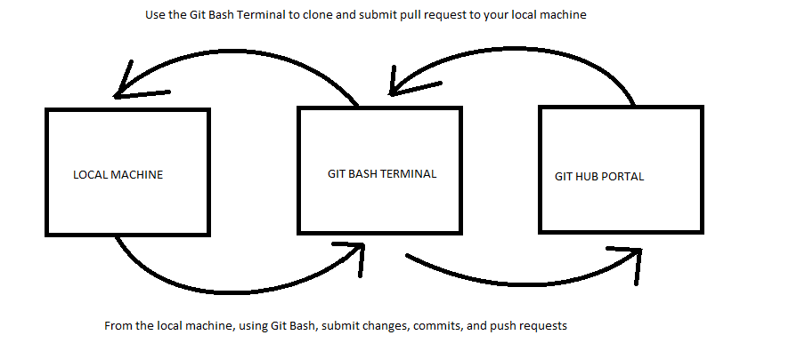

Git Bash Theory Figure 2- Basic workflow of using Git Bash.

-Create or use an existing repository, in this case we will be using <https://github.com/LCRoysterproject/Data.git>

-Clone the repository to your local machine, new repositories will have Git Bash command steps to initiate the repository to the local machine

-Use the Git Bash terminal to add/ commit/ push changes to the Git Hub portal

-You can choose to delete the local machine copy of the repository, to keep the Git Hub portal repository as the most up to date version, instead of having out of date local copies, this can avoid confusion of which repository has the latest changes

-If a local repository is kept on the local machine, use a pull request to update the local repository to the latest version of the Github Portal

Moreno, Melissa

WIS 5496

Assignment 4- Diagrams

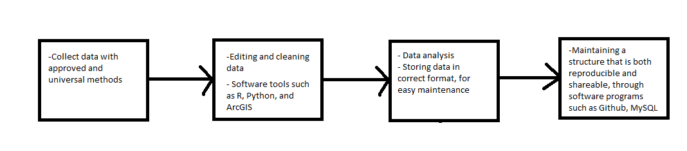

Data Management Workflow Theory Figure 1- Data collection and storage

- Collect data with approved and universal methods:

Designed to help monitor data collect, and by standardizing data collection methods, gear types. This step is necessary to avoid:

* Data collection inconsistencies, gear types
* Incorrect data collection, such as incorrect units, very typical in GPS data

- Editing and cleaning:

Data collected appropriately will need very little cleaning, or editing. However, there will still have to be checks in the data, to avoid inaccurate data analysis. This step will also have to be heavily notated.

- Data analysis:

Data that is collected correctly, and cleaned, will be able to be analyzed. Using universal or easily reproducible methods, can help make the data analysis shareable with other agencies.

-Maintaining a structure:

Maintaining a structure that is consistent and reproducible is key to data management. Using readily available tools, instead of one of a kind highly custom made tools, will ensure that data and its analysis will be able to be used by any conservation agency/ organization.