**A Case Study- Big Changes in the Big Bend**

**Melissa Moreno**

**SNRE Graduate Assistant**

**November 8, 2018**

**Project Summary**

Changing coastlines impact both commercial harvesters, and residents. Accurately mapping these changing shores, aids in recording historical shoreline trends. Along with changing shorelines, there has been a lack of documentation of long-term collected water quality data. The broader implications of this work are that it will aid in future conservation efforts which will gain insight on fluctuating shorelines and water qualities.

**Introduction**

The “Nature Coast” region of the northeastern Gulf of Mexico extending generally from the Waccasassa River to St. Marks, is a low-energy coastline characterized by extensive seagrass habitats, coastal marshes and upland habitats, and limited human development. This region has large state and federal public land holdings that together place about 24% of the land area in conservation. Private land holdings in the region are primarily used for forestry and agricultural operations Unlike most coastlines in the US, the Nature Coast is not extensively developed and waterfront development is mostly concentrated in small towns (<1000 people). A recent economic assessment has shows that about 13% of the jobs in this region are dependent on natural resources, and that these jobs, and the economy of the Big Bend, is highly dependent on “healthy” forests, rivers, and coasts. In contrast to more urban coastal areas of Florida which are perceived by the public and resource managers to be at greater risk of impairment due to human development, the Nature Coast is often considered pristine. Long-time local residents in this region including commercial shellfish harvesters have alternative perspectives based on their observed changes throughout the region including changes in the abundance and distribution of oysters, the persistence of coastal landforms including islands and shorelines, and large changes in fish populations. Recent research efforts have begun to quantify changes in the vegetation and oyster populations in this region and how these changes may be related to sea-level rise, changing freshwater availability, or climate. My research will focus on two areas (1) assess change in topographic coastal features including islands and coastlines with an emphasis on public land holdings near Cedar Key, Florida; (2) synthesize multiple decades of water quality data collected by agency cooperators and integrate these data with the assessment of spatial features. My work will help to provide information to inform conservation decisions such as directing mitigation efforts to protect vulnerable coastal areas and promote resources critical to the economy and ecosystems of the Big Bend.

**Background**

Mapping coastlines is a challenging endeavor for any region. There are multiple ways to create dynamic and informative maps that show an accurate and more complete history of an area (Guariglia, 2006). Maps are used by the public and conservation agencies to aid in displaying spatial information (Sesli, 2010).

It has also been previously recorded that with rapid coastline changes, islands have been disappearing (Farbotko, 2010). Having a good representation of how the shorelines has been changing over time, is an excellent way to improve the publics knowledge of the effects of climate change in any area.

Cedar Key, FL is a small town with a small-town feel. Many of the residents are part of the founding families, that have built Cedar Key from the ground up from the economy of commercial fishing. These residents have an elaborate tapestry of rich history that has been recorded and documented poorly. Many new reports or documentation has been on case studies on the aquaculture (Colson, 2000), but despite these reports there is very little researched on the changing coastlines. It has been topic of conversation that the residents are concerned with what the future of the shorelines means to them.

The main research question that I will be diving into is how is the Cedar Key coastline changing, and when did some of the once prevalent coastal islands disappear? Another research question that will be tackled is what do the residents of Cedar Key value in terms of future conservation efforts?

**Project Objectives**

My project is dependent on developing an efficient data work-flow of complex data of two types. The first will be a variety of imagery data including satellite, aerial imagery, and LiDAR. These data include reconstructions of coastal maps first created in the mid 1800’s. The second data challenge will be integrating water quality data collected at different times and locations by agency and academic partners beginning in the 1990’s in a common framework that allows for comparison. The presentation and integration of both data products will be made graphically through a representation of how these data appear over time.

Key data challenges in working with this imagery include management of meta-data that allows for correctly projecting the data in comparable ways and correctly assessing projection error from each data source. As an example, mapping error between surveys conducted in the 1800’s and today are very different, however, the surveys collected in the 1800’s are essential for defining major coastal features (e.g, islands, navigation hazards) known at that time.

**Preliminary Work**

My research will build on previous historic maps of the Cedar Key area. These maps were constructed based on historic naval charting from the mid 1800s. These maps were created due to a lack of understanding of the area, and documented in detail.

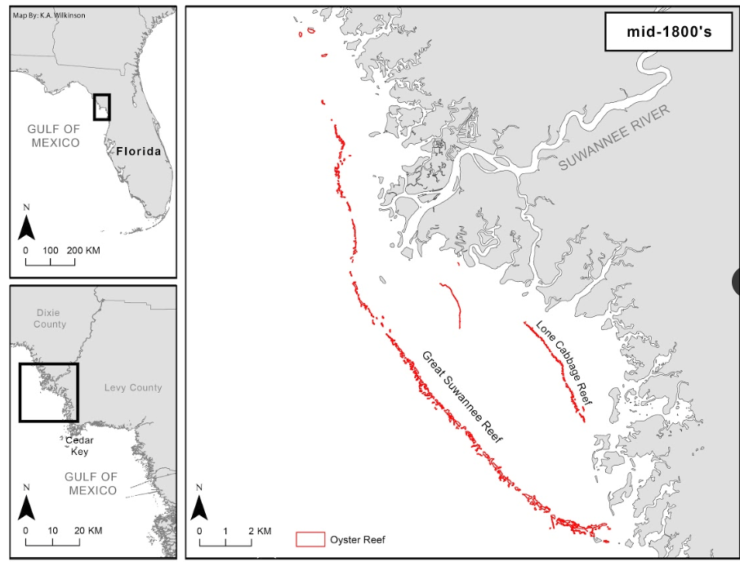

Figure 1- Rendering of naval historical detail, recreated by K.A. Wilkinson

Other than these maps and modern satellite imagery that can be acquired, there are no preliminary results at this time.

**Research Design – Descriptive**

The research design for this study, descriptive. My research will use various tools, ArcGIS and R to view and analyze historical maps of Cedar Key, from the late 1880s to modern day. There are no hypotheses to test or compare, as the research conducted will be from already collected data.

**Synthesis**

My research will allow for a thorough and detailed representation of the changing shoreline of Cedar Key. Noticing trends will contribute in future conservation efforts to reduce shoreline loss and retain shore integrity.

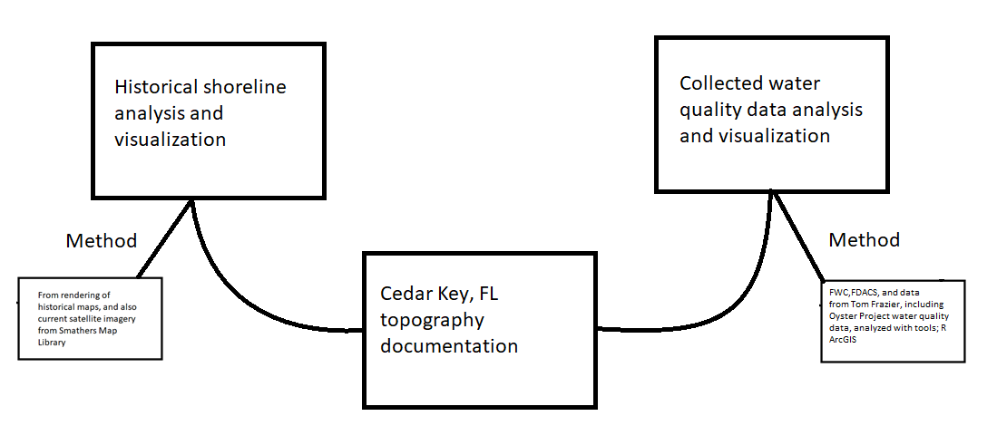

Figure 2- Preliminary outline of research design and methods

# Bibliography

Colson, S. (2000). One shining moment known as Clamelot: the Cedar Key story. *Journal of Shellfish*, 477-480.

Farbotko, C. (2010). Wishful sinking: Disappearing islands, climate refugees and cosmopolitan experimentation. *Asia Pacific Viewpoint*, 47-60.

Guariglia, A. (2006). A multisource approach for coastline mapping and identification of shoreline changes . *ANNALS OF GEOPHYSICS*.

Sesli, F. A. (2010). Mapping and monitoring temporal changes for coastline and coastal area by using aerial data images and digital photogrammetry: A case study from Samsun, Turkey. *INTERNATIONAL JOURNAL OF* , 1567-1575.