**WIS 5496 – HW5: “SHOW ME THE MONEY!”**

**Melissa Moreno**

**October 29, 2018**

**TO DO:**

1) Sit down at a UF computer, or, if you work from home – use the VPN program from UF to identify your computer as a UF user.

2) Go to pivot.cos.com. Sign up for an account.

* Click on ***Home*** button at top left, and view/click on the left menu of services/functions Pivot provides.
  + See where those links lead. Then
* 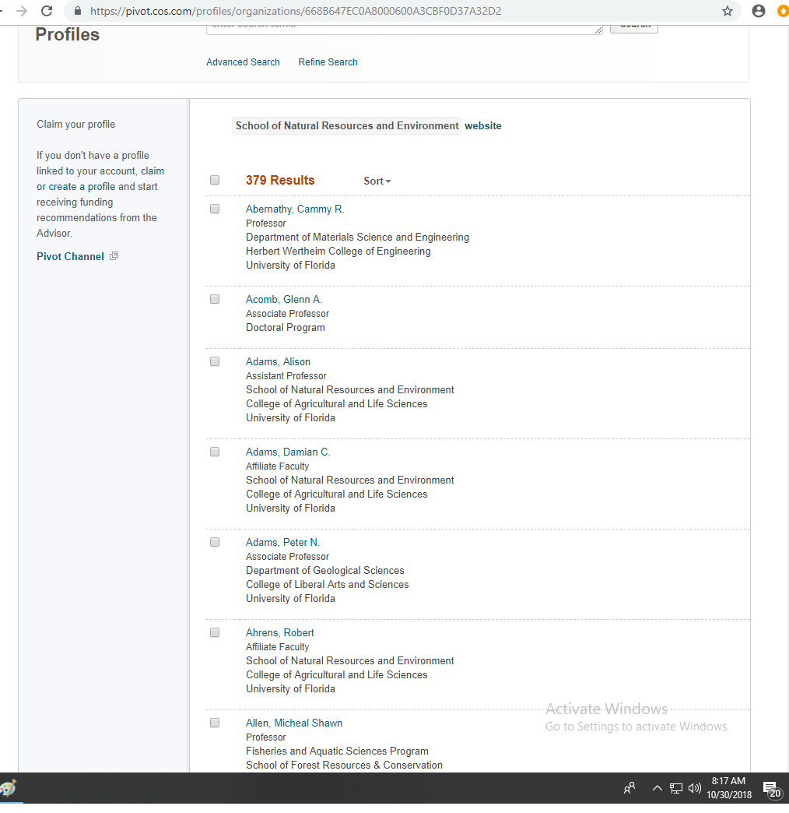Click on the ***Profiles*** tab to see other funding profiles at UF. Anyone you know? Click on one and see how it is laid out.

3) Click on the ***Funding*** tab, and then click on ‘advanced search’ and try each of these 2 searches;

a) Easiest –

* Click….. Match any of the fields
* In the boxes at the top add up to 3 research terms that best describe what you propose
* Hit search at top

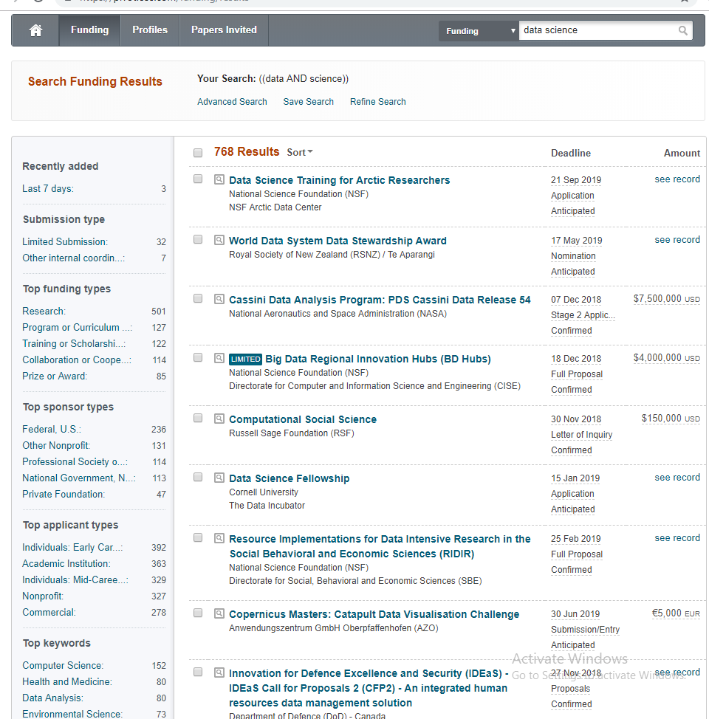

b) Harder (but potentially more refined)

* 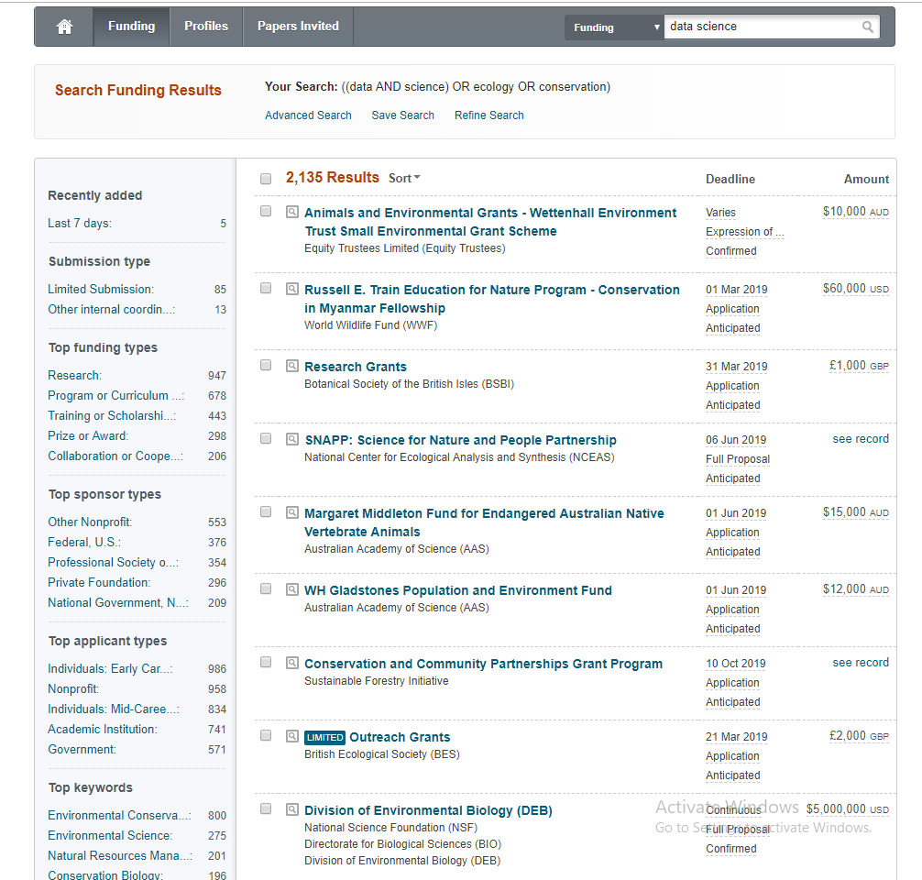Play with the ‘match all’ versus ‘match any’ function in the first set of search term boxes. Try to find a way (few terms, match all VERSUS lots of terms, match any) that works better.

c) Hardest (but may be very targeted and specific to you…) – start adding conditions and exclusions.

For examples -

* Go down to Activity Location and input where you work or use ‘unrestricted’ and/or ‘unspecified’. What does that do to your search? Include certain countries, continents, etc.
* Go to Citizenship and type in yours
* Go to funding type – if you need a fellowship and/or research money
* Try Source of money options
* Try using the ‘exclude’ options at the bottom if your search gets polluted.

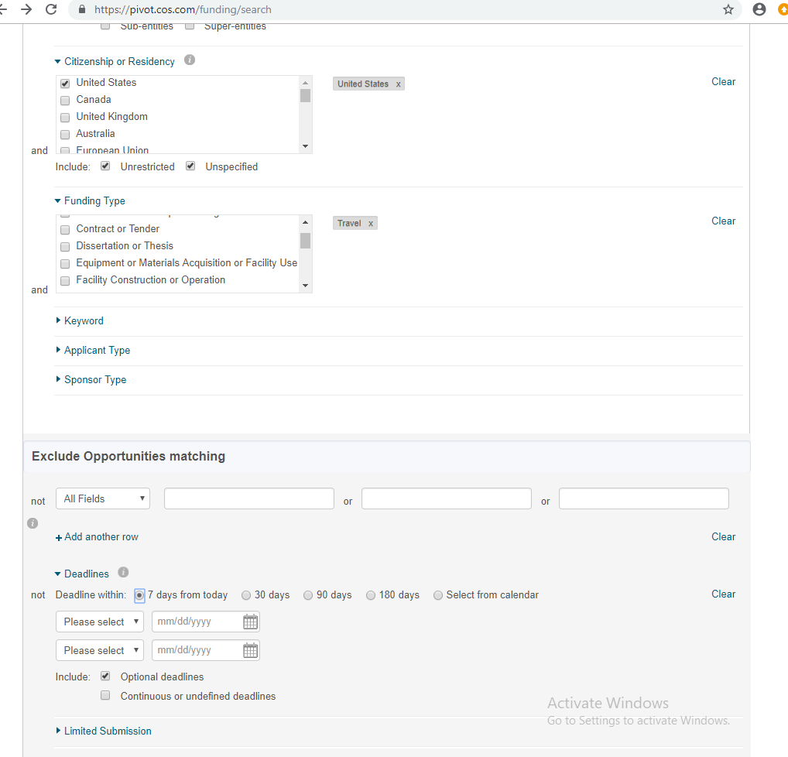

4) Set up two different searches and have PIVOT send you an email weekly on upcoming deadlines.

***-- figure out how to print out your search details to hand in for each of them.***

5) For your top 3 best opportunities, click on each one, click on the URL near the top of the description and find the ***specific proposal / application requirements***. Cut and paste the content into a Word document – and collect all three together to hand in.

(In the questions below)

**TO Hand In:**

1. A narrative on what features you found most useful (1 paragraph) or problematic (1 Paragraph).

Wow! I didn’t even know that this website existed. The most useful feature of this website is that you can search for specific funding. So currently, I’m looking for travel grants, and I can specify the search by that. This will be really useful for me, since I plan to attend many workshops for technical training. I will have to check my email to make sure I get all of the notifications for this search result.

1. The conditions you set for your two automated search strategies – print them out of COS if possible.

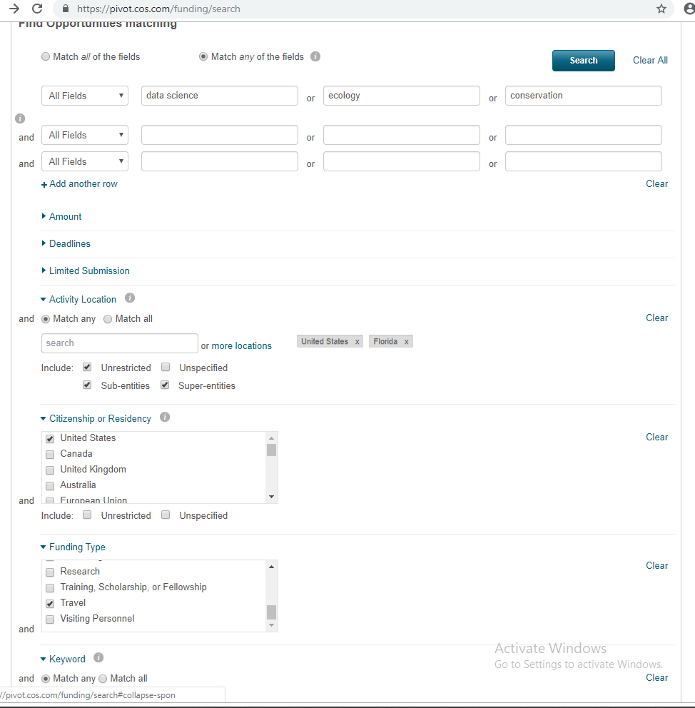For travel grants in the United States.

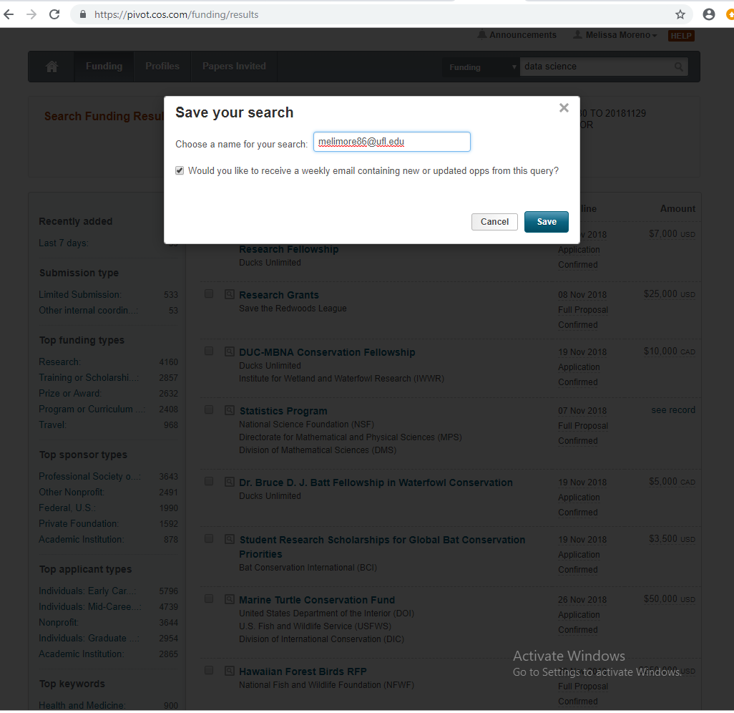

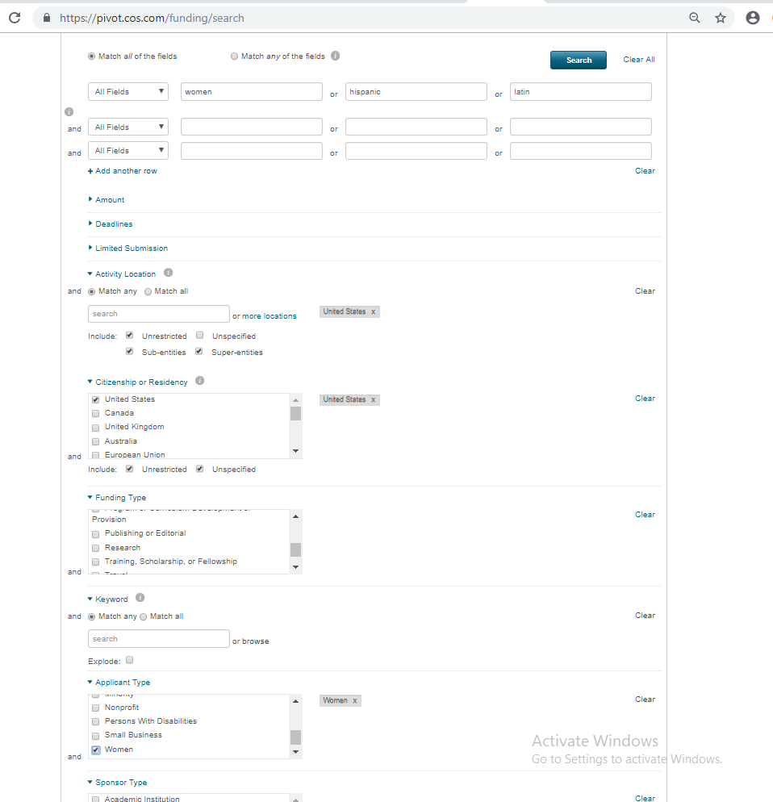For women and minority grants

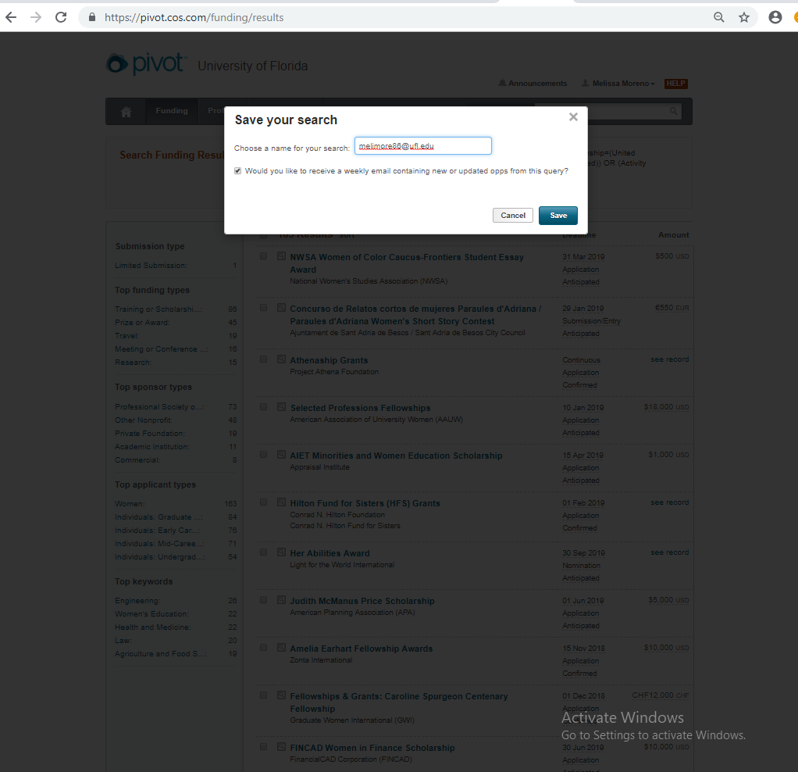

1. The detailed descriptions of the funding applications (your top 3) that you found that you really might/should apply for.

**North American Conservation Award**

https://pivot.cos.com/funding_opps/136026

Application Requirements:

PROGRAM SUMMARY Provide a concise program description, maximum of one-half of a single-spaced page of 12 point type to introduce your program to the judges and possibly be used for publicity purposes. D. PROGRAM NARRATIVE Describe your program as completely as possible, addressing the following specific topics: 1. Description and significance of conservation problem • Describe background, location, species • What are the goals of the project and how does it relate to the goals of the institution and AZA program? 2. Describe the project action. • Include an outline and timeline for the conservation project. • What group, if any, was helped or affected? 3. Educational Impact • Describe educational component and impact on conservation issue. 2018 N American Cons Award Guidelines.doc Page 2 of 2 4. Level and significance of institutional commitment • Outline time, funds, staff commitment • Include annual budget for project development. 5. Cooperation with other institutions • List AZA and other institutions and what percentage of the budget from each institution. 6. Project results and ongoing commitment • How will the results of the project be shared and disseminated? • Describe how the project is being evaluated. Your Program Narrative may not exceed three single-spaced pages of 12 point type, and it should adhere to the Format for Narrative. Please number the six required topics in your narrative.

For 2017 and 2018: A cash award for TOP HONORS in the North American Conservation category thanks to the Arthur L. and Elaine V. Johnson Foundation.

**Society for Conservation Biology Marine Section Conservation Research Small Grants Program (CSGP)**

<https://pivot.cos.com/funding_opps/176662>

Application Requirements:

Applicants must be members of the Society for Conservation Biology's Marine Section. Applicants must be conducting conservation efforts in developing countries. If your project is being conducted in a country that is not designated as developing by the World Bank, but has less access to conservation funding, your application may still be considered with sufficient justification. Priority will be given to applicants who demonstrate capacity to accomplish the proposed work (e.g., through matching funds, matching funds in kind, or existing in-country capacity), and to first-time applicants.

**Conservation Partners Program**

<https://pivot.cos.com/funding_opps/167720>

Application requirements:

Eligible applicants include: non-profit 501(c) organizations, farmer and commodity-led organizations, educational institutions, tribal governments, and state or local units of governments (e.g. state agricultural and/or conservation agencies, counties, townships, cities, conservation districts, utility districts, drainage districts, etc.). 

1. Check the other funding search links below – see if you can find something else interesting to apply for – list any!

**Louis Stokes Alliances for Minority Participation (LSAMP)**

http://my.research.ufl.edu/ProgramDevelopment/FundingOpportunities/OpportunitiesManager.aspx?oppID=59027

**Computational and Data-Enabled Science and Engineering  (CDS&E)**

https://www.nsf.gov/funding/pgm_summ.jsp?pims_id=504813&WT.mc_id=USNSF_25&WT.mc_ev=click

**Money for Research Search Engines**

* PIVOT <https://pivot.cos.com/funding_main>
* Oppman <http://research.ufl.edu/research-program-development/research_program_development_docs/OppManUserGuide.pdf>
* UF Libraries Grants etc <http://guides.uflib.ufl.edu/funding>
* Instrumentl <https://www.instrumentl.com/> free trial but 45/mo after