**A Case Study- Big Changes in the Big Bend**

**Melissa Moreno**

**SNRE Graduate Assistant**

**November 8, 2018**

1. **Project Summary**

Changing coastlines impact both commercial harvesters, and residents. Accurately mapping these changing shores, aids in recording historical shoreline trends. Along with changing shorelines, there has been a lack of documentation of long-term collected water quality data. The broader implications of this work are that it will aid in future conservation efforts which will gain insight on fluctuating shorelines and water qualities.

1. **Introduction**

The “Nature Coast” region of the northeastern Gulf of Mexico extending generally from the Waccasassa River to St. Marks, is a low-energy coastline characterized by extensive seagrass habitats, coastal marshes and upland habitats, and limited human development. This region has large state and federal public land holdings that together place about 24% of the land area in conservation. Private land holdings in the region are primarily used for forestry and agricultural operations Unlike most coastlines in the US, the Nature Coast is not extensively developed and waterfront development is mostly concentrated in small towns (<1000 people). A recent economic assessment has shows that about 13% of the jobs in this region are dependent on natural resources, and that these jobs, and the economy of the Big Bend, is highly dependent on “healthy” forests, rivers, and coasts. In contrast to more urban coastal areas of Florida which are perceived by the public and resource managers to be at greater risk of impairment due to human development, the Nature Coast is often considered pristine. Long-time local residents in this region including commercial shellfish harvesters have alternative perspectives based on their observed changes throughout the region including changes in the abundance and distribution of oysters, the persistence of coastal landforms including islands and shorelines, and large changes in fish populations. Recent research efforts have begun to quantify changes in the vegetation and oyster populations in this region and how these changes may be related to sea-level rise, changing freshwater availability, or climate. My research will focus on two areas (1) assess change in topographic coastal features including islands and coastlines with an emphasis on public land holdings near Cedar Key, Florida; (2) synthesize multiple decades of water quality data collected by agency cooperators and integrate these data with the assessment of spatial features. My work will help to provide information to inform conservation decisions such as directing mitigation efforts to protect vulnerable coastal areas and promote resources critical to the economy and ecosystems of the Big Bend.

1. **Background**

Cedar Key, FL is a small town with a small-town feel. Many of the residents are part of the founding families, that have built Cedar Key from the ground up by generating a stable economy through commercial harvesting. Many new reports or documentation has been on case studies on the wild harvesting and aquaculture (Colson, 2000), but aside from these reports there is very little research on ecological factors which directly impact these efforts. Furthermore, there has been intensive water quality data collected, but these attempts have been segregated and have much left to be desired in terms of a proper evolutionary analysis. Much of this data are not available, and thus must be requested from the individuals or agencies. This makes it difficult to have a broader sense of the natural fluctuations in the area. It has been topic of conversation in what way has Big Bend has gone through momentous transformations.

Mapping precise and true landscape features is usually a challenging endeavor (San & Ulusar, 2018). Multiple ways to create dynamic and informative maps, with a more accurate and complete history of an area (Guariglia, 2006), are being created with modern technological advancements. Aerial and satellite mapping are commonly used in modern charting efforts (Sesli, 2010). Small shore islands near coastlines are at a great risk of disappearing (Farbotko, 2010), which can make charting especially trying. There is current satellite imagery of the area that are available to the public but lack strong coastal presentation. Recording these expired landscape features, can prove to be problematic, but with using the correct tools, can establish a comprehensive analysis of the vicinity.

Commercial harvesting and aquaculture can be sensitive to salinity gradients. Salinity regimes can impact numerous species, not excluding bivalves (Christensen, et al., 1997). Many species cannot thrive with radical salinity instability, thus making areas with these features’ undesirable for any harvesting or aquaculture attempts. With the possibility of increasing occurrences in drastic fluctuations of salinity, it is very likely that harvesting will not yield a suitable product as well (Motes, et al., 1998). Species can develop illness in an inappropriate habitat. Having precise documentation of water quality changes can lead to a greater general understanding of environment differences (States National Ocean Service Strategic Environmental Assessments Division,1993). Representing these changes can have huge influence on water quality management that can impact locals and conservation agencies.

The main research question that I will be diving into is how the Cedar Key coastline

topographic coastal features including islands has changed over time. My second objective is to compile the multiple sources of water quality to create an inclusive analysis of salinity in the area. Analyzing theses separate but equally important variables, will be a huge step in many conservation efforts, and the sustainability of local economy.

1. **Project Objectives**

My project is dependent on developing an efficient data work-flow of complex data of two types, (Yenni, et al.). The first will be a variety of imagery data including satellite, aerial imagery, and LiDAR. These data include reconstructions of coastal maps first created in the mid 1800’s. The second data challenge will be integrating water quality data collected at different times and locations by agency and academic partners beginning in the 1990’s in a common framework that allows for comparison. The presentation and integration of both data products will be made graphically through a representation of how these data appear over time.

Key data challenges in working with this imagery include management of meta-data that allows for correctly projecting the data in comparable ways and correctly assessing projection error from each data source. As an example, mapping error between surveys conducted in the 1800’s and today are very different, however, the surveys collected in the 1800’s are essential for defining major coastal features (e.g, islands, navigation hazards) known at that time.

**V. Research Design**

This case study will have a descriptive research design. My research will use various tools, ArcGIS and R to portray an accurate representation of shoreline loss/gain and salinity changes of Cedar Key, FL, focusing on the Big Bend. There are no hypotheses to test, since the descriptive research design is non-inferential and will only measure the broader changes, without discerning the “why” of these ecological variations.

The descriptive study will be a statistical inference, measuring the amount of shoreline lost/gained over time in meters. Salinity trends will also be represented visually, and represented in a time series investigation, in parts per trillion.

An assumption for this study will be that there have been immense changes in shoreline and salinity gradients over the past 20 ye ars. This case study will characterize these changes in a straightforward manner, readily available to be recognized by the public and other conservation agencies.

1. **Preliminary Work**

The preliminary work for this case study involves data sets that were collected by various individuals and conservation agencies.

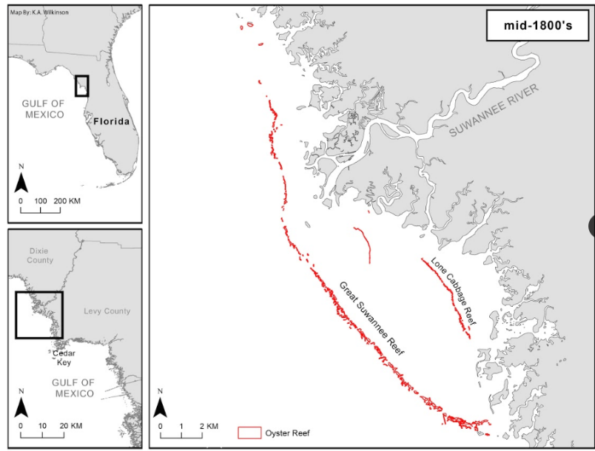Dr. K. Wilkinson has digitized historical maps that were first records in the late 1800’s. Due to her diligent efforts, there is an excellent representation of how Big Bend shorelines were before industrial advancements and possibly before it was impacted by human development.

Figure 1- Rendering of naval historical detail, recreated by K.A. Wilkinson, (not published)

Another source of initial mapping data is the work of E. Raabe. Her works stems from a wide array of research conducted on Florida tidal marshes, (Raabe & Stumpf, 2016), and general coastal and marine resource charting, (Raabe E. , 2008). Her research gives my case study a strong direction on the current monitoring work that has been done and will be done on Florida coastlines.

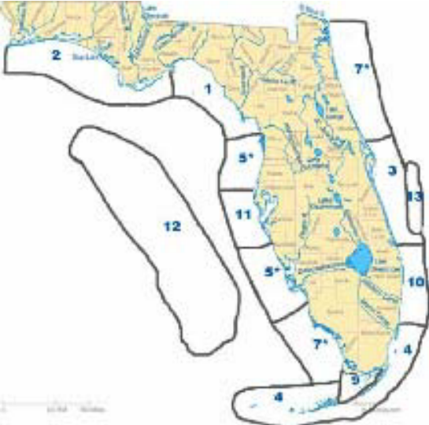

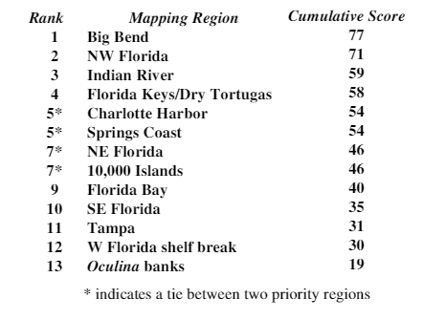Figure 2- Map showing numerical ranking of priority areas as scored by Florida State agencies. (Raabe E. , 2008), note the relevance of the Cedar Key area

Table 1- Priority mapping region by rank as scored by Florida State agencies, 2007. (Raabe E. , 2008)

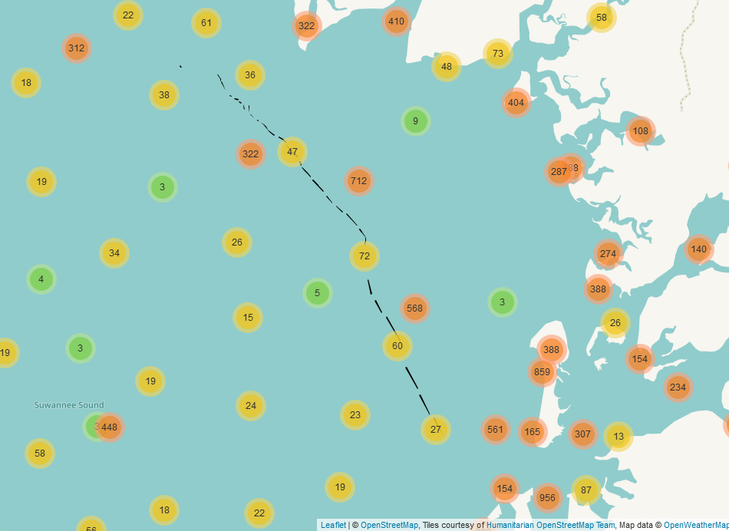

Figure 3- Preliminary mapping efforts of water quality sampling from FWC, FDACS, and Tom Frazer, based on Dr. E Christensen data set

For introductory salinity data, I am compiling data sets from multiple sources. One resource is the water quality data collected by Dr. Tom Frazer, Director of School of Natural Resources and Environment, at the University of Florida. His data sets were collected from 1997 to 2015. Florida Fish and Wildlife Conservation Commission (FWC), has also collected water quality data in the Big Bend area from 1996 to present day. Florida Department of Agriculture & Consumer Services has also collected water quality data in the Gulf of Mexico, Cedar Key area since 1981. Compiling these data will require a huge effort, which some has been completed by PhD student E. Christensen in early 2018.

# Bibliography

Christensen, J., Monaco, M., Lowery, T., Christensen, J., Monaco, M., & Lowery, T. (1997). An Index to Assess the Sensitivity of Gulf of Mexico Species to Changes in Estuarine Salinity Regimes Recommended Citation AN INDEX TO ASSESS THE SENSITIVITY OF GULF OF MEXICO SPECIES TO CHANGES IN ESTUARINE SALINITY REGIMES. *019*(4), 219-229.

Colson, S. (2000). One shining moment known as Clamelot: the Cedar Key story. *Journal of Shellfish*, 477-480.

Farbotko, C. (2010). Wishful sinking: Disappearing islands, climate refugees and cosmopolitan experimentation. *Asia Pacific Viewpoint*, 47-60.

Guariglia, A. (2006). A multisource approach for coastline mapping and identification of shoreline changes . *ANNALS OF GEOPHYSICS*.

Motes, M., Depaola, A., Cook, D., Veazey, J., Hunsucker, J., Garthright, W., . . . Chirtel, S. (1998). *1 ; State Cooperative Programs, Southeast Region, U.S. Food and Drug Administration.*

Raabe, E. (2008). *Mapping of Florida's Coastal and Marine Resources: Setting Priorities Workshop.*

Raabe, E., & Stumpf, R. (2016). Expansion of Tidal Marsh in Response to Sea-Level Rise: Gulf Coast of Florida, USA. *Estuaries and Coasts*.

Roy, S., Mahapatra, M., & Chakraborty, A. (2018). Shoreline change detection along the coast of Odisha, India using digital shoreline analysis system. *Spatial Information Research*.

San, B., & Ulusar, U. (2018). An approach for prediction of shoreline with spatial uncertainty mapping (SLiP-SUM). *International Journal of Applied Earth Observation and Geoinformation*.

Sesli, F. A. (2010). Mapping and monitoring temporal changes for coastline and coastal area by using aerial data images and digital photogrammetry: A case study from Samsun, Turkey. *INTERNATIONAL JOURNAL OF* , 1567-1575.

States National Ocean Service Strategic Environmental Assessments Division, U. (n.d.). *Salinity characteristics of Gulf of Mexico estuaries.*

Yenni, G., Christensen, E., Bledsoe, E., Supp, S., Diaz, R., White, E., & Morgan Ernest, S. (n.d.). Developing a modern data workflow for living data.