**A Case Study- Big Changes in the Big Bend**

**Melissa Moreno**

**SNRE Graduate Assistant**

**November 8, 2018**

**Background:**

Cedar Key, Florida is a small town with a small-town feel. Located on the Gulf of Mexico coast in northern Florida near the “big bend” in the coast that marks the transition from the east-west oriented Florida panhandle to the north-south oriented Florida peninsula, Cedar Key is a coastal town whose residents and economy is tightly coupled with the harvest of seafood products. From an economic, human development, and cultural perspective Cedar Key may be more similar to coastal Florida communities from 50-75 years ago than many urban coastal areas found <100 miles away such as the Tampa Bay region. Many Cedar Key residents are part of the founding families of the community that have built Cedar Key from the ground through an economy closely linked to natural resource harvests, including commercial harvest of fish and shellfish. As an example, while 1.5% of the private sector jobs in Florida overall are linked to farming, forestry, and commercial fishing, in the Big Bend more than 13% of the economy is tied to these sectors (Conservation Fund 2016). Despite substantial investment in conservation lands by state and federal partners in the Big Bend through ecological studies of the region are limited with few synoptic assessments of vegetation, wildlife, of fisheries resources in this region. However, the perception exists that given the low human population density in this region, that natural resources have also not been highly impacted. As part of the Conservation Fund’s (2016) recent SWOT assessment of the Big Bend, a common area of concern is changes in the regions water quality and quantity which could impact the natural resource based economy of the area. Water quality and quantity data have been collected at irregular intervals by different federal, state, and university cooperators. However, these data have not been synthesized and standardized in a way that allows the data to be examined for long-term trend assessment or to compare to data on commercial harvests of fish and shellfish for the region. In addition to concerns over water quality and water quantity, long-time residents of this coastline have noted changes in the geographic features of the region. This has motivated cooperative research that has documented large changes in oyster reefs (Seavey et al. 2011) and coastal forests (Geselbracht 2011) in the area and has recently motivated new restoration efforts for oyster reefs (cite link to LCR project). A limited assessment of landform changes in the region has been made based on digitization of historic surveys from a large geographic area (Raabe) but a fine-scale assessment of historic changes in land form in the Cedar Keys area adjacent to areas where restoration efforts are ongoing, has not been done. This makes it difficult to have a broader sense of the natural fluctuations in the area. It has been topic of conversation in what way has Big Bend has gone through momentous transformations.

Mapping precise and true landscape features is usually a challenging endeavor (San & Ulusar, 2018). Multiple ways to create dynamic and informative maps, with a more accurate and complete history of an area (Guariglia, 2006), are being created with modern technological advancements. Aerial and satellite mapping are commonly used in modern charting efforts (Sesli, 2010). Small shore islands near coastlines are at a great risk of disappearing (Farbotko, 2010), which can make charting especially trying. There is current satellite imagery of the area that are available to the public but lack strong coastal presentation. Recording these expired landscape features, can prove to be problematic, but with using the correct tools, can establish a comprehensive analysis of the vicinity.

Commercial harvesting and aquaculture can be sensitive to salinity gradients. Salinity regimes can impact numerous species, not excluding bivalves (Christensen, et al., 1997). Many species cannot thrive with radical salinity instability, thus making areas with these features’ undesirable for any harvesting or aquaculture attempts. With the possibility of increasing occurrences in drastic fluctuations of salinity, it is very likely that harvesting will not yield a suitable product as well (Motes, et al., 1998). Species can develop illness in an inappropriate habitat. Having precise documentation of water quality changes can lead to a greater general understanding of environment differences (States National Ocean Service Strategic Environmental Assessments Division,1993). Representing these changes can have huge influence on water quality management that can impact locals and conservation agencies.

The main research question that I will be diving into is how the Cedar Key coastline

topographic coastal features including islands has changed over time. My second objective is to compile the multiple sources of water quality to create an inclusive analysis of salinity in the area. Analyzing theses separate but equally important variables, will be a huge step in many conservation efforts, and the sustainability of local economy.

**Research Objectives:**

My project is dependent on developing an efficient data work-flow of complex data of two types, (Yenni, et al.). The first will be a variety of imagery data including satellite, aerial imagery, and LiDAR. These data include reconstructions of coastal maps first created in the mid 1800’s. The second data challenge will be integrating water quality data collected at different times and locations by agency and academic partners beginning in the 1990’s in a common framework that allows for comparison. The presentation and integration of both data products will be made graphically through a representation of how these data appear over time.

Key data challenges in working with this imagery include management of meta-data that allows for correctly projecting the data in comparable ways and correctly assessing projection error from each data source. As an example, mapping error between surveys conducted in the 1800’s and today are very different, however, the surveys collected in the 1800’s are essential for defining major coastal features (e.g, islands, navigation hazards) known at that time.

**Preliminary Work:**

The preliminary work for this case study involves data sets that were collected by various individuals and conservation agencies.

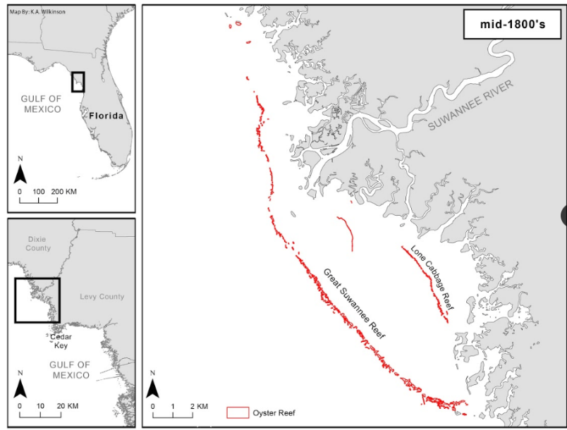Dr. K. Wilkinson has digitized historical maps that were first records in the late 1800’s. Due to her diligent efforts, there is an excellent representation of how Big Bend shorelines were before industrial advancements and possibly before it was impacted by human development.

Figure 1- Rendering of naval historical detail, recreated by K.A. Wilkinson, (not published)

Another source of initial mapping data is the work of E. Raabe. Her works stems from a wide array of research conducted on Florida tidal marshes, (Raabe & Stumpf, 2016), and general coastal and marine resource charting, (Raabe E. , 2008). Her research gives my case study a strong direction on the current monitoring work that has been done and will be done on Florida coastlines.

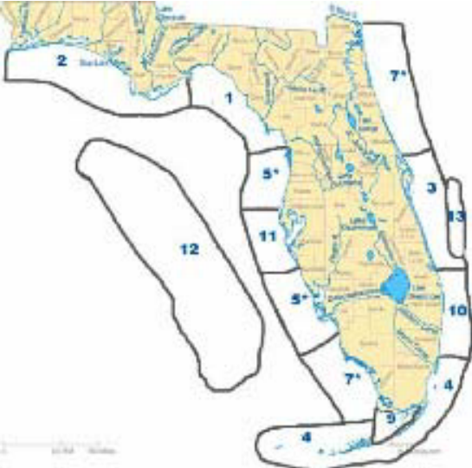

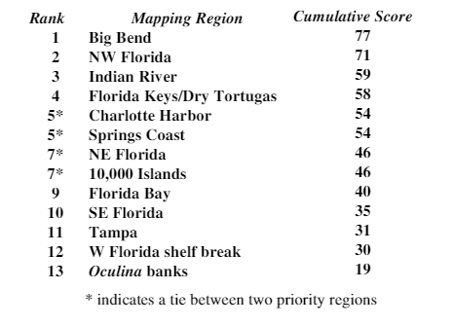Figure 2- Map showing numerical ranking of priority areas as scored by Florida State agencies. (Raabe E. , 2008), note the relevance of the Cedar Key area

Table 1- Priority mapping region by rank as scored by Florida State agencies, 2007. (Raabe E. , 2008)

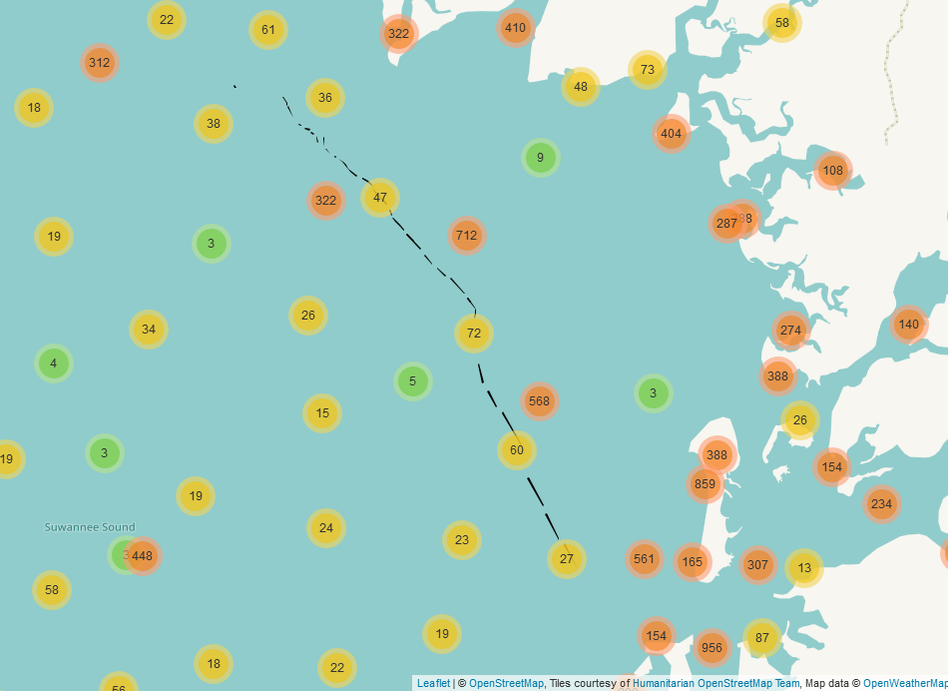

Figure 3- Preliminary mapping efforts of water quality sampling from FWC, FDACS, and Tom Frazer, based on Dr. E Christensen data set

For introductory salinity data, I am compiling data sets from multiple sources. One resource is the water quality data collected by Dr. Tom Frazer, Director of School of Natural Resources and Environment, at the University of Florida. His data sets were collected from 1997 to 2015. Florida Fish and Wildlife Conservation Commission (FWC), has also collected water quality data in the Big Bend area from 1996 to present day. Florida Department of Agriculture & Consumer Services has also collected water quality data in the Gulf of Mexico, Cedar Key area since 1981. Compiling these data will require a huge effort, which some has been completed by PhD student E. Christensen in early 2018.

**Research Design:**

This case study will have a descriptive research design. My research will use various tools, ArcGIS and R to portray an accurate representation of shoreline loss/gain and salinity changes of Cedar Key, FL, focusing on the Big Bend. There are no hypotheses to test, since the descriptive research design is non-inferential and will only measure the broader changes, without discerning the “why” of these ecological variations.

The descriptive study will be a statistical inference, measuring the amount of shoreline lost/gained over time in meters. Salinity trends will also be represented visually, and represented in a time series investigation, in parts per trillion.

An assumption for this study will be that there have been immense changes in shoreline and salinity gradients over the past 20 ye ars. This case study will characterize these changes in a straightforward manner, readily available to be recognized by the public and other conservation agencies.

# Bibliography

Christensen, J., Monaco, M., Lowery, T., Christensen, J., Monaco, M., & Lowery, T. (1997). An Index to Assess the Sensitivity of Gulf of Mexico Species to Changes in Estuarine Salinity Regimes Recommended Citation AN INDEX TO ASSESS THE SENSITIVITY OF GULF OF MEXICO SPECIES TO CHANGES IN ESTUARINE SALINITY REGIMES. *019*(4), 219-229.

Colson, S. (2000). One shining moment known as Clamelot: the Cedar Key story. *Journal of Shellfish*, 477-480.

Farbotko, C. (2010). Wishful sinking: Disappearing islands, climate refugees and cosmopolitan experimentation. *Asia Pacific Viewpoint*, 47-60.

Guariglia, A. (2006). A multisource approach for coastline mapping and identification of shoreline changes . *ANNALS OF GEOPHYSICS*.

Motes, M., Depaola, A., Cook, D., Veazey, J., Hunsucker, J., Garthright, W., . . . Chirtel, S. (1998). *1 ; State Cooperative Programs, Southeast Region, U.S. Food and Drug Administration.*

Raabe, E. (2008). *Mapping of Florida's Coastal and Marine Resources: Setting Priorities Workshop.*

Raabe, E., & Stumpf, R. (2016). Expansion of Tidal Marsh in Response to Sea-Level Rise: Gulf Coast of Florida, USA. *Estuaries and Coasts*.

Roy, S., Mahapatra, M., & Chakraborty, A. (2018). Shoreline change detection along the coast of Odisha, India using digital shoreline analysis system. *Spatial Information Research*.

San, B., & Ulusar, U. (2018). An approach for prediction of shoreline with spatial uncertainty mapping (SLiP-SUM). *International Journal of Applied Earth Observation and Geoinformation*.

Sesli, F. A. (2010). Mapping and monitoring temporal changes for coastline and coastal area by using aerial data images and digital photogrammetry: A case study from Samsun, Turkey. *INTERNATIONAL JOURNAL OF* , 1567-1575.

States National Ocean Service Strategic Environmental Assessments Division, U. (n.d.). *Salinity characteristics of Gulf of Mexico estuaries.*

Yenni, G., Christensen, E., Bledsoe, E., Supp, S., Diaz, R., White, E., & Morgan Ernest, S. (n.d.). Developing a modern data workflow for living data.