Pickett et al. Reading Concepts

**Pickett chapter 1**

**Themes:**

Integration

Tools needed for integration

What is the purpose of the chapter from the authors point of view?

The purpose of the chapter is to talk about how there is a need for greater integration across diverse discipline of ecology, and secondly for an enhanced opportunity because new tools are available for integration. The author, Pickett, wants to explain these principles he believes in.

Three goals:

* First is an examination of what constitutes understanding and its components.
* Second is an evaluation of integration and how it might be accomplished in ecology.
* The third goal is an exploration of the relationships between ecological integration and its larger social contexts and constraints.

Do we (as a class) have the same purpose in reading these chapters? If not, what should you be getting from this and the other chapters in this book?

Be able to describe these things as Pickett et al. do;

* Scientific content

The second, related theme is the tools needed for effective integration. These tools enhance the clear elaboration of sound scientific content. The basic concepts that are used in different ways across the breadth of ecological science require clarification. Finally, we must articulate the nature of the broad understanding that we seek. To appreciate how these tools are used, their relationship to novel philosophical insights about how science progresses is required.

* Sub-disciplines in ecology (Figure 1-1 Legend).

Paradoxically, the first theme, integration in ecology, arises from progress in the field’s subdisciplines; the substance of ecology in specific subjects has advanced greatly over the past several decades. However, the progress of individual subdisciplines does have some negative consequences. Ecologists often debate whether the approach of one subdiscipline is better than that of another; or ecologists with training in different specialties approach the same question in seemingly contradictory ways. While different subdisciplines offer unique perspectives that can contribute to solving problems, much of the subdisciplinary debate within ecology is in fact damaging to progress. That damage can be repaired and prevented by integration.

* What are some fundamental ecological concepts? (Table 1.1) (added only the top 10 )
  1. Ecosystem
  2. Succession
  3. Energy Flow
  4. Conservation of resources
  5. Competition
  6. Niche
  7. Materials cycling
  8. Community
  9. Life-history strategies
  10. Ecosystem fragility
* What dichotomous debates in ecology might there be in ecology?
* Gaps between areas may result in unnecessary and unproductive debate. Dichotomous debate can also occur in the unoccupied territory that appears between hardened polar positions or hypotheses within a specialty. For example, debates over whether a community is a discrete unit in and of itself or is an assemblage of interacting populations have been persistent and sterile ones in ecology (cf. Parker 2004). Likewise, whether populations are internally or extrinsically regulated has been a thorny debate.
* Unfortunately, real dichotomous choice is rarely the case in ecology, since ecological systems are invariably contingent upon history and spatial context
* The limitations of dichotomous debate make it reasonable to suppose that advances in understanding may be made by asking questions such as when, where, and why some processes are more important than others, rather than asking whether process A or B is the right solution.
* Contrast the population vs ecosystem paradigms
  1. A paradigm is the set of background assumptions that a discipline makes. Another way to summarize the idea of paradigm is that it is the worldview that the scientists in a discipline hold. Paradigms mold subject area, approaches, and modes of problem solving (Kuhn 1962).
  2. The contrast between the ecological paradigm focusing on entities or “things” and the paradigm focusing on fluxes or “stuff.” The “things” paradigm is most frequently encountered in organismal or population ecology and is shown on the left. The “stuff” paradigm reflects the common view of the ecosystem ecology, shown on the right. Basically, the organismal paradigm is concerned with biological entities that can be differentiated and enumerated. The ecosystem paradigm is basically concerned with the controls on fluxes of materials and energy. Within each list appear some entities or processes that are of particular concern under each of these two major ecological worldviews.

|  |  |
| --- | --- |
| Population Paradigm | Ecosystem Paradigm |
| Things | Stuff |
| Individuals | Elements |
| Variation | Fluxes |
| Reproduction | Reactions |
| Allocation | Distribution |
| Behavior | Redox |
| Optimality | Boundaries |

Defi nitions are given, along with sources, for different ecological paradigms or viewpoints:

* Ecosystem paradigm. The study of the structure and function of nature (Odum 1971).
* Population paradigm. The study of the interactions that determine the distribution and abundance of organisms (Krebs 2001); the study of the natural environment, particularly the interrelationships between organisms and their surroundings (Ricklefs 1977).
* Toward integration — organism centered. The scientific study of the processes influencing the distribution and abundance of organisms, the interactions among organisms, and the interactions between organisms and the transformation and flux of energy and matter (IES definition; see Likens 1992).
* Toward integration — general. The study of ecological systems, and their relationship with each other and with their environment, where ecological system is defined as any natural or arbitrary unit at or above the organismal level of complexity.
* Come up with an example of the 3 dimensions of concepts (meaning, model, metaphor)
  1. The meaning of a concept is the core or most fundamental definition it has. Such a core definition would be general and would underwrite a broad domain. For example, the concept of ecosystem refers at its core, to a biotic complex and an abiotic complex in a specified area (Likens 1992, Tansley 1935). The use of the root “system” in the term “ecosystem” confirms that the core definition also includes the interaction between the abiotic and biotic complexes in that area.
  2. Models take the basic, general idea embodied in a concept and indicate what specific place or kind of place it refers to, what the spatial and temporal scales are, and what structures and interactions are expected to hold there. A single concept may result in many models. For example, the concept of ecosystem can apply to a laboratory aquarium with measured inputs of energy and minerals, and the system may exist for the duration of an experiment.
  3. The third dimension of concepts is their metaphorical connotations. Such connotations may be the impressions that members of the public or practitioners of another discipline think of when they encounter an ecological term. For example, the “ecosystem” may connote connectedness, stability, and diversity in the minds of citizens who know the term.
* What is "Scale" vs "organizational level" in ecological systems?
  1. The second negative consequence of narrow progress is that disciplines tend to focus on specifi c scales or levels of organization (see Allen and Hoekstra 1992). For example, in the past the study of plant communities focused on fi ne scale structures and processes that could be found within a few hectares and that generated change on the scale of years to a few decades. This was traditionally considered a discrete level of organization suitable for focused ecological study. Plant population ecology represents a different level of organization, one that focuses on the demography of a single species in a circumscribed area. When these two levels were integrated in the 1970s and 1980s, understanding of how plant succession occurs was substantially advanced (e.g., Bazzaz 1996).
  2. Scale is critical, integration often crosses organizational levels
  3. If we take species as a basic unit, we may observe that two species, A and B, share a common resource and that the density of species B is negatively correlated with the abundance of species A. This could be because species A uses the resource more effectively than species B, which requires understanding of the autecological mechanisms of resource use.
  4. Thus, answering our question would force us to move up and down organizational “levels” (i.e., be simultaneously reductionistic and holistic; Thornley 1980).
* In the points of classical philosophy of science section - refer back to the Sage encyclopedia entry (linked on Module 1 page) and try to ID and describe all points in common between the two references.
* What is your initial understanding of The 'pluralistic view' of the new philosophy of science (pg. 24).
  1. The new philosophy of science maintains a pluralistic view of science, rather than assuming that there is one way to practice science. It applies to sciences that require various causal structures, not only the simple direct causality of classical mechanics (Salmon 1984). Moreover, it admits many tactics other than falsification for conducting scientific research (Hill 1985, May and Seger 1986).
* Can you explain / contrast Figures 1.6 vs 1.7?

Figure 1.6

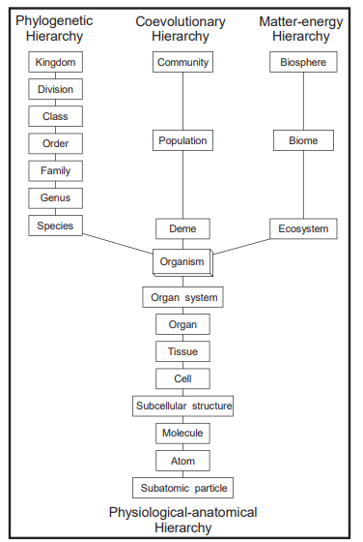

A refinement of traditional ecological hierarchies. Traditionally, ecological phenomena have been described as residing on a single nested hierarchy ranging from subatomic particles to the entire universe. MacMahon et al. (1978) refined the traditional view by dividing the hierarchy beyond the organism level, depending on the kind of question posed. One ecological hierarchy focuses on phylogenetic change, a second focuses on interaction of organisms within assemblages (“coevolutionary”), and a third focuses on the exchange of matter and energy. Within the organism, the hierarchy focuses on component structures, ranging down to the molecular and atomic. Adapted from MacMahon et al. (1978).

Figure 1.7

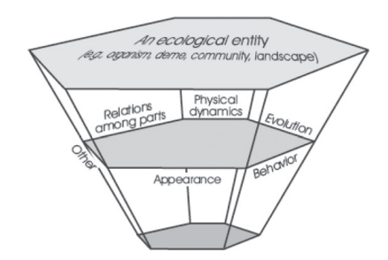

The various facets of ecological entities are the subjects of different research traditions. All these facets can, in relationship with the entity, scale up or down, and they can be applied to different hierarchical layers. The three hexagonal surfaces labeled “ecological entity” represent three nested hierarchical levels of ecological systems. We include a facet for “other” to indicate that the range of ecological concerns is broad, as we do not intend to exclude any legitimate ecological questions here.

**Pickett Chapter 3**

*NOTE: In this chapter the modern pluralist view of theory is richly explained; what it is, does, and why it is so important for all of you to accept this view of theory as environmental professionals. We will be going back in time to explore the 'classic' view of natural science theory structure - but this chapter is the modern view you need to apply to your work from today forward.*

* Define and explain theory! (Box 3.3)

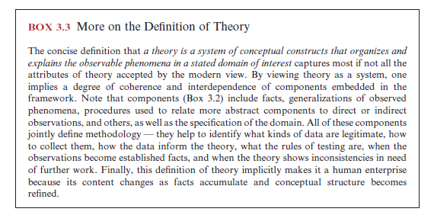

* + Theory is a system of conceptual constructs.
  + First, because theories are conceptual constructs, they are composed of various parts or specific components. Second, because theories are systems of such parts, their components must have some order and must interact via combination, derivation, inference, entailment, or other logical or empirical relationships.
* List all the components of theory. (Box 3.2)

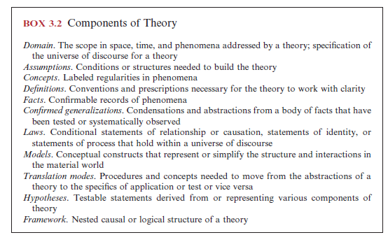

* Define assumptions of theory.
  + Assumptions are the explicit presumptions about the nature of the system of interest. Assumptions state what components and interactions will be included, the structure of the models to be employed to represent the system of observed phenomena, the facts that will be accepted into the theory, and the initial or external conditions for the system to exist or behave in a certain way. In other words, assumptions are the conditions needed to justify the content and structure of the theory (Lewis 1982, Lloyd 1987, Murray 1986, Stegmüller 1976). In a poorly developed theory, some assumptions may be implicit rather than clearly stated.
* Identify a 'simple' and a 'complex' ecological concept.  What is the difference between simple and complex concepts?
  + Simple ecological concept- not built from other concepts
  + Complex ecological concept- the idea that environments differ in a way that can be ordered and that organisms differ in the degree to which their structure of function matches the range od environments available
  + Simple concepts differ from, for example, compound concepts, highly derived models, and complete theories because simple concepts are not built from other concepts, do not involve a high degree of abstraction or idealization, do not have internal logical structure, and do not themselves generate empirical implications
* If concepts refer to ideas, then what are definitions?

The concise definition that *a theory is a system of conceptual constructs that organizes and*

*explains the observable phenomena in a stated domain of interest* captures most if not all the

attributes of theory accepted by the modern view. By viewing theory as a system, one

implies a degree of coherence and interdependence of components embedded in the

framework. Note that components (Box 3.2) include facts, generalizations of observed

phenomena, procedures used to relate more abstract components to direct or indirect

observations, and others, as well as the specification of the domain. All of these components

jointly define methodology — they help to identify what kinds of data are legitimate, how

to collect them, how the data inform the theory, what the rules of testing are, when the

observations become established facts, and when the theory shows inconsistencies in need

of further work. Finally, this definition of theory implicitly makes it a human enterprise

because its content changes as facts accumulate and conceptual structure becomes refined.

* Define what a fact is.  Give some examples related to you work.

Facts are confi rmable records of phenomena — that is, events, processes, and objects (Mahner

and Bunge 1997, Novak and Gowin 1984). Many philosophers recognize that facts have a theoretical component, so concept and fact depend on one another (Hacking 1983).

* Define what a confirmed generalization is. State one that relates to your own work.
  + An abstraction and a generalization
* What is the definition of a law; explain one ecological law from box 3.5, or a different ecological law.

Definition- Laws constitute a special class of generalizations. Laws specify relationships between two or

more phenomena, and this relationship may be correlational, or it may be causal. They may be

formulated verbally or quantitatively.

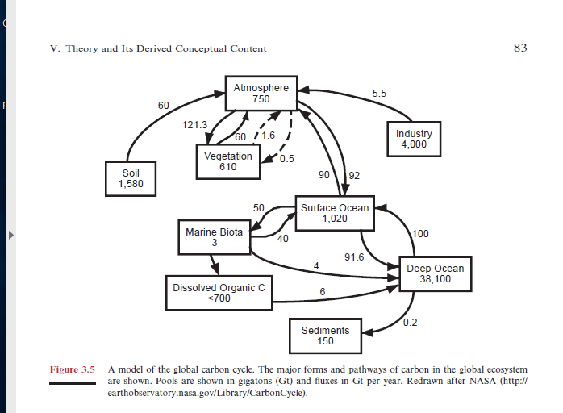

* Read box 3.6 carefully. Summarize the source of the debate (about whether ecology has universal laws). What doe Pickett point out about how physics laws are typically stated that make the existence of ecological laws equally plausible? (Read the middle paragraphs of pg. 80 to get traction on this).

A number of objections or arguments for ecological laws have been presented by both

ecologists and philosophers of science. The debate does not appear resolved but it may be

important to the determination and pursuit of ecological questions and ultimately to the

success of ecology.

Let us begin with an assertion that the existence of emergent properties precludes

obtaining high-level ecological laws by just deducing them from those of other sciences

(Bunge 2003). Hence, ecological laws must be deduced at the appropriate levels of ecological

organization, involve ecologically based assumptions, and use logic or known ecological

relationships to organize the assumptions into a prospective law. For example, the

mechanisms by which plants or animals compete are entirely different from those by which

atoms compete. While plants process energy and matter consistent with the laws of physics,

it does not mean that the dynamics of competition are directly deducible from physical

knowledge (Marone and Del Solar, in press, Murray 2000). A simple example illustrates

this point. When lions and hyenas compete for a carcass, the outcome determines where

the energy is going to be allocated and in what quantities. However, neither the energy of

the carcass, the energy of hyenas, nor that of lions appears to be informative of the outcome

of competition. Thus, competition is a phenomenon that appears at the level of a system

that consists of at least two ecological entities (i.e., populations) and cannot be deduced

from nor rigorously linked to the principles of physics.

Having asserted that laws of ecology are not those of physics, the question arises of why

ecologists seem to have diffi culty with formulating and agreeing to what the laws are. The

most common putative cause invoked by ecologists, as well as some philosophers of science

(Shrader-Frechette 2001), is the contingency of ecological phenomena (Knapp et al. 2004,

Lawton 1999, Marone and Del Solar, in press). Sagoff (e.g., 1997) and Shrader-Frechette

and McCoy (1993) have repeatedly condemned ecology’s pretensions to nomotheticity, or

law-likeness, of some of its regularities. Ecology is too complex, they have said, to be

V. Theory and Its Derived Conceptual Content 77

78 3. The Anatomy of Theory

fruitfully characterized in terms of general laws (Mikkelson 2003). However, Simberloff

(2004) cautioned after Windelband (1894) that ecologists should not confuse the distinction

between general laws about the structure and workings of nature with idiographic

knowledge, which depicts singular events and focuses on unique aspects of particular

phenomena — the sources of complexity.

Complexity is then seen to derive from contingency, and contingency itself is seen as a

condition where any particular outcome depends on a number of contributory causes that

can act in a fairly unpredictable mix. Irrespective of the level of organization, contingency

is believed to be fundamentally different from that of physical phenomena and hence an

insurmountable obstacle to fi nding meaningful laws in ecology. However, this claim seems

to be taken on faith and, when confronted with reality, borders on absurdity. The great

majority of physical phenomena is as contingent as biological ones, and some are entirely

indeterminate. Whether one considers a fl ight trajectory of a falling object, the distribution

of rocks on the slope of a mountain, movement of air particles or air masses, locations of

lightning strikes, arrangement of matter in the universe, spread of fi re, shape of a snowfl ake,

or hundreds of other physical phenomena, contingency is pervasive. Rather, it is a matter

of abstraction and idealization (see Chapter 2), not of subject, that differentiates the

constructs of physics as compared to constructs of ecology, at the moment at least. This

means that laws of physics are usually formulated as if no other forces or modifying factors

existed. Laws of physics rely on stripping the contingency to expose an ideal relationship,

a relationship that is diffi cult to observe in nature. Consider the simplest and best known

law of physics, that of the fi rst law of mechanics. The fi rst law deals with forces and changes

in velocity. For just a moment, let us imagine that you can apply only one force to an

object — that is, you could choose to push the object to the right or you could choose to

push it to the left, but not to the left and right at the same time, and so on.

Under these conditions, the fi rst law says that if an object is not pushed or pulled, its

velocity will naturally remain constant. This means that if an object is moving along,

untouched by a force of any kind, it will continue to move along in a perfectly straight line

at a constant speed. The operative phrase is *under these conditions* (i.e., of one force only)*.*

When more forces apply, as always is the case, the fi rst law of mechanics will fail in its

predictions. However, physicists are happy with this law. Should not ecologists be able to

construct similar laws and be happy with them?

In spite of the reasons to the contrary, ecologists worry about the contingency and its

negative effect on their ability to synthesize multiple streams of observations. One attempt

to come to rescue (Knapp et al. 2004) starts by conceding to critics that laws may not be

attainable because of fuzziness of relationships among ecological entities and phenomena.

Knapp et al. (2004) postulated a scaled-back program for ecology — a program that will

focus on fi nding rules. They seem to subscribe to the collective arguments and logic of

Lawton (1999), Simberloff (2004), or Berryman (2003) and fi nd comfort in the fact that

most ecologist agree to the existence of rules. They defi ned rules as generalizations or

statements that predict the occurrence of a particular ecological phenomenon if certain

conditions are met. However, their defi nition of rule is not much different from the

defi nition of law. So what is the problem? The quality of prediction or the quality of the

formulation?

One might argue that the search for rules might be good because it could inspire fi nding

laws. One might also argue that the search for rules might hinder progress by emphasizing

empirical over conceptual work. Newton’s fi rst law of mechanics illustrates these two

possibilities. The law says that an object pushed should move at a constant speed along

a straight line. Although no object obeys this law in the natural world, the fact that most

objects tend to move in one predominant direction and continue to do so for a while might

lead a speculative observer, as it did, to the formulation of the law. Hence, empirical

observations summarized as a rule that movement occurs, at least initially, in a direction

not much different from a straight line and continues for a while at least after the force

stopped suggested a general conditional rule that would only work in an idealized

setting — a law in short. However, these same observations might lead one to a proliferation

of rules such that, for example, (1) fl uffy objects show greater trajectory variance than do

dense objects (like bullets), (2) objects whose initial speed is less that the fi rst cosmic speed

tend to fall to Earth, (3) objects whose initial speed is greater than the fi rst cosmic speed

tend to orbit Earth, (4) objects in water fl oat if their density is less than that of water or

sink to the bottom if their density is greater than that of water, and so on. All of these

rules, and many others, are useful, true, and would represent progress in recording and

understanding natural phenomena. The question ecology faces is not which of the strategies

to pursue but what is the most promising mix of strategies, all of which should be pursued.

The claim that laws cannot be found and cannot be useful in ecology (see Mikkelson 2003)

has little basis in logic and the practice of science in general.

* List and define 4 different kinds of models.
  + Verbal
  + Quantitative
  + Graphical
  + Physical
* Define translation mode in relation to testing of a theory.

Translation modes are required to relate the abstractions made by laws, generalizations, and

conceptual or quantitative models to the fi eld or to experimental systems relevant to the theory (Levins 1966).

Translation modes allow ecologists to deal with the contingency of their subject matter while being guided by the clean, clearly derived components of theory. The mode of translation may be a more specifi c model or a subtheory of the more abstract one (Grant and Price 1981, Levins 1966, Lewontin 1974, Suppe 1977a).

* Hypothesis. Bottom of page 87 - where Pickett et al. define what a hypothesis is and give an example. Please read this entry ([Research Hypothesis](https://ufl.instructure.com/courses/355207/files/39297132/download?wrap=1)

[Settings](https://ufl.instructure.com/courses/355207/pages/pickett-et-al-reading-concepts)

 ) from the Sage encyclopedia and explain whether Pickett et al. present a Research Hypothesis or a Statistical Hypothesis?   When you have decided -- please state both the research hypothesis and the statistical (working and null ) hypothesis that are relevant here.

Note that the experimental hypothesis, let alone the research or the substantive hypothesis, is neither the statistical alternative (*H*1; see row 5b) nor the statistical null hypothesis (*H*0; see row 5a). While the nonstatistical hypotheses are conceptual conjectures about a phenomenon or the conceptual relationships between the independent and dependent variables, the statistical hypotheses are hypotheses about the effects of chance influences on research data. That is, the conceptual and statistical hypotheses implicated in a research belong to different domains.

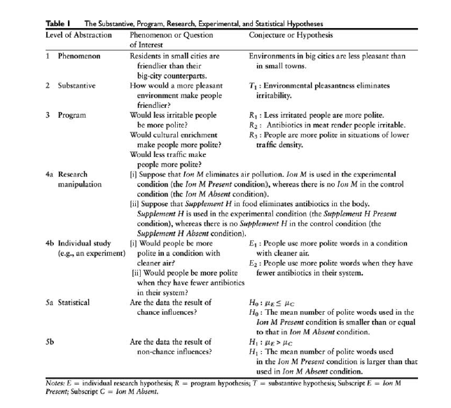

*What's a theory framework?*

A framework is the structure that relates all the other components of the theory. The importance

of the framework is emphasized by the common reference to well-developed theories as “theoretical

systems” (Suppe 1977a). The term “system” requires that the various parts of the theory

be related to one another. The conceptual framework of a theory is a general model of the relationships of the various conceptual devices that constitute the theory (Box 3.2).

**Pickett Chapter 4**

* As a graduate student, which kind of theory is better to base your thesis on - a new young theory or a mature theory? Explain why?

Neglecting theory change can lead to reliance on a theory that is incomplete or immature. Several failings may arise from using an immature theory. Many such failures are caused by the absence of components or of integrating

links in the theory. More unfortunate, an immature theory may be prematurely rejected or entirely ignored when it is subjected to an overdesigned test at an early developmental stage. The relationship of theory change to testing is explored next.

* Can you identify a narrow scope theory and a broad scope theory relevant to your work?

Theories of broad scope, or domain, are less likely to be rejected by one

or a very few negative tests than are narrow theories. This assertion assumes, of course, that such

a theory is well developed. We expect narrow theories to have specifi c implications that apply

only under narrowly defi ned conditions. Thus, the relevant universe of discourse is limited for

narrow theories. However, a theory with a broad scope will more likely be divided into subdomains,

each with well-developed models, assumptions, and translation modes to deal with special cases.

* Study Box 4.1 and Figure 4.1 while you read about all the theory components (pgs. 103-108).  Now, can you explain the relationship between Figures 4.1 and 4.2?

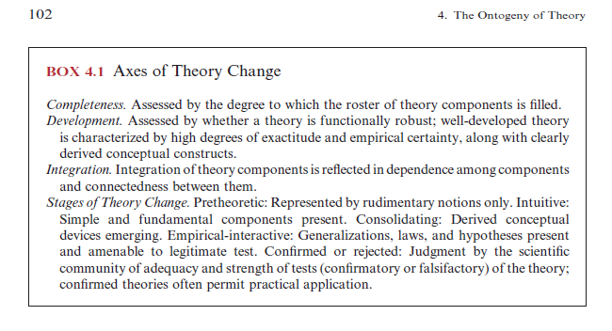

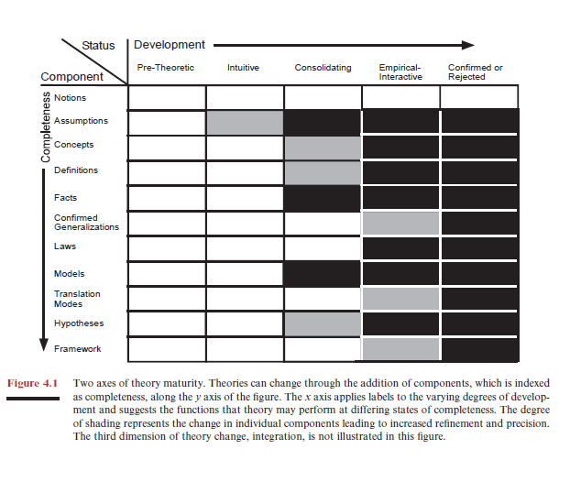

* Can you name a pre-theoretic ecological theory or discipline? Can you name a mature, confirmed body of theory that ecologists use?
* Read box 4.3. Can you identify what components of which theory were missing for Jan Baptista van Helmont to wrongly conclude that plant growth occurs with the addition of water only?
* Which component(s) of theory seem most difficult for you to define/understand?

Additional (test like) question. Consider a named theory that is relevant to your work (e.g., theory of population regulation or predator-prey theory or plant functional traits theory). Now, when your thesis is done, what component(s) of your theory is your work most likely to affect (ie, improve, support, validate, challenge, revise, etc)?  Keep this in mind when you are writing the Synthesis and Significance section of your research proposal.... Just sayin'!

**These chapters are not assigned in 2018. But this book is worth keeping; Use at will.**

**Pickett Chapter 6**

- State the definition of a fundamental question (see section A).  Now consider the theory of evolution by natural selection.  When Charles Darwin published "On the Origin of Species", he did not understand the mechanism of inheritance of traits. Use the discovery and subsequent understanding of DNA structure and function to explain how asking (and answering) a fundamental question can foster theory change.  Figure 6.2 should help you.

- List the types of fundamental questions and the ways that Pickett et al. say they can change understanding.

- Examine Box 6.1 carefully. Which one of these fundamental questions is most related to your study? In what way could your study contribute to answering that fundamental question (in addition to your specific goals).

- Read section B, 1. What fundamental question did Darwin probably ask that stimulated him to develop (establish) evolutionary theory?

- What sort of question leads to rejection of a theory? (Section B, 3). Can you think of any theories that have been rejected in ecology?

- Read section III. Here they dicuss three ecological theories that have been weakened or attacked by studies that ask fundamental questions about them. Which of the three theories are you most familiar with? Did you know that all three of these have been criticized?

- Explain where radically new theories can come from (pg. 144).

- Finally, what is an "inductive stroke"? Relate it to your homework 1 exercise on observation.

**Pickett - Chapter 7**

Nested paradigms (disciplinary within ecological within scientific) - be able to say what assumption, exemplars, and techniques would be shared by the ecologists within each nested layer.

"Thing" vs "Stuff" ecology and "Then" vs "Now" ecology: defining the two axes of what Pickett refers to as the 4 paradigms in ecology (the largest ecological paradigms).