Salinity and Temperature Quarterly Reports

ggplot() +  
 geom_line(data=sal_summ, aes(x=dsal2, y=meanVal, fill = "Salinity"), size= 1.1, color= "#0072B2") +  
 geom_ribbon(data=dis3, aes(x=d2, ymax=maxVal, ymin=minVal, fill=Measure),   
 alpha=0.4) +  
 xlab("Date") +  
 scale_y_continuous(name = "Salinity(ppt)",   
 limits=c(-20,40),   
 breaks = seq(0, 40, 10),  
 sec.axis = sec_axis(~(.+20),   
 name = "River Discharge (1,000 cfs)  
 ",  
 breaks = seq(0, 20, 10))) +  
 scale_x_date(date_breaks = "2 months", date_labels = "%y-%m-%d", expand = c(0, 0)) +  
   
 scale_fill_manual(values = c("#56B4E9", "#0072B2")) +  
   
 scale_color_manual(values = c("#56B4E9", "#0072B2")) +  
   
 theme(legend.position=("top"),  
 panel.grid.major = element_blank(),  
 panel.grid.minor = element_blank(),  
 panel.border = element_rect(color = "black", size = 1, fill = NA, linetype="solid"),  
 axis.text=element_text(size=10),  
 axis.title=element_text(size=13,face="bold"),  
 plot.title =element_text(size=13, face='bold'),  
 axis.text.x = element_text(angle = 90, hjust = 1, face= "bold"),  
 axis.text.y = element_text(face= "bold"),  
 legend.title=element_blank()) +  
   
 guides(color = guide_legend(override.aes = list(linetype = c(0, 1)))) +  
   
 facet_wrap(~ Site, ncol=3, labeller = label_both)

## Warning: Ignoring unknown aesthetics: fill

## Warning: Removed 11 rows containing missing values (geom_path).

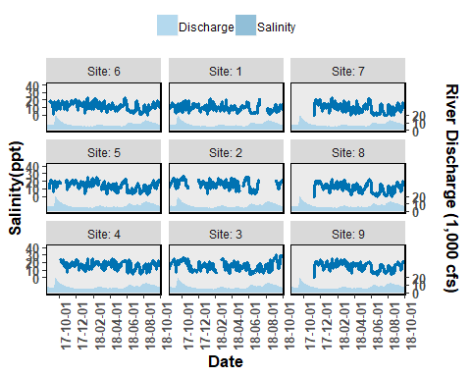

Figure 1. Salinity and discharge data collected from autonomous sensors from the Lone Cabbage Reef restoration site near Suwannee, FL. Each graph represents a sensor location, with top of page as north, and right of page as east. The center column of figures (Sites 1-3) represent the eastern side of the Lone Cabbage Reef restoration site. The left column of figures (Sites 4-6) represent the western side of the Lone Cabbage Reef restoration site. The right column of figures (Sites 7-9) represent sensors close to shore in an area where salinity may be influenced by restoring Lone Cabbage Reef. The first two columns from the west (Sites 1-6) represent the inshore and offshore sides of the restoration reef. The primary y-axis is Salinity (ppt, parts per thousand), and the secondary y-axis is Suwannee River discharge (CFS, cubic feet per second) measured at USGS Wilcox station 02323500 on the Suwannee River. River discharge is graphed as a daily mean in the light blue filled shape near the bottom of each graph. Daily mean Salinity values (dark blue line) are shown in the center of each graph. The shaded dark blue region of the Salinity values are minimum and maximum values of that date. Missing values are provisional data that have not been finalized or represent periods of time when sensors were not yet deployed or off line due to user error or vandalism.