Moreno, Melissa

March 20, 2016

PCB 4043

Take Home Exam 3

1.

k1=100, initial population is 25

k2=150, initial population is 50

σ=2

β=3

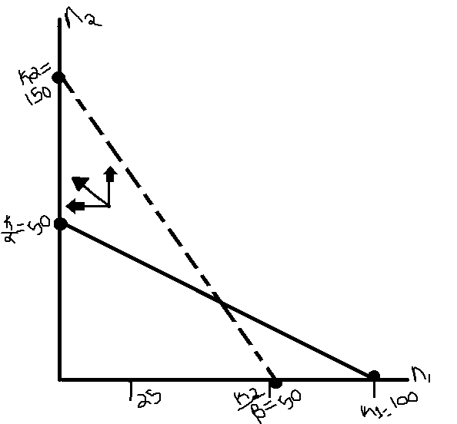

Species 1 =_____________

K1= 100

K1/α= 100/2 = 50

Species 2= - - - - - - - -

K2=150

K2/β=150/3=50

Short term dynamics for Species 1 will decline, while the short term dynamics for Species 2 will grow.

3.

r= 0.1

q= 0.5

α=β= 0.001

Predator population at time (t)=p=200

Victims of population at time (t)=v=600

dv/dt= rv-αvp

dv/dt= (0.01)(600)-(0.001)(600)(200)

dv/dt=-60

dp/dt= βvp-qp

dp/dt= (0.001)(600)(200)-(0.5)(200)

dp/dt=120-100=20

This makes this because the change in population size of flies would be greater than the change in population size of spiders. The short term population dynamics would show that at any time (t) the flies population would change much higher than the population change of spiders.

4. Competition Field Experiment

According to T. Underwood there are key elements of a good competition field experiment. T. Underwood published this paper based on Dayton (1973) and Roezweig (1975) conducting experiments and showing that there is a need for “well- planned field experiment to prevent totally spurious conclusions about processes in natural communities”. T. Underwood also mentions that “experimental studies of competitive interactions in natural populations are scarcely new…. [but] what is not clear from these reviews is how good is the evidence”. Throughout the article T. Underwood references that he is more concerned with how the experiment is conducted and not with the actual results.

T. Underwood mentions that when writing a journal it’s necessary to cite from other publications. In Birche’s (1979) had cited 95 papers. This seems to be a huge amount of citations, and because of this he found that many of these studies were incomprehensible, some were not at all about his topic (competition), some were not actual experiments, and he found that some were not even in his related field. Many lacked sensible controls and had no real crucial tests.

T. Underwood finds that it is also difficult to study the competition in the field because it is almost impossible to retain the experimental densities of species in natural areas with the use of an artificial enclosure. The results concluded might not be sensible or might not actually be what would occur in natural competition. The same can be true in a competition experiment with a species who is being tested using inappropriate densities (densities that would not occur naturally).

“A “natural” experimens is one where the hypothesis concerns the effects of a putative species (B) on the biology or demography of a target species (A)”. This kind of investigation would take into account the mortality, growth, migration, reproduction, etc of species (A) in areas where the predator species (B) is not found natural, with the biology of species (A) in similar areas where species (B) is present. Understanding these relationships in these kinds of environments will yield accurate results. A competitive field experiment will conclude if the above hypothesis is true. It can also be tested to see if the performance of species (A) changes with the removal of species (B).

T. Underwood writes that there is an absolute need for replication in the experiment. He mentioned that about 16% of the 95 papers were considered a “natural experiment” with the rest being very unsuccessful field experiments. He mentions how Hurlbert (1984) has coined the phrase ‘pseudoreplication’, where a scientist will conduct a field experiment but will not provide adequate replication methods. You probably like the part where he writes “for further considering of this, consult any sensible book about statistical procedures and random sampling” (a.k.a burn!).

The 16% of papers mentioned previously had no chance of accurate replication. Many of the field experiments had only ‘pseudoreplication’ in some aspects of comparison. Pseduoreplications can only indicate the existence of patterns of difference between the units that are being experimented on. Many researchers are also just repeating their experiments but not providing enough information to replicate the experiment by another scientist. Some reasons that could contribute to scientist not having proper replication methods could be money, lack of manpower, or lack of resources.

It could be very difficult to replicate some experiments because of mobility, size, rareness, size of territory, home range, or sparsity on resources. But in this case I would say that instead of calling the experiment an ‘experiment’ it would be more likely an observation. But definitely you can’t argue that the lack of attention to the design of the experiment and the need for replication are more important than the difficulty of the subject matter. He writes that many experiments with mice or salamanders are easy to replicate, but most of the time they are just repeated. T. Underwood concludes that the authors apparently choose whether or not the experiments can be replicated on a whim. Like “maybe you can replicate my experiment….or not”! Basically if an experiment cannot be replicated, then you could argue that the hypothesis or conclusion is meaningless.

There also seems to be problems with controls in these competition field experiments. Many of the experiments lack sensible controls. Several papers had experiment disturbances of transplanted animals and plants. This manipulation would yield much different results than what would actually happen in the field. With many active animals such as rodents and ants, any kind of disturbance would seriously alter their behavior. Other instances the controls what were added totally failed. This is because the necessary manipulations for the experiment are often inadequate or lacking. The more care added to the establishment of proper controls, the more likely this experiment will be considered relevant to natural populations.

In some of the experiments the scientist used an experimental design of replacement series. This is when experimental plots are used, all at a fixed density, but made up of variable proportions to the two species being tested. Without using proper controls the competition of the two species might be clouded by intraspecific effects of equal degree so that no change from the treatments would be recorded when one of the species is replaced by members of another species.

A mechanical diallel makes comparisons between pure ‘stands’ of each species plus a mixture of the both species. With this kind of experiment the density of the individuals will be different between the plots. This kind of experiment can be unconfounded. “In these studies, comparison between areas with a single species and with a mixture were therefore confused because the addition of putative competitor was confounded with the simultaneous decrease in density of the target species”.

Many of the papers T. Underwood investigated on Dhondt and Eyckerman’s (1980) experiment with blue tits showed they were drawn to the experimental nest boxes when the opening hole was smaller, keeping great tits out. The conclusion could be unconfounded because the blue tits were not interested in the nesting boxes prior to changing the entry size of the opening, so the observation of competition cannot be accurately described since a key aspect of the experiment was manipulated.

Another issue that T. Underwood addresses is the problem with experimental manipulations of active wide, ranging animals is that of maintaining the treatment after the start of the experiment. Spatial and temporal variations can cause problems for a short or small scaled environment. Even with that, short-term experiments can give rise to inconsistencies early in the experiment, but not all of these inconsistencies are caught.

Intraspecific competition should be the most important topic in the development of theory about competitive interactions and subsequent development. With intraspecific competition, the results will yield a hypothesis about interspecific competition.

Another issue arises when then densities of the competing species are not the same in the experiment. Even though interspecific asymmetry will be unavoidable the scientist has to take into account, however the appropriate measurements for accurate population densities is necessary.

According to an article in the Journal of European Economic Association, ENERGY CONSERVATION “NUDGES” AND ENVIRONMENTALIST IDEOLOGY: EVIDENCE FROM A RANDOMIZED RESIDENTIAL ELECTRICITY FIELD EXPERIMENT,the researchersselected random high density single family homes from 85 census tracts to ( not apartments or houses), as well as a random control group of houses to “nudge” them to restrain their electricity use. They found that the nudges decreased consumption by 1%-2%. This field experiment was done well because they chose random housing to test, as well as having a control group in similar sized without being manipulated with.

5. What are trophic modules and why are studying them important in community ecology?

Within a food web, species can sectioned into sets according to various conditions. Trophic modules have been recently added to ecology literature having a lot of new information on empirical food webs. A trophic module can be found within a common food web. Trophic groups have also been generally used but largely based on expert research on a particular species. The relationship between the groups and modules is unknown but they both do have basis on food webs.

In nature, the species found within a community are connected by their common predator. The complex links or interactions can be considered a network. The food webs are not random and they major influence on the function of the web, including the ability of the species to persevere. The notion of the group (an assortment of nodes with exact characteristics) in a complex network is an important feature of a food web. These trophic groups, however, cover a broad set of definitions and methods.

Trophic modules on the other hand refers to the groups or nodes that are contacting more frequently between themselves instead of with other nodes. This concept is challenging because of its relation with the food network functionality. Trophic modules can filter out aspects of the food web to give rise to other characteristics between the predator/pray network. Some characteristics that have been identified in a community is a niche species and its diet, phylogeny, or spatial isolation between species.

According to (Benoit Gauzens), a food web of Chesapeake Bay, showed a split between large modules which directly corresponds to the division between pelagic (fish living in the Pelagic Coastal Zone) and benthic species (i.e amphipods, polychaete worms, snails, midge larva, etc). Normally a trophic group would display a top-down predator/pray model but using trophic modules the scientists could discover a correlating relation, other than the pelagic fish consuming the benthic species, between the sets of species.

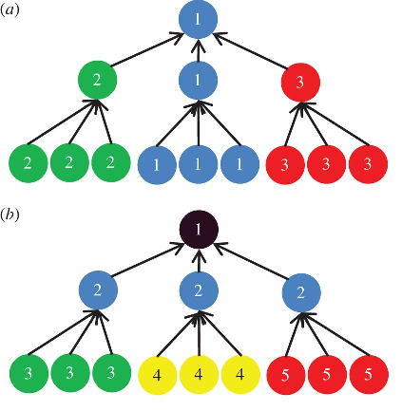At this point trophic groups and trophic modules can provide complementary, similar, or even opposite results. It is important to research trophic modules because it can display relationship between species that can be overlooked in a traditional food web model. Figure 5.1- Representation of different group detection methods for a hypothetical food web. Same color and numbers belong to the same group. a) trophic module showing the relationship in a food web between a group predators and some lesser pray. b) trophic group showing the relationship between a top predator in a food web and lesser pray.

In Figure 5.1 portion a) we can see that in this hypothetical food web that species 1 is affecting its own food web group but also affecting the food web groups of 2 and 3, but not necessarily all the individuals. In portion b) we see that top predator is affecting all the individuals of species 2, while species 2 is affecting species 3,4 and 5 individually.

7. Extra Credit: How many different ways are there to do this exam are there if you pick 4 out of 6?

To select each question, the probability is 1/6. I can select question 1, only once out of 6 question. Since this is a real life situation a combination like 1,2,3,4 would be the same as 4,3,2,1. The combinations are listed thus far:

1,2,3,4 2,3,4,5 6,5,3,2

1,2,3,5 2,3,4,6

1,2,3,6 3,4,5,6

1,3,4,5 3,4,5,1

1,3,4,6 4,5,6,2

2,1,4,6 4,5,6,3

2,1,4,5 6,5,3,4

The total number of different combinations for 4 questions out of 6 on the exam is 15.

# Bibliography

Benoit Gauzens, Elisa Thébault, Gérard Lacroix, Stéphane Legendre. *Benoit Gauzens, Elisa Thébault, Gérard Lacroix, Stéphane Legendre*. 15 April 2015. Benoit Gauzens, Elisa Thébault, Gérard Lacroix, Stéphane Legendre. 2016 March 2016.

Dora L. Costa, Matthew E. Kahn. "ENERGY CONSERVATION “NUDGES” AND ENVIRONMENTALIST IDEOLOGY: EVIDENCE FROM A RANDOMIZED RESIDENTIAL ELECTRICITY FIELD EXPERIMENT." *Journal of European Economic Association* (2013): 680-702. Volume 11.

Community Ecology. Pattern and Process.1986. Edited by Jiro Kikkawa and  
Derek J. Anderson. Blackwell Scientific Publications. Melbourne, Australia

Interaction strength combinations and the overfishing of a marine food. " Jordi Bascompte, Carlos J. Melián, and Enric Sala." *PNAS* (2005): Volume 102. No. 15.