Moreno, Melissa

February 26, 2016

PCB 4043C

Exam 2- Take home

1. The frequency distribution of the value of x of a polygenic trait follows a bell shape curve. In a Central Limit Theorem normally µ is the mean and σ^2 is the variance as the sample size (n) approaches infinity. The mean is necessary in the curve because it will dictate the highest point of the bell. The σ^2 will determine how fat or skinny the curve is, because the variance is how many different variations of phenotypes are available. When you have polygenetic traits (2 or more genes) for a samples size the recombination for the genotypes has a greater variability. So where there are multiple genes for a trait in a large population you will find the majority will have a more gene combinations that are similar (aka the mean) and fewer gene combinations that are on opposite extreme ends of the mean (Figure 1.1). If there are 2 or less gene combinations in a population size you will find ½ of a bell shape curve. This is because in the population there will be a decline towards either extreme due to the probability of occurrence (Figure 1.2). Table 1.1 shows the standard probability percentage based on the how many alleles of a gene are present.

Figure 1.1

Table 1.1

|  |  |  |  |
| --- | --- | --- | --- |
|  | 1 | 2 | 3 |
| 1 | 0.12 | 0.18 | 0.6 |
| 2 | 0.18 | 0.9 | 0.3 |
| 3 | 0.6 | 0.3 | 0.1 |

Figure 1.2

2. Does the data contain enough evidence that evolution occurred?

Mean of normal distribution (µ)= 45 mm

σ^2= 13.5

σ= 3.67

Sample size (n) = 25 beak measurements

Sample size mean as a random variable (X) = 46.1

x= realized fix value

N= normal distribution

The null hypothesis is that the mean is equal to 45mm. Ho: µ0= 45 mm. (null hypothesis)

The alternative hypothesis is that the mean is greater than 45 mm. Ha: µ > 45 mm. (alternative hypothesis), (right tail)

Since the population size is < 30 we cannot use the Central Limit Theorem find out if we can reject the null hypothesis.

In this case I would recommend using a Z- test for a small sample size (n=25):

Z= (x-µ0)*square root of n/ stdev

Z=(46.1-45)5/3.67= 1.49

So reject null hypothesis if

Z> Zα (it is > because it is a right tail)

Ta= degrees of freedom+ α

Lets use α = 0.100

Degrees of freedom n-1= 24

Ta= 24.100 = 1.318 (Zα)

So,

1.49> 1.318 (True)

In a normal curve area we can find that a 1.49 Z- test would equal to the chart area of 0.4319. To find the p-value we can estimate one side of the curve 0.5- CA (0.4319)= 0.045681. The p-value 0.045681 is an estimation of α. This would mean that the p-value would be less than 0.05 so that would indicate that we can reject the null hypothesis and accept the alternative. Also since 46.1 is within the critical region we can also decide to reject the null hypothesis. We can reject the skeptics claim that evolution did not occur based on our tests. (The information above was listed in my Statistics Notebook, STA 2122 FIU)

3.

A) Human population is expected to double in 50 years

Current population is 7.4 billion

Project population in 2040?

First we find the rate:

(Ln2-ln1)/ (t2-t1)= r

(Ln14.8-ln7.4)/50=0.013

Then we find out the population at year 2040:

N(t)= Noe^rt

N(t)= 7.4 e^(0.013)(24)= 10.33

The projected human population at year 2040 is 10.37 billion.

B)

3000 individual beetles

Grows continuously

400 births (in one month)

150 deaths (in one month)

Population projection in six months?

Birth rate= 400/3000= 0.133

Death rate= 150/3000= 0.050

Rate= birth rate- death rate= 0.133-0.05= 0.0833

N(t)= Noe^rt

N(t)= 3000e^(0.0833)(6 (months))= 4945.17

So,

Ln 4945.17 -ln3000=0.4998

Population projection of beetles in 6 month is 4945.

C)

Measurements for a growing population of flatworms for 5 days.

100,158, 315,398,794

The inﬂection point at the maximum growth rate:

Dn(t)/dt = rk\k

So according to the ppt slides

R= 0.6528385

y = 60.25e0.5047x

R² = 0.9817

Figure 3C- Initially the population starts off at 100, which can be represented with y = 99.807e0.5047x,, which is very close to 100. That is why we don’t see y = 60.25e0.5047

as a starting point.

D)

Annual population of grasses increase is 12%

What is the doubling time?

e^r= e^.12= 1.12=⋋

⋋= 1.12

R=ln⋋= ln (1.12)=0.113

Doubling time= ln2/r

Doubling time= ln2/0.113= 6.1 years

It will take 6.1 years for the grass to double in population with a 12% increase.

4.

W= intrinsic growth rate of the plasmid free cells/ intrinsic growth rate of plasmid-carrying cells

σ= 1.5

t= 1 generation of plasmid carrying cells

n(t+1)=2n(t) = number of plasmid carrying cells from one generation to the next

n(t)= number of plasmid carrying cells at time t

^ finite rate of increase ⋋=2

m(t+1)= 2^(1+σ) m(t)

m(t)= denotes the number of plasmid-free cells t time t

^ finite rate of increase is 2^(1+σ)

Plasmid Carrying Cell - e^rpc= ⋋pc = lnr^rpc = ln⋋pc = rpc =ln⋋pc

Plasmid Free Cell – e^rpf= ⋋pf = lne^rpf = ln ⋋pf= ln 2^1+σ

Lna^b= bln^a

Rpf= (1+σ) ln 2

W= rpf/rpc= (1+σ)ln2/ln2= (1+σ) = 1 + 1.5= 2.5

A) What is the maximum possible growth rate of the population per month?

K= 400 butterflies

R= 0.08 individuals per month

Max growth rate at k/2

N= k/2= 200 butterflies

Logistic growth equation

dN/dt = rN[1-N/K]

dN/dt = (0.08)(200) [1 - (200)/400)]

dN/dt = 8 individuals/month

The maximum growth of individuals per month is 8 butterflies.

B)

Figure 5.1- This figure displays the birth rate and death rate relationships in a density dependent turtle population. The population size was 100 (n=100). The intersection point is the carrying capacity k.

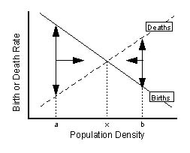

Figure 5.2- This figures shows a normal logistic growth model with linear birth and death rate functions. The intersection of the two lines is k, the carrying capacity, in the graph it is labeled as x. (the image above image was found during a google search and can be found in this link http://www2.nau.edu/~doetqp-p/courses/env470/Lectures/lec15/Density_Dependence_2.jpg)

In these two graphs we can see that in Figure 5.1 the birth rates had a downward bell shaped curve. This graph could happen if lets say a nest of turtles was hatched, and some of those turtles survived and laid several eggs, thus increasing the birth rate. Before the carrying capacity we can estimate births> deaths, so growth rate is “without bounds”. But then drastically something happened where the turtles did not lay any more eggs and the birth rate dropped rapidly. Maybe the adult turtles could not find a suitable beach, or there were too many predators around their nesting site. At k we can say that births=deaths and that the population isn’t changing. The death rate on the other hand is steadily increasing, which is normal. It seems as though after we get to carrying capacity, k, the birth rate drops considerably more than the rate of death rate, which in this case is increasing. After k the births< deaths and we can see this with the downward curve of the birth line. The maximum growth for this population is around 35 individuals.

In Figure 5.2 we see that the birth rate and the death rate are increasing/decreasing simultaneously or at the same rate. This is the point where births > deaths and “grow without bounds”. As birth rate decreases and approaches k, death rates increase. At k births= deaths and “population doesn’t change”. And as we pass k the birth rates continue to drop while the death rates continue to rise. This is where births< deaths and “decay is toward extinction. Death rates increasing is a normal instance in a population. In a linear density dependence model normally the birth rate will start off higher than the death rate. It seems as though after carrying capacity the birth rate will continue to drop, so the turtles cannot handle to gather resources or support their population size after carrying capacity.

6.

The logistic differential equation:

dn(t)/dt = rn(t) (1 −n(t)/k)

The logistic differential equation is able to determine the effects of population size increase in a growth rate. The exponential growth model normally only shows the overall rate of increase but does not mention what happens during each segment of the line. The intrinsic growth rate is r and k is the carrying capacity. As a population size is reaching carrying capacity natural resources become threatened and animals are more prone to illnesses. This will make the net amount contributed by each individual unit of abundance smaller. The growth rate from its value under exponential growth will effect crowding in a progressive decline until it reaches 0. When the growth rate reaches 0 the population size will no longer increase or decrease, it will remain constant. This can be explained by n(t)=k. The first part of the equation is similar to the growth rate under exponential growth rn(t). The second part of the equation (1 −n(t)/k) is between 0 and 1 because n(t) ≤ k. As the population grows to reach k, n(t)/k becomes closer to 1 and (1-n(t)/k) becomes closer to 0. The term is multiplying the exponential growth rate rn(t). As n(t) grows larger the population growth rate becomes a smaller fraction of the exponential growth rate. The hypothesis is basically that as the population size grows larger the net amount that each individual contributes to the unit of abundance becomes small until it reaches k.

We can rewrite

dn(t)/dt = rn(t) (1 −n(t)/k)

as

rn(t)- (r/k) n(t)^2

If the starting population is

n1> k

Δn=n1- k

Dn(t)/dt when n(t)= k+ Δn

The differential logistic equation is:

Dn(t)/dt= r(k+Δn)-(r/k)(k+Δn)^2

For n2 population we have

n2<k

Δn= k – n2

Dn(t)/dt when n(t)= k+ Δn

And Δn= k-n2

The differential logistic equation is:

Dn(t)/dt= r(k-Δn)- (r/k)(k-Δn)^2

If we compare the two equations we can see that regardless of the values we will that the equation for n1 will be negative, probably a small value, and the equation for n2 will lead to a positive number.

If we substitute values for the n1 equation we get,

N1>k, n1= 100, k=90, r=0.03 (3%)

We get 2.9667

If we do the same for the n2 equation we get,

N2<k, n2= 80, k = 90, r= 0.03 (3%)

We get 2.37333

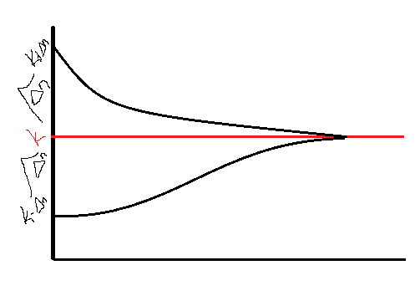This can also be explained by this graph

<- Figure 6.1- Shows how k+Δn=n1 downward rate of change of population to reach k, and k-Δn=n2 will need a upward rate of change of the population.

We can conclude from these two equation values are approximately close to each other so I will say that it requires similar amount of energy to bring n1 population down to carry capacity and to bring up the n2 population up to carrying capacity.

7.

|  |  |  |  |  |  |  |  |  |  |  |  |  |  |  |  |  |  |  |  |  |  |  |  |  |  |  |  |  |  |  |  |  |  |  |  |  |  |  |  |  |  |  |  |  |  |  |  |  |  |  |  |  |  |  |  |  |  |  |  |  |  |  |  |  |  |  |  |  |  |  |  |  |  |  |  |  |  |  |  |  |  |  |  |  |  |  |  |  |  |  |  |  |  |  |  |  |  |  |  |  |  |  |  |  |  |  |  |  |  |  |  |  |  |  |  |  |  |  |  |  |  |  |  |  |  |
| --- | --- | --- | --- | --- | --- | --- | --- | --- | --- | --- | --- | --- | --- | --- | --- | --- | --- | --- | --- | --- | --- | --- | --- | --- | --- | --- | --- | --- | --- | --- | --- | --- | --- | --- | --- | --- | --- | --- | --- | --- | --- | --- | --- | --- | --- | --- | --- | --- | --- | --- | --- | --- | --- | --- | --- | --- | --- | --- | --- | --- | --- | --- | --- | --- | --- | --- | --- | --- | --- | --- | --- | --- | --- | --- | --- | --- | --- | --- | --- | --- | --- | --- | --- | --- | --- | --- | --- | --- | --- | --- | --- | --- | --- | --- | --- | --- | --- | --- | --- | --- | --- | --- | --- | --- | --- | --- | --- | --- | --- | --- | --- | --- | --- | --- | --- | --- | --- | --- | --- | --- | --- | --- | --- | --- | --- |
| |  |  |  |  |  |  | | --- | --- | --- | --- | --- | --- | | Time | population size | logistic prediction | SSQ deviations | r | k | | 0 | 2 | 2 | 0 | 1.14461472 | 438.744137 | | 1 | 6 | 6.221733083 | 0.04916556 |  |  | | 2 | 24 | 18.96795105 | 25.3215166 |  |  | | 3 | 75 | 54.53443366 | 418.8394055 |  |  | | 4 | 182 | 135.2963991 | 2181.226334 |  |  | | 5 | 264 | 255.9768412 | 64.37107765 |  |  | | 6 | 318 | 357.4875042 | 1559.262989 |  |  | | 7 | 373 | 409.1388789 | 1306.018565 |  |  | | 8 | 396 | 428.8650034 | 1080.108449 |  |  | | 9 | 443 | 435.550125 | 55.50063819 |  |  | | 10 | 454 | 437.7222633 | 264.9647124 |  |  | | 11 | 420 | 438.4183096 | 339.2341302 |  |  | | 12 | 438 | 438.6403584 | 0.410058829 |  |  | | 13 | 492 | 438.711094 | 2839.707502 |  |  | | 14 | 468 | 438.7336172 | 856.5211595 |  |  | | 15 | 400 | 438.7407879 | 1500.848649 |  |  | | 16 | 472 | 438.7430707 | 1106.023344 |  |  | |  |  | Total SSQ | 13598.4077 |  |  | | | | | | | |  |  |  |  |  |
|  | | | | | | |  |  |  |  |  |
|  | | | | | | |  |  |  |  |  |
|  | | | | | | |  |  |  |  |  |
|  | | | | | | |  |  |  |  |  |
|  | | | | | | |  |  |  |  |  |
| Figure 7.1- The graph shows the number of P. Aurelia in one loop. The carrying capacity is 438 and the rate of change is 1.14 for this population. | | | | | | |  |  |  |  |  |
|  |  |  |  |  |  |
| Time | population size | logistic prediction | SSQ deviations | r | k |
| 0 | 2 | 2 | 0 | 1.3 | 252 |
| 1 | 3 | 7.186351245 | 17.52553674 |  |  |
| 2 | 29 | 24.50361396 | 20.21748738 |  |  |
| 3 | 92 | 71.38327035 | 425.0495414 |  |  |
| 4 | 173 | 149.1503268 | 568.8069138 |  |  |
| 5 | 210 | 212.1337296 | 4.552801991 |  |  |
| 6 | 210 | 239.7221797 | 883.4079671 |  |  |
| 7 | 240 | 248.5309488 | 72.77708799 |  |  |
| 8 |  |  | 0 |  |  |
| 9 |  |  | 0 |  |  |
| 10 | 240 | 251.9288197 | 142.2967403 |  |  |
| 11 | 219 | 251.9805971 | 1087.719787 |  |  |
| 12 | 255 | 251.9947118 | 9.031757139 |  |  |
| 13 | 252 | 251.9985588 | 2.07713E-06 |  |  |
| 14 | 270 | 251.9996072 | 324.0141403 |  |  |
| 15 | 240 | 251.999893 | 143.9974309 |  |  |
| 16 | 249 | 251.9999708 | 8.999824961 |  |  |
|  |  |  |  |  |  |
|  |  |  |  |  |  |
|  |  |  |  |  |  |
|  |  |  |  |  |  |
|  |  | Total SSQ | 3708.397019 |  |  |
|  |  |  |  |  |  |

Figure 7.2- The graph shows the number of P. Aurelia in a half loop. The carrying capacity is 252 and the rate of change is 1.3 for this population.

|  |  |  |  |  |  |
| --- | --- | --- | --- | --- | --- |
| Time | population size | logistic prediction | SSQ deviations | r | k |
| 0 | 2 | 2 | 0 | 1.176552 | 130.4561 |
| 1 | 6 | 6.270695 | 0.073276 |  |  |
| 2 | 31 | 18.35756 | 159.8313 |  |  |
| 3 | 46 | 45.25252 | 0.558725 |  |  |
| 4 | 76 | 82.53804 | 42.74597 |  |  |
| 5 | 115 | 110.6489 | 18.93168 |  |  |
| 6 | 118 | 123.6322 | 31.72124 |  |  |
| 7 | 140 | 128.273 | 137.5215 |  |  |
| 8 | 125 | 129.7751 | 22.80171 |  |  |
| 9 | 137 | 130.2454 | 45.62483 |  |  |
| 10 | 162 | 130.3911 | 999.1241 |  |  |
| 11 | 124 | 130.4361 | 41.42292 |  |  |
| 12 | 135 | 130.4499 | 20.70303 |  |  |
| 13 | 133 | 130.4542 | 6.480986 |  |  |
| 14 | 110 | 130.4555 | 418.4292 |  |  |
| 15 | 113 | 130.4559 | 304.7101 |  |  |
| 16 | 127 | 130.4561 | 11.94445 |  |  |
|  |  |  |  |  |  |
|  |  |  |  |  |  |
|  |  |  |  |  |  |
|  |  |  |  |  |  |
|  |  | Total SSQ | 2262.625 |  |  |

Figure 7.3- The graph shows the number of P. caudatum in one loop. The carrying capacity is 130 and the rate of change is 1.17 for this population.

|  |  |  |  |  |
| --- | --- | --- | --- | --- |
| Time | population size | logistic prediction | SSQ deviations | r |
| 0 | 2 | 2 | 0 | 0.967647541 |
| 1 | 5 | 4.989608971 | 0.000107973 |  |
| 2 | 22 | 11.54974345 | 109.207862 |  |
| 3 | 16 | 23.07995101 | 50.12570625 |  |
| 4 | 39 | 37.18573191 | 3.291568685 |  |
| 5 | 52 | 48.4334246 | 12.72046008 |  |
| 6 | 54 | 54.72286403 | 0.522532409 |  |
| 7 | 47 | 57.56318617 | 111.580902 |  |
| 8 | 50 | 58.72129783 | 76.0610359 |  |
| 9 | 76 | 59.17366397 | 283.1255842 |  |
| 10 | 69 | 59.34738486 | 93.17297911 |  |
| 11 | 51 | 59.41366233 | 70.78971372 |  |
| 12 | 57 | 59.43888499 | 5.948160002 |  |
| 13 | 70 | 59.44847461 | 111.334688 |  |
| 14 | 53 | 59.45211925 | 41.62984278 |  |
| 15 | 59 | 59.45350424 | 0.205666094 |  |
| 16 | 57 | 59.45403052 | 6.022265782 |  |
|  |  |  |  |  |
|  |  | Total SSQ | 975.739075 |  |

Figure 7.4- The graph shows the number of P. caudatum in a half loop. The carrying capacity is 59.45 and the rate of change is 0.96 for this population.

8.

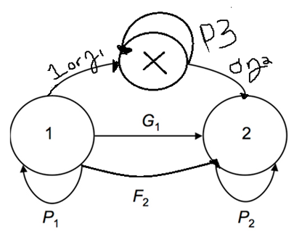

(States) 1= Juveniles

(States) 2= Adults

(States) X= Sub-adults

M= Probability of maturing

G1= Rate of survival of juveniles to adulthood

P1= Probability of survival of juveniles

P2= Probability of survival of adults

P3= Probability of sub adults staying sub adults

F2= average # of babies produced*σ

P1= (1-M)P1

This equation means that the probability of juveniles is 1 minus the probability of maturing times the probability of survival for the juveniles.

When we estimate the probability of juveniles of surviving and reaching maturation:

G1= P1 * M

How we calculate the how many juvenile individuals in the next generation:

1(t+1)= P1(1-M)1(t)+ F2(2)(t)

This equation is that the probability of survival of juveniles times the probability of maturing minus 1 times to calculate how many individuals will be in the next generation.

The equation below is the difference equation for sub adults:

X(t+1)=X(t)P2(1-M)+1(t)ʒ1

How we calculate how many adults individuals will continue to the next generation are:

2(t+1)=P1*M*1(t)+P2*N(t)

The difference equation for adults

2(t+1)=2(t)P2+ X(t)σ1ʒ2

9.

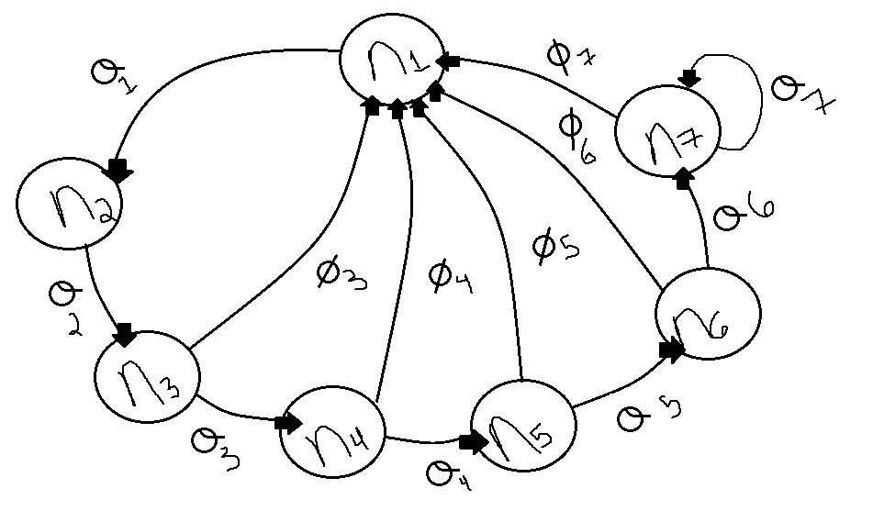

Figure 9.1- The table above is the life-cycle table for the 7 age classes of whales.

|  |  |  |  |  |  |
| --- | --- | --- | --- | --- | --- |
| sigma1 | sigma 2 | sigma 3 | sigma 4 | sigma 5 | sigma 6 |
| 0.87 | 0.87 | 0.87 | 0.87 | 0.87 | 0.87 |
| sigma 7 | phi 3 | phi 4 | phi 5 | phi 6 | phi 7 |
| 0.87 | 0.19 | 0.44 | 0.5 | 0.5 | 0.45 |

Table 9.1- Above is a table of the values we calculate for the sigma and phi of the whale’s7 age class.

Figure 9.2- This graph shows the projected populations of whale classes 1-3.

Figure 9.3- This graph shows the projected populations of whale classes 4-7.

|  |  |  |  |  |  |  |  |
| --- | --- | --- | --- | --- | --- | --- | --- |
|  | Juveniles | Adults |  |  |  |  |  |
| Year | Age Class 1 | Age Class 2 | Age Class 3 | Age Class 4 | Age Class 5 | Age Class 6 | Age Class 7 |
| 0 | 200 | 150 | 120 | 90 | 80 | 60 | 100 |
| 2 | 177.4 | 174 | 130.5 | 104.4 | 78.3 | 69.6 | 139.2 |
| 4 | 207.321 | 154.338 | 151.38 | 113.535 | 90.828 | 68.121 | 181.656 |
| 6 | 239.9373 | 180.36927 | 134.27406 | 131.7006 | 98.77545 | 79.02036 | 217.30599 |
| 8 | 270.145936 | 208.745451 | 156.921265 | 116.818432 | 114.579522 | 85.9346415 | 257.803925 |
| 10 | 297.483998 | 235.026964 | 181.608542 | 136.5215 | 101.632036 | 99.6841841 | 299.052552 |
| 12 | 329.806842 | 258.811078 | 204.473459 | 157.999432 | 118.773705 | 88.4198713 | 346.900961 |
| 14 | 368.071928 | 286.931952 | 225.165638 | 177.891909 | 137.459506 | 103.333124 | 378.729124 |
| 16 | 411.878332 | 320.222577 | 249.630799 | 195.894105 | 154.765961 | 119.58977 | 419.394155 |
| 18 | 459.528494 | 358.334149 | 278.593642 | 217.178795 | 170.427872 | 134.646386 | 468.916015 |
| 20 | 512.040797 | 399.789789 | 311.750709 | 242.376469 | 188.945551 | 148.272248 | 525.099289 |
| 22 | 570.781861 | 445.475494 | 347.817117 | 271.223117 | 210.867528 | 164.38263 | 585.833238 |
| 24 | 636.673459 | 496.580219 | 387.56368 | 302.600892 | 235.964112 | 183.454749 | 652.687805 |
| 26 | 710.200434 | 553.90591 | 432.024791 | 337.180401 | 263.262776 | 205.288777 | 727.444022 |
| 28 | 792.069673 | 617.874378 | 481.898141 | 375.861568 | 293.346949 | 229.038615 | 811.477535 |
| 30 | 883.29741 | 689.100616 | 537.550709 | 419.251383 | 326.999564 | 255.211846 | 905.249051 |
| 32 | 985.073021 | 768.468746 | 599.517536 | 467.669116 | 364.748703 | 284.489621 | 1009.60098 |
| 34 | 1098.62235 | 857.013528 | 668.567809 | 521.580256 | 406.872131 | 317.331372 | 1125.85882 |
| 36 | 1225.26142 | 955.801441 | 745.601769 | 581.653994 | 453.774823 | 353.978754 | 1255.57547 |
| 38 | 1366.47784 | 1065.97743 | 831.547254 | 648.673539 | 506.038975 | 394.784096 | 1400.31217 |
| 40 | 1523.96235 | 1188.83572 | 927.400367 | 723.446111 | 564.345979 | 440.253908 | 1561.73375 |

Table 9.2- Above is are the values calculates for whale age classes 1-7.

+

10.

|  |  |  |  |  |  |  |  |  |
| --- | --- | --- | --- | --- | --- | --- | --- | --- |
|  |  |  |  |  |  |  |  |  |
|  |  |  |  |  |  |  |  |  |
|  |  |  |  |  |  |  |  |  |
|  |  |  |  |  |  |  |  |  |
|  |  |  |  |  |  |  |  |  |
|  |  |  |  |  |  |  | Approx Euler | Euler with solver |
| X | S(x) | b(x) | l(x) | g(x) | l(x)b(x) | l(x)b(x)x | e^(-rx)l(x)b(x) | e^(-rx)l(x)b(x) |
| 0 | 530 | 0 | 1 | 0.77358491 | 0 | 0 | 0 | 0 |
| 1 | 410 | 2.5 | 0.77358491 | 0.09756098 | 1.93396226 | 1.93396226 | 0.963057934 | 0.889864592 |
| 2 | 40 | 3 | 0.0754717 | 0 | 0.22641509 | 0.45283019 | 0.056145404 | 0.047935497 |
| 3 | 0 | 0 | 0 | 0 | 0 | 0 | 0 | 0 |
|  |  |  |  |  |  |  |  | 0 |
|  |  |  |  |  |  |  |  |  |
|  |  |  |  | R0= | 2.16037736 | 2.38679245 | 1.019203338 | 0.93780009 |
|  |  |  |  |  |  |  |  |  |
|  |  |  |  |  | G= | 1.10480349 |  |  |
|  |  |  |  |  | r approx = | 0.69721259 |  |  |
|  |  |  |  |  | r solver = | 0.77625686 |  |  |

s(x)= is the age classes we are selecting

b(x)= is the average number of off spring per unit time born to a

female of age x, these are given values

l(x)= proportion of the original cohort that survives to the start of age x. The equation is s(x) age class divided by the one before.

g(x)= probability of survival from age x to age x + 1, given that an individual has already survived to age x. This equation is the l(x) value of one age class to the one before.

Net reproductive rate R0 = mean number of off spring produced per female over her

lifetime.

In this case mx is b(x).https://www.scienceopen.com/document_file/3885a866-736f-4825-b9be-c63dc2b846f7/PubMedCentral/image/e03_01

Generation time G = average age of the parents of all the off spring produced by a single cohort.

You can calculate the exact r value using the Euler Equation, which is listed in the above graph.