Moreno, Melissa

November 12, 2017

WIS 4934

Assignment 10

Assumptions-

-No tag shedding

-Constant survival rate **(S)**

-Putting tags back into the population immediately, not removing

-The fate of capturing an animal does not affect the fate of another animal being captured

-Poisson error structure

|  |  |  |  |  |  |  |  |
| --- | --- | --- | --- | --- | --- | --- | --- |
|  |  | Recapture Year | | | | | |
| **OTR** | Tag Year | 2013 | 2014 | 2015 | 2016 | 2017 | Total |
| 200 | 2012 | 10 | 4 | 19 | 9 | 3 | 45 |
| 150 | 2013 |  | 7 | 20 | 10 | 9 | 46 |
| 400 | 2014 |  |  | 70 | 25 | 25 | 120 |
| 200 | 2015 |  |  |  | 22 | 13 | 35 |

Table 1.1- Observed tagged returns **(OTR).** This is the observed and raw data collected.

|  |  |  |  |  |  |  |  |  |
| --- | --- | --- | --- | --- | --- | --- | --- | --- |
|  |  | Recapture Year | | | | |  |  |
| **M** | Tag Year | 2013 | 2014 | 2015 | 2016 | 2017 | Total | **MLE** |
| 200 | 2012 | 146.97 | 107.99 | 79.36 | 58.31 | 42.85 | 435.48 | 0.10 |
| 150 | 2013 |  | 110.22 | 81.00 | 59.52 | 43.74 | 294.47 | 0.16 |
| 400 | 2014 |  |  | 293.93 | 215.99 | 158.72 | 668.64 | 0.18 |
| 200 | 2015 |  |  |  | 146.97 | 107.99 | 254.96 | 0.14 |
|  | **Surv (S)** | 0.73 | 0.73 | 0.73 | 0.73 | 0.73 |  |  |
|  | **Pcap t** | 0.07 | 0.05 | 0.24 | 0.14 | 0.14 |  |  |

Table 1.2- Marks available to be recaptured **(M)**. **MLE** is the maximum likelihood estimate of the likelihood of making the observations given the parameters. **S** is the survival per year, and **Pcap t** is the probability of capture for a given year.

Discussion-

Our survival rate **(S)** is constant, since we are assuming that it will be the same for all years and cohorts. We can see that the highest **Pcap t** is on year 2015, when the year before there were 400 tagged animals added to the population. We can conclude that the more tags sent out in each year, should allow for a higher probability of capturing the tag in the next year since we are assuming no tag shedding. And, also, if more tags are sent out and more individuals are caught, the higher our **MLE** will be. We can see that the highest **MLE** is in year 2014, when more individuals were tagged, and several were caught that year.

|  |  |  |  |  |  |  |  |
| --- | --- | --- | --- | --- | --- | --- | --- |
|  |  | Recapture Year | | | | | |
| **PTR** | Tag Year | 2013 | 2014 | 2015 | 2016 | 2017 | Total |
| 200 | 2012 | 10.00 | 5.44 | 19.04 | 8.01 | 6.06 | 48.55 |
| 150 | 2013 |  | 5.56 | 19.43 | 8.17 | 6.19 | 39.35 |
| 400 | 2014 |  |  | 70.53 | 29.65 | 22.46 | 122.64 |
| 200 | 2015 |  |  |  | 20.17 | 15.28 | 35.46 |

Table 1.3- Predicted tag return **(PTR)**.

Discussion-

We can see in Table 1.3, compared to Table 1.1 **(OTR)**, shows that our predicted tag returns for those years and cohorts is generally less than our actual observed tag returns **(OTR)**, but not by much. We can see that for year 2012 and 2015, we predicted higher tag returns **(PTR)**, but the other years are slightly less or just about the same. With very overall similar predicted and observed tags, we might be able to assume that the observed tag returns **(OTR)** are representational of the true capture probability for each year and cohort.

|  |  |  |  |  |  |  |  |
| --- | --- | --- | --- | --- | --- | --- | --- |
|  |  | Recapture Year | | | | | |
| **NLL** | Tag Year | 2013 | 2014 | 2015 | 2016 | 2017 | Total |
| 200 | 2012 | -13.03 | -1.33 | -36.94 | -10.72 | 0.66 | -61.36 |
| 150 | 2013 |  | -6.45 | -39.91 | -12.83 | -10.22 | -69.41 |
| 400 | 2014 |  |  | -227.39 | -55.09 | -55.33 | -337.81 |
| 200 | 2015 |  |  |  | -45.92 | -20.16 | -66.09 |
|  |  |  |  |  |  |  | -534.67 |

Table 1.4- Assuming a Poisson error structure, the total negative log likelihood **(NLL)** is minimized by changing survival **(S).**

Discussion- Using the **OTR** and **PTR** we calculated our **NLL** per year and cohort.

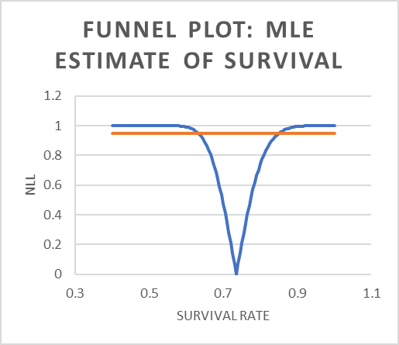

Figure 1.1- Funnel plot displaying the estimate survival rate **(S)**.

Discussion-

With the Total calculated, we were able to create a table that would calculate for us what the estimate survival rate would be in relation to our **NLL**. We used a 95% confidence interval, and Chi Squared test to create a funnel plot. The funnel plot displays that the survival rate would be 0.73. We can probably assume that this is a high survival rate for this animal/fish based on our **OTR** and **PTR**.