Melissa (Mel) Moreno

September 17, 2017

Assignment 3 Density Dependent

WIS4934

There are all wildlife populations, there are limiting factors that prohibit the population from growing exponentially. Some examples could be food, habitat, disease, territory, and cover. Usually all of these factors are contributing to a population either increasing or decreasing. If any of the factors are limiting the population in any way, we can consider this population, density dependent. We can use density-dependence to calculate the carrying capacity (K).

Density-Dependence definition-

Dependence of per capita population growth rate on present or past density, which is normally a negative relationship, but not always.

* Requires a feedback loop from the relationship of the factor and the population growth rate.
  + Requires a limiting or regulating factor that will ultimately decrease or increase the population growth rate (r ).
* Requires a rate of change in the population (r ), not just a total population size change, can also be a proportional change.

Total rate- Change in growth rate ( r) for the whole population.

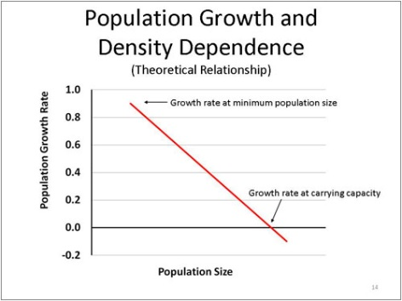Specific rate- Change in growth rate (r ) of an individual’s response as part of a population. (total rate/ population size)

(http://www.msudeerlab.com/img/dynamics/dynamics9.jpg)

Figure 1- Figure displaying density-dependence, when the population reaches carrying capacity (K) it growth rate ( r) will be 0.

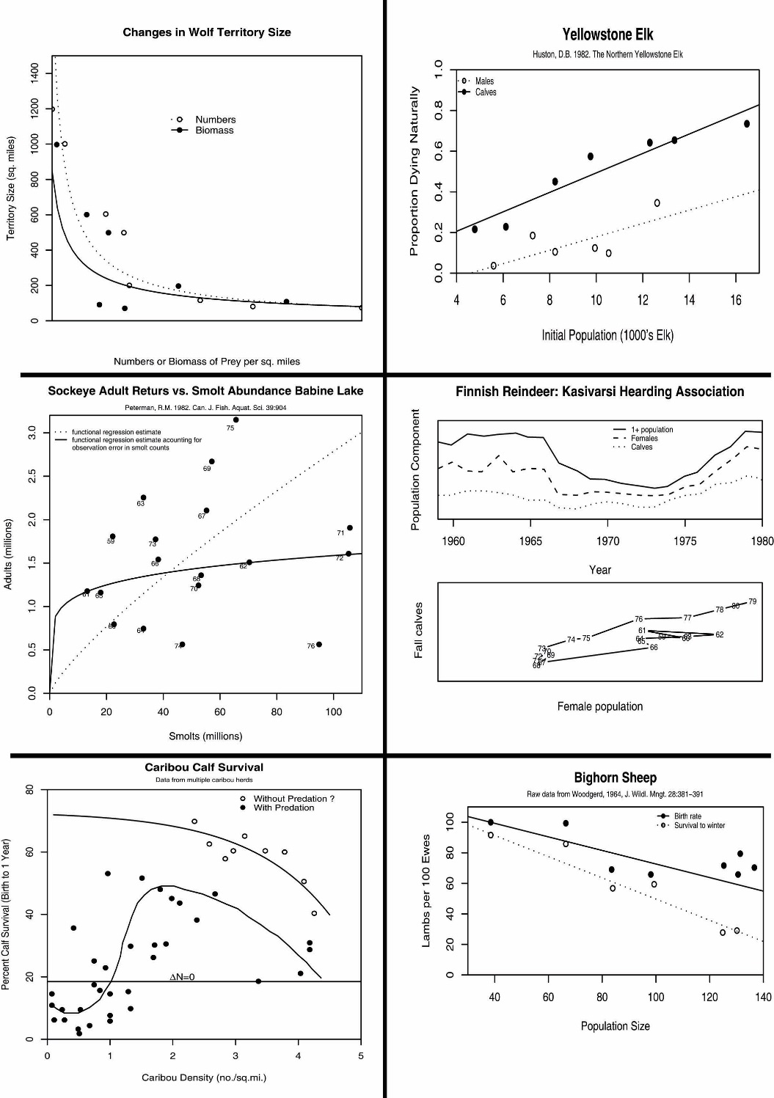Graph 1

In this graph we can see that as the wolf size territory decrease the numbers of biomass of prey increases. Wolves would need less of a territory size if there is a lot of prey available because they would not have to travel as much to hunt for food. This graph might also imply that if there is a lot of prey availability, more wolves might want to hunt/shelter in the same territory, making all of the territory sizes smaller in relation. This graph is not directly displaying density dependence because we don’t see a direct relationship with the population growth rate (r ) with either the prey availability or the territory size.

I would consider this graph as displaying a specific rate, because the graph is showing the individual response of the wolves territory size measured, instead of entire territory size of the wolf pack in relation to the prey biomass.

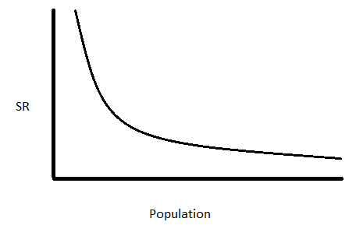Figure 2- Figure displaying a general decreasing curve line for a specific rate of a population.

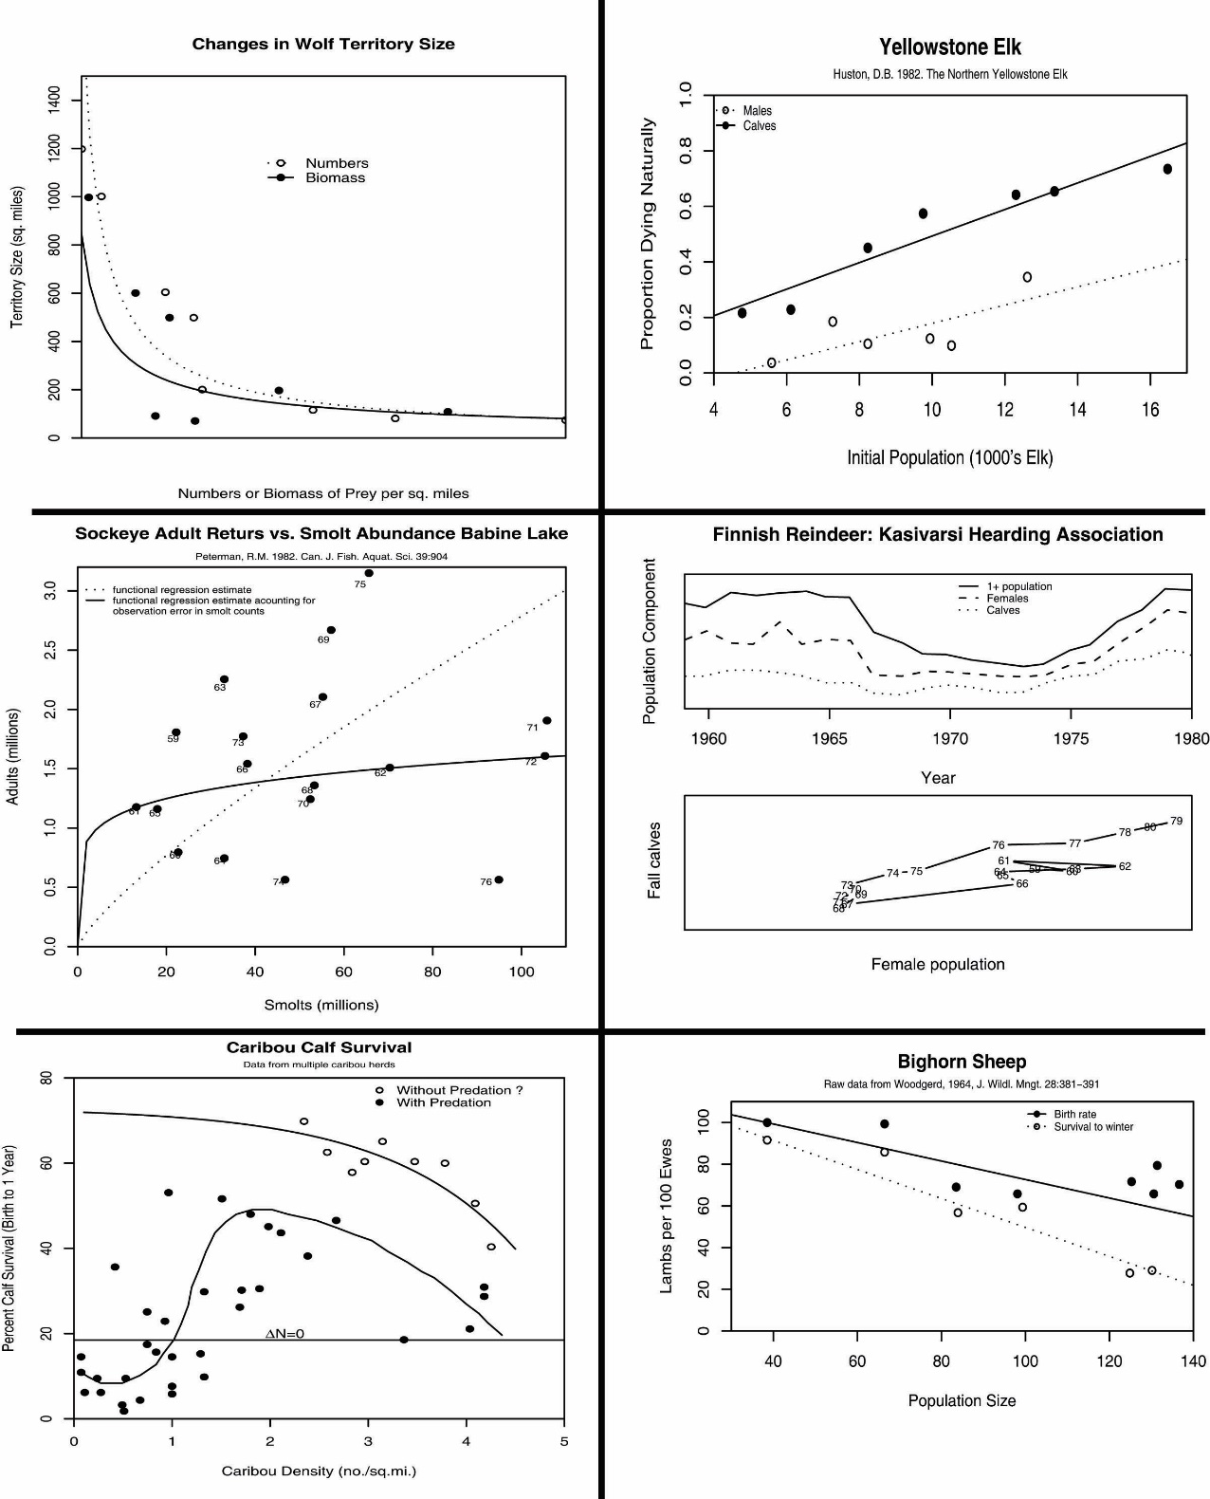Graph 2

In this graph it displays the portion of elk dying naturally is increasing as the population of elk is increasing. I would say that this is an obvious relationship, because as more animals are being born, eventually more animals will die. This relationship is density- dependent because the death rate (d ) is increasing with the population size (N). An example of a possible mechanism for elk naturally dying could be disease, competition, and reduction of food or resources.

This graph is displaying a total rate change since the entire elk population is being measured as a whole and not as an individual measurement.

Graph 3

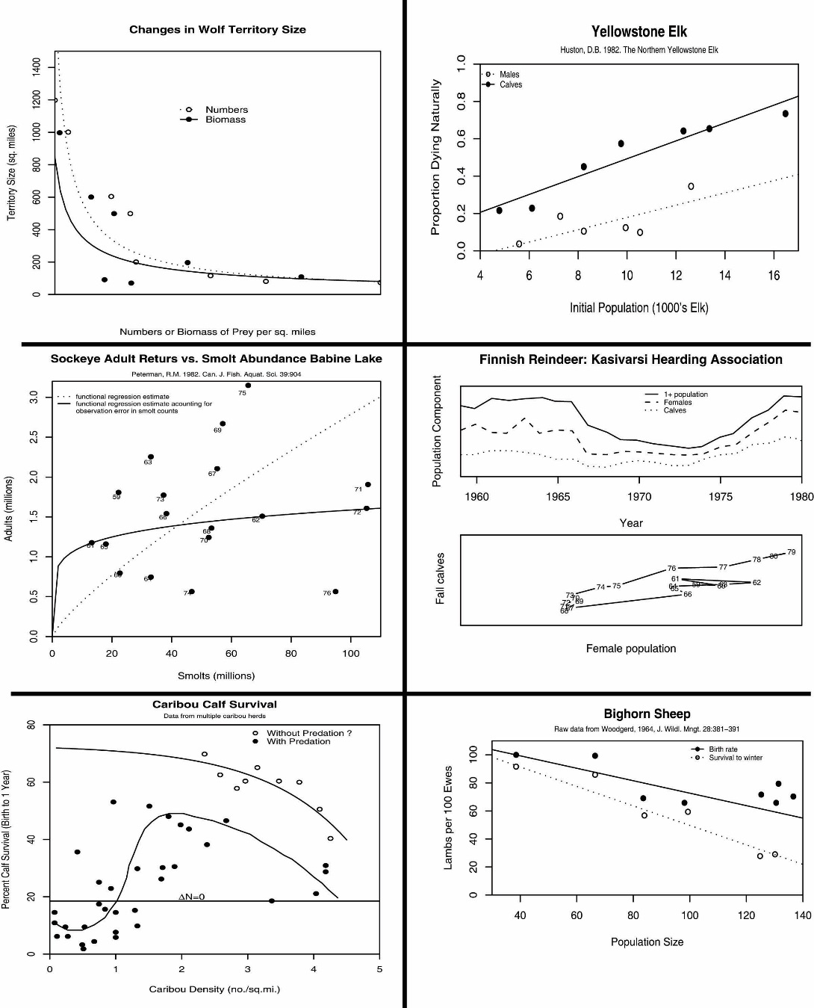In this graph we can see that there is a relationship between the juvenile smolts and the adult sockeye fish. This graph can be difficult to determine if it is density-dependent or not because in my definition, I require that density-dependence needs a population growth rate change (r ), and this graph is showing whole numbers of the sockeye’s adults and smolts. However, this graph is overall density-dependence because we can see that there is a proportional change in the rate of survival of smolts when there are a lot of sockeye adults. Some limiting factors that could be contributing to this density-dependence is resource availability, which might not the smolts continue to grow into adults.

This could be displaying total rate response since the graph is showing the entire population of the sockeye and not an individual response rate of with the adults or smolts.

Graph 4

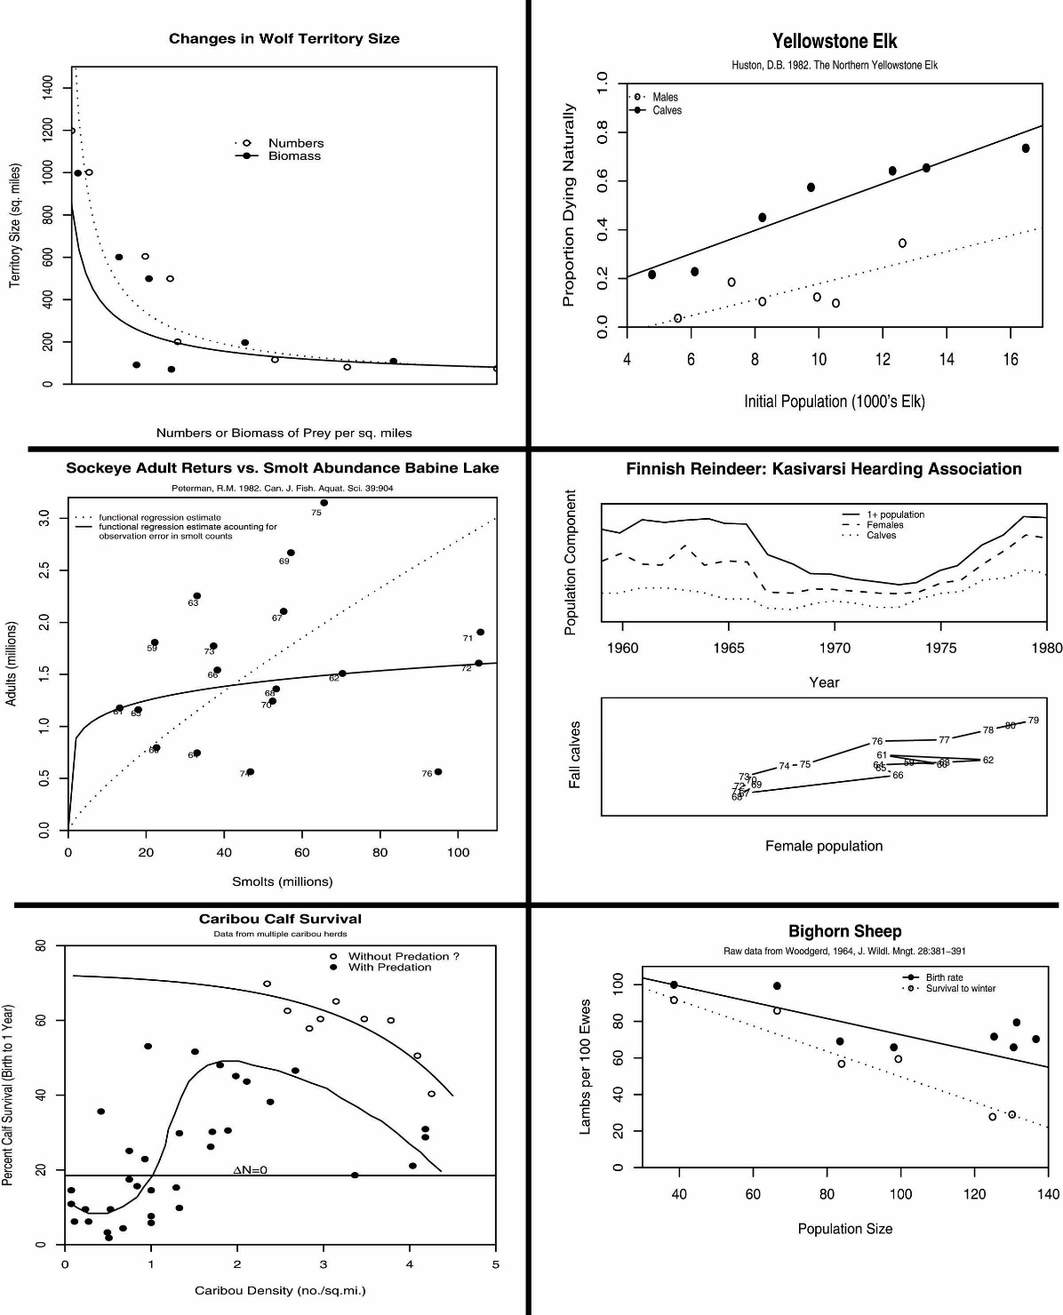The first graph, upper part, of the graph is displaying the reindeer over +1, females and calves for a given area and time. The second graph is displaying how in each year the number of fall calves, and the number of female population is associated. The second graph shows that the there was a decrease in the female reindeer population during years 1965-1974, which is also the what is displayed in the first graph. Neither graphs is displaying a relationship between the female reindeer population and the fall calves, so I would conclude both graphs are not showing density-dependence. There is no population growth rate change relationship that would fit in my definition of density-dependence.

I would consider this graph to show a total rate response, but there is no clear relationship between any of the variables. However, I definitely would not classify any of these graphs as having a specific rate.

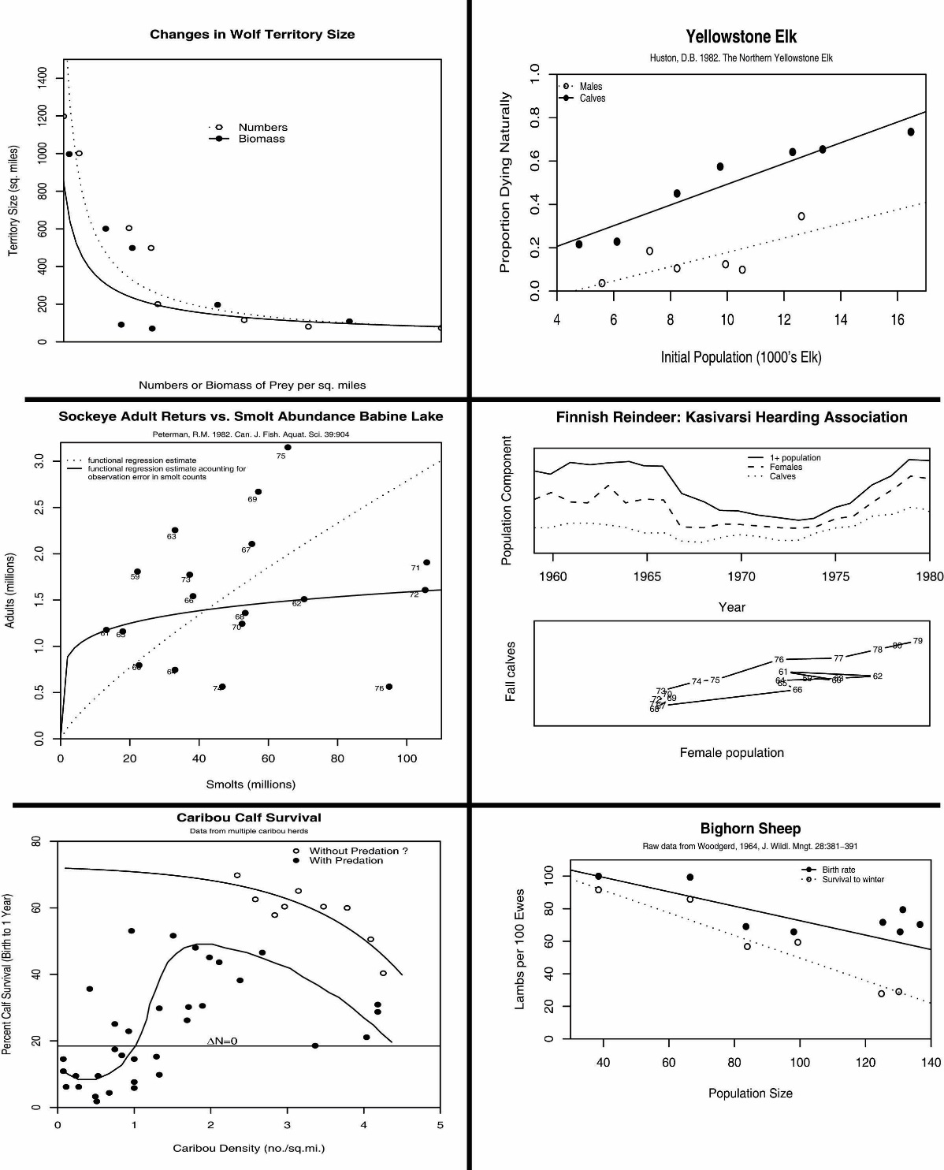Graph 5

This graph is displaying how caribou density is associated with the percent of calf survival. The relationship between is representative of an allee effect, especially a strong allee effect. When the caribou density is low, the percent of calf survival is low. This might be because at low caribou densities the adults might not be able to protect the calves from predation. When the caribou reach their carrying capacity (K), they are able to protect both themselves and the calves from predation while keeping a stabilized population size. After this capacity (K) the herd would run out of resources, and competition will being to increase among the caribou and calve and adult survival will begin to decrease.

I would consider this graph displaying the total rate change since we are dealing with whole population densities.

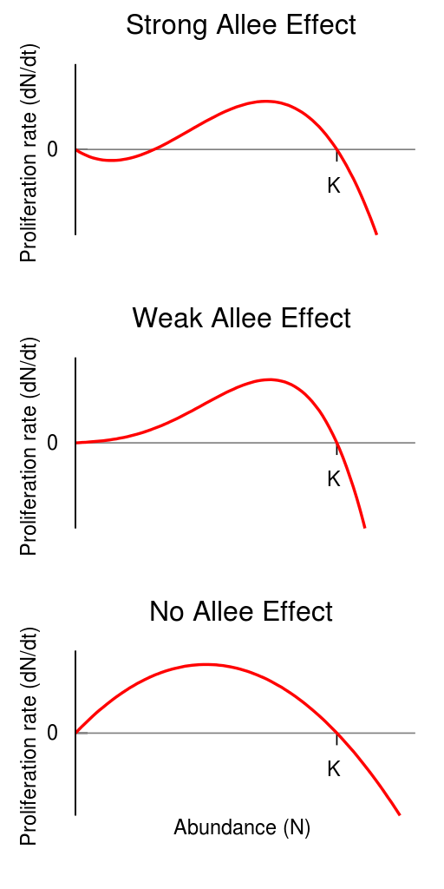

Figure 3- Figure displaying the different levels of the allee effect in abundance and proliferation rate.

(https://www.google.com/imgres?imgurl=https://upload.wikimedia.org/wikipedia/en/thumb/7/7f/A_graph_showing_the_difference_between_strong_and_weak_Allee_effects.svg/512px-A_graph_showing_the_difference_between_strong_and_weak_Allee_effects.svg.png&imgrefurl=https://en.wikipedia.org/wiki/Allee_effect&h=1024&w=512&tbnid=2gtHnyomHJaqJM:&tbnh=160&tbnw=80&usg=__fAxwA3ghYzSm-IyHDPWgTAF48BU=&vet=10ahUKEwiRhPe74KzWAhVEeSYKHWi_DhwQ9QEILDAA..i&docid=qhyy_JZCCr2FHM&sa=X&ved=0ahUKEwiRhPe74KzWAhVEeSYKHWi_DhwQ9QEILDAA)

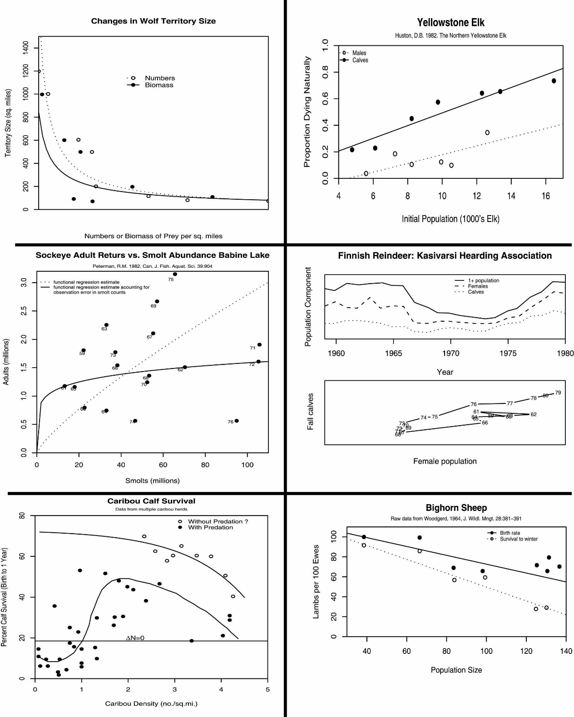Graph 6

In this graph we can see the associate between the bighorn sheep lambs per 100 ewes and sheep population size. As the population size is decreasing, so is the lamb size per 100 ewes. I would conclude that there is density-dependence because both rates are changing when the population size increases. We can see that both survival rates and birth rates are decreasing as population increases. One reason this could happen in a population is effected by resource limitation, such as food or water, in which both survival and birth rates decrease.

I would consider this graph to have a specific rate, even though it is not per individual lamb but per 100 ewes.