**Moreno, Melissa**

**September 24, 2017**

**WIS 4934**

**Assignment 4 A Question of Balance.**

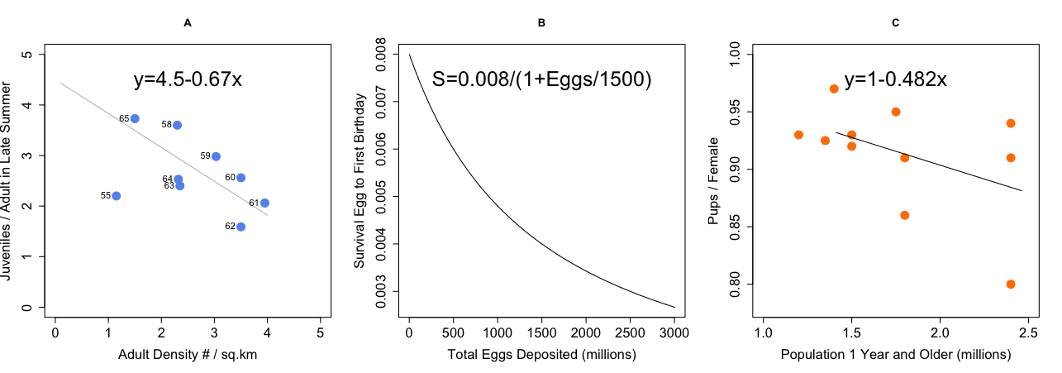A: Ptarmigan Population (From Bergerun, Oikos 21:299). Sexes are harvested non-selectively, in fall. The late summer juvenile production is apparently density dependent and is related to late summer adult density, see figure plot A. Juveniles recruit to the breeding population after 1 year. The late summer survival rate of juveniles 0.6, and of adults is 1.0. The winter survival rate (after hunting to next breeding) of both adults and juveniles is density independent, and is about 0.6.

Figure 1.1-Late summer juvenile production measured in late summer.

**-Variables**

Sas=1 Sjw=0.6

Saw=0.6 Sjs=0.6

Brslp=0.67 Brmax=4.5

Figure 1.2- Ptarmagin population displaying the harvest rate is 0.38. The equilibrium harvest 2.57 adult density per kilometer. The population equilibrium is at 2.46 adult density per kilometer.

**Defining N-**

The N +1 population of juvenile and adults in the late Summer

**-Balance Model (assuming harvest)**

Nt+1= Nt*Sas*(1-hr)*Saw+(4.5-0.67Nt)Nt*Sjs(1-hr)*Sjw

- The balance model for the Ptarmagin population is calculated by multiplying the harvest rates to all of the adult and juvenile survival in winter and summer seasons, and by juvenile production, which is density independent.

**-Equilibrium Population (assuming harvest)**

Ne= (Sas*Saw +4.5*Sjs*Sjw-(1/(1-hr))/ (0.67*Sjs*Sjw)

- The equilibrium population is calculated by adult seasonal survival and the juvenile seasonal survival and simplification of the harvest rates, divided by the slope of the juvenile seasonal survival.

**-Equilibrium Harvest**

He= hr(Ne*Sas+ (4.5-0.67*Ne)*Ne*Sjs)

-The equilibrium harvest is the harvest rate of the equilibrium population of both the adult and juvenile summer survival adding the total population slope. We need to calculate the equilibrium harvest before the Fall season, to see how much Ptarmagin density per kilometer can be harvested prior to the harvesting season.

**-Assumptions**

-Juveniles and adults are harvested, in the Fall

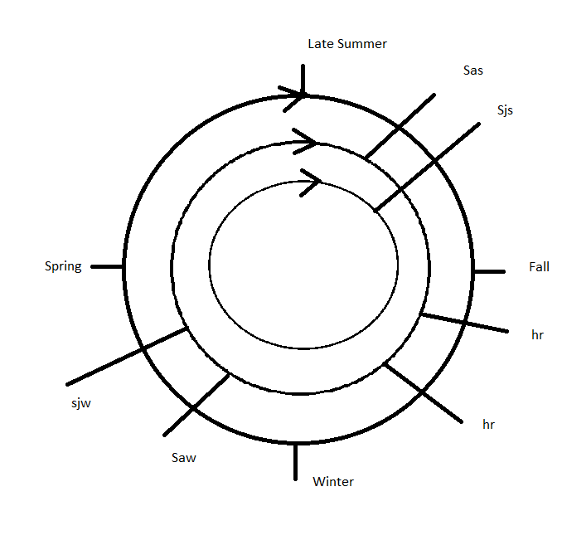- Juveniles population (Sjs) calculated after harvested

Figure 1.3- Graphic showing the juvenile and adult survival through late summer to spring. We can see that there is harvest for both the adults and juveniles in the Fall.

B: Lake Superior Lake Trout (from Walters, 1981, J. Fish. res. Board Can.: 2133). Lake Trout mature at their 8th birthday, and females reproduce every other year thereafter. The average fecundity is 6000 eggs/female, and the sex ratio is 50:50 (NB: these are poor assumptions when harvest rate is high). The survival rate from hatching to first birthday is density dependent, according to figure plot B. The natural annual survival rate thereafter is 0.8. Fish become vulnerable to harvesting by age 7.



Figure 2.1- Egg to fry survival for Lake Superior Lake Trout.

**-Variables**

Sa= 0.8 br=1500x

Sj=0.8

Figure 2.2- The trout population equilibrium would be around 2.52 million. Equilibrium harvest is at 1.62 million. The harvest rate is .33.

**Defining N-**

Adult population 8+ years in the early Summer

**-Balance Model**

Nt+1=Nt*Sa(1-hr)+1500Nt((0.008/1+1500Nt/1500))Sa^7*(1-hr)

- The balance model will be the population times the adult survival harvest rate, with the egg proportion of the population, and times the survival of the harvesting from ages 1-7.

**-Equilibrium Population**

Ne=(Sa-Sa*hr+12Sa^7(1-hr)-1)/(1-Sa+Sa*hr)

- The equilibrium population is the is the surviving adult and the adult harvest rate times the harvest rates of the adults from ages 1-7, divided by the surviving adult harvest rate at one year.

**-Equilibrium Harvest**

He= hr(Ne+(12Ne/1+Ne))* Sa^6

**-Assumptions**

-Harvested in Summer season

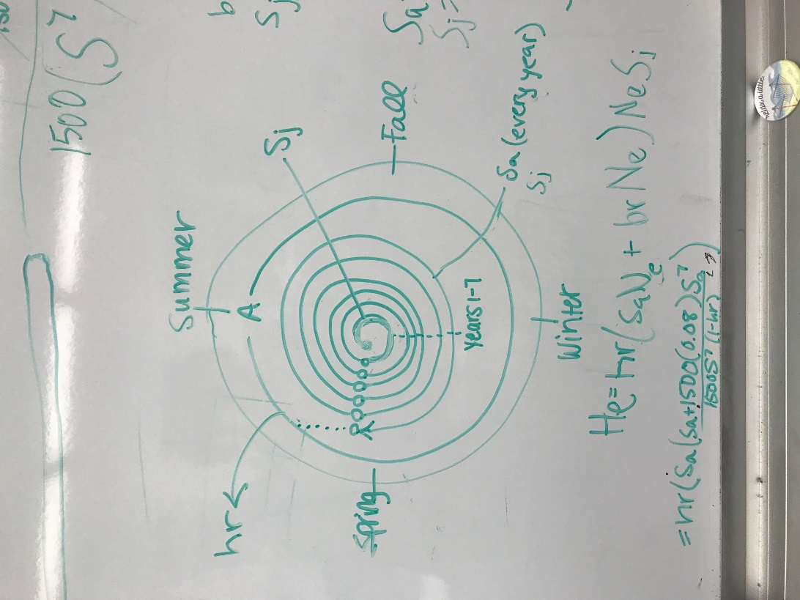 -Sex ratio, 50:50, so 6000/3= 1500, 1500x

Figure 2.3- Graphic showing that harvest occurs from spring to summer. In the fall to winter months, juveniles will become adults after 1 year.

C: Harp Seals (from Winter, 1978, J. Fish. Res. Board Can.: 1249). Assume the animals enter the breeding population at age 4 and the sex ratio is 50:50. Consider only pup harvest in the first few week of life on the ice when they still have their white coats. Assume the annual survival rate (including pups after they leave the ice) is 0.85. Pup production per female relates to total stock (1 year and older (1+)) as shown in figure plot C.

Figure 3.1- Harp Seal pup production as a function of 1yr and older population size.

**-Variables**

Sa=0.85 Brslp=0.482

Sj=0.85 Brmax=1

Br= 1-0.482x

Figure 3.2- Harp seal population will have an equilibrium harvest at .328 million. The equilibrium population would be 0.87 million. The harvest rate at .335.

**Defining N-**

Seals +1 years, in late winter

**-Balance Model-**

Nt+1= Nt*Sa+(1-0.482Nt)*0.5*Nt*Sa^3(1-hr)Sa

- Since at age 4 the sex ratio is 50:50, the survival is calculated after year 3 with 0.5. That survival is then applied to the survival rate.

**-Equilibrium Population**

Ne=(Sa+0.5*Sa^4(1-hr)-1)/(0.241*Sa^4(1-hr))

- For the equilibrium population the survival rate of half of the population is applied to the survival of the population from ages 1-4, which is then divided by the half of the birth rate slope and the harvest rate of the survival from ages 1-4.

**-Harvest Equilibrium**

He=hr(1-0.482Nt)*0.5Nt*Sa^3

- The harvest rate is the slope of the population applied to ½ of the population sex ratio and the survival of the harp seals from ages 1-3.

**-Assumptions**

- Harvest occurs early spring

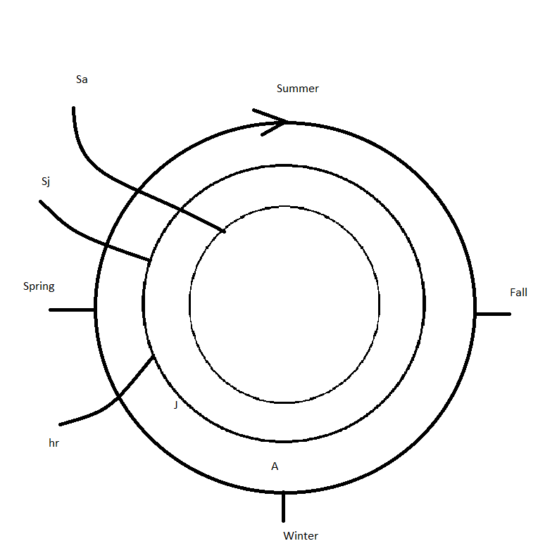

Figure 3.3- For the harp seals the harvest occurs in early spring. Harp seal juveniles are born in mid spring and then at 4+ age the juveniles are mature around late spring.