**Moreno, Melissa**

**October 22, 2017**

**WIS 4934**

**Assignment 7 Evaluating Feedback Policies for Limiting Harvest Rates**

Using the spreadsheet Solver technique and the balance model below (like the balance model used in early labs). Perform and open loop optimization to determine feedback policy rules. Solve for an optimum sequence of annual exploitation rates (the vector of harvest rates) over 100 yrs assuming management objectives are to maximize 1) Total harvest over the 100 years 2) Total log utility of the harvest. Note that log utility is the sum of ln(catch). If catch in any year is zero then the natural log is negative infinity so this function penalizes years with no harvest strongly. Evaluate the optimal harvest sequence and explore the emerging feedback policy by plotting both harvest rate vs. population size and harvest vs. population size for each objective under two conditions.

Condition #1

* Random effects on juvenile survival are independent from year to year, such that sjt=sj*exp(vt) where vt is a random variable from a normal distribution with mean 0 and standard deviation 0.5, sj is the average rate described below, and exp is the exponential.

Objective 1) Total harvest over the 100 years

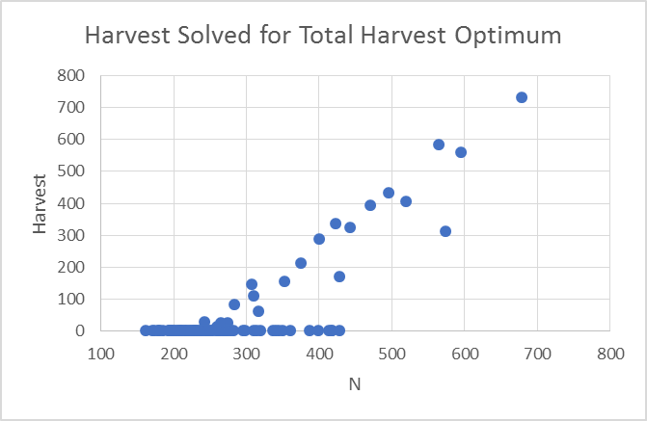

Figure 1.1- Graph showing the harvest optimization as the population is increasing. We can see around 250 N, the harvest rate will increase dramatically. As N increases, after 250 N, the harvest will also increase. Below 250 N, we can see that the optimum harvest should be around 0.

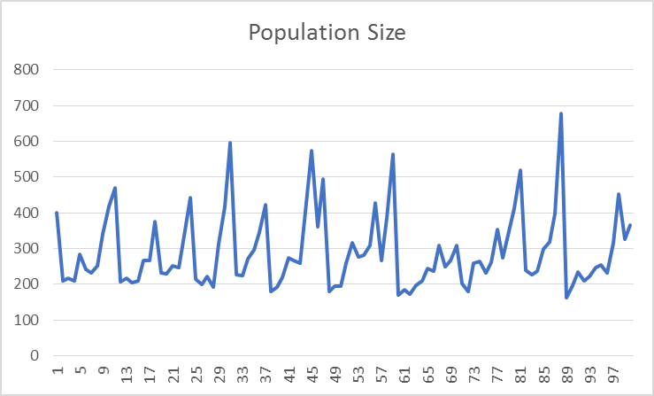

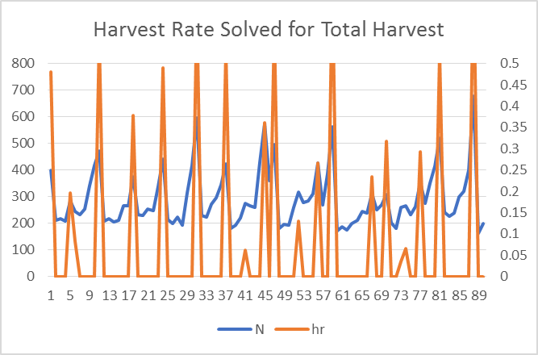Figure 1.2- Graph displaying the harvest optimization per year with an increasing population rate. We can see that the manager will be able to harvest more towards the 100 year mark, because there is more individuals to harvest. The harvest optimization rate will not being the population to extinction.

Figure 1.3- Graph displaying that as individuals increase in population, the harvest rate will increase. Throughout the years, the population will cycle from a high to low population numbers. When the population numbers get to 200, the harvest rate dramatically drops. We can also see that the harvest rate will be considerably higher than the next condition.

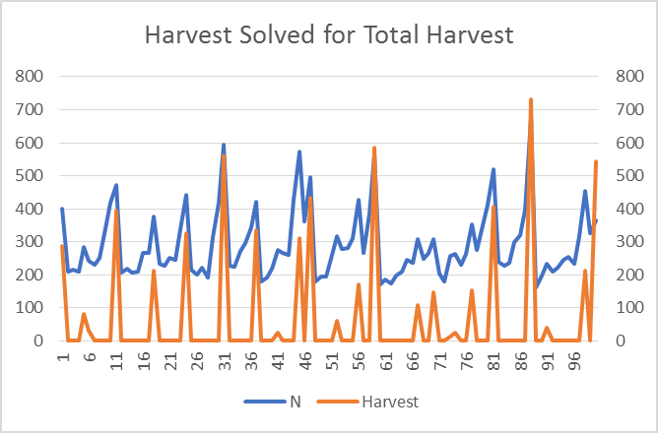

Figure 1.4- Graph displaying that as individuals increase in population, the harvest total will increase. Throughout the years, the population will cycle from a high to low population numbers. This could be due to a resource limiting factor, such as the classic example of the lynx and snow show hare. When the population numbers get to 200, the harvest total drops quickly to 0. This suggests that the population will not be able to sustain itself with any harvesting, at that population number size. We can see that in this condition, the population numbers and total harvest is higher.

Objective 2)

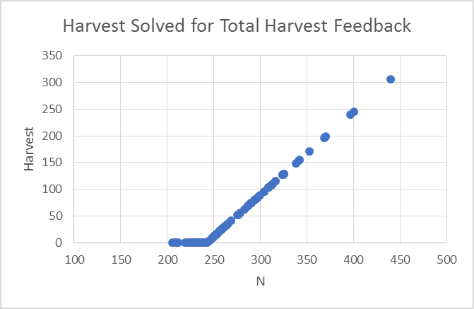Total log utility of the harvest. Note that log utility is the sum of ln(catch). If catch in any year is zero then the natural log is negative infinity so this function penalizes years with no harvest strongly. Evaluate the optimal harvest sequence and explore the emerging feedback policy by plotting both harvest rate vs. population size and harvest vs. population size for each objective under two conditions.

Figure 1.5- Graph displaying the harvest for the total harvest feedback. We can see that the feedback loop is linear with breaks as the population grows. This suggests that harvesting should be done in the beginning of the management plan, and have breaks as population numbers increase.

Figure 1.6- 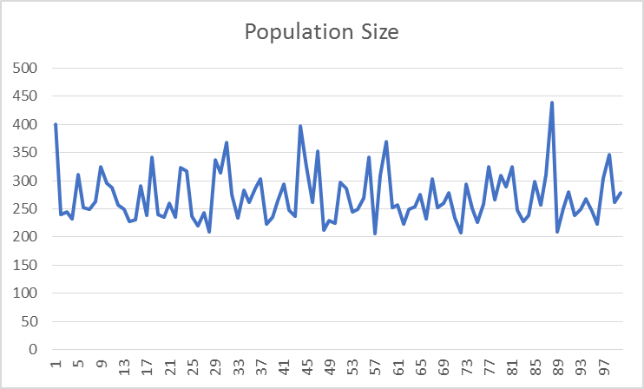 Population size for this condition is relatively similar throughout the 100 years. We can see some spikes in the population size, but it relatively stays around 250 to 350. By emerging the feedback policy, the population size will drop in the beginning, since that is the best time to harvest, and then the population size will remain constant.

Figure 1.7- Graph showing 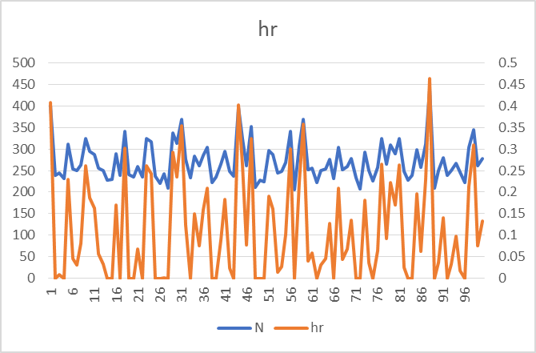the harvest rate for the feedback policy. We can see that the harvest rate and population numbers are less than in condition one. There is more need for no harvesting with this policy. Overall the population will remain stable if there is a variable harvest rate throughout the 100 years.

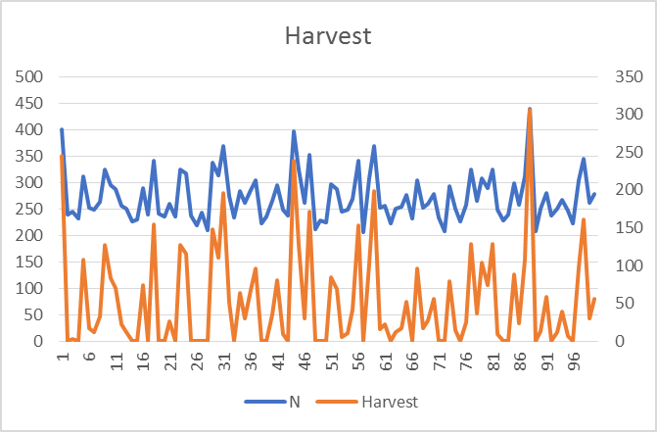

Figure 1.8- Graph display the population numbers in relation to total harvest during the feedback policy management strategy. The population will remain moderately the same while

Condition #2

* Random effects are correlated from year to year, using the relationship wt+1=0.8wt + 0.2vt. Where wt is the lognormal effect applied to survival in year, vt is the normal deviate you used as independent effect. 0.8 is the "lag 1 autocorrelation" and 0.2 is the standard deviation of annual changes in w such that sjt=sj*exp(wt). Note that in the first year wt=vt. Correlation over time in random effects should exaggerate any cyclic or "regime shift" affects you were seeing with independent effects.

1) Total harvest over the 100 years

Objective 2

Total log utility of the harvest. Note that log utility is the sum of ln(catch). If catch in any year is zero then the natural log is negative infinity so this function penalizes years with no harvest strongly.

For each case, find a feedback policy rule to approximate the optimum policy (remember these rules are usually simple linear relationships), by plotting the optimum exploitation rates and/or catches versus annual population size N. The feedback policy rule should be a smooth function of exploitation rate or catch vs. N, which could be implemented in the field knowing only N (but not knowing future environmental effects). Apply this function to calculate the annual and total harvests, and report how big the loss in yield would be compared to following the "open loop, perfect knowledge" exploitation rate sequence obtained with Solver.

The balance model is

*Nt*+1=*SaNt*(1−*h*)+*brNtSj*(1−*h*)

*Sj*=*Sjmax*(1−*NtNK*)

N is the adult population size, h is the harvest rate, Sa is the adult survival rate (0.8), br is the birth rate per adult (0.5), Nk equals (1000) and Sjmax is the maximum juvenile survival rate (0.7).Note that Juvenile survival is density dependent.

Extra Credit-

A nice addition is to explore what happens to the performance of these simple policies as the ability to estimate N degrades. One potential way to explore this is to instead of using the true value of N to look up the catch or harvest rate to apply each year you can add error to this value such that the N used is N*exp(et) where e is a normally distributed error term with mean 0 and as standard deviation that you can specify to suggest low or high implementation error.