**Moreno, Melissa**

**November 4, 2017**

**WIS 4934**

**Assignment 9 - Alas poor Bambi. I knew him Horatio… #hamlet**

 The Disney Corp. hired you as the regional manager responsible for the deer herds in Bambi’s forest, and you would like to know something about the mortality rates in the population. Last year you collected jaws from hunters and measured the composition of the kills:

|  |  |  |  |  |  |  |  |
| --- | --- | --- | --- | --- | --- | --- | --- |
| Age | 0 | 1 | 2 | 3 | 4 | 5 | 6+ |
| Number of females killed in 2007 | 96 | 60 | 34 | 22 | 20 | 10 | 18 |

 Your predecessor trapped 200 female fawns in July 1998, and ear tagged each animal. A very good reward was offered for returning the tag, with the following results:

|  |  |  |  |  |  |  |  |  |
| --- | --- | --- | --- | --- | --- | --- | --- | --- |
| Year | ‘99 | ‘00 | ‘01 | ‘02 | ‘03 | ‘04 | ‘05 | ‘06 |
| Number of Tags Returned | 40 | 15 | 12 | 12 | 10 | 3 | 0 | 1 |

This summer you collected skulls of animals who died naturally on the winter range; you cannot be sure when the animals died, but it appears that the skulls do not decompose for at least one year. Your results were:

|  |  |  |  |  |  |  |  |
| --- | --- | --- | --- | --- | --- | --- | --- |
| Age | 0 | 1 | 2 | 3 | 4 | 5 | 6+ |
| Number of Female Skulls | 30 | 10 | 15 | 5 | 5 | 6 | 10 |
|  |  |  |  |  |  |  |  |

What do you conclude about the age specific natural and harvest mortality rates in this population? Be sure to indicate all of your assumptions clearly.

Assumptions

-100% tag retention

- Closed population

- Fawn is year 0-1 in 1998

- Fawns that had tags returned at year 1999, are age 1

- There are more than 200 female fawns, so the 200 tagged were not 100% of the female fawn population

-H, harvesting is in the fall

-1000 total individuals, starting population

-N is Spring population after Winter mortality

Table 1.1- Table displaying the data and calculated proportional harvest and mortality rates, and conditional harvest and mortality rates. Both conditional harvested and natural mortality are following a similar trend as proportional harvest and mortality rates.



Table 1.2- Table displaying population size that has died per age class that are being influenced by harvest, and natural mortality, respectively. Both in harvesting and natural mortality, after year 0, the population size drastically declines, but both increase slightly after age 6.

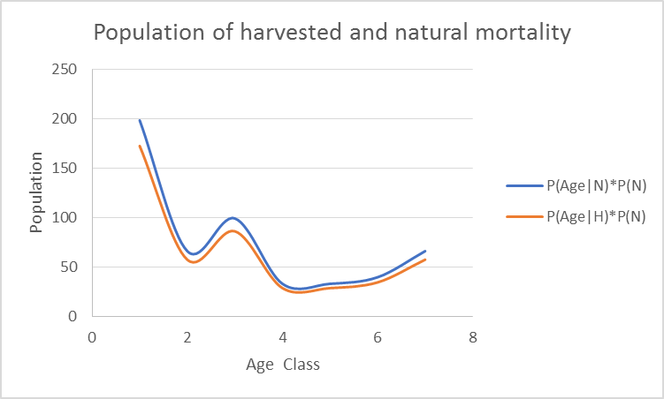Table 1.3- Table displaying total hunted and natural mortality rates with the difference of the previous age classes. The hunted mortality rate will ultimate reach to 46% after age 6, but the natural mortality rate will be 100% at that age.

Figure 1.1- The population size considering conditional harvested and natural mortality. We can see in the graph that both hunting and mortality deaths are roughly occurring in similar trends. There is high mortality and hunting in age class 0-1, with a deep downward slope, but we see a bump of harvesting and natural deaths around age class 3. The overall trend is that the population size is declining considering both hunted and natural mortality.

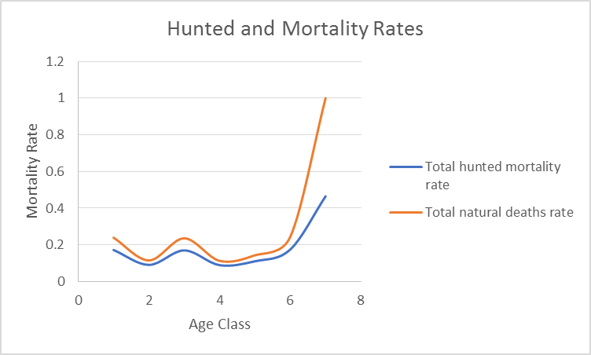Figure 1.2- At age class 6+, the mortality rate of the deer will reach to 1, meaning that 100% of the deer population will not survive past that age class. Their mortality is influenced by the likelihood that they will naturally die based on the prior information we have on the age classes. The total hunted mortality rate at 6+ will be about 50% of the population. The mortality rates is considering conditional harvested and natural deaths.

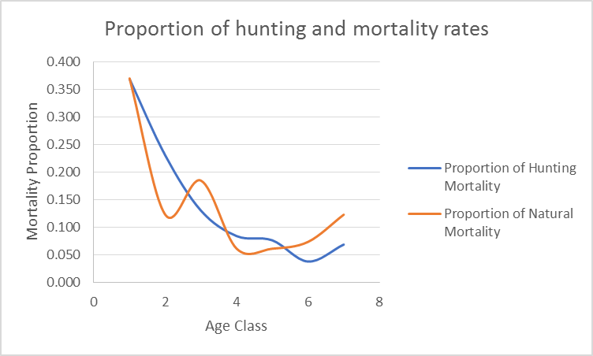

Figure 1.3- Graph displaying the proportion of harvested and mortality rates. The graph shows that the portion of harvest mortality proportion will decrease over time, but natural mortality proportions will undulate from increasing to decreasing, but ultimately increase after age 6.

Conclusion- Based on Figure 1.1 and Figure 1.2, I would conclude that older deer are more susceptible to natural mortality than young deer, but those same younger deer are more vulnerable to harvesting at that age. With this information, I would not be able to conclude a strong management plan for Disney, but I would advise that if harvest rates are too high for young deer, it could cause an issue for population size once the deer are older. And if mortality rates are too high, we could see a declining population size trend. The current birth rate is not known, we don’t know how these mortality rates are drastically affecting the real population size numbers. More information would be needed to create an efficient management plan.