Moreno, Melissa

October 31, 2017

WIS 3934

Lincoln-Petersen

Question 1: Choose one small population (50) and one large population (600) and choose two different capture probability estimates (0.05 and the other 0.9) and explore the performance of the LP model and the Chapman modified LP for estimating abundance. To do this, you will fill the table in below (in the blank squares) with the true value of N and p-hat that you input into your spreadsheet.

|  |  |  |  |  |  |  |  |  |
| --- | --- | --- | --- | --- | --- | --- | --- | --- |
|  | Capture probability value high | N (small population, high capture probability) | Capture probability value low | N (small population, low capture probability) | Capture probability value high | N (large population, high capture probability) | Capture probability value low | N (large population, low capture probability) |
| True value used | 0.9 | 50 | 0.05 | 50 | 0.90 | 600 | 0.05 | 600 |
| Estimated N Lincoln-Petersen | 51.69 |  | - |  | 609 |  | 300 |  |
| Estimated N Chapman modified Lincoln-Petersen | 51.675 |  | 15 |  | 609 |  | 239.50 |  |
| Approximate 95% Confidence intervals for Chapman modified LP | 51.60-45.19 |  | 18-1.6 |  | 584.54-572.41 |  | 1285-418 |  |

Table 1.1- Table displaying estimated population for a high and low population using Lincoln- Peterson and Chapman modified Lincoln-Peterson. We can see from this table that when there is a high capture probability, it doesn’t matter whether the population is low or high, it would still have less variance than if the capture probability was low.

2. Let’s evaluate the performance of the Lincoln-Petersen and the Chapman modified Lincoln-Petersen model using simulation. Create 500 replicated LP and Chapman modified Lincoln-Petersen estimates. Create plots using an N of 50 and capture probabilities of 0.10 and 0.80. Present the summary statistics and create frequency distribution plots to demonstrate the distribution of estimated N for each model and capture probability (create four plots total for full credit).

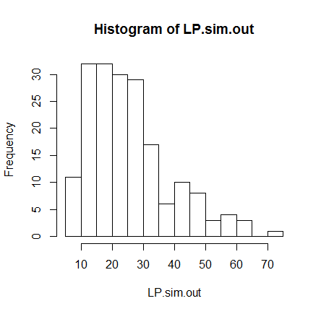

Figure 2.1- Chapman modified Lincoln Peterson with 0.10 capture probability.

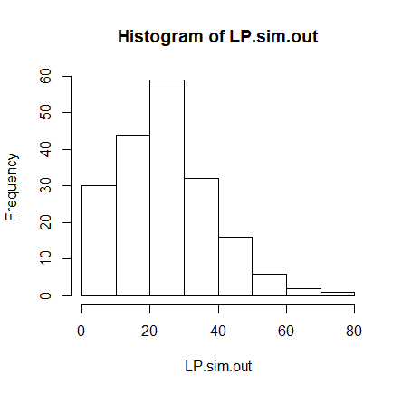

Figure 2.2- Lincoln Peterson with 0.10 capture probability.

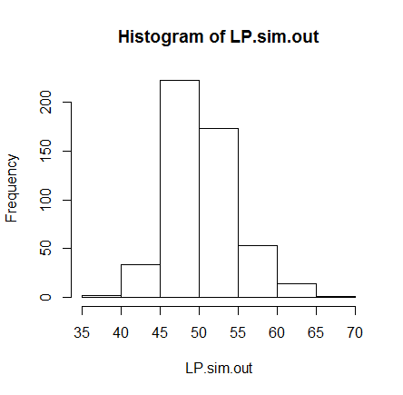

Figure 2.3- Chapman modified Lincoln Peterson with 0.80 capture probability.

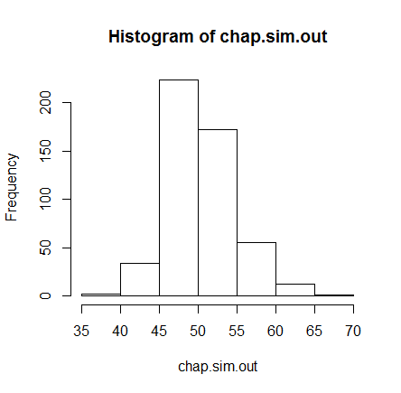

Figure 2.4- Lincoln Peterson with 0.80 capture probability.

Are there conditions when one model performs better than the other? Does one model tend to over or underestimate abundance? If so how? Write one complete paragraph for your answer.

When the capture probability is low, we can see our distributions vary tremendously. When the capture probability is low, it seems that the Chapman modified Lincoln Peterson will perform a better. Regardless of which method you were to use, having a higher capture probability will give you less variance, and a more accurate analysis of your data. When capture probability is higher, we can see that our Lincoln Peterson and Chapman modified Lincoln Peterson histograms are almost the same. This would be because since our probability is so high, there is less confidence interval, leading the distribution to be similar. Overall, this means that the higher the capture probability, the more accurate our abundance estimations will be.

3. Sometimes things don’t work out as you would plan and you violate the assumptions of your model. Animals can die between marking events, tags can be shed, animals die, births happen, and emigration or immigration can occur. All of these are important assumption violations that you should think about, but which of these should you be MOST concerned with in terms of the magnitude and direction of bias?

- The violation that would be most concerning would be the tags being lost. It would be easier to determine whether an animal has moved or died, since the tag would still be on the animal when it would probably be found, than to find out if the same animal is still living but with a missing tag. This could be even more difficult if the study species was in a large population, or was located a huge habitat. With tag loss, we will over estimate our abundance since we could accidently recount the same animal during our recount periods.

How does tag shedding bias abundance estimates for large (400) population sizes with low (0.1) and high (0.6) capture probability? You can use either the Lincoln-Petersen or Chapman-modified Lincoln-Petersen model, whichever you think works better.

|  |  |  |
| --- | --- | --- |
|  | 0.1 | 0.6 |
| Abundance | 441 | 569.5403 |
| Variance | 54821.66 | 1076.347 |
| 95% CI | -17.54648 900.28332 | 505.2371 633.8434 |

Table 3.1- Table using Chapman modified Lincoln Peterson.

We can see that using a low capture probability will estimate a high variance and confidence internal, meaning that the abundance estimation that is computed is very likely to be inaccurate. Tag shedding will bias an abundance estimate by over estimating the population. Since we cannot see the “missing tags”, we might recount the same animal, making the abundance higher than it actually is, especially if your capture probability is high.

4. How is your abundance estimate biased when you have an emigration rate of 0.3, tag retention of 0.9, 30 new births and 25 individuals that immigrated? Use a capture probability of 0.3 and a population size of 200 and the Chapman modified LP model.

|  |  |
| --- | --- |
|  | Capture probability at 0.3 |
| Abundance | 194.4711 |
| Variance | 102.3791 |
| 95% CI | 174.6393 214.3029 |

Table 4.1- A table using Chapman modified LP model with an open population.

|  |  |
| --- | --- |
|  | Capture probability at 0.3 |
| Abundance | 199.5616 |
| variance | 86.91697 |
| 95% CI | 181.2887 217.8346 |

Table 4.1- A table using Chapman modified LP model with a closed population.

The abundance estimation is more biased toward being slightly underestimated, compared to the closed model system. Our open population model has more variance and confidence intervals, meaning that it much less accurate than our closed population model.