**Moreno, Melissa**

**October 14, 2017**

**WIS 4934**

**Assignment 6 - The Information Age**

Assume the sex ratio is 50:50 and spring-to-summer mortality is negligible (survival is 100%). Construct an age structured simulation model (there is nothing wrong with modeling only the female population, sorry bulls!). In your model set up be careful about the 9 and older category (this is comprised every year of surviving 9 and older and the 8's becoming 9). Before you construct your model look over the questions to see how flexible you model needs to be (eg. will harvest be removed). Remember that the proportion of the population in a specific age group is the numbers in that age divided by the total population size. Note that the model does not contain density dependence in any rate thus no negative feedback. Your simulation will therefore only simulate a population that will grow or decline geometrically. Answer the following questions with regards to age structure (proportions-at-age ). Na/Sum(Na)

1. 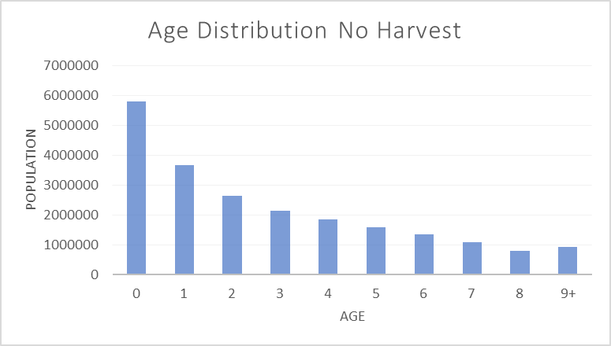What happens to the age distribution if the population grows without harvesting?

Figure 1.1- The population will decline over time due, with no harvest, in each subsequent age class.. From year 0-1 we can see a huge drop in population size, while in following years the decline is proportionally smaller by comparison. The vulnerability is the same for all of the ages in the population as well.

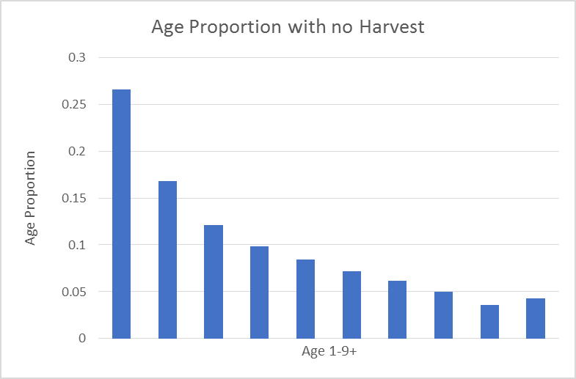

Figure 1.2- Graph showing the age proportion distribution with no harvest. We can see that the highest age proportion for year 0-1 is around .27 and declines drastically in the first year. Afterward we can see a curved declination. This suggests that there are higher proportion rates at younger ages, than at older ages. Since this is the age distribution when hr=0, we can use this as a “base” age distribution to compare other management strategies.

1. What nonselective (all ages equal %) harvest rate will just hold the population constant?

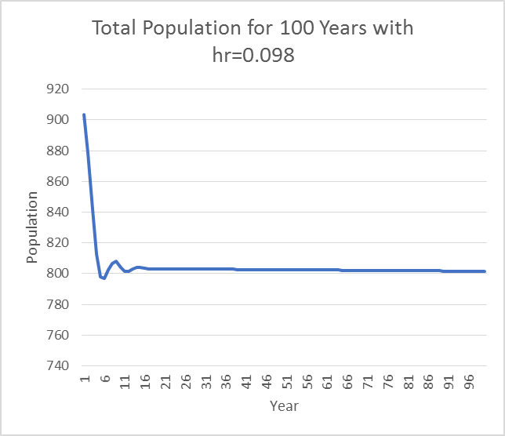

Figure 2.1- The population will remain stable at a harvest rate of 0.098. The prediction shows at first, the population will decline drastically around year 1-7, but afterwards will remain stable after year 8.

1. How does this value relate to the population intrinsic rate of growth value?

The harvest rate that will hold the population constant would be the same value as the intrinsic growth rate.

1. What happens to the age structure if a nonselective harvest rate of 40% is applied for several years?

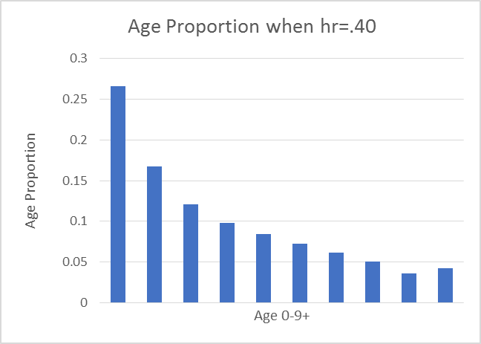

Figure 4.1- Graph showing age proportion distribution when the harvest rate is 40%. Since harvest is the same consistently through the age distributions it is very similar to Figure 1.1. This graph doesn’t let us know if our management plan when hr=.40, is over or under exploiting the population.

1. What happens to the age structure if the juvenile (age 0) harvest is 60%, older animal rate is 30%.

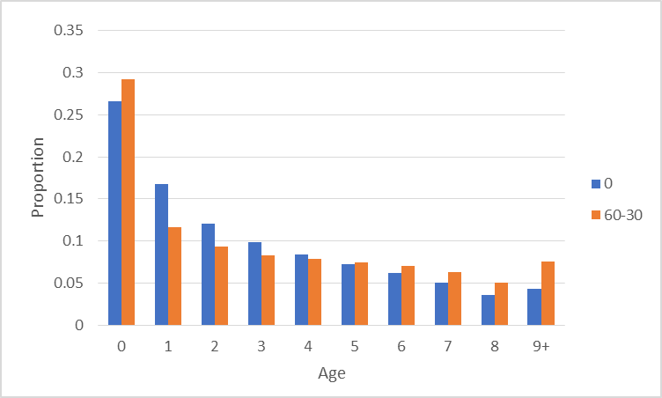

Figure 5.1- Graph showing that the higher harvest rate in year one, will dramatically affect the age proportion distribution until around age 4. This means that the population will be able to “bounce” back to a similar age proportion as if there was no harvest after that time. We can also see after age 6, that the age proportion of %60-%30 is higher than if the population has no harvest rate.

1. What happens to the age structure if the juvenile and yearling harvest rate is 10% and older animal rate is 50%.

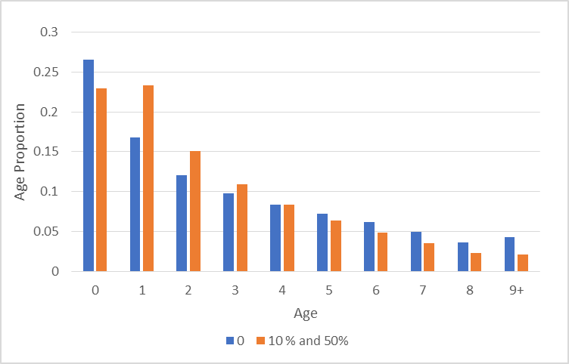

Figure 6.1- Graph displaying a yearly harvest rate at 10%, and all subsequent years are a harvest of 50%. We can tell that the population is struggling to “bounce” back to age proportion that is similar to no harvest rate in almost every year.

1. 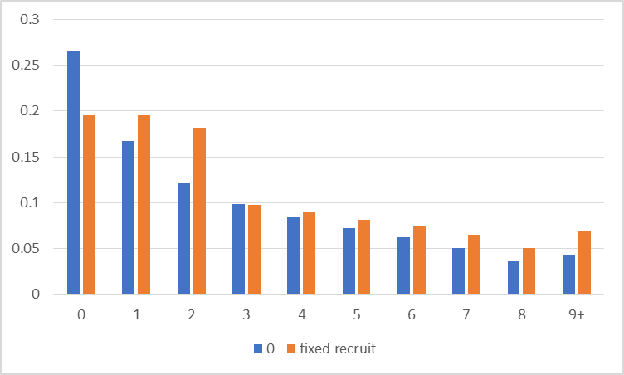How would your conclusions change if the population had a fixed number of recruits (e.g. 100) per year instead of fixed birth rates? Given your findings above, what can you say about the utility of population age structure as an indicator of over exploitation? Remember from discussions that a population is recruitment over exploited (production is sub optimal) when recruitment declines with population size. It is convenient to set up you spread sheet with columns as ages (age 0 to 9+) and rows as years but use the first few rows for you age schedule values.

Figure 7.1- Graph displaying that with fixed recruits with no harvest, and natural recruits with no harvest. The proportions are still very similar in ages 1-3. In a population that has continuous recruits, and contact harvest, we will see that there will be a tipping point where the population can start to be over exploited. We see that the age proportion distributions are very different compared to the no harvest age distribution.

Age structure monitoring is difficult to determine, and might not be the best method for age distribution analysis. It might be beneficial to look at the actual population numbers, including male and female ratios, as well as fecundity to determine what the population is doing in response to a management strategy. It would be better management practices to use multiple forms for analysis and not just age distribution. In an age proportion graph, it might show that age proportions are in acceptable numbers, but the actual population might be declining overall. Age distribution models can be used suggest negative population growth that might be due to any number of factors, including high death rates, low birth rates, and increased emigration from the area.