**Moreno, Melissa**

**October 22, 2017**

**WIS 4934**

**Assignment 7 Evaluating Feedback Policies for Limiting Harvest Rates**

* -Scenario 1, Condition 1

Random effects on juvenile survival are independent from year to year, such that sjt=sj*exp(vt) where vt is a random variable from a normal distribution with mean 0 and standard deviation 0.5, sj is the average rate described below, and exp is the exponential. “open loop, perfect knowledge” total harvest 100 years.

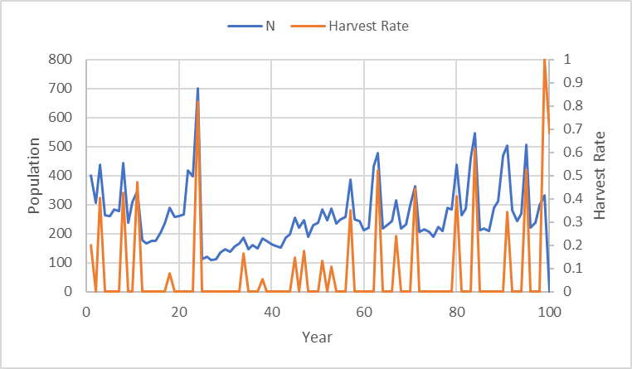

Figure 1.1-

Graph displaying “open loop, perfect knowledge”. We can see that in the first years that the population will be harvested very hard and the rest of years there will be time for recovery. The total harvest is 4953 for the 100 years. The effects on juveniles are independent with optimal variable harvest rates.

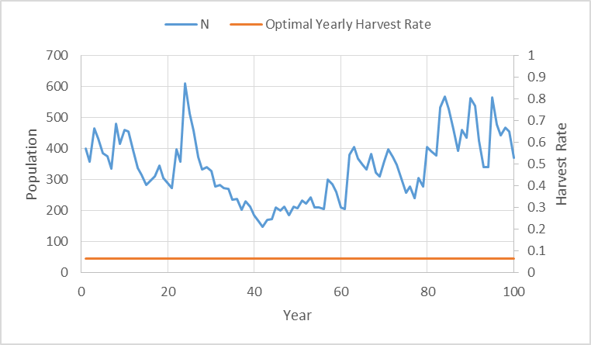

Figure 1.2- Graph displaying the “feedback loop” with a constant harvest rate. The harvest rate is constant for this condition. If we see the average harvest rate for the 100 years it is about 6.4%. This scenario will yield a total harvest of 3247, this is less than Figure 1.1.

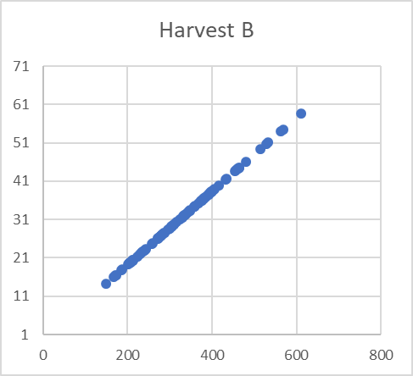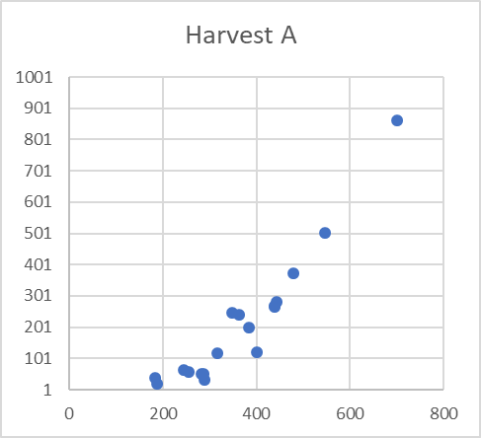

Figure 1.3- A) Open “loop perfect, knowledge” harvesting. We can see the in the “loop perfect, knowledge” that there will be continuously less harvesting as the population recovers. The early years will have the most harvesting. B) Average yearly rate harvesting. With a constant harvest rate the harvesting remains relatively constant.

* -Scenario 1, Condition 2

Random effects on juvenile survival are independent from year to year, such that sjt=sj*exp(vt) where vt is a random variable from a normal distribution with mean 0 and standard deviation 0.5, sj is the average rate described below, and exp is the exponential. “open loop, perfect knowledge”, total log utility of harvest.

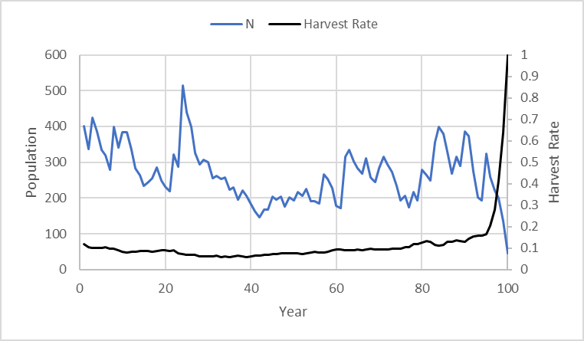

Figure 1.4- harvest scenario. The effects on juveniles are independent with optimal variable harvest rates. This scenario will yield 4077 total harvest over 100 years.

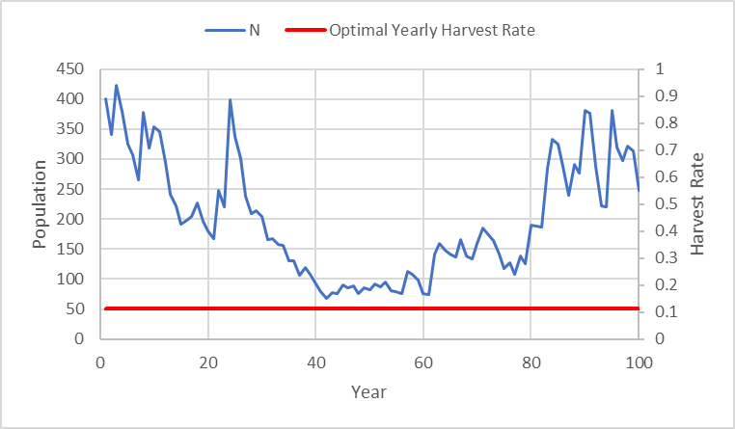

1.5- “Feedback loop”, with random juvenile effects, and constant log harvest rate. The average harvest rate is around 11%, which would yield around 3370 total harvest. This is less than in Figure 1.5 because the feedback loop is using an average the harvest rate compared to the “open loop, perfect knowledge” management strategy.

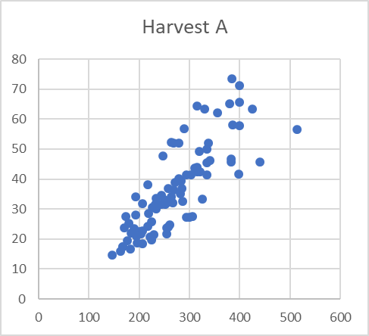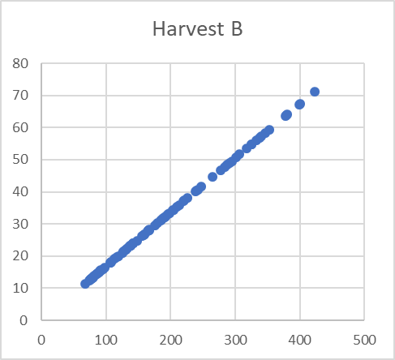

Figure 1.6- A) Open “loop perfect, knowledge” harvesting. We can see the in the “loop perfect, knowledge” that there similar harvesting near 100-200 individuals, but then the management plan will change over time as the population increases. The early years will have the most harvesting. B) Average yearly rate harvesting. With a constant harvest rate the harvesting remains relatively constant throughout the years, but will taper off near a larger population size.

-Scenario 2 part 1. Random effects are correlated from year to year, using the relationship wt+1=0.8wt + 0.2vt. Where wt is the lognormal effect applied to survival in year, vt is the normal deviate you used as independent effect. 0.8 is the "lag 1 autocorrelation" and 0.2 is the standard deviation of annual changes in w such that sjt=sj*exp(wt). Note that in the first year wt=vt. Correlation over time in random effects should exaggerate any cyclic or "regime shift" affects you were seeing with independent effects for total harvest of 100 years.

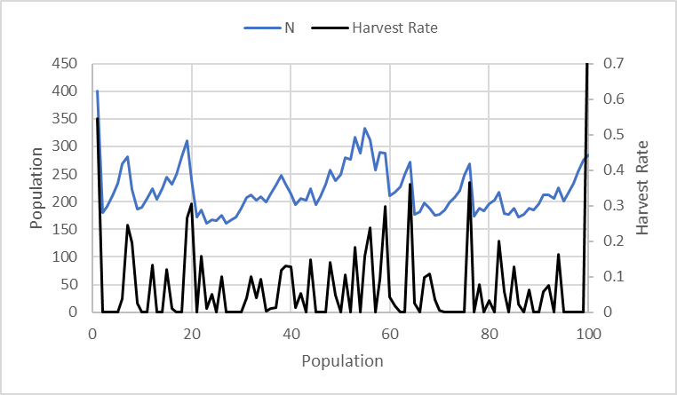

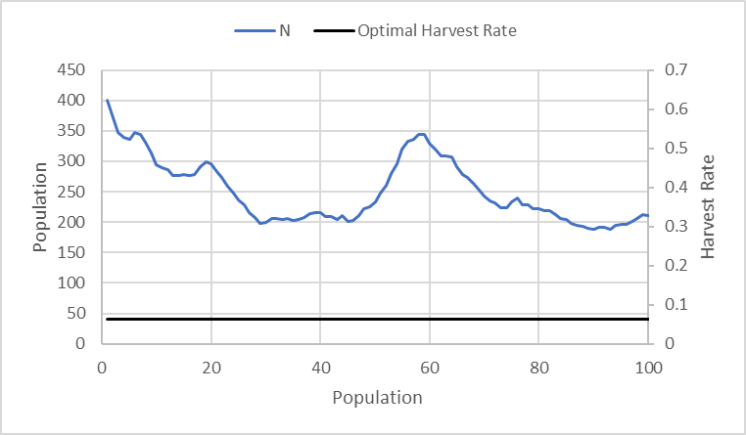Figure 2.1- Graph displaying “open loop, perfect knowledge”, with independent juvenile survival and variable optimal harvest rate. In this scenario, similar to Scenario 1, Condition 1, we can see that the population should be harvested optimally in the beginning years, while on the subsequent years there should be implemented a harvesting reduction. The total harvest for this management strategy is around 2870 for 100 years.

Figure 2.2- Graph displaying the “feedback loop” with a constant harvest rate. The average harvest rate is around 6.4%, with a total harvest of 2380. This will be less than the Figure 2.1, because the rate would be an average harvest of the optimal harvest rate.

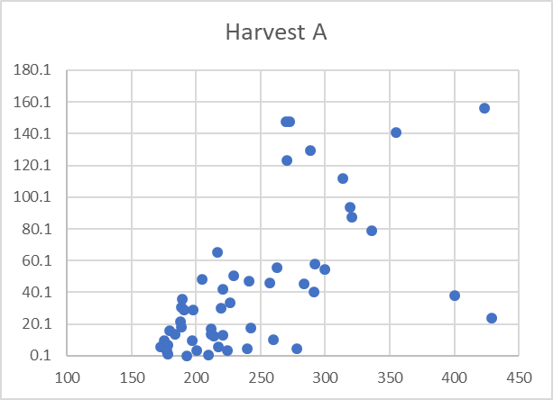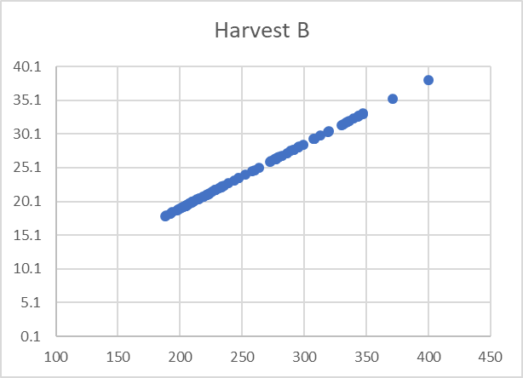

Figure 2.3- A) “Open loop, perfect knowledge”. We can see the harvesting in the earlier population size should be implemented more intensely, and in the later population sizes it should be lessen. B) Average yearly harvest rate.

* Scenario 2, Condition 2

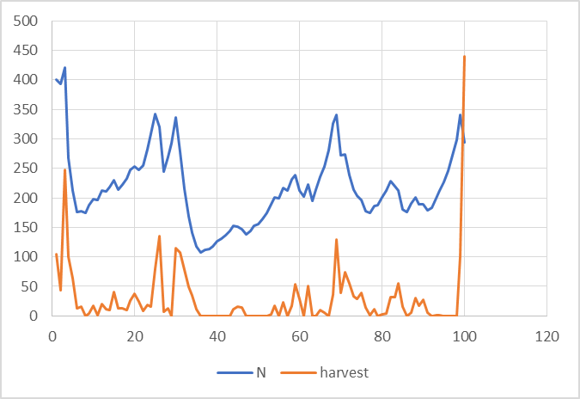Random effects on juvenile survival are independent from year to year, such that sjt=sj*exp(vt) where vt is a random variable from a normal distribution with mean 0 and standard deviation 0.5, sj is the average rate described below, and exp is the exponential. “open loop, perfect knowledge”, total log utility of harvest.

2.4- Graph displaying the “open loop, perfect knowledge”, with independent juvenile survival and variable optimal harvest total. We can see that the population should be harvested optimally in the beginning years, while on the subsequent years there should be implemented a harvesting reduction.

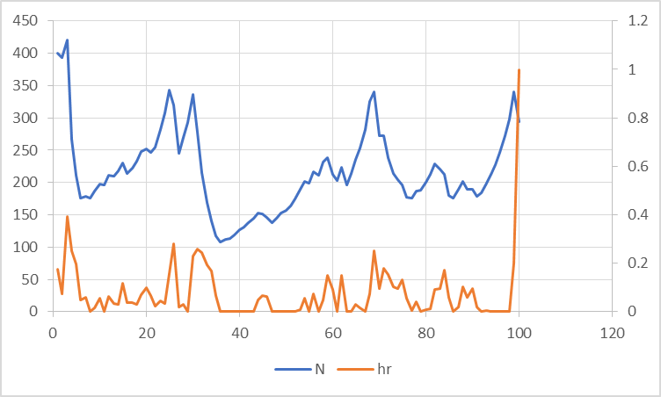

2.5- Graph displaying the “open loop, perfect knowledge”, with independent juvenile survival and variable optimal harvest rate. We can see that the population should be harvested optimally in the beginning years, while on the subsequent years there should be implemented a harvesting reduction.

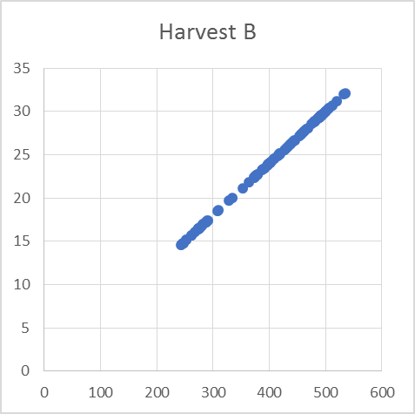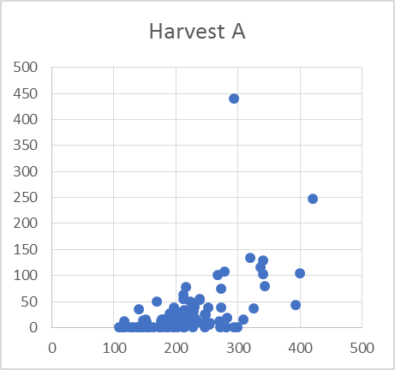 2.6- Graph displaying the “feed back loop”, with independent juvenile survival and variable optimal harvest rate. We can see that the population should be harvested optimally in the beginning years, while on the subsequent years there should be implemented a harvesting reduction.

2.7- Graph displaying the - A) “Open loop, perfect knowledge”. We can see the harvesting in the earlier population size should be implemented more intensely, and in the later population sizes it should be lessen. B) Average yearly harvest rate.