Melissa Moreno
September 13, 2017
WIS 4934
Assignment 2 Gnus a plenty?

The attached graph (Figure 1) shows population trends for the Serengeti wildebeest population from 1960 to 1989. As you can see from the "predicted" population trends (dashed line), a very simple model can describe the pattern of population growth.

Namely: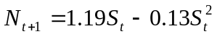

Where: N_{t+1} is the population size of next year of individuals 1 year and older, before the harvest is taken. S_{t} is the population size just after harvest in the current year t (so harvest in the year H_{t} = N_{t}-S_{t} ) note that H_{t} can also be expressed as a proportion (hr) of the pre-hunt population H_{t} = hr N_{t}. We will be discussing the biological basis for such simple ‘balance models’ later in the term. For now, take as given that there is a defensible basis. Recent pressure from harvesting in the park for ‘bush meat’ has raised questions about the level of harvesting pressure the population can withstand. Answer the following policy question:

- At what value of S would the population "stabilize" (carrying capacity level) in the absence of harvest?

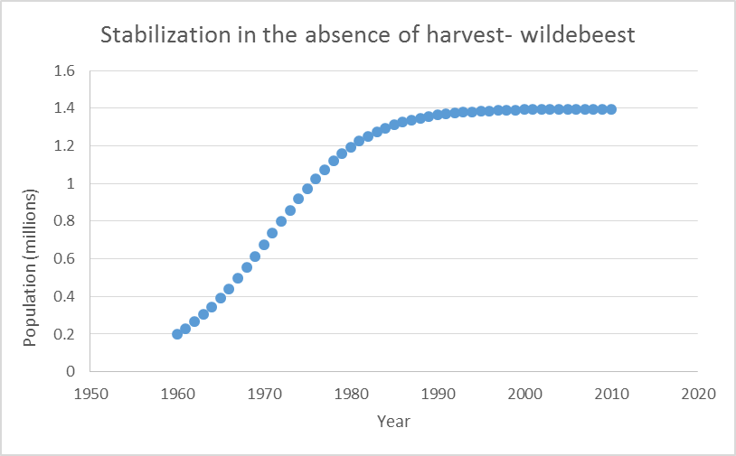
Figure 1.1- Graph displaying at what population size the wildebeest would stabilize in the absence of harvest.

Stabilization would occur around 1.46 million wildebeest, if harvest as absent. This will take approximate 30 years, starting in the early 1960, according to the projection

- For what "targets/equilibrium" values of S would the average harvest N-S be maximized? Call this value S*.

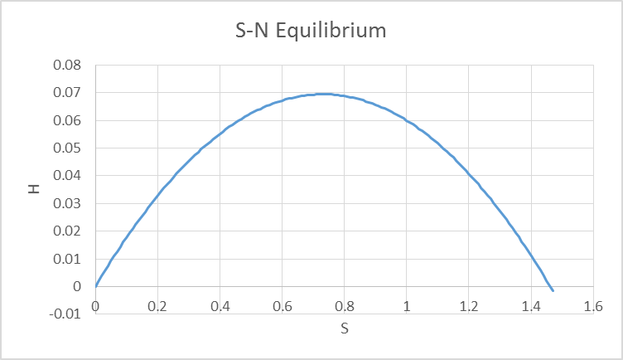
Figure 1.2- Graph displaying the equilibrium/targets at S*=0.07.

We can see that around 0.07 is when the what "targets/equilibrium" values of S would the average harvest N-S be maximized

The harvest rate, at right below 0.09, will allow the population to remain stable. The maximum sustainable yield will be at around 0.07, and that would allow for the population to remain stable while still allowing for wildebeest to be harvested for profit/tourism revenue.

- Suppose the population is reduced through some natural disaster (Rinderpest virus) or over hunting to a low level, say S = 0.2 million animals. Calculate the total yield over the next 50 years for several alternative recovery policies (to the level S* estimated above), ranging from no harvest until S* is reached, through to allowing a high enough harvest rate every year so that the population is barely able to reach S* after the 50 years.
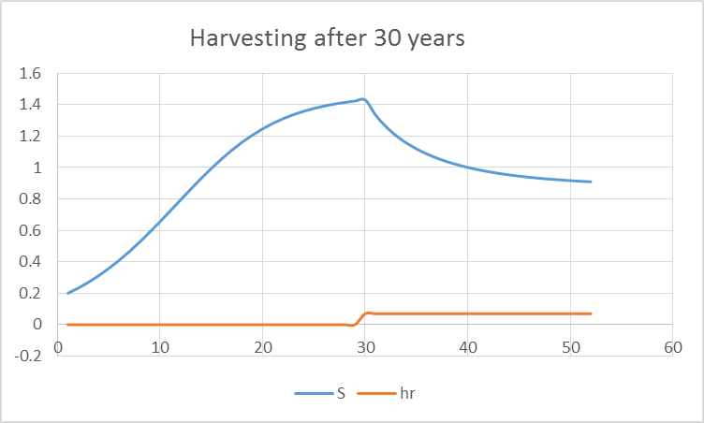
Figure 1.3- Graph showing that when there is no harvest for 30 years, and then max S* is harvested, the
the survival will decrease over time. The total harvested would be around 1.6.

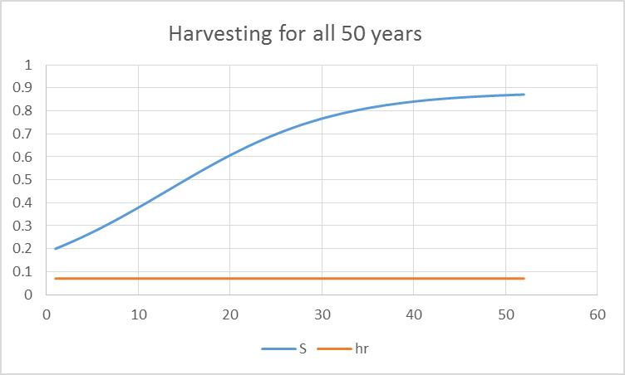

Figure 1.4- Graph displaying that when S* is constant over 50 years, that survival will increase over time. The total harvested would be 2.4 with this management strategy.

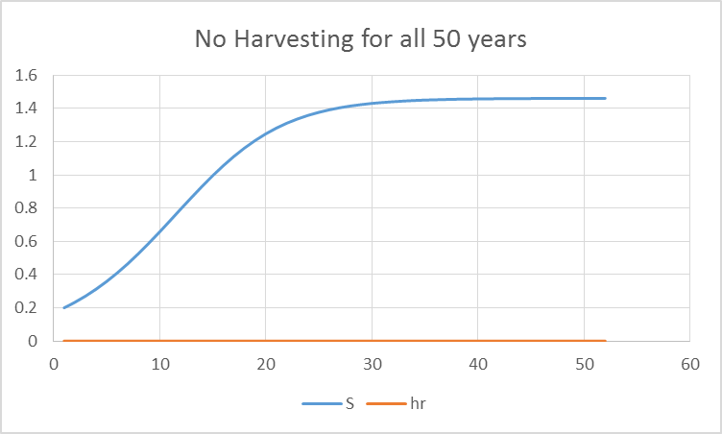
Figure 1.5- Graph displaying that when S* is 0.0 over 50 years, that survival will increase and plateau over time. The total harvested would be 0.0 with this management strategy.

If the population was managed for an ecotourism, it would be a good management strategy to not harvest over some time and then continue to harvest. The population would grow over time and then harvesting would only reduce the population slightly. (Figure 1.3)

Another management strategy for the wildebeest would be for constant harvesting, since the population would never be able to grow to its max stabilized population size, but they would be able to earn profits during the whole 50 years. This would be a good management plan for people who need to harvest the wildebeest for bush meet. (Figure 1.4)

It depends on what the wildebeest as being managed for. If wildebeest were managed with conservation in mind, then no harvesting would be a viable option. It will allow for the population to increase to it’s max over the 50 years of management. No profit could be made during the 50 years, however. (Figure 1.5)

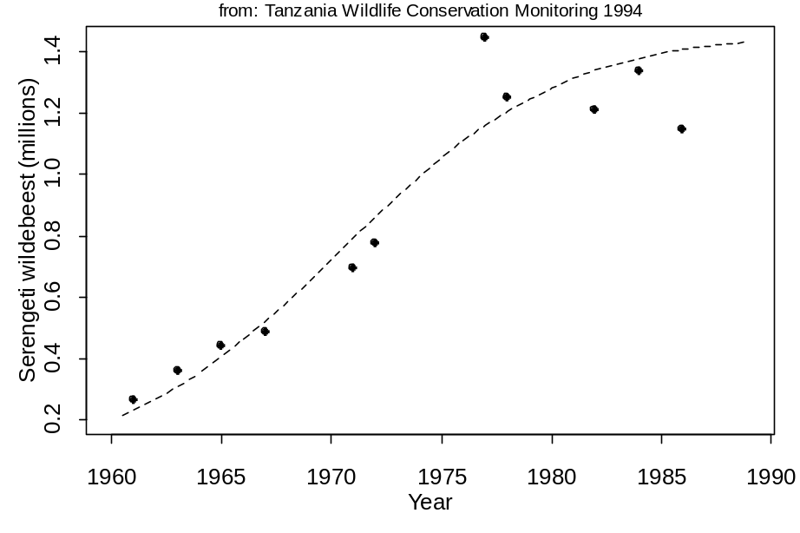
Discuss your results from question 3 in terms of the assertion often made by biologists that the objective of management should be to maximize long-term yield. Is the policy that most closely meets this objective defensible from a social or economic standpoint?
Figure 1: Population census (black dots) for the Serengeti wildebeest population taken from Tanzania Wildlife Conservation Monitoring 1994. Dashed line shows best model fit.

The biologists that were monitoring the wildebeest were right in determining their management plan based on what would be the best method to obtain a long term maximum yield. For any species conservation it’s important to realize that short term goals are important, but long term yield is what will help shape and change the ecosystem of the conservation species, usually for the better. Usually management plans that use economics to push it, are the most successful in being implemented, but that doesn’t mean they are the most effective. I think that the best management strategy for the wildebeest to have a constant harvesting, with a low harvesting rate. The population would continue to grow, and the profits made by selling bush meet or ecotourism will allow the management to continue. This policy would allow for both social and economic standpoints to be met.

