How to use LinearModelR: Linear Model Shiny App
Melina Brunelli – User Guide v1.0
This App serves as a wrapper for the R package limma. enabling complex, multivariate statistical modeling in an accessible and user-friendly way. If you intend to use this App for data analysis which will later be published, please cite Brunelli et al., 2026 (DOI HERE) AND Ritchie et al., 2015 (10.1093/nar/gkv007).
Table of Contents
Before getting started 1
Downloading and setting up the App 1
Uploading and configuring your data 1
Analyzing your results 1

Before getting started
- Download the latest version of R: https://cran.r-project.org/
- Download the RStudio IDE: https://docs.posit.co/ide/user/#rstudio-ide-oss-downloads
- Download the following packages (if you have not already):

if (!requireNamespace("BiocManager", quietly = TRUE)) {

install.packages("BiocManager")}
BiocManager::install(c(“shiny”, “limma”, “cmapR”))
- Load the packages:
Library(c(“shiny”, “limma”, “cmapR”))

Downloading and setting up the App
- There are two ways to access the App: manual download of the raw file or accessing the app through Github.
- *Recommended* Access through Github:
  - Open a new R session in RStudio. In the R console, run the following code block:
library(shiny)
shiny::runGitHub("LinearModelR", "melinabrunelli")
  - The app interface should automatically pop up within a few seconds.
- Manual download:
  - Navigate to https://github.com/melinabrunelli/LinearModelR.
  - Click on the app.R file link. Click on the “Download raw file” button in the top right corner. The App will immediately start downloading to your computer.
  - Store the App script in an easily accessible place on your local computer. It does not need to be in the same directory as your data files or R project files.
  - Open a new R session in RStudio, then open the LinearModelR.R file.
  - Click the 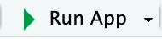 button in the top right corner of the script editor window. The app interface should pop up within a few seconds.

Uploading and configuring your data
- First, you must upload your data file. On the left-hand side, you will see the following:
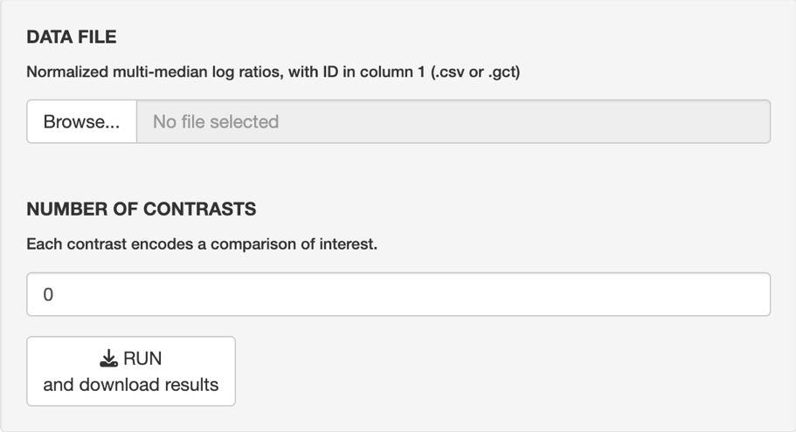
- Before uploading your data file, make sure that it is either a .csv or .gct file. This file should have an ID column (accession number, gene symbol) as the first column and the subsequent columns as normalized abundance values (log₂ transformed intensities, log₂ ratios, etc.). Example:
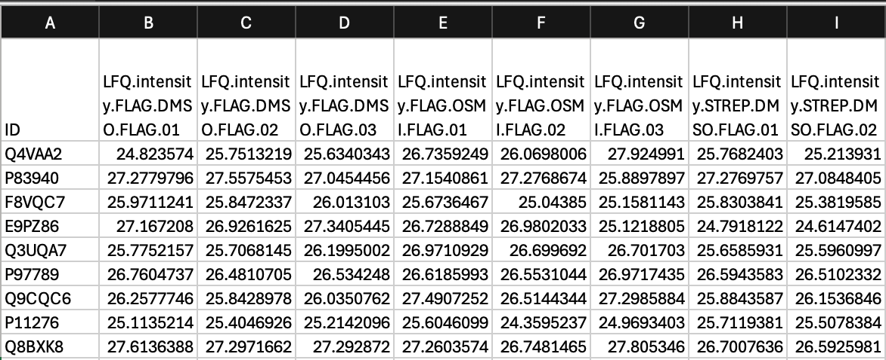
  - Ensure that “Upload complete” has appeared after uploading your file before proceeding.
  - Note that you may have other columns that contain metadata or other samples, for example, but these cannot be the first column, and you will need to specify later that these are not sample columns.
  - An error will be thrown if you have spaces or special characters in your column headers.
  - If you upload a file that is not .csv or .gct, you will see error messages on the right-hand side: “Not a supported data file! csv and gct only.”
- Optional: set your number of contrasts. If you have more than two main comparisons (e.g., mutant vs. WT vs. control) or more than two secondary effects (e.g., treatment 1 vs. treatment 2 vs. control), you will have more than one contrast that can be made. If you only want the app to make a subset out of all possible contrasts, then indicate the appropriate number.
  - If you can only make one contrast, simply enter “1”.
- [Samples] If you want all of the columns to be considered as samples, check the “Use all columns as samples.” box. If you have columns that do not represent samples, make sure to un-check this box, and then un-check those columns within the pop-up that appears.
  - Note that the App automatically considers the first column to be the ID column, so it will not show up here.
  - If you indicate any non-numeric columns as samples, an error will be thrown in the “Experimental Design” section and will not allow you to run the analysis.
- [Main Comparisons] Your main comparisons will be the first contrast that is made. For AP-MS, your main comparison is enrichment (e.g., fOGT_{FLAG}) versus control (e.g., stOGT_{FLAG}). Indicate which columns in your data file correspond to which group by checking the corresponding boxes like so:
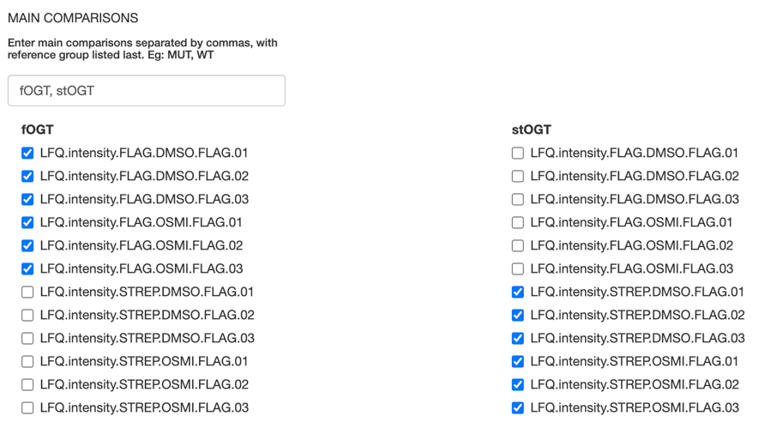
  - If you have more than two groups, just ensure that the control is last.
- [Secondary Effects] Secondary effects will be the second contrast that is made. Here, this is DMSO versus OSMI-4 treatment. The control treatment should be listed last. Format your groups in the same manner as was done in the Main Comparisons section.
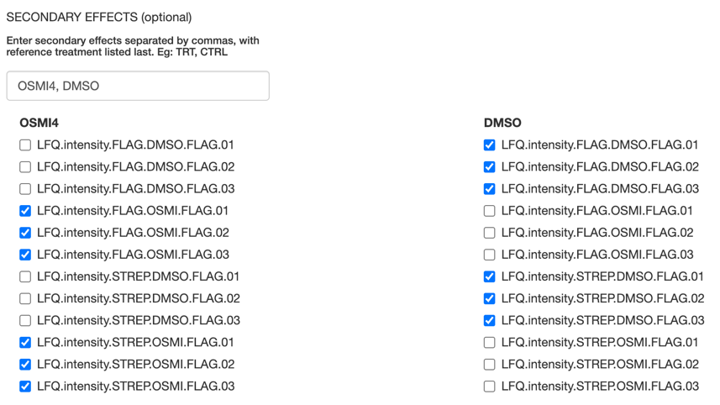
  - This step is optional: you may simply contrast your main comparisons, which is essentially a moderated T-test with BH multiple test correction.
- [Contrasts] If your experimental design was set up correctly, you should see a contrast automatically populate.
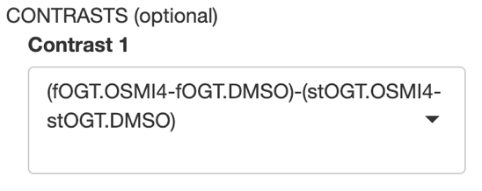
  - You should see your controls listed last (e.g. stOGT and DMSO are after fOGT and OSMI-4).
- If your experimental design was set up correctly, a message will appear at the bottom, indicating your data can be analyzed:
- Hit the 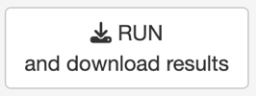 button in the top left panel. This will prompt you to choose where your results file will be saved and rename the file if you wish.
  - If there are any issues that arise, you may see “downloadData.html” as the file name instead. This means the App will not process your results. Check the console in RStudio for errors.
- Your results file should be available within a few minutes, depending on how many samples and contrasts you have.

Analyzing your results
- Three new columns per contrast, in addition to the original columns in your data file, will be in the results file: [contrast].logFC, [contrast].P.Value, and [contrast].adj.P.Val
  - Note that the column header for the ID column may have been written over and is now blank.
- The data may now be analyzed just like any other pairwise comparison! Specifically, you are now directly comparing the two groups in the first set of parentheses (e.g. fOGT.OSMI4 – fOGT.DMSO) and the other control groups have been taken into account with the model.
- Questions? Please post on our Github page (https://github.com/melinabrunelli/LinearModelR).

