Environmental vulnerability to linear erosive processes in a tropical watershed in Brazil

1. Introduction

Erosion is a natural process that can be intensified by anthropogenic activities, making it one of the greatest problems of land degradation (van Beek et al., 2008; Vanmaercke et al., 2021). Accelerated erosion on-site removes the fertile topsoil, leading to the formation of rills, ravines, and gullies, and damaging agricultural fields, and off-site causes sedimentation in valley bottoms and silting of reservoirs (Biswas & Biswas, 1978; Goudie, 1995; Guerra et al., 2017; Kertzman et al., 1995; Morgan, 2005; Nandi & Luffman, 2012; Pimentel, 2000; Renschler & Harbor, 2002; van Beek et al., 2008; Walling, 2005).
The on-site and off-site effects are a major global concern, as the loss of arable land through accelerated erosion can directly affect food production and compromise the food security of the population (Pimentel, 2000; Pinto et al., 2020; Wang et al., 2021). According to Palm et al. (2007), 2 billion hectares of soil were affected by soil degradation worldwide in 1991. Recently, the Food and Agriculture Organization of the United Nations (FAO, 2022) estimated that approximately 95% of global food production depends on soil, however, erosion could cause a 10% loss in agricultural production and remove 75 billion tons of soil by 2050.
Despite being a worldwide problem (FAO, 2019; Vanmaercke et al., 2021), erosion occurs with greater intensity in tropical areas, such as in the Central-East region of the state of São Paulo, Brazil (Couto et al., 2019; Dorici et al., 2016). The impact of raindrops on the surface breaks up soil aggregates (sand, silt, clay, organic matter, and colloidal material), reducing them into smaller particles and leading to a decrease in infiltration capacity (Bertoni & Lombardi Neto, 2017; Li et al., 2025; Li et al., 2024; Mcintyre, 1958; Nouhou-Bako et al., 2019). When the soil is saturated, runoff occurs in diffuse or concentrated flow, also intensifying the process of sheet and surface erosion. During each rainy period or in the rainy season, rills can form, with the possibility of evolution to ravines and gullies (Bertoni & Lombardi Neto, 2017; Conoscenti et al., 2025; He et al., 2022; Lal, 1990; Ou et al., 2021; Queiroz Neto & Christofoletti, 1968). Furthermore, much of the state of São Paulo is covered by soils derived from sedimentary rocks of the Paraná Sedimentary Basin (IPT, 1981a) and the local relief conditions and land use and cover trigger significant erosive processes (Dorici et al., 2016).
There are components of the landscape that can influence the erosive process, such as climate, relief, soil, vegetation and anthropogenic activities (FAO, 2019; Williams, 2003; Zhou et al., 2016). Although erosion factors combine and interact, one factor or group of factors may prevail and become of fundamental importance.
Thus, the current study aims to analyze the relations of environmental vulnerability to linear erosive processes in a tropical watershed based on human action (land use and cover) and natural aspects (relief compartments, slope, and soil).
Although erosion research has been carried out in the Central-East region of the state of São Paulo, there are no current studies that map the erosion potential on a local scale, only on a regional level, such as the map of erosion by ravines and gullies of the State of São Paulo at a scale of 1:250,000 (Kertzman et al., 1995), erosion risk map of the Corumbataí Watershed at a scale of 1:100,000 (Koffler, 1997), and atlas of soil susceptibilities of the State of São Paulo (Rossi et al., 2022).
Considering that environmental vulnerability is dynamic, as it is the result of the interaction of natural and anthropogenic attributes that are dynamic and that can undergo modifications over time (such as the land use and cover factor), it is essential to prepare a current and accurate diagnosis, which can serve to aid understanding of the space-time of the erosive process in relation to existing mappings from the 1990s and support local and regional governance actions. According to Vanmaercke et al. (2021), few studies have monitored the evolution of gullies for periods longer than 20 years, revealing an important research gap in understanding the long-term evolution of erosion systems.

2. Study area

The study was conducted in the Jacutinga Stream basin (Fig. 1), located in the Central-East sector of the state of São Paulo, Brazil, specifically in the rural areas of the municipalities of Rio Claro and Corumbataí, between the coordinates of 22°16' S to 47°39' W and 22°22' S to 47°35' W. The basin covers an area of 28.75 km².
Fig. 1. Location of the Jacutinga Stream basin.

The lithological types are the claystones of the Corumbataí Formation, the sandstones from the Pirambóia Formation, and the Cenozoic Deposits of the Rio Claro Formation, located in the Northeastern portion of the Paraná Sedimentary Basin (Zaine, 1995). The study area is in the geomorphological compartment of the Paulista Peripheral Depression (IPT, 1981; Ross & Moroz, 1996) which Penteado (1976) characterized as being represented by hills with convex slopes and sloping terraces between 550 and 650 m of height. According to the nomenclature of USDA (Baillie, 2001), the mains soils are Ultisols with a medium to clay texture (29 %) of the Corumbataí Formation, Inceptisols, with a sandy to very clay texture (30.4 %) of the Pirambóia and Corumbataí Formations, Entisols (Quartzipsamments) (30.4 %) of the Pirambóia Formation, and Oxisols (1.13 %) of the Rio Claro Formation (Corrêa, 2016; Corrêa et al., 2015). The main land uses and covers are pasture, forestry, exposed soil, and sugarcane cultivation (Corrêa, 2016). The native vegetation is Semideciduous Seasonal Forest located in the transition between the Atlantic Forest and Cerrado biomes (Rio Claro, 2014).
The region's climate is characterized as humid tropical, with a well-defined rainy season in summer and a drier season in winter, reflecting the typical climate of the Paulista Peripheral Depression. The average annual temperature is around 21–22°C, with a small temperature range, reinforcing the humid and warm nature of the local climate. Analysis of the historical series of daily data from the Meteorological Station of Analysis Center and Environmental Planning (CEAPLA/IGCE/UNESP) (Prefix D4 – 112M), from 1994 to 2025, confirms this climate pattern, with an average annual rainfall of around 1,419 mm and a strong concentration between the months of November and February. The strong seasonality of rainfall in the region is associated with the action of the South Atlantic Convergence Zone (SACZ) and mesoscale convective systems that intensify the occurrence of heavy rainfall in summer (Carvalho et al., 2004).

3. Materials and methods

Environmental vulnerability to linear erosive processes was analyzed using the Analytic Hierarchical Process (AHP) with ArcGIS 10.8 based on the landscape components, relief compartments, slope, soil, and land use and cover, spatialized in thematic maps.
The relief compartment map was prepared by Refosco & Fushimi (2025) at a scale of 1:25,000 using the anaglyph method, photointerpretation, and Google Earth Pro images. The relief compartments were identified and vectorized, in this order, using digital stereoscopy: hilltop, alluvial plain, and hillslope. The legend was based on the 6th taxonomic unit 10⁻² of Tricart (1965), Verstappen & Zuidam (1975), and Nunes & Fushimi (2010).
For the slope map, topographic maps from the Geographic and Cartographic Institute of the State of São Paulo from 1979 were used, at a scale of 1:10,000 and with a 5 m equidistance from the contour lines. A triangular grid structure TIN (Triangular Irregular Networks) was generated and the option “Face slope with graduated color ramp” was added. The slope classes were adapted from EMBRAPA (1979), as no slopes above 45% were observed in the Jacutinga Stream basin (Table 1).
Table 1
Adaptation of Embrapa (1979) slope classes to the study area.
Classes of slope (%) from EMBRAPA (1979) | Classes of slope (%) adapted to the study area
0–3 | 0–3
3–8 | 3Ⱶ8
8–20 | 8Ⱶ20
20–45  45–75  >75 | >20

The soil map was made by Corrêa (2016) and Corrêa et al. (2015) at a scale of 1:40,000. The land use and cover map was created using the database and legend, level 1, of the MapBiomas project, Beta Collection, which uses images from the Sentinel-2 satellite and a spatial resolution of 10 m. The mapping year (2022) is considered the most recent and detailed period made available by the platform MapBiomas (2022). The information contained in the map was updated in fieldwork during the rainy months (December 2024 and January 2025) and dry months (April and May 2025), with the survey of representative control points in each type of land use and cover mapped.
For the attributes of each variable (thematic map), weights from 1 to 3 were applied, considering the morphodynamic of Tricart (1977) and the relationship between pedogenesis and morphogenesis of Crepani et al. (2001), with adaptations to the erosion dynamics of the study area. Attributes that provide stable morphodynamic and predominance of pedogenesis were assigned a weight of 1. Attributes that influence intergrade morphodynamic and the balance between pedogenesis and morphogenesis were assigned a weight of 2. Attributes that contribute to highly unstable morphodynamic and predominance of morphogenesis were assigned a weight of 3 (Table 2).
Table 2
Weights assigned to the attributes of the variables.
Variable | Variable attribute | Morphodynamic (Tricart, 1977) | Pedogenesis/morphogenesis (Crepani et al., 2001) | Weight
Relief compartments | Hilltop | Estable | Pedogenesis | 1
 | Alluvial plain | Intermediate | Balance between pedogenesis and morphogenesis | 2
 | Hillslope | Strongly unstable | Morphogenesis | 3
Slope (%) | 0−3 | Estable | Pedogenesis | 1
 | 3Ⱶ8 | Intermediate | Balance between pedogenesis and morphogenesis | 2
 | 8Ⱶ20 | Intermediate | Balance between pedogenesis and morphogenesis | 2
 | >20 | Strongly unstable | Morphogenesis | 3
Soil | Oxisols | Estable | Pedogenesis | 1
 | Inceptisols | Intermediate | Balance between pedogenesis and morphogenesis | 2
 | Entisols (Fluvents) | Intermediate | Balance between pedogenesis and morphogenesis | 2
 | Entisols (Quartzipsamments) | Strongly unstable | Morphogenesis | 3
 | Entisols (Lithic) | Strongly unstable | Morphogenesis | 3
 | Ultisols | Strongly unstable | Morphogenesis | 3
Land use and cover | Forest vegetation | Estable | Pedogenesis | 1
 | Temporary crop and pasture | Strongly unstable | Morphogenesis | 3
 | Exposed soil | Strongly unstable | Morphogenesis | 3

Given the relative importance of each variable for the analysis of environmental vulnerability to linear erosive processes, the factors: relief compartments, slope, soil, and land use and cover were compared in pairs using AHP. AHP is a decision-making model where all factors relevant to a study are weighted against each other with the help of preference matrix (Mahapatra et al., 2015; Saaty, 1988). With reference to Saaty (1988), a pairwise comparison matrix was generated (Tables 3a and 3b) and final weights (Table 3c) with a Consistency Ratio (CR)=0.0017385. The values ​​were adapted from Saaty (1988) and Ribeiro et al. (2016), considering the environmental characteristics and dynamics of the Jacutinga Stream basin. According to Saaty (1988), pairwise comparisons are essential when using AHP, and the CR must be less than 0.1.
Table 3
Parameters, pairwise comparison matrix, and final weight of the variables.
(a) Parameters for pairwise comparison
1/9 | 1/7 | 1/5 | 1/3 | 1 | 3 | 5 | 7 | 9
Extremely | Very strongly | Strongly | Moderately | Equally | Moderately | Strongly | Very strongly | Extremely
Less important |  |  |  |  | More important
*1/2, 1/4, 1/6, 1/8, 2, 4, 6, 8: intermediate values

(b) Pairwise comparison matrix |  |  |  |  | (c) Weight
Variable | Relief compartments | Slope | Soil | Land use and cover
Relief compartments | 1 | 1 | 3 | 1/2 | 0.235
Slope | 1 | 1 | 3 | 1/2 | 0.235
Soil | 1/3 | 1/3 | 1 | 1/5 | 0.081
Land use and cover | 2 | 2 | 5 | 1 | 0.449
Source: Saaty (1988); Ribeiro et al. (2016).

The weights obtained were inserted into ArcGIS with the “Raster Calculator” tool using Equation (1):
E = (R * 0.235) + (SL * 0.235) + (SO * 0.081) + (L * 0.449) (1)

E = Environmental vulnerability to linear erosive processes
R = Relief compartments
SL = Slope
SO = Soil
L = Land use and cover

The information obtained from the map was updated during fieldwork in representative areas of low, medium, and high environmental vulnerability to linear erosive processes. The linear erosive features (rill and ravine) were previously identified in images from World Imagery® (of ArcMap®), Google Earth Pro® (from February 20, 2025), and CBERS-4A (from June 19, 2024), validated during fieldwork, and overlaid on the map of environmental vulnerability to linear erosive processes.
The soils were collected and analyzed in profiles and toposequence, according to Lemos & Santos (1996); IBGE (2015); Dessalegn et al. (2014). Granulometric analyses were carried out in the laboratory, where the quantities of clay, silt, total sand, fine sand, and coarse sand were measured using the method of Teixeira et al. (2017). Soil fractions (sand, silt, and clay) are one of the main soil attributes that influence erosion potential, that is, the amount of soil transported by erosion (Bertoni & Lombardi Neto, 2017).
Complementing the methodology used to assess environmental vulnerability to linear erosive processes, the analysis of the erosion potential of rainfall in the Jacutinga Stream basin was incorporated. The inclusion of this stage is justified because, in humid tropical environments, the rainfall regime, especially the intensity, frequency, and seasonal distribution of rainfall, is a determining factor in triggering and in the evolution of linear erosive features (Panagos et al., 2017). Understanding these characteristics enables us to establish more consistent relationships between climate patterns and the areas most vulnerable to erosion identified in the integrated landscape analysis.
Daily precipitation data from the Meteorological Station of Analysis Center and Environmental Planning (CEAPLA/IGCE/UNESP) (Prefix D4 – 112M), located at 22°23’ S to 47°32’ W, with an altitude of 626.5 m, were used, covering the period from 1994 to 2025 (first half of the year). Data processing consisted of:
- Monthly and annual aggregation from daily records;
- Calculation of the Modified Fournier Index (MFI):
$MFI=\sum_{i=1}^{12}{\frac{P_{i}^{2}}{P_{\text{anual}}}}$ (2)where Pi corresponds to the monthly total and Pannual​ to the total annual precipitation;
- Estimation of the R-factor (MJ·mm·ha⁻¹·h⁻¹·ano⁻¹) from the MFI, using the exponential and quadratic equations proposed by Renard & Freimund (1994).
Exponential form:
$R_{\text{exp}}=0.07397⋅\text{MF}{\text{I}}^{\text{1.847}}$ (3)
Quadratic form:
$R_{\text{quad}}=95.77-6.081⋅\text{MFI}+0.477⋅\text{MF}{\text{I}}^{\text{2}}$ (4)

In addition, the number of days with precipitation greater than 10 mm, 12.7 mm, and 20 mm was counted, recognized as indicators of potentially erosive days (Beskow et al., 2009; Wischmeier & Smith, 1978). This approach was adopted because it is compatible with daily rainfall series and allows the integration of climate data with geomorphological and land use and cover parameters considered in the assessment of environmental vulnerability to erosion.

4. Results

The human action and natural aspects were represented in the thematic maps of relief compartments, slope, soil, and land use and cover (Fig. 2). Based on the AHP weighting, three classes of environmental vulnerability to linear erosive processes were identified: low, medium, and high (Fig. 3). High vulnerability is the most representative, with an area of ​​22.09 km² (76.86 % of the total area of ​​the basin), followed by medium vulnerability (4.71 km² and 16.37 %), and low vulnerability, in only 1.95 km² (6.77%) of the Jacutinga Stream basin.
Fig. 2. Factors (landscape components) used to define areas of environmental vulnerability to linear erosive processes.
Fig. 3. Environmental vulnerability to linear erosive processes.

The Jacutinga Stream basin presents an environmental diversity of relief compartments, slope, soil, and land use and cover that provide a basis for analyzing low, medium, and high environmental vulnerability to linear erosive processes.
The alluvial plain of the Jacutinga Stream, located in the northern sector of the study area, are characterized by low environmental vulnerability to linear erosion. The predominant morphology is flat valley bottoms, with slopes ranging from 0 % to 8 %. Forest vegetation and cattail (Typha domingensis) are common in the floodplain area. The predominant soils are Entisols (Fluvents) (Corrêa, 2016; Corrêa et al., 2015).
The alluvial plain with slope are associated with vegetation that, despite being remnant and covering an area of ​​3.63 km², acts as a direct shield against the impact of raindrops on the surface, reducing the erosive potential of the splash effect, the initial stage of erosion. These landscape characteristics provide morphodynamic stability and low environmental vulnerability to linear erosive processes.
The medium environmental vulnerability to linear erosive processes is found on hilltops with slopes between 3 and 8 % and on low slopes with slopes between 8 and 20 %. Areas of medium erosion potential are also related to land use, such as sugarcane (Saccharum spp.) cultivation and pasture on shallow soils (Entisols Lithic and Inceptisols), providing intergraded morphodynamic and medium environmental vulnerability to linear erosive processes.
High environmental vulnerability to linear erosion is characterized primarily by slopes with gradients between 8 % and over 20 %, and land uses such as pasture and exposed soil. On the steepest slopes (over 20 %) are the concave slopes, where springs are located. Fieldwork has shown that eucalyptus (Eucalyptus spp.) is cultivated in the drainage headwaters. According to Corrêa (2016) and Corrêa et al. (2015), the main types of soil are Ultisols, Inceptisols, and Entisols Quartzipsamments.
Forty-nine erosion hotspots were identified, all of which are located in pasture areas. Cattle trampling removes vegetation cover, compacting the surface horizons, and consequently, reducing infiltration and increasing concentrated runoff. Initially, rills form, which can develop into ravines.
The landscape components, relief compartments, slope, soil, and land use and cover that influence the relationships of environmental vulnerability to linear erosive processes (low, medium, and high) of the Jacutinga Stream basin are systematized in Table 4.
Table 4
Integrated synthesis of environmental vulnerability to linear erosive processes.
Vulnerability class | Relief compartments and slope | Soil |  | Land use and cover |  |  | Morphodynamic
Low | Alluvial plain and 0−8 % | Entisols (Fluvents) |  | Forest vegetation |  |  | Stable
Medium | Hilltop and 3−8 % | Entisols (Lithic) |  | Temporary crop of sugar cane |  |  | Intermediate with rill
 | Low slope and  8−20 % | Inceptisols |  | Pasture |  |  | Intermediate with rill
High | Slope and 8 to >20 % | Ultisols, Inceptisols, Entisols (Quartzipsamments) |  | Pasture, exposed soil |  |  | Strongly unstable with rill, ravine and gully
Class of environmental vulnerability to linear erosive processes |  |  | Area |  |  | Linear erosive feature
 |  |  | km² |  | %
Low |  |  | 1.95 |  | 6.77 | 0
Medium |  |  | 4.71 |  | 16.37 | 2
High |  |  | 22.09 |  | 76.86 | 47
Total |  |  | 28.75 |  | 100 | 49

The soils of profiles 1, 2, and 3 (Fig. 4) presented variations in the thickness of the horizons and in the morphological and granulometric characteristics (Tables 5 and 6). Soil profiles 1 and 3 are shallow (40 cm and 20 cm) compared to soil profile 2 which is over 150 cm deep. The colors range from red (in soil profiles 1 and 2 which are at the hilltop and hillslope) to reddish brown (in soil profile 3 on the alluvial plain), indicating the influence of relief on soil color patterns. Consistency varies from very friable to firm in moist soil and soft to hard in dry soil. Determinations of fractions in field and laboratory work demonstrated the predominance of clay and sand (mainly fine sand). The silt:clay ratio is equal to or less than 0.7, with the exception of soil profile 1.
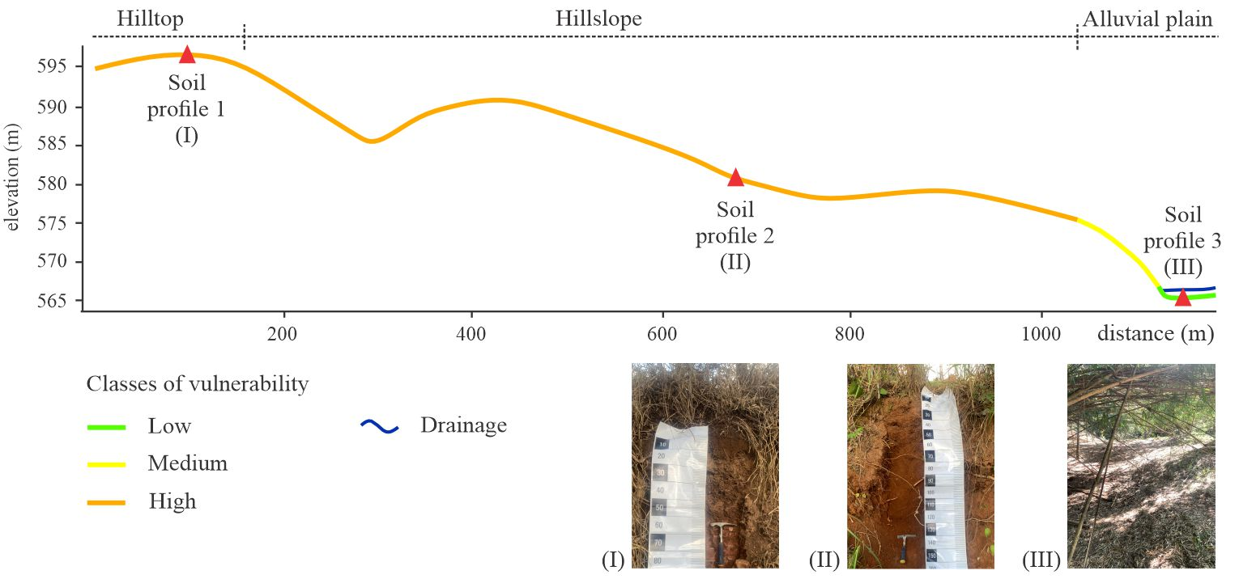
Fig. 4. Soil profiles along the toposequence.

Table 5
Morphological properties of the soils in the horizons.
Soil profile | Horizon | Depth  (cm) | Munsell color (dry) | Structure | Consistency
 |  |  |  |  | Dry | Moist
1 | Ap | 0–40 | 10R 3/3 | Granular | Slightly hard | Friable
2 | Ap | 0–40 | 10R 3/6 | Granular | Hard | Firm
2 | B | 40Ⱶ150+ | 10R 3/4 | Sub-angular blocks | Hard | Firm
3 | Ap1 | 0–10 | 5YR 4/3 | Granular | Soft | Very friable
3 | Ap2 | 10Ⱶ20+ | 5YR 4/3 | Granular | Soft | Very friable

Table 6
Physical properties of the soils in the horizons.
Soil profile | Horizon | Depth  (cm) | Particle size distribution (%) |  |  |  |  | Textural class | Silt:  clay ratio
 |  |  | Clay | Silt | Total sand | Coarse sand | Fine sand
1 | Ap | 0–40 | 30.8 | 40.2 | 29.0 | 7.4 | 21.5 | Clay loam | 1.3
2 | Ap | 0–40 | 49.3 | 25.7 | 25.1 | 6.2 | 18.9 | Clay | 0.5
2 | B | 40Ⱶ150+ | 67.3 | 19.3 | 13.5 | 2.8 | 10.7 | Clay | 0.3
3 | Ap1 | 0–10 | 17.6 | 5.4 | 77.0 | 15.8 | 61.2 | Sandy loam | 0.3
3 | Ap2 | 10Ⱶ20 | 17.9 | 12.2 | 70.0 | 12.8 | 57.2 | Sandy loam | 0.7

The rainfall analysis for the period 1994 to 2025 (first half of the year) shows that the average annual precipitation in the Jacutinga Stream basin was approximately 1419 mm, with a strong concentration in the period from November to February. The average Modified Fournier Index (MFI) calculated for the period was 208.1, indicating a high monthly concentration of rainfall, and the R-factor showed average annual values ​​of 1464.6 MJ·mm·ha⁻¹·h⁻¹·year⁻¹ (exponential equation) and 20406.1 MJ·mm·ha⁻¹·h⁻¹·year⁻¹ (quadratic equation). In years with higher annual totals (such as 1995, 1999, 2010, and 2011) or a higher frequency of intense events, these values ​​significantly exceeded the average, increasing the potential for sediment mobilization. The monthly climatology (Fig. 5a) confirms the predominance of summer rainfall, and the MFI time series (Fig. 5b) indicates that higher values ​​reflect years in which precipitation was concentrated in a few months.
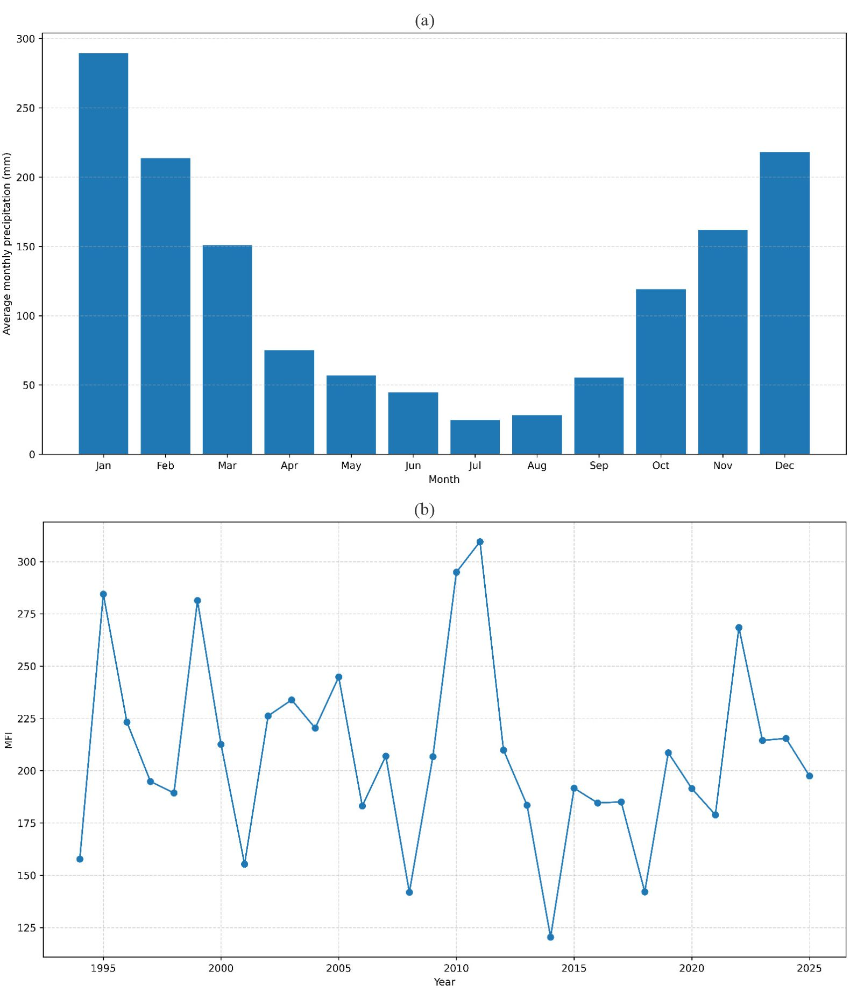
Fig. 5. (a) Monthly climatological distribution of precipitation in the Jacutinga Stream basin (1994–2025). (b) Annual time series of the MFI (1994–2025).

Additionally, the annual time series of the R-factor (Fig. 6), estimated by the exponential and quadratic equations, proposed by Renard & Freimund (1994), necessarily follows the form of the MFI, since it is an index derived from this parameter.
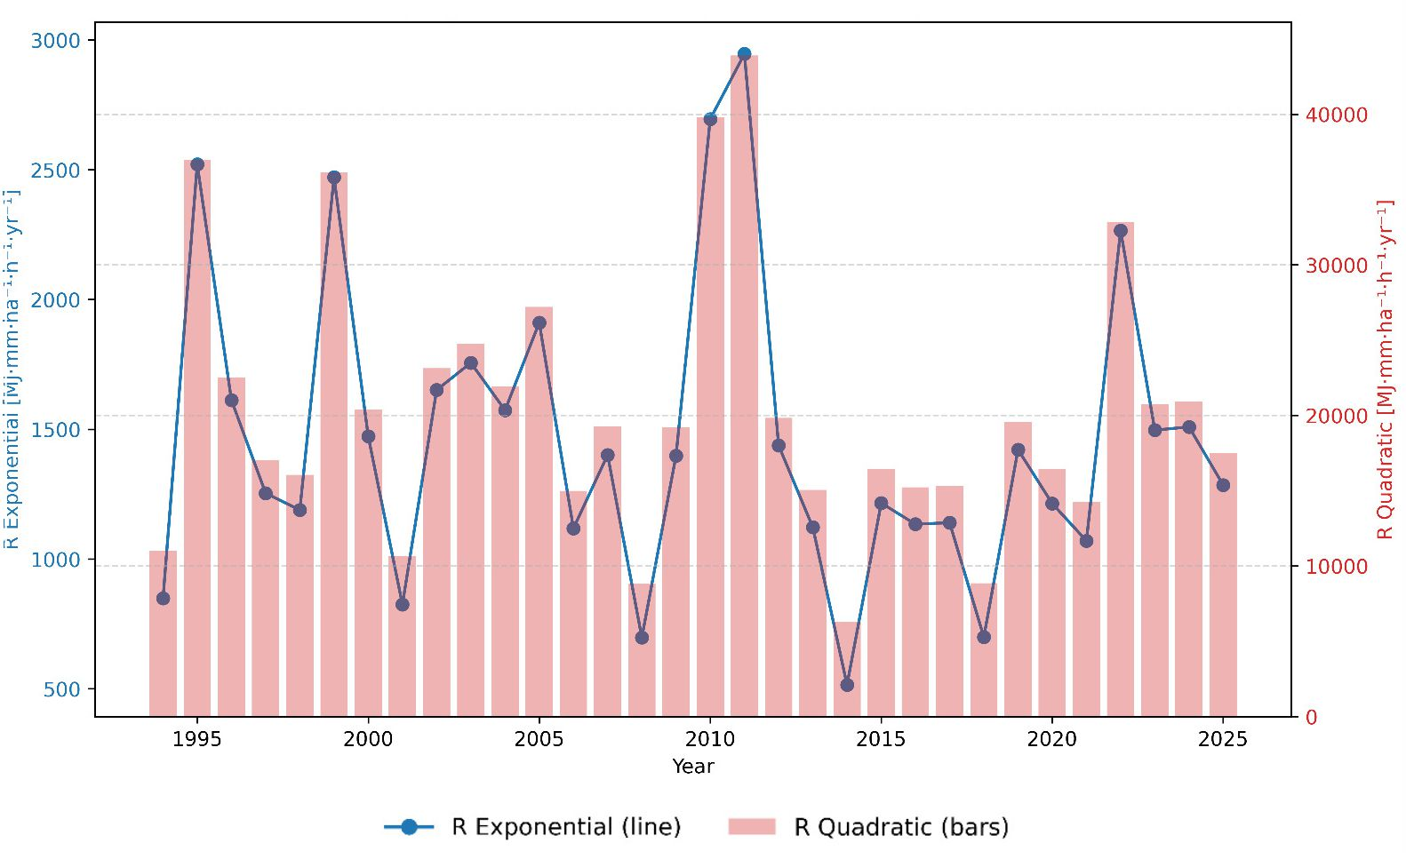
Fig. 6. Annual time series of rainfall erosivity factor (R) estimated using exponential (line) and quadratic (bars) equations (1994–2025).

The number of days with precipitation exceeding 10 mm, 12.7 mm, and 20 mm (Fig. 7) adds an important dimension to the analysis, as it highlights not only the monthly concentration but also the frequency of effective erosion events. The frequent occurrence of days with rainfall above 12.7 mm, a reference value generally used to identify erosive rainfall (Beskow et al., 2009), confirms the high potential for soil particle mobilization in certain years, especially in summer. This means that, even in years without exceptional rainfall totals, the greater recurrence of storms above these thresholds can create field conditions favorable to the development of hills and ravines, especially in areas with steep slopes or that are subject to agricultural activity.
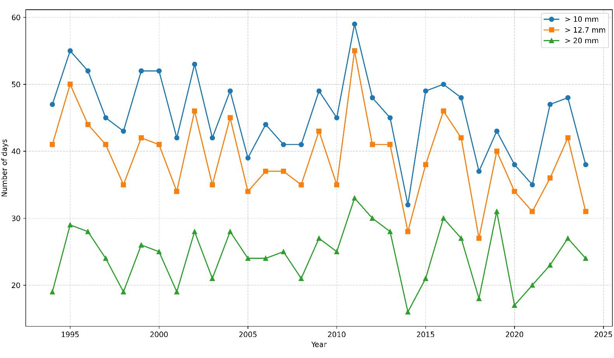
Fig. 7. Number of annual days with precipitation above 10 mm, 12.7 mm, and 20 mm (1994–2024).

These results indicate that potential rainfall erosivity plays an important role in explaining the environmental vulnerabilities identified in the Jacutinga Stream basin. Years with high MFI and R values ​​or a higher frequency of intense events (such as 2011) tend to amplify existing environmental vulnerability due to land use and cover characteristics, especially in areas of sugarcane cultivation.

5. Discussion

Areas of low erosion potential are mainly associated with soil protection by vegetation (Ribeiro et al., 2016; Ross, 2012; Saraiva-Maia et al., 2024; van Beek et al., 2008). The effects of vegetation cover include direct protection against impact of raindrops, decreasing their erosive capacity, dispersion of water, intercepting it and evaporating it before it reaches the soil, decomposition of plant roots, that increase infiltration and improve soil structure in view of their water retention capacity, and reduction of the kinetic energy of the runoff which favors water infiltration into the soil (Bertoni & Lombardi Neto, 2017; van Beek et al., 2008).
In the medium environmental vulnerability to linear erosive processes, sugarcane cultivation is one of the main land uses in the study area, in the region (Corrêa et al., 2016; Dorici et al., 2016; Oliveira, 2024) and in a large part of the state of São Paulo (Bonzanini e Lupinacci, 2022; Piacente et al., 2022) and Brazil. Bombardi (2017) estimates that 10.5 million hectares of sugarcane are cultivated on Brazilian soil, which corresponds to 3.5 times the area of ​​Belgium, 1.1 times the area of ​​Portugal, and 1.3 times the area of ​​Scotland. Camargo & Santos (2014); Corrêa (2016) demonstrated the occurrence of sheet erosion in sugarcane plantations, especially in the period after harvesting and before planting. This temporary situation of soil exposed to erosive agents increases the erosion potential.
The medium potential for erosion is also found in hilltops with gradients from 3 to 8%. The sandstones are from the Pirambóia Formation (Corrêa, 2016; Corrêa et al., 2015) which are whitish, yellowish, and reddish, of fine to medium grain size, with intercalations of thin layers of claystone and siltstone (Zaine, 1995). According to Dorici et al. (2016), the resulting soils are sandy, with a high permeability coefficient, and in areas with slopes of up to 10 %, they result in lower runoff potential. In these sandy soils, a balance between pedogenesis and morphogenesis occurs, as infiltration is favored by the existing macropores; however, particle cohesion is low (Bertoni & Lombardi Neto, 2017).
Areas highly vulnerable to linear erosive processes present slopes ranging from 8% to over 20%. Drainage headwaters are located on slopes with gradients above 20%. According to Penteado (1976), in the geomorphological context of the Paulista Peripheral Depression, where the Jacutinga Stream basin is located, despite the relief of hills having low potential energy for morphogenetic processes, the friable lithologies, especially in the drainage headwaters, condition the dynamization of erosive processes. The soils are clay loam to clay, resulting from the sandstones of the Corumbataí Formation. These sandstones have low permeability and limited percolation capacity, and the soils are fine-textured with clay particles, providing medium to very high potential for runoff (Dorici et al., 2016).
Pasture is composed of grass, a type of vegetation that tolerates continuous and frequent grazing due to its ability to grow densely, produce 500 to 2,000 stems per square meter, and develop a system of fine roots that branch out in the soil (Bertoni & Lombardi Neto, 2017). Grasses have dense stems and root systems and are therefore adapted to erosion control. However, their erosive potential can increase significantly due to excessive grazing, causing a reduction in plant vigor, decline, and even death, and the appearance of uncovered areas of vegetation (Bertoni & Lombardi Neto, 2017). In these exposed soil areas, the soil is directly exposed to the splash effect, initiating the erosive process with the disruption of soil aggregates. Studies on the occurrence of accelerated erosion in pasture areas, such as by Merten and Minella (2013); van Beek et al. (2008); Fushimi et al. (2025), corroborate the results obtained.
Soil profiles 1 and 2 have a clay loam to clay texture and are related to the Corumbataí Formation (Corrêa, 2016; Corrêa et al., 2015). In soil profile 2, the increase in clay from the Ap horizon to the B horizon hinders water infiltration into the profile, which favors runoff (Corrêa et al., 2015; Crepani et al., 2001; Dorici et al., 2016). Soil profile 3 is located on the alluvial plain and has a predominance of sand, mainly very fine sand, influencing the greater friability of moist soil. These sediments possibly come of the runoff from the hilltop and hillslope areas or from the alluvial deposits of the Jacutinga Stream. Alluvial deposits overlying varied lithologies in valleys were observed in the region by Dorici et al. (2016). Therefore, vegetation is of fundamental importance in protecting the soil and reducing its erosion potential.
The silt:clay ratio serves as a basis for evaluating the stage of weathering of soils in tropical regions (Santos et al., 2025). With the exception of the Ap horizon of soil profile 1, the soils present values​≤0.7, indicating a high degree of weathering and pedogenesis, a factor that contributes to morphodynamic stability (Crepani et al., 2001).
The seasonal pattern of precipitation concentration between November to February coincides with critical phases of the sugarcane production cycle, especially after cutting, when vegetation cover is reduced and the soil is temporarily exposed, increasing environmental vulnerability to sheet and linear erosion for the formation of rills (Camargo & Santos, 2014; Corrêa et al., 2016). During these intervals, protection from direct raindrop impact is reduced, increasing vulnerability to sheet erosion and the development of rills in areas classified as medium and high vulnerability. The MFI time series reinforces this pattern, increasing the effectiveness of rainfall in promoting erosive processes (Harsányi et al., 2022).
The partial overlap of the exponential and quadratic curves for the R-factor time series does not indicate redundancy, but rather methodological convergence, lending robustness to the estimates obtained. This behavior is consistent with more recent evaluations that apply the R-factor (as a component of the Revised Universal Soil Loss Equation – RUSLE) in different climatic contexts and demonstrates that, even with different methods, the temporal variability of erosivity tends to be captured similarly (Nunes et al., 2023; Panagos et al., 2017).
To prepare the map of environmental vulnerability to linear erosive processes, the AHP was used, which presented an adequate Consistency Ratio (0.0017385) and the weighting was based on theories and real-world evidence. Future studies should be performed using other mapping methods of decision-making scenarios, like the Analytical Network Process (ANP) with Ordered Weighted Average (OWA) and Weighted Linear Combination (WLC). Modeling from algorithms, such as Random Forest (RF), Logistic Regression (LR), Support Vector Machine (SVM) and Multi-layer Perceptron (MLP) may also be carried out.
The current study contributes to the literature, but some limitations can be observed. The classes of environmental vulnerability to erosive processes (low, medium, and high) are dynamic and can change as landscape components change. In areas of low environmental vulnerability, erosion potential may increase with the development of fluvial erosion on the alluvial plains. Furthermore, the vegetation is non-native and pasture intensifies erosion. Therefore, it is important to conduct a temporal analysis of environmental vulnerability to erosive processes. Mapping with land use and cover data from previous decades will provide a more detailed diagnosis of erosion potential and aid in projecting future scenarios.
Future studies can contribute to and complement the current work, as erosion has natural causes, such as soil erodibility and slope morphology and length. According to van Beek et al. (2008), the chemical characteristics of the soil determine the level of resistance to erosion, for example, quantity of organic matter and pH. The morphology and length of the slope together with the steepness influence the energy of the runoff, and the capacity for soil removal and sediment production (Bertoni & Lombardi Neto, 2017; Rieke-Zapp; Nearing, 2005).

6. Conclusion

(i) The current study showed that environmental vulnerability to linear erosive processes increases with the replacement of vegetation by sugarcane plantations, pasture, and soil exposed to rain events (more frequent and intense rainfall) that are characteristic of the region's hot and humid climate. The runoff also intensifies on slopes with greater steepness and clay soils.
(ii) Landscape aspects result in different scenarios when evaluated separately. Integrated analysis is necessary to obtain a response to erosion potential consistent with reality.
(iii) The AHP model can be applied in other studies, such as compartmentalization into landscape units, mapping of subsurface erosive processes, and selection of appropriate and effective techniques for the recovery of degraded areas in sectors of medium to high vulnerability to erosion.
(iv) The current study can contribute to advancing the understanding of the controlling factors of erosive dynamics from an international perspective, especially in tropical watershed, since accelerated erosion is a worldwide problem that occurs with greater intensity in tropical landscapes.
(v) Future studies are recommended to monitor the evolution of environmental vulnerability to erosive processes over time. Furthermore, the current study considered precipitation, but it is important to assess how climate change impacts erosion potential.

References

Baillie, I. C. (2001). Soil Survey Staff 1999, Soil Taxonomy. Soil Use and Management, 17(1), 57–60. https://doi.org/10.1111/j.1475-2743.2001.tb00008.x
Bertoni, J., & Lombardi Neto, F. (2017). Conservação do Solo (10th ed.). Icone.
Beskow, S., Mello, C. R., Norton, L. D., Curi, N., Viola, M. R., & Avanzi, J. C. (2009). Soil erosion prediction in the Grande River Basin, Brazil using distributed modeling. CATENA, 79(1), 49–59. https://doi.org/10.1016/j.catena.2009.05.010
Biswas, M. R., & Biswas, A. K. (1978). Loss of productive soil. Intern. J. Environmental Studies, 189–197.
Bombardi, L. M. (2017). Geografia do Uso de Agrotóxicos no Brasil e Conexões com a União Europeia. FFLCH - USP.
Bonzanini, H. L. ., & Lupinacci, C. M. (2022). Uso da terra e mudanças morfológicas em ambiente de cuesta na alta Bacia do Rio Capivara – Botucatu (São Paulo, Brasil). Geografares, 2(35), 277–303. https://doi.org/10.47456/geo.v2i35.38377
Camargo, L. J. ., & Santos, K. R. (2014). Erosão laminar em áreas de cultivo de cana-de-açúcar em Ceres (GO). Revista Geonorte, 10(1), 98–102. https://periodicos.ufam.edu.br/index.php/revista-geonorte/article/view/1283/1168
Carvalho, L. M. V., Jones, C., & Liebmann, B. (2004). The South Atlantic Convergence Zone: Intensity, Form, Persistence, and Relationships with Intraseasonal to Interannual Activity and Extreme Rainfall. Journal of Climate, 17(1), 88–108. https://doi.org/10.1175/1520-0442(2004)017<0088:TSACZI>2.0.CO;2
Conoscenti, C., Azzara, G., & Sheshukov, A. Y. (2025). Pixel-scale gully erosion susceptibility: Predictive modeling with R using gully inventory consistent with terrain variables. CATENA, 257, 109091. https://doi.org/10.1016/j.catena.2025.109091
Corrêa, E. A. (2016). Perdas de solos e índices de vegetação: proposta metodológica para a determinação do fator C (MEUPS) em pastagens e cana-de-açúcar [Universidade Estadual Paulista]. https://doi.org/10.11606/rdg.v2i0.116671
Corrêa, E. A. ., Moraes, I. C. ., Pinto, S. A. F. ., & Lupinacci, C. M. (2016). Perdas de Solo, Razão de Perdas de Solo e Fator Cobertura e Manejo da Cultura de Cana-de-Açúcar: Primeira Aproximação. Revista Do Departamento de Geografia, 32, 72–87. https://doi.org/10.11606/rdg.v2i0.116671
Corrêa, E. A., Moraes, I. C., & Pinto, S. dos A. F. (2015). Estimativa da erodibilidade e tolerância de perdas de solo na região do Centro Leste Paulista. Geociências, 34(4), 848–860. https://www.revistageociencias.com.br/geociencias-arquivos/34/volume34_4_files/34-4-artigo-08.pdf
Couto, A. A., da Conceição, F. T., Fernandes, A. M., Spatti, E. P., Lupinacci, C. M., & Moruzzi, R. B. (2019). Land use changes associated with the expansion of sugar cane crops and their influences on soil removal in a tropical watershed in São Paulo State (Brazil). CATENA, 172, 313–323. https://doi.org/10.1016/j.catena.2018.09.001
Crepani, E., Medeiros, J. S. De, Hernandez Filho, P., Florenzano, T. G., Duarte, V., & Barbosa, C. C. F. (2001). Sensoriamento Remoto e Geoprocessamento Aplicados ao Zoneamento Ecológico-Econômico e ao Ordenamento Territorial. In Inpe (Inpe-8454-Rpq/722). http://www.dsr.inpe.br/laf/sap/artigos/CrepaneEtAl.pdf
Dessalegn, D., Beyene, S., Ram, N., Walley, F., & Gala, T. S. (2014). Effects of topography and land use on soil characteristics along the toposequence of Ele watershed in southern Ethiopia. CATENA, 115, 47–54. https://doi.org/10.1016/j.catena.2013.11.007
Dorici, M., Costa, C. W., de Moraes, M. C. P., Piga, F. G., Lorandi, R., de Lollo, J. A., & Moschini, L. E. (2016). Accelerated erosion in a watershed in the southeastern region of Brazil. Environmental Earth Sciences, 75(19), 1301. https://doi.org/10.1007/s12665-016-6102-7
Empresa Brasileira de Pesquisa Agropecuária EMBRAPA. (1979). Serviço Nacional de Levantamento e Conservação de Solos (Rio de Janeiro, RJ).
FAO. (2019). Soil erosion: the greatest challenge to sustainable soil management. https://openknowledge.fao.org/server/api/core/bitstreams/a268e967-a373-4a56-adac-ae1d7ab3567f/content
FAO. (2022). Solos saudáveis para as pessoas e para o planeta: FAO pede reversão da degradação do solo. https://www.fao.org/
Fushimi, M., Capoane, V., & Marques dos Santos, C. A. (2025). Environmental vulnerability to linear erosive processes in Brazilian Cerrado. CATENA, 260, 109496. https://doi.org/10.1016/j.catena.2025.109496
Goudie, A. (1995). The changing Earth-Rates of Geomorphological Processes. Blackwell Publishers.
Guerra, A. J. T., Fullen, M. A., Jorge, M. do C. O., Bezerra, J. F. R., & Shokr, M. S. (2017). Slope Processes, Mass Movement and Soil Erosion: A Review. Pedosphere, 27(1), 27–41. https://doi.org/10.1016/S1002-0160(17)60294-7
Harsányi, E., Bashir, B., Alsilibe, F., Moazzam, M. F. U., Ratonyi, T., Alsalman, A., Széles, A., Nyeki, A., Takács, I., & Mohammed, S. (2022). Predicting Modified Fournier Index by Using Artificial Neural Network in Central Europe. International Journal of Environmental Research and Public Health, 19(17), 10653. https://doi.org/10.3390/ijerph191710653
He, T., Yang, Y., Shi, Y., Liang, X., Fu, S., Xie, G., Liu, B., & Liu, Y. (2022). Quantifying spatial distribution of interrill and rill erosion in a loess at different slopes using structure from motion (SfM) photogrammetry. International Soil and Water Conservation Research, 10(3), 393–406. https://doi.org/10.1016/j.iswcr.2022.01.001
IBGE. (2015). Manual Técnico de Pedologia. In IBGE (Vol. 3, Issue 4). https://biblioteca.ibge.gov.br/index.php/biblioteca-catalogo?view=detalhes&id=295017
IPT. (1981a). Mapa Geológico do Estado de São Paulo: 1:500.000 (I). IPT.
IPT. (1981b). Mapa Geomorfológico do Estado de São Paulo: 1:1.000.000.
Kertzman, F. F., Oliveira, A. M. S., Salomão, F. X. T., & Faria Gouveia, M. I. (1995). Mapa de erosão do estado de São Paulo. Revista Do Instituto Geológico, 16(esp), 31–36. https://doi.org/10.33958/revig.v16iesp.610
Koffler, N. F. (1997). Aptidão agrícola e suscetibilidade à erosão das terras da Bacia do rio Corumbataí através de sistemas de informações geográficas. Educação Gráfica, 1(1), 11–26.
Lal, R. (1990). Erosion in the Tropics: Principles and Management (I. McGrawHill (ed.)).
Lemos, R. C., & Santos, R. D. (1996). Manual de descrição e coleta de solo no campo (3. ed.). Sociedade Brasileira de Ciência do Solo. https://www.infoteca.cnptia.embrapa.br/infoteca/handle/doc/330369
Li, S., Qu, S., Zhang, D., Yang, W., Liu, X., Liu, J., Zhao, Y., & Jiang, W. (2025). Ecological impact of rain splash erosion on saline-alkali grassland surfaces under photovoltaic panels. CATENA, 254, 108988. https://doi.org/10.1016/j.catena.2025.108988
Li, X., Fan, H., Wang, P., Zhang, X., Li, A., Yang, X., & Zhang, G. (2024). Interactive effect of soil dispersity and rainfall intensity on splash erosion: Insights from laboratory tests. CATENA, 238, 107843. https://doi.org/10.1016/j.catena.2024.107843
Mahapatra, M., Ramakrishnan, R., & Rajawat, A. S. (2015). Coastal vulnerability assessment using analytical hierarchical process for South Gujarat coast, India. Natural Hazards, 76(1), 139–159. https://doi.org/10.1007/s11069-014-1491-y
MapBiomas. (2022). MapBiomas - Coleção Beta da série anual de Mapas de Cobertura e Uso da terra do Brasil. https://plataforma.brasil.mapbiomas.org/
Mcintyre, D. S. (1958). Soil splash and the formation of surface crusts by raindrop impact. Soil Science, 85(5), 261–266. https://doi.org/10.1097/00010694-195805000-00005
Merten, G. H., & Minella, J. P. G. (2013). The expansion of Brazilian agriculture: Soil erosion scenarios. International Soil and Water Conservation Research, 1(3), 37–48. https://doi.org/10.1016/S2095-6339(15)30029-0
Morgan, R. P. C. (2005). Soil erosion & conservation (3rd ed.). Blackwell Publishing.
Nandi, A., & Luffman, I. (2012). Erosion Related Changes to Physicochemical Properties of Ultisols Distributed on Calcareous. Journal of Sustainable Development, 5(8). https://doi.org/10.5539/jsd.v5n8p52
Nouhou-Bako, A., Darboux, F., James, F., & Lucas, C. (2019). Rainfall erosivity in interrill areas: Insights about the choice of an erosive factor. CATENA, 180, 24–31. https://doi.org/10.1016/j.catena.2019.02.025
Nunes;, J. O. R., & Fushimi, M. (2010). Mapeamento geomorfológico do município de Presidente Prudente-SP. VIII Simpósio Nacional de Geomorfologia, III Encontro Latino Americano de Geomorfologia, I Encontro Ibero-Americano de Geomorfologia, I Encontro Ibero- Americano do Quaternário.
Nunes, M. C. M., Cardoso, D. P., Melo, T. V., Dorneles, V. R., Knapp, A. P., & Cecconello, S. T. (2023). Erosivity and seasonal rainfall for Pelotas-RS, Brazil with the RainfallErosivityFactor package and Modified Fournier Index. Journal of South American Earth Sciences, 132, 104649. https://doi.org/10.1016/j.jsames.2023.104649
Oliveira, T. P. (2024). Uso e cobertura da terra nos municípios de Rio Claro-SP e Corumbataí-SP. Universidade Estadual Paulista.
Ou, X., Hu, Y., Li, X., Guo, S., & Liu, B. (2021). Advancements and challenges in rill formation, morphology, measurement and modeling. CATENA, 196, 104932. https://doi.org/10.1016/j.catena.2020.104932
Palm, C., Sanchez, P., Ahamed, S., & Awiti, A. (2007). Soils: A Contemporary Perspective. Annual Review of Environment and Resources, 32(1), 99–129. https://doi.org/10.1146/annurev.energy.31.020105.100307
Panagos, P., Borrelli, P., Meusburger, K., Yu, B., Klik, A., Jae Lim, K., Yang, J. E., Ni, J., Miao, C., Chattopadhyay, N., Sadeghi, S. H., Hazbavi, Z., Zabihi, M., Larionov, G. A., Krasnov, S. F., Gorobets, A. V., Levi, Y., Erpul, G., Birkel, C., … Ballabio, C. (2017). Global rainfall erosivity assessment based on high-temporal resolution rainfall records. Scientific Reports, 7(1), 4175. https://doi.org/10.1038/s41598-017-04282-8
Penteado, M. M. (1976). Geomorfologia do setor centro-ocidental da Depressão Periférica Paulista. Universidade de São Paulo.
Piacente, F. J., Silva, V. de C., & Armas, O. F. De. (2022). Evolução da produção agrícola canavieira na região noroeste do estado de São Paulo: fases de expansão e crise no setor e seus impactos no uso da terra entre 2000 e 2013. Revista de Economia e Sociologia Rural, 60(1). https://doi.org/10.1590/1806-9479.2021.228194
Pimentel, D. (2000). Soil Erosion and the Threat to Food Security and the Environment. Ecosystem Health, 6(4), 221–226. https://doi.org/10.1046/j.1526-0992.2000.006004221.x
Pinto, G. S., Servidoni, L. E., Lense, G. H. E., Moreira, R. S., & Mincato, R. L. (2020). Estimativa das perdas de solo por erosão hídrica utilizando o Método de Erosão Potencial. Geography Department University of Sao Paulo, 39, 62–71. https://doi.org/10.11606/rdg.v39i0.160233
Queiroz Neto, J. P. ., & Christofoletti, A. (1968). Ação do escoamento superficial das águas pluviais na serra de Santana (E. S. Paulo). Boletim Paulista de Geografia, 45, 59–71. https://publicacoes.agb.org.br/boletim-paulista/article/view/1171
Refosco, P. S., & Fushimi, M. (2025). No Title (pp. 551–562). UNESP / IGCE - Programa de Pós-Graduação em Geografia. https://doi.org/0.5016/cboe.5.9788589082839
Renard, K. G., & Freimund, J. R. (1994). Using monthly precipitation data to estimate the R-factor in the revised USLE. Journal of Hydrology, 157(1–4), 287–306. https://doi.org/10.1016/0022-1694(94)90110-4
Renschler, C. S., & Harbor, J. (2002). Soil erosion assessment tools from point to regional scales—the role of geomorphologists in land management research and implementation. Geomorphology, 47(2–4), 189–209. https://doi.org/10.1016/S0169-555X(02)00082-X
Ribeiro, A. dos S., Mincato, R. L., Curi, N., & Kawakubo, F. S. (2016). Vulnerabilidade Ambiental à Erosão Hídrica em uma Sub-Bacia Hidrográfica pelo Processo Analítico Hierárquico. Revista Brasileira de Geografia Física, 9(1), 016–031. https://doi.org/10.26848/rbgf.v9.1.p016-031
Rieke-Zapp, D. H., & Nearing, M. A. (2005). Slope Shape Effects on Erosion. Soil Science Society of America Journal, 69(5), 1463–1471. https://doi.org/10.2136/sssaj2005.0015
Rio Claro, P. M. (2014). Diagnóstico ambiental e desenvolvimento de sistemas de implementações de projetos de recuperação da qualidade dos corpos d’água. https://www2.rioclaro.sp.gov.br/pd/arquivos/VolumeIIISolo.pdf
Ross, J. L. S. (2012). Landforms and environmental planning: potentialities and fragilities. Revista Do Departamento de Geografia, 38–51. https://doi.org/10.7154/RDG.2012.0112.0003
Rossi, M., Nalon, M. A., & Kanashiro, M. M. (2022). Atlas de Suscetibilidades dos Solos do Estado de São Paulo. SIMA/IPA. https://doi.org/10.5935/978-65-996417-4-9.B0001
Saaty, T. L. (1988). What is the Analytic Hierarchy Process? In H. J. Mitra, G., Greenberg, H.J., Lootsma, F.A., Rijkaert, M.J., Zimmermann (Ed.), Mathematical Models for Decision Support (pp. 109–121). Springer Berlin Heidelberg. https://doi.org/10.1007/978-3-642-83555-1_5
Santos, H. G. et al. (2025). Sistema brasileiro de classificação de solos. In Embrapa (Ed.), Embrapa Solos. https://www.embrapa.br/busca-de-publicacoes/-/publicacao/1176834/sistema-brasileiro-de-classificacao-de-solos
Saraiva-Maia, J. J. de O., Santos, D. L. do N., Souza, A. L. E., Silva, M. D., & Almeida, N. V. (2024). Vulnerabilidade à erosão do solo na Bacia Hidrográfica do Baixo São Francisco: uma visão integrada entre geomorfologia e cobertura e uso da terra. Revista Contexto Geográfico, 9(n. 18), 468–484.
Teixeira, P. C., Donagemma, G. K., Fontana, A., Teixeira, W. G., & Técnicos, E. (2017). Manual de Métodos de Análise de Solo. Embrapa. https://www.infoteca.cnptia.embrapa.br/infoteca/bitstream/doc/1085209/1/ManualdeMetodosdeAnalisedeSolo2017.pdf
Tricart, J. (1965). Príncipes et Méthodes de la Geomorphologie. Masson & Cie.
Tricart, J. (1977). Ecodinâmica. IBGE, Diretoria Técnica, SUPREN.
van Beek, R., Cammeraat, E., Andreu, V., Mickovski, S. B., & Dorren, L. (2008). Slope Stability and Erosion Control: Ecotechnological Solutions. In J. E. Norris, A. Stokes, S. B. Mickovski, E. Cammeraat, R. van Beek, B. C. Nicoll, & A. Achim (Eds.), Slope Stability and Erosion Control: Ecotechnological Solutions. Springer Netherlands. https://doi.org/10.1007/978-1-4020-6676-4
Vanmaercke, M., Panagos, P., Vanwalleghem, T., Hayas, A., Foerster, S., Borrelli, P., Rossi, M., Torri, D., Casali, J., Borselli, L., Vigiak, O., Maerker, M., Haregeweyn, N., De Geeter, S., Zgłobicki, W., Bielders, C., Cerdà, A., Conoscenti, C., de Figueiredo, T., … Poesen, J. (2021). Measuring, modelling and managing gully erosion at large scales: A state of the art. Earth-Science Reviews, 218, 103637. https://doi.org/10.1016/j.earscirev.2021.103637
Verstappen, H. T. ., & Zuidam, R. A. V. (1975). ITC System of geomorphological survey. Manuel ITC Textbook.
Walling, D. E. (2005). Tracing suspended sediment sources in catchments and river systems. Science of The Total Environment, 344(1–3), 159–184. https://doi.org/10.1016/j.scitotenv.2005.02.011
Wang, Y., Zhang, Z., Zhang, J., Liang, X., Liu, X., & Zeng, Y. (2021). Effect of surface rills on soil redistribution by tillage erosion on a steep hillslope. Geomorphology, 380, 107637. https://doi.org/10.1016/j.geomorph.2021.107637
Williams, M. (2003). Deforesting the Earth: From Prehistory to Global Crisis. University of Chicago Press.
Wischmeier, W. H., & Smith, D. D. (1978). Predicting Rainfall Erosion Losses. A Guide to Conservation Planning. The USDA Agricultural Handbook No. 537.
Zaine, J. E. (1995). Geologia da formação Rio Claro na Folha Rio Claro (SP) [Universidade Estadual Paulista]. http://hdl.handle.net/11449/92931
Zhou, J., Fu, B., Gao, G., Lü, Y., Liu, Y., Lü, N., & Wang, S. (2016). Effects of precipitation and restoration vegetation on soil erosion in a semi-arid environment in the Loess Plateau, China. CATENA, 137, 1–11. https://doi.org/10.1016/j.catena.2015.08.015

