Phase III: Software Design and Modeling

1. Software Architecture

System Architecture
The system follows a three-tier architecture: Frontend (HTML/CSS/JS), Backend (PHP), and Database (MySQL). Here is how the parts work together for each key scenario:
- Student selects a department or club filter on the timetable page (Frontend) → Request goes to Backend → Backend queries the Events table filtered by the student's department ID or club ID → Backend returns matching events → Student sees their personalised timetable
- Student submits an RSVP for an event (Frontend) → Request goes to Backend → Backend validates the student session and event ID → Registration is stored in the EventRegistrations table in the Database
- Student browses available mentors and submits a mentorship request (Frontend) → Request goes to Backend → Backend links the student's user ID with the chosen mentor's ID → Stored in the MentorshipRequests table
- Student submits an application to become a mentor (Frontend) → Request goes to Backend → Backend validates the student's details and saves the application → Stored in the MentorApplications table → Admin reviews the application → If approved, Backend updates the student's record in the Users/Roles table, granting them the Student Mentor role → Student can now appear in the mentors list for other students to apply to
- Admin adds, edits, or removes a user account (Frontend) → Request goes to Backend → Backend applies role-based access check → Changes saved to the Users table
- Admin reviews a club event pending approval (Frontend) → Request goes to Backend → Backend updates the event's status field from "pending" to "approved" → Updated in the Events table → Event becomes visible to students
- Club President fills in the event creation form (Frontend) → Request goes to Backend → Backend validates the form and saves the event with status "pending" → Stored in the Events table → Awaits admin approval

Component Diagram (UML)
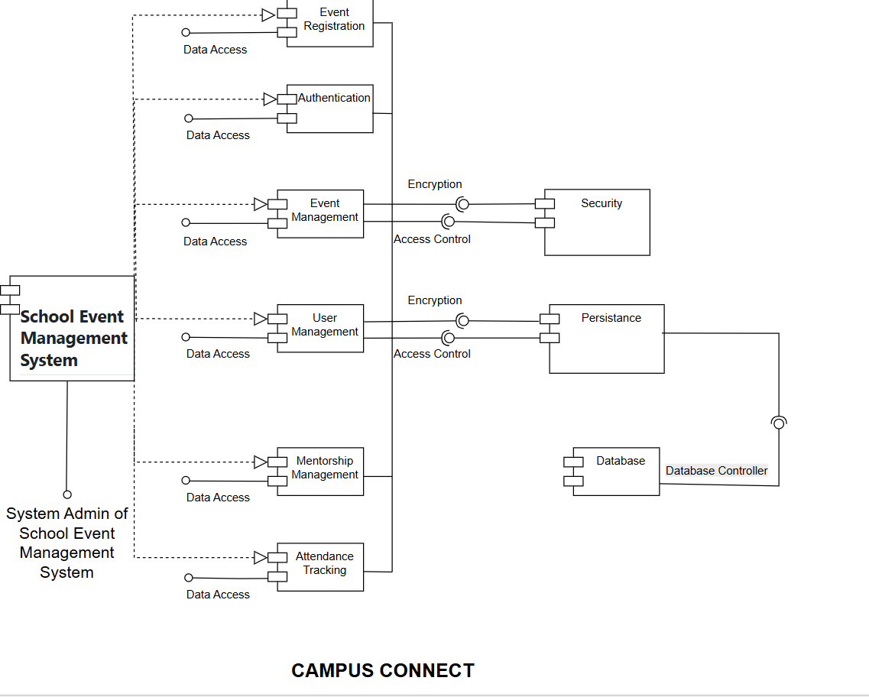
Components (Middle Part)
Event Registration: processes student registrations for events
Authentication: handles login, user verification, and secure access to the system
Event Management: manages event details such as creating, updating, and deleting events
User Management: handles user information such as students, admins, and roles
Mentorship Management: manages mentorship requests between students and mentors
Attendance Tracking: tracks student participation in events
Left Side of the Diagram
School Event Management System: represents the main system that connects all components together
System Admin of School Event Management System: the admin controls and manages the system, including users, events, and overall functionality
Data Access (Left Connections)
Data Access: meaning it reads and writes data from the database
- Each component (Event Registration, Authentication, Event Management, etc.) connects through Data Access
- This ensures all components can store and retrieve data properly
Right Side of the Diagram
Security: ensures system protection through:
- Encryption (protecting data)
- Access Control (restricting unauthorized users)
Persistence: handles storing system data permanently and managing database operations
Bottom Right Side
Database: stores all system data such as users, events, registrations, and mentorship data
Database Controller: connects the persistence layer to the database and manages communication
Interaction Explanation
System → Components: the main system communicates with all components
Components → Security: data passes through security for encryption and access control
Components → Persistence: data is sent for storage and retrieval
Persistence → Database: data is stored in the database
Database Controller: manages the connection between persistence and database
2. Detailed Design

Class Diagram
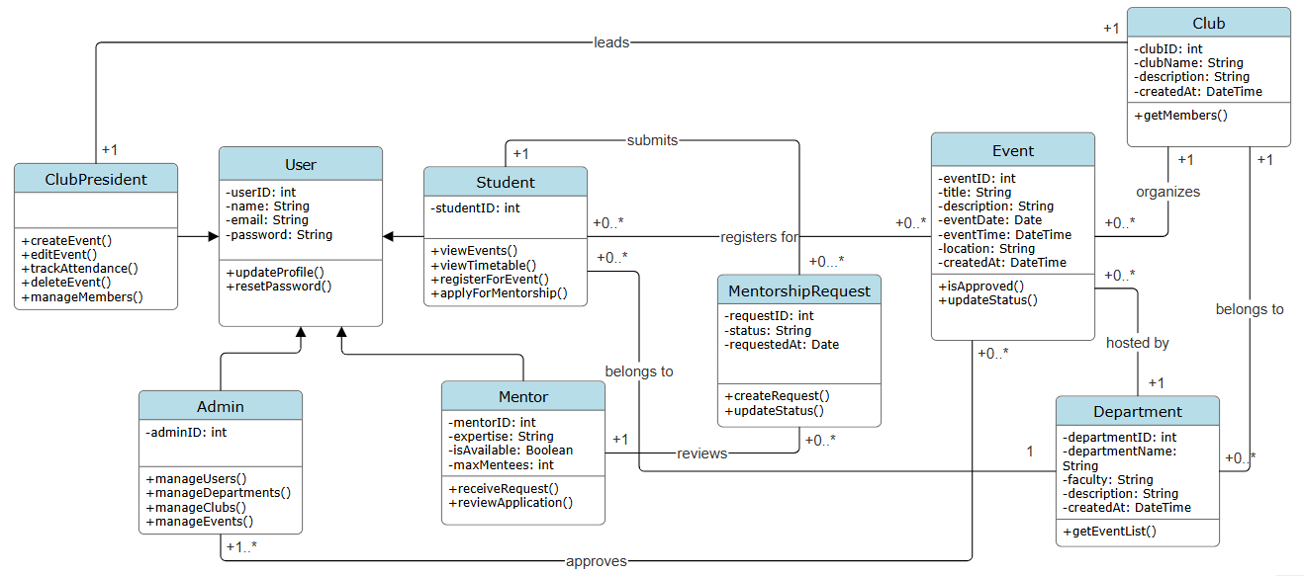

Sequence Diagrams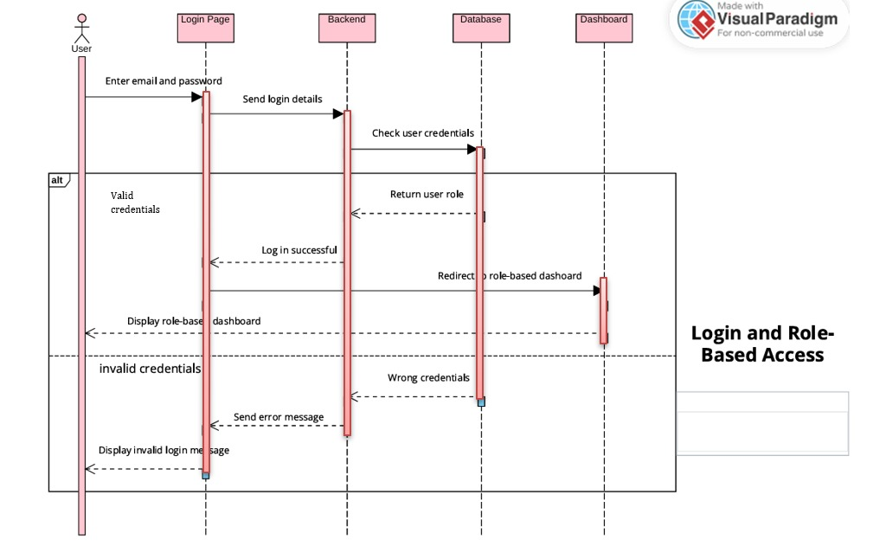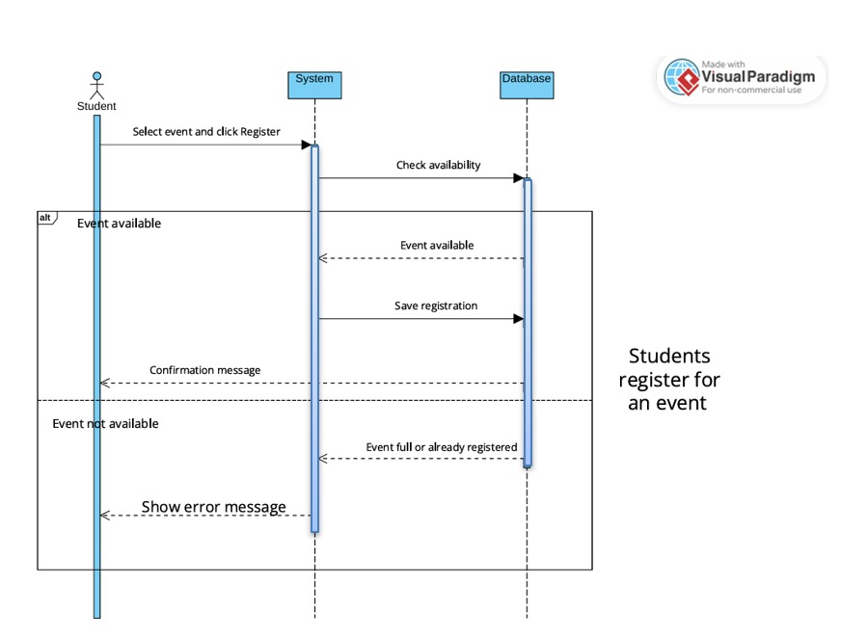
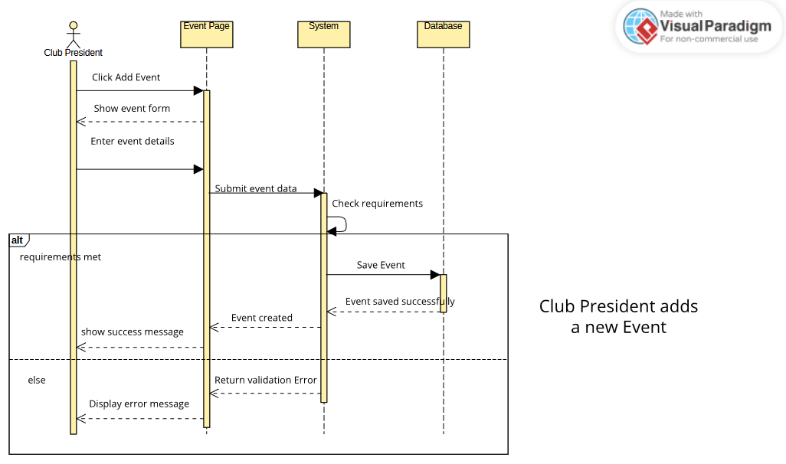

3. Modeling

Use Case Diagram
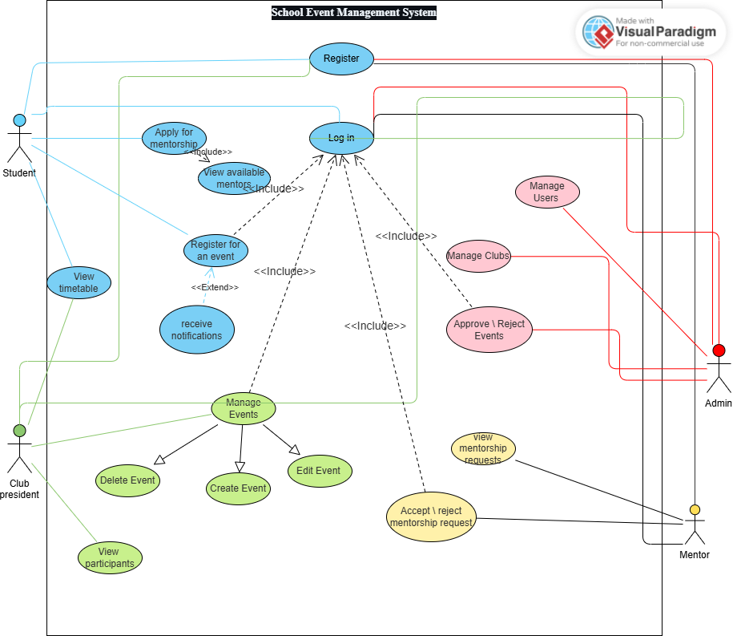

Activity Diagrams
User Login & Role-Based Access
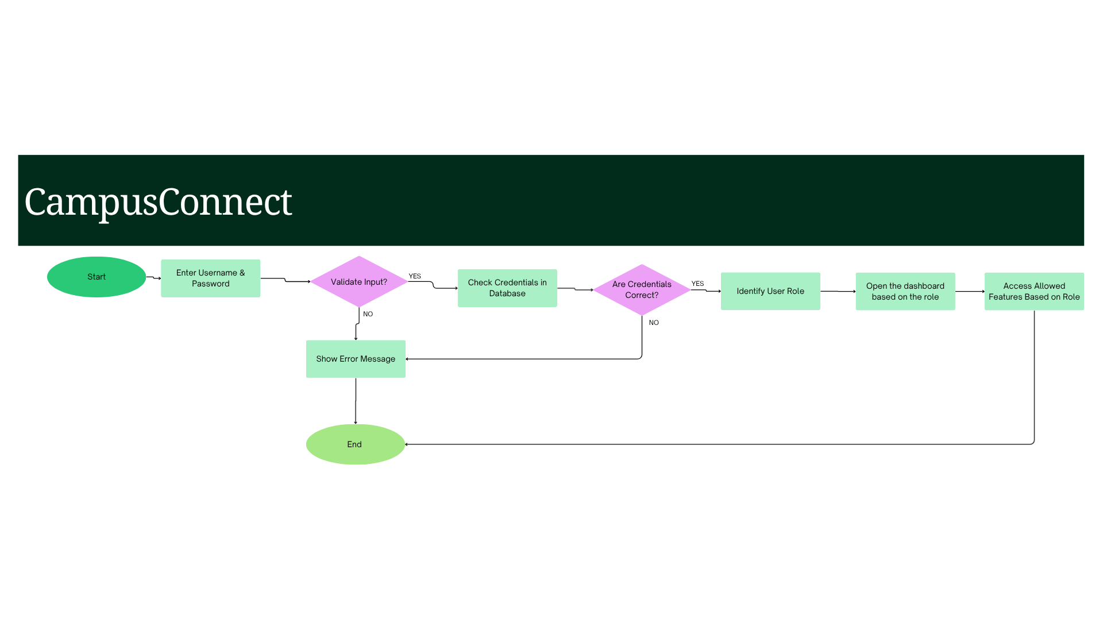
Event Creation & Approval Process
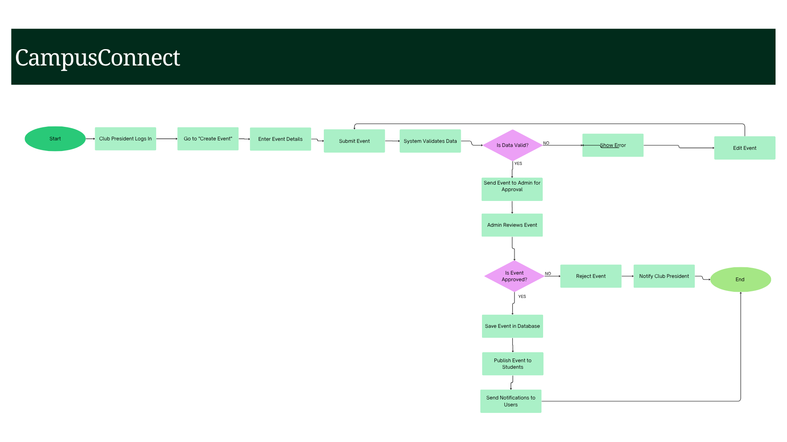

State Diagrams
Mentorship Request Process
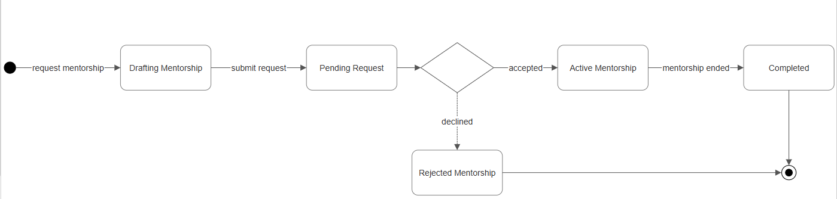
Event Creation & Approval Process
