Creating a color ensemble discrimination task
We are interested in measuring a color discrimination ability: how well someone is able to differentiate between visually similar hues in a color ensemble/ color grid. To manipulate how easy it is to tell apart colors, we can mathematically define how “far apart” colors are by changing the perceptual distance between.
In the examples I have below, there are 2 bars of colors taken from color space (more on “color space” later). These bars are the same except the top bar samples color space with 72 hues and the bottom bar samples color space with 18 colors. Lightness is the same for both.
Critically, sampling more hues leads to a more fine-grained palette whereas sampling from less creates very discrete hues. For our task, we prefer sampling more colors to create the difficult trials with very similar hues that people have to tell apart.
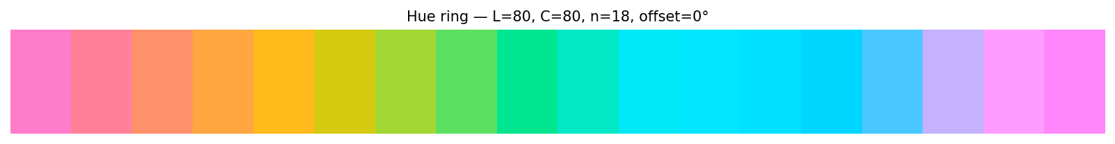
For fine-grain color discriminations, we would ideally want to stay within a single color category (e.g., blue, green, purple). Changing color category boundaries could make the trial easy if someone can detect a purple among the blues, for example.
You may notice that the blue and green bars clearly stay within their respective color categories but the purple one very quickly shifts to pink. Yes, there can be some individual differences in where that category boundary is, but generally the first two rows can be labeled as one category (green, blue) but the bottom bar has purple and pink.
See next section about non-uniformity in color space.
Non-uniformity in color space and Selecting Hues
Color space is not uniform, meaning that the way we perceive distances in hues is not equal. This isn’t intuitive because the color spectrum appears to be smooth and continuous (like in the bars I showed above). One way to visualize this is by looking at a visualization of color space.
If you look at this color spindle below, green spans the entire top left portion of the spindle, but yellow is a narrow sliver. If you traverse left or right in color space starting in yellow, you quickly change color categories (see Berlin & Kay, 1969). This isn’t necessarily contingent on color categories and some recent work even suggests that these differences arise in early cortical sensory representations of color (Macyczko et al. 2025).

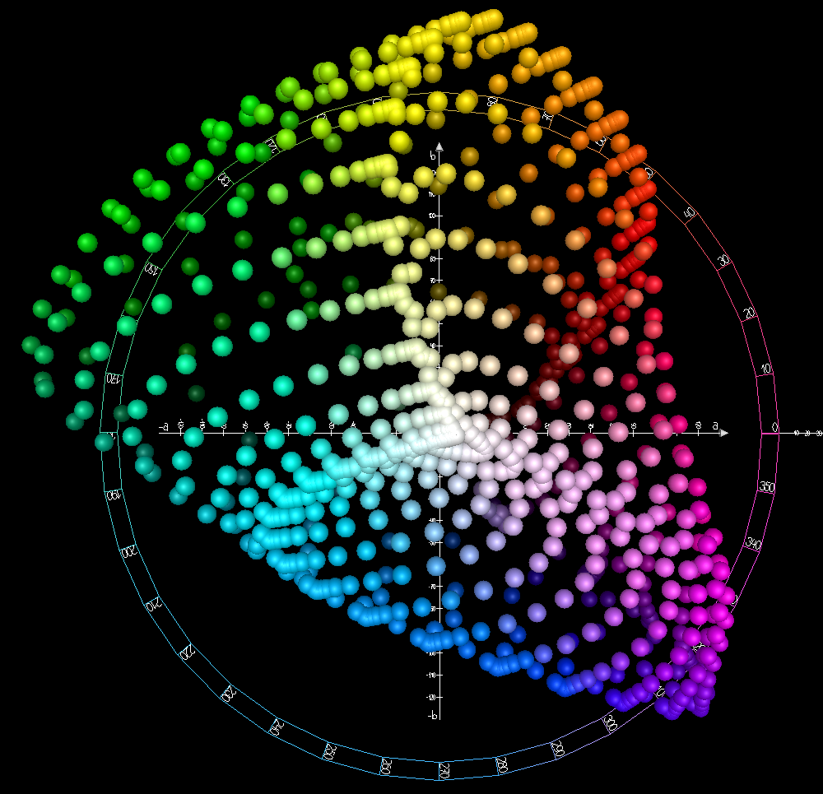
Figure 1. CIELAB color space from Wikipedia https://en.wikipedia.org/wiki/CIELAB_color_space
In LAB color space, L * indicates lightness, a * indicates red to green, and b * indicates blue to yellow. LAB space is an attempt at creating a perceptually uniform color space, meaning that numerical changes in color coordinates should result in equal changes in the perception of colors. I think it is the more common model of color space used by color psychology researchers because it is used to model surface colors in the real world (e.g., objects, natural scene statistics). This model is preferred to CIELUV which is used to model colors in digital displays / graphics. CIE HCL is also used by color researchers https://arxiv.org/abs/2511.14009. No need to get into the details about this one but the C stands for chroma (aka, the intensity/saturation of a color)
You may be wondering why this matters – this non-uniformity is relevant for how we generate the color bitmaps!
Examples of non-uniformity when generating colors for our task:
For blue and green, there are many colors to sample from within the space, so we can create highly difficult trials with many colors BECAUSE there are so many perceptually similar colors within the space. I don’t know how many colors there are in these chunks I grabbed, but lets say there’s 15-20.
For purple, you can still create highly difficult trials, but you have to shrink where you’re sampling from since there are not as many purples available in the space. For example, if we were grabbing from this part of the slice, we would be grabbing maybe 4 colors.

These two sets are sampling only from the purple part of color space but the top row samples 20 colors whereas the bottom row samples 5.

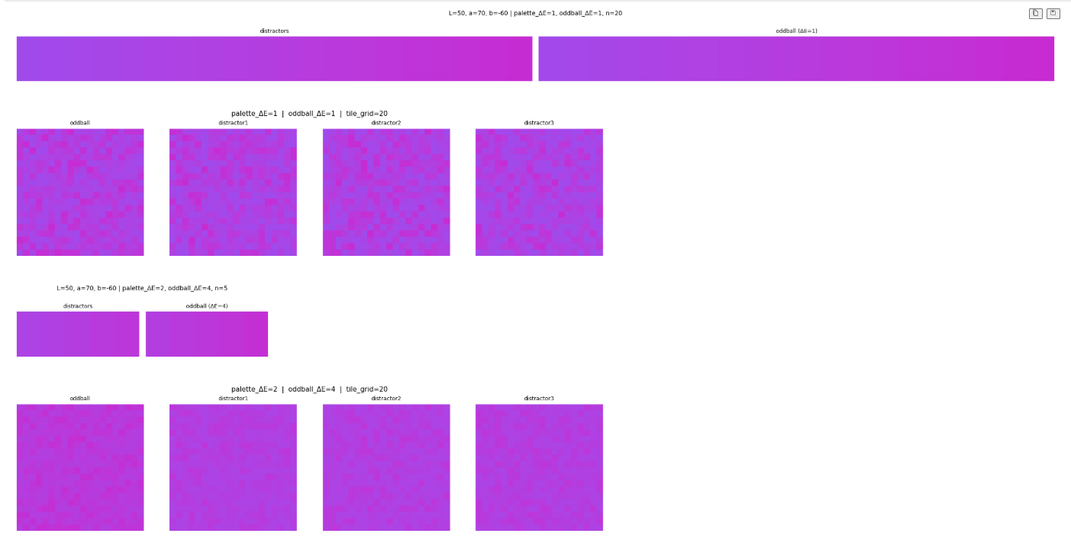

The point of showing these two examples is that EVEN THOUGH color space is non-uniform, you can still create difficult color discrimination trials. It’s just important to highlight that the number of colors within a palette and how much each color varies won’t be equal for the different color categories. TBH this is just something you have to deal with when you’re working with color.

Creating “Colormaps” for color discrimination:
Methodologically, there are different ways you can sample colors to create these color grids (e.g., varying number of colors in a grid / grid size itself) and how colors are applied to the grid.

Does reducing grid size change trial difficulty? I think the answer is no because it really has to do with (1) how many colors are being sampled and (2) how similar the colors are.
For example, in this example, the top set has a 20x20 grid and the bottom set has a 12x12 grid. This is a particularly difficult trial because of the similarity between the colors sampled, not because of the number of squares in the grid.

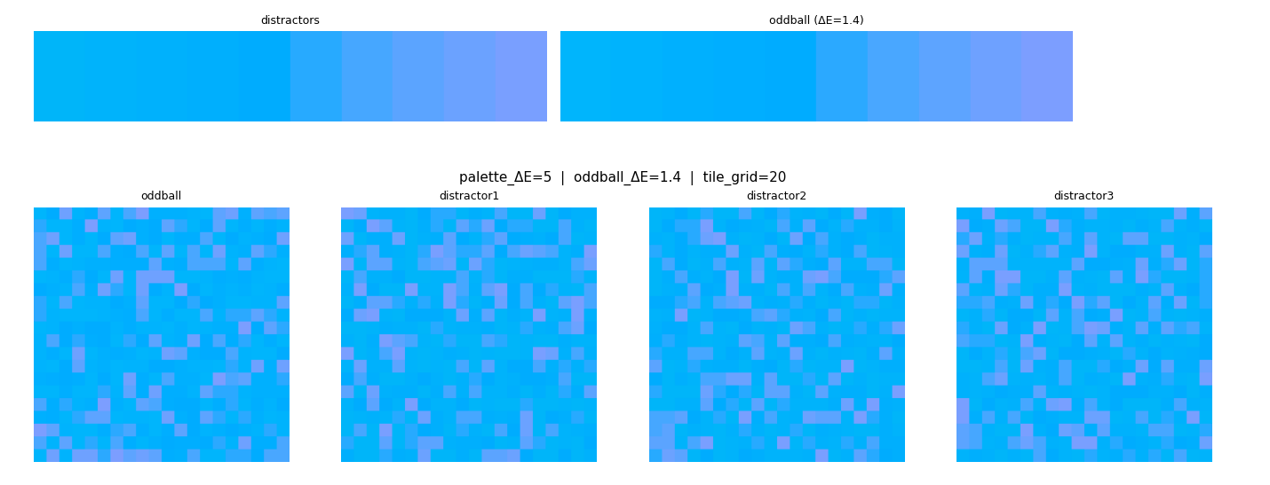
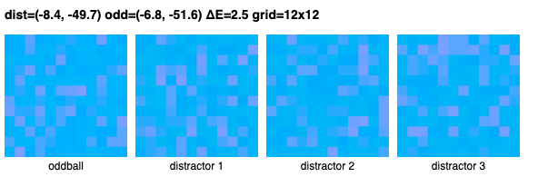

Discussing Methods of Color Samplings
ok, I’m using claude to help me with this part.
Basically, there are two methods that we came up with. The former method I tried is a “hue shift method” where the oddball’s color distribution is slightly shifted from the distractor distribution. This means that while the distributions overlap in many colors, the oddball does contain colors that do not exist in the distractors. The idea is that even though the distribution of the oddball is shifted, it is shifted ever so slightly that someone would need to identify which image contains hue(s) that are not in the distractors.
The second method is a “Mean Shift”. The oddball and distractors sample from the same color distribution but the proportions of colors represented gets shifted (specifically the mean color represented in the distribution is shifted).
While I think that both methods lead to visually similar outcomes, it is still worth thinking through different options.

Two Methods for Creating Color Oddball Bitmaps
Each trial consists of four patchwork bitmaps — one oddball and three distractors. The goal is for the oddball to look similar to the distractors, but to be detectably different. The two methods differ in how that difference is created.
Method 1 — Hue Shift
Think of a color wheel. The distractors are painted using colors from one small region of that wheel — say, a range of slightly different pinks. The oddball is painted using colors from a neighboring region — a slightly different set of pinks, shifted a few degrees around the wheel. The two sets of colors are close but not identical. Because the shift is small, the bitmaps look very similar, but the oddball is genuinely using different colors.

Method 2 — Shifted Mean
Here, every bitmap — distractor and oddball alike — is painted using the exact same set of colors. What differs is how much of each color is used. Imagine the palette laid out from left (cooler) to right (warmer). The distractors use a little more of the middle shades. The oddball uses a little more of the shades toward one end. The result is a subtle overall shift in tone, even though no new colors were introduced.
The core difference: In Method 1, the oddball contains colors the distractors don't have. In Method 2, the oddball contains the same colors as the distractors, just in slightly different amounts.

TOP ROW: HUE SHIFT; BOTTOM ROW: MEAN SHIFT
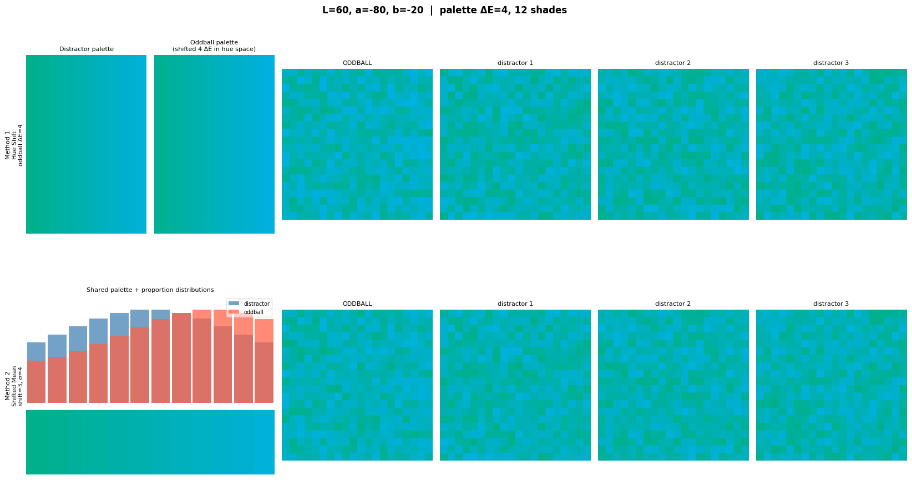
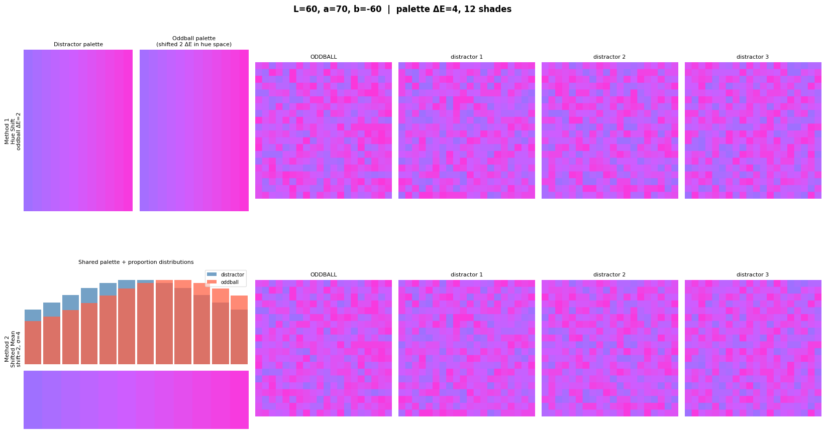
Examples where the grids are 12x12 instead of 20x20:
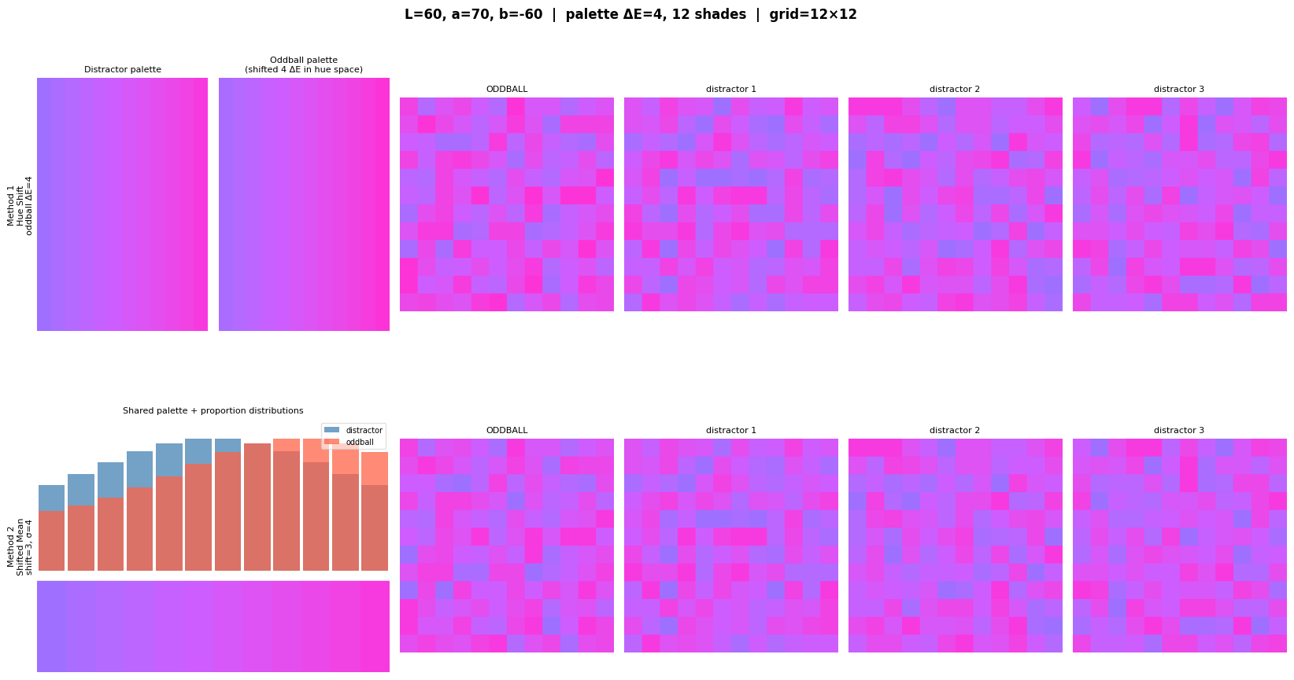
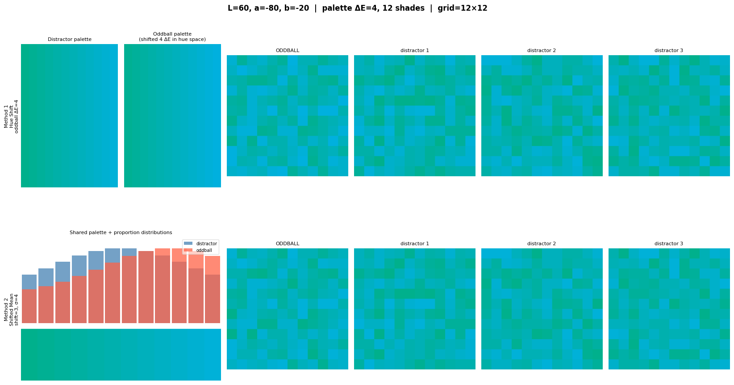

More 12x12 examples:

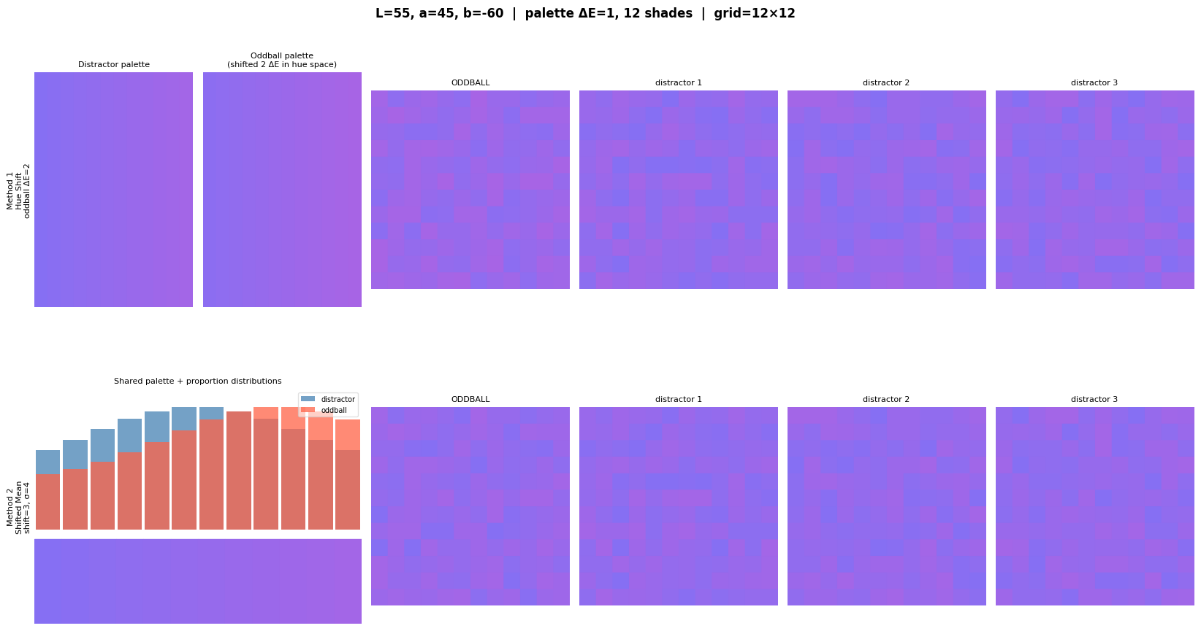

More extreme shift example:
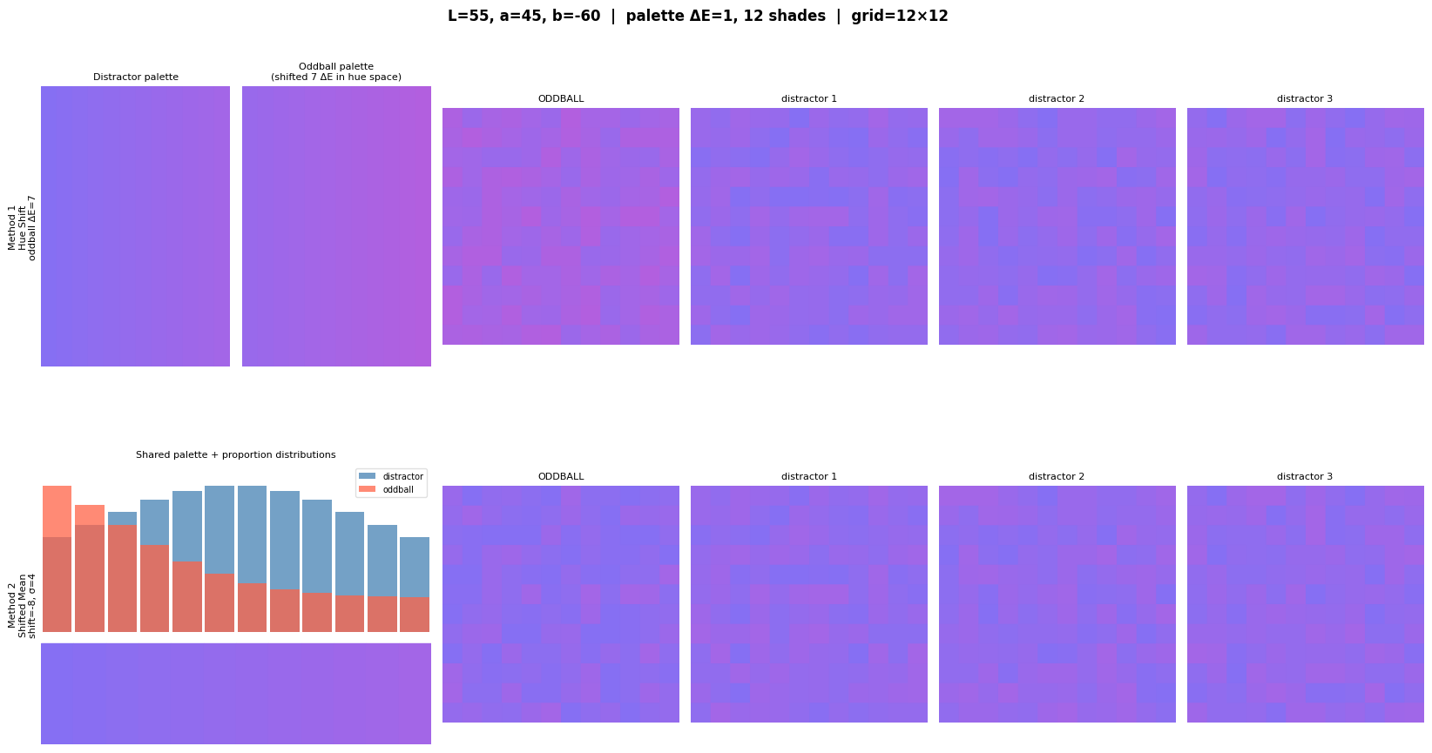

Literature Summary: 0-Literature/COLOR/
10 papers total.

Color Space & Measurement Foundations
- MacAdam (1942) — The classic paper establishing that color discrimination thresholds are not uniform in chromaticity space. Introduces the "MacAdam ellipses," which directly motivate why equal numerical steps in color space don't produce equal perceptual differences.
- McLaren (1980) — A technical note on anomalies in CIELAB hue-angle calculations at low tristimulus ratios. Relevant if you're doing precise hue-angle math in CIELAB.
- Ohno (2000) — Overview of the CIE colorimetry system (fundamentals, calibration methods). A reference/tutorial paper on color measurement standards.

Color in Scene and Object Recognition
- Gegenfurtner & Rieger (2000) — Examines what role color plays in natural scene recognition. Finds that color contributes to both early sensory processing and higher-level cognitive recognition of scenes. Directly relevant to the SceneFactor project.
- Gegenfurtner, Wichmann, & Sharpe (1997/1998) — Uses dichromats to isolate the contribution of color to visual memory in a recognition paradigm. Establishes that color supports scene memory beyond luminance information.

Color Perception & Cognition
- Conway et al. (2010) — Journal of Neuroscience mini-symposium reviewing advances in color science from retina to behavior. Broad review covering neural color coding, color constancy, and higher-level color cognition.
- Macyczko et al. (2025) — bioRxiv preprint on asymmetries in hue perception, measured both behaviorally and with VEPs. Directly cited in thinking_about_color.docx to motivate why some color categories have denser perceptual structure than others. Very current.

Color Search & Discriminability
- Rosenholtz, Nagy, & Bell (2004) (background_effect_on_color_jov.pdf) — Examines how background color affects discriminability and asymmetries in color search. Relevant to understanding how context affects color oddball detection.

Color Ensemble Perception ⚑
- Maule & Franklin (2015) (maule_franklin.pdf) — "Effects of ensemble complexity and perceptual similarity on rapid averaging of hue", Journal of Vision. This is the color ensemble paper. Directly investigates how people extract mean hue from heterogeneous arrays — exactly the perceptual mechanism your task is designed to probe. Core reference.

