(Original text is on the left. Text run through the function is on the right)

TEST: U.S.<sup>
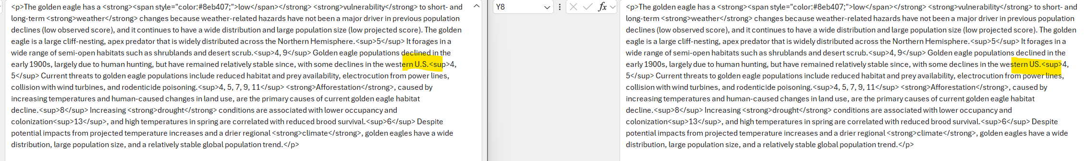
TEST: U.S.,
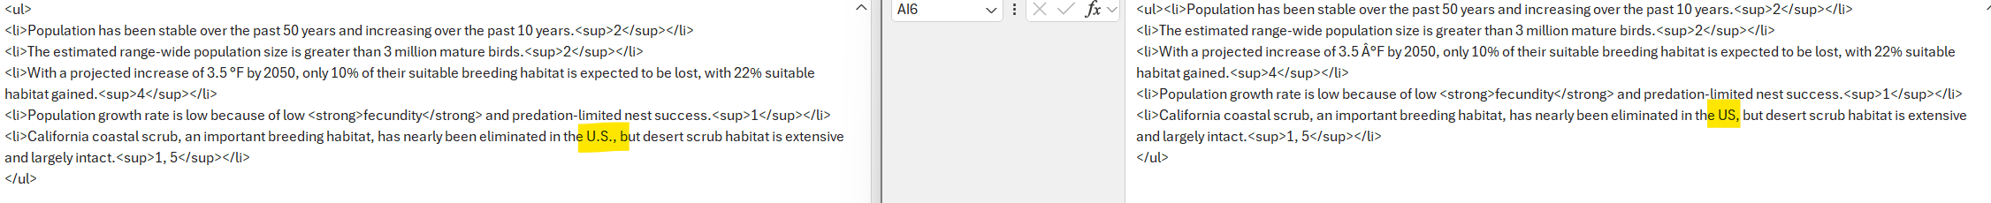
TEST: U.S. [sentence continues]…
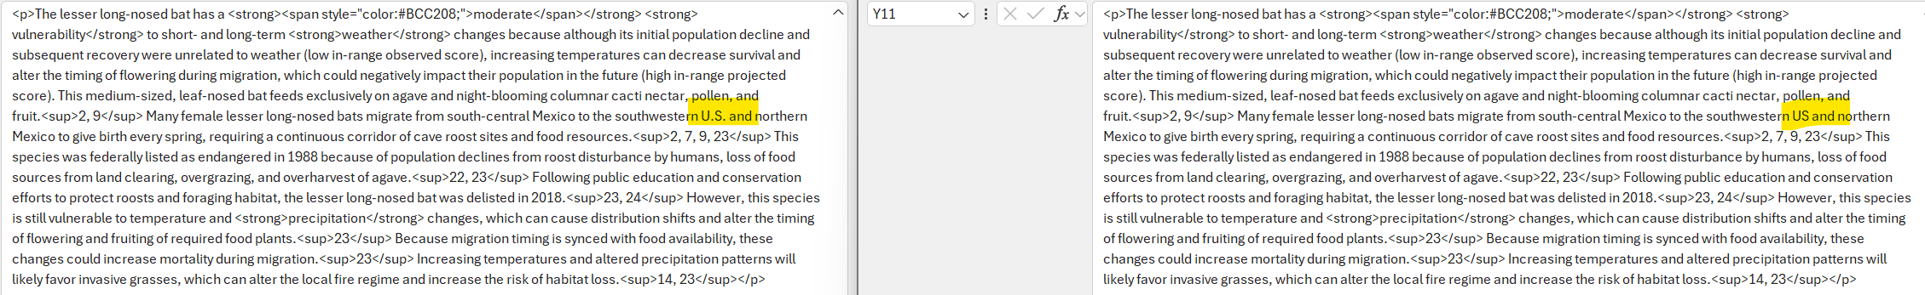
TEST: U.S. [New sentence]
TEST: (…. U.S.)
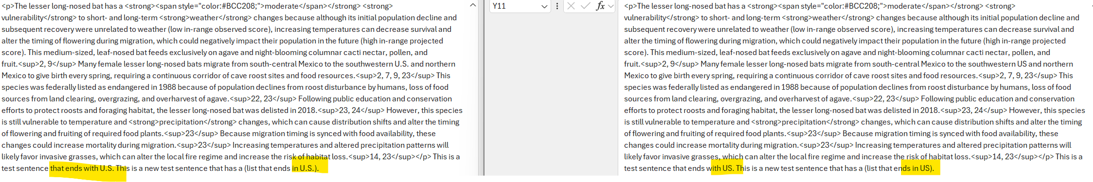
U.S. [with nothing after it] – did not work
