Chapter Annual Reports for 2019 - Summaries of Text Responses

Melinda Higgins, PhD; Vice-Chair District 5

8/3/2020

## 2019 Annual Chapter Reports from 2019

The Excel file containing all of the 2019 Annual ASA Chapter Reports was downloaded from the ASA Leader Hub - under Annual Chapter Reports. Go to <https://ww2.amstat.org/MembersOnly/chapterreportsnew/adminreportstatus_districts.cfm> logged in with an ASA leader/officer account.

## Text Summary of “Other Chapter Activities”

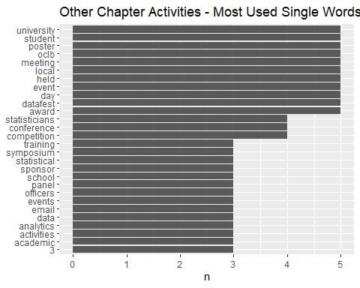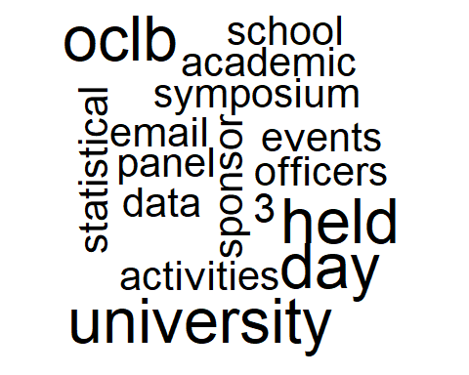

Other Chapter Activities - Bigram (2 word) Summary

|  |  |
| --- | --- |
| bigram | n |
| poster competition | 4 |
| award event | 2 |
| career day | 2 |
| carleton university | 2 |
| data fest | 2 |
| email list | 2 |
| panel discussion | 2 |
| regular events | 2 |
| science fair | 2 |
| successfully held | 2 |

## Text Summary of “Other Details of Chapter Activities”

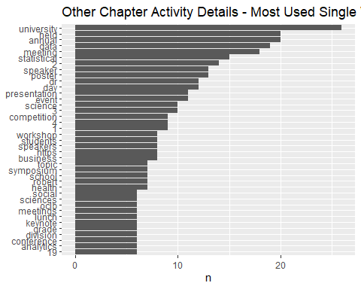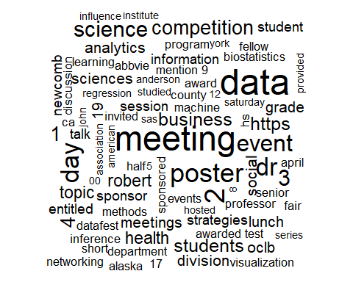

Other Chapter Activity Details - Bigram (2 word) Summary

|  |  |
| --- | --- |
| bigram | n |
| poster competition | 7 |
| business meeting | 6 |
| data science | 5 |
| presentation entitled | 5 |
| honorable mention | 4 |
| machine learning | 4 |
| newcomb fellow | 4 |
| senior division | 4 |
| 11th grade | 3 |
| causal inference | 3 |
| division honorable | 3 |
| engineering fair | 3 |
| half day | 3 |
| invited speaker | 3 |
| pacific university | 3 |
| poster session | 3 |
| statistical methods | 3 |

## Text Summary of “Use of Stimulus Funds”

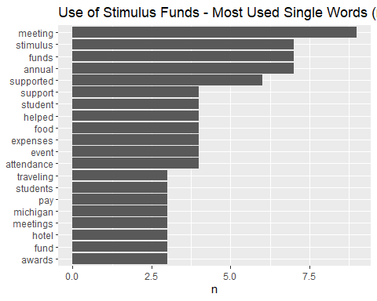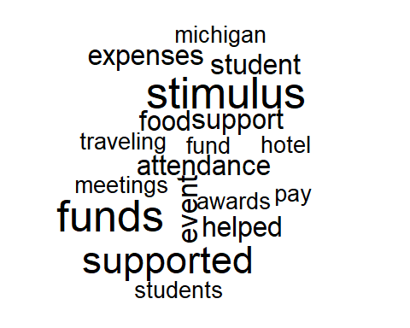

Use of Stimulus Funds - Bigram (2 word) Summary

|  |  |
| --- | --- |
| bigram | n |
| stimulus funds | 4 |
| 100 awards | 2 |
| discussant event | 2 |
| engineering fair | 2 |
| funds supported | 2 |
| hotel cost | 2 |
| meetup site | 2 |
| michigan science | 2 |
| panel discussant | 2 |
| research presentation | 2 |
| spring meeting | 2 |

## Text Summary of “How can ASA help your chapter?”

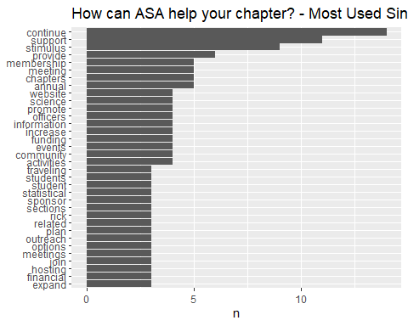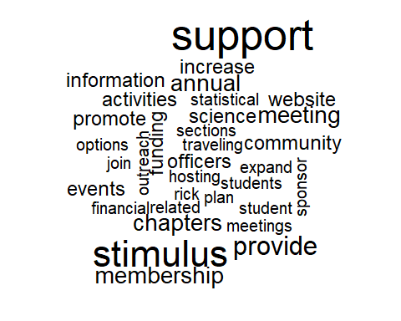

How can ASA help your chapter? - Bigram (2 word) Summary

|  |  |
| --- | --- |
| bigram | n |
| stimulus funding | 4 |
| financial support | 3 |
| outreach activities | 2 |
| science fair | 2 |
| stimulus fund | 2 |
| stimulus funds | 2 |