Fulton County COVID Stats

Melinda Higgins

2022-11-11

# Report Overview

add text here on what this report is for…

## Fulton County COVID Data

The dataset has 82101 COVID cases from mostly the Fulton County, GA area. These data cover COVID cases reported from December 2019 to July 2021.

### Table of Demographics

|  | Overall (N=82101) |
| --- | --- |
| **case_age** |  |
| N-Miss | 48 |
| Mean (SD) | 39.685 (19.159) |
| Range | -20.000 - 106.000 |
| **case_gender** |  |
| N-Miss | 63 |
| Female | 43299 (52.8%) |
| Male | 38393 (46.8%) |
| Unknown | 346 (0.4%) |
| **case_race** |  |
| N-Miss | 2630 |
| AMERICAN INDIAN/ALASKA NATIVE | 84 (0.1%) |
| ASIAN | 3075 (3.9%) |
| BLACK | 35048 (44.1%) |
| NATIVE HAWAIIAN/PACIFIC ISLANDER | 79 (0.1%) |
| OTHER | 5863 (7.4%) |
| UNKNOWN | 3723 (4.7%) |
| WHITE | 31599 (39.8%) |
| **case_eth** |  |
| N-Miss | 2574 |
| HISPANIC/LATINO | 8625 (10.8%) |
| NON-HISPANIC/LATINO | 62677 (78.8%) |
| NOT SPECIFIED | 8225 (10.3%) |

### Table of symptoms

|  | Overall (N=82101) |
| --- | --- |
| **sym_fever** |  |
| N-Miss | 31577 |
| No | 33951 (67.2%) |
| Unk | 1446 (2.9%) |
| Yes | 15127 (29.9%) |
| **sym_subjfever** |  |
| N-Miss | 37908 |
| No | 30457 (68.9%) |
| Unk | 1024 (2.3%) |
| Yes | 12712 (28.8%) |
| **sym_myalgia** |  |
| N-Miss | 32137 |
| No | 29210 (58.5%) |
| Unk | 1220 (2.4%) |
| Yes | 19533 (39.1%) |
| YES | 1 (0.0%) |
| **sym_losstastesmell** |  |
| N-Miss | 50724 |
| No | 18109 (57.7%) |
| Unk | 534 (1.7%) |
| Yes | 12734 (40.6%) |
| **sym_sorethroat** |  |
| N-Miss | 32241 |
| No | 36106 (72.4%) |
| Unk | 1238 (2.5%) |
| Yes | 12516 (25.1%) |
| **sym_cough** |  |
| N-Miss | 31630 |
| No | 27474 (54.4%) |
| Unk | 1054 (2.1%) |
| Yes | 21943 (43.5%) |
| **sym_headache** |  |
| N-Miss | 32018 |
| No | 27196 (54.3%) |
| Unk | 1212 (2.4%) |
| Yes | 21675 (43.3%) |
| **sym_resolved** |  |
| N-Miss | 42294 |
| No, still symptomatic | 14466 (36.3%) |
| Unknown symptom status | 2076 (5.2%) |
| Yes, date specified below | 15304 (38.4%) |
| Yes, date unknown | 7961 (20.0%) |

## Clean up data and recode

### Table of some symptoms after recoding

|  | Overall (N=82101) |
| --- | --- |
| **sym_fever.c** |  |
| No, unk, na | 66974 (81.6%) |
| Yes | 15127 (18.4%) |
| **sym_sorethroat.c** |  |
| No, unk, na | 69585 (84.8%) |
| Yes | 12516 (15.2%) |
| **sym_cough.c** |  |
| No, unk, na | 60158 (73.3%) |
| Yes | 21943 (26.7%) |
| **sym_headache.c** |  |
| No, unk, na | 60426 (73.6%) |
| Yes | 21675 (26.4%) |

### Table of symptoms by race

Let’s also add some nicer labels and then make the table of these recoded symptoms by race.

Symptoms by race

|  | Black (N=35048) | Other, unknown or missing (N=15454) | White (N=31599) | Total (N=82101) |
| --- | --- | --- | --- | --- |
| **Fever** |  |  |  |  |
| No, unk, na | 28725 (82.0%) | 13017 (84.2%) | 25232 (79.9%) | 66974 (81.6%) |
| Yes | 6323 (18.0%) | 2437 (15.8%) | 6367 (20.1%) | 15127 (18.4%) |
| **Sore Throat** |  |  |  |  |
| No, unk, na | 30356 (86.6%) | 13393 (86.7%) | 25836 (81.8%) | 69585 (84.8%) |
| Yes | 4692 (13.4%) | 2061 (13.3%) | 5763 (18.2%) | 12516 (15.2%) |
| **Cough** |  |  |  |  |
| No, unk, na | 25000 (71.3%) | 12471 (80.7%) | 22687 (71.8%) | 60158 (73.3%) |
| Yes | 10048 (28.7%) | 2983 (19.3%) | 8912 (28.2%) | 21943 (26.7%) |
| **Headache** |  |  |  |  |
| No, unk, na | 25909 (73.9%) | 12415 (80.3%) | 22102 (69.9%) | 60426 (73.6%) |
| Yes | 9139 (26.1%) | 3039 (19.7%) | 9497 (30.1%) | 21675 (26.4%) |

### Table of Symptoms by Race for People who Died

Symptoms by race - people who died

|  | Black (N=1042) | Other, unknown or missing (N=63) | White (N=599) | Total (N=1704) |
| --- | --- | --- | --- | --- |
| **Fever** |  |  |  |  |
| No, unk, na | 848 (81.4%) | 46 (73.0%) | 485 (81.0%) | 1379 (80.9%) |
| Yes | 194 (18.6%) | 17 (27.0%) | 114 (19.0%) | 325 (19.1%) |
| **Sore Throat** |  |  |  |  |
| No, unk, na | 1020 (97.9%) | 61 (96.8%) | 581 (97.0%) | 1662 (97.5%) |
| Yes | 22 (2.1%) | 2 (3.2%) | 18 (3.0%) | 42 (2.5%) |
| **Cough** |  |  |  |  |
| No, unk, na | 839 (80.5%) | 48 (76.2%) | 482 (80.5%) | 1369 (80.3%) |
| Yes | 203 (19.5%) | 15 (23.8%) | 117 (19.5%) | 335 (19.7%) |
| **Headache** |  |  |  |  |
| No, unk, na | 1007 (96.6%) | 61 (96.8%) | 577 (96.3%) | 1645 (96.5%) |
| Yes | 35 (3.4%) | 2 (3.2%) | 22 (3.7%) | 59 (3.5%) |

# Maps with points and markers

intro to making maps with data points on them

## Make a Map of Atanta with leaflet

Learn more about the [leaflet package](https://rstudio.github.io/leaflet/).

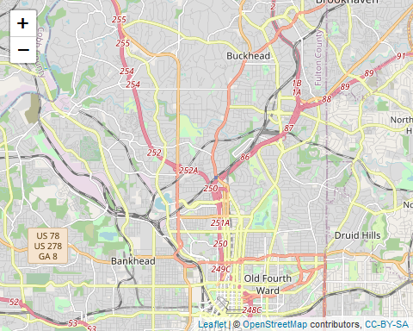

## add data to the map

Let’s look at the locations of the COVID deaths under review and color the points by gender.

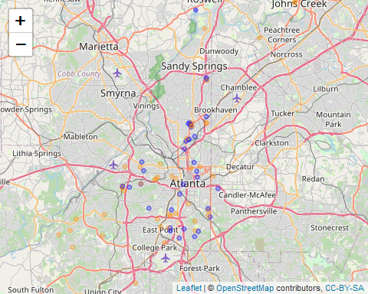

## Change the base layer if wanted to simplier road map

Learn more with basemaps at <https://rstudio.github.io/leaflet/basemaps.html>.

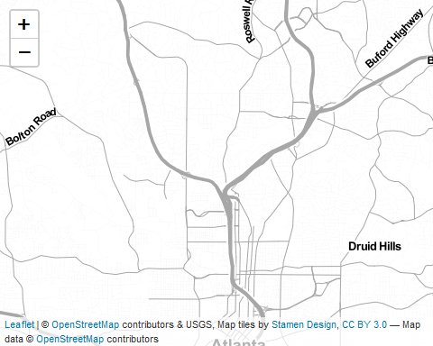

## Add some data to the map

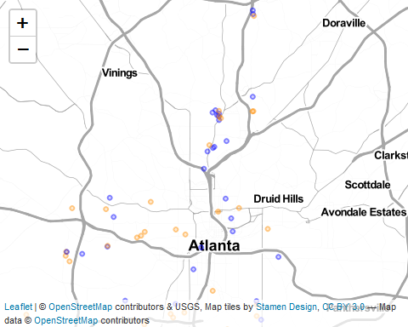

# Aggregating data

info here on aggregating data by categories - like by zipcode

then merge with the shapefile data for the Fulton County zipcodes

and then we can make choropleth maps - maps with colored areas filled in to represent values or categories.

## Load shapefiles for Fulton County Map

Read in the SHP shapefile for Fulton County, GA using the sf package. Then plot the map.

## Reading layer `FultonCountyZipCodes' from data source   
## `C:\MyGithub\Emory_RWorkshop_11Nov2022\FultonCountyZipCodes\FultonCountyZipCodes.shp'   
## using driver `ESRI Shapefile'  
## Simple feature collection with 48 features and 4 fields  
## Geometry type: MULTIPOLYGON  
## Dimension: XY  
## Bounding box: xmin: 2087952 ymin: 1274336 xmax: 2317492 ymax: 1522856  
## Projected CRS: NAD83 / Georgia West (ftUS)

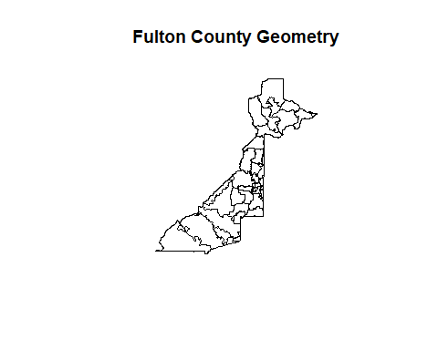

## pull data of interest and summarize by zipcode

## then merge and make a choropleth map

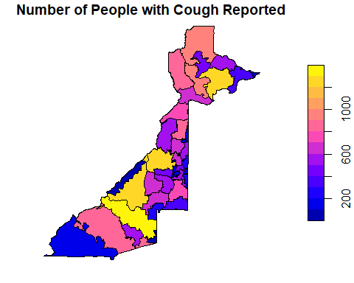

## another map option with ggplot2

