**Homework 5 – Answer Key**

ANCOVA - Analysis of Covariance Exercise

For Homework 05, you will be using the HELP dataset, learn more at:

* <https://melindahiggins2000.github.io/N736Fall2017_HELPdataset/> &
* <https://github.com/melindahiggins2000/N736Fall2017_HELPdataset>

Complete the following for these variables:

1. OUTCOME VARIABLE (Y): indtot
2. INDEPENDENT VARIABLE (X): mcs
3. COVARIATES (other X’s): pss_fr or female
4. Run ANCOVA *(using a regression, ANOVA, or GLM approach - your choice)* for the association between the SF36 Mental Component Score (mcs) and Inventory of Drug Use (indtot) adjusting for perceived social support from friends (pss_fr). Remember to:
   * mean center continuous variables before computing the interaction term *(i.e. create a new mean-centered variable by subtracting the mean)*
   * check for the assumption of homogenity of variance *(i.e. is the interaction term significant?)*
   * make an “effects plot” plot of the interaction between mcs and pss_fr
5. Run ANCOVA *(using a regression, ANOVA, or GLM approach - your choice)* for the association between the SF36 Mental Component Score (mcs) and Inventory of Drug Use (indtot) adjusting for gender (female). Remember to:
   * mean center continuous variables before computing the interaction term *(i.e. create a new mean-centered variable by subtracting the mean)*
   * check for the assumption of homogenity of variance *(i.e. is the interaction term significant?)*
   * make an “effects plot” plot of the interaction between mcs and female

**Answer Key**

1. ANCOVA of the Inventory of Drug Use (INDTOT) by the SF36 Mental Composite Score (MCS) “adjusting for” Perceived Social Support from Friends (PSS_FR). The table below is basically the regression model results showing the model results after each variable is added to the model. I added the first few columns to also include the model summary stats and the change in R2 after each variable is added to the model.

**ANCOVA Results Table – Using a sequential regression approach**

|  |  |  |  |  |  |  |  |  |  |  |  |
| --- | --- | --- | --- | --- | --- | --- | --- | --- | --- | --- | --- |
| Model Step | | Adj R2 | F(df1, df2)  p-value | Change  in R2 | B | SEB | β | t | p-value | 95% CI LB | 95% CI UB |
| 1 | (Constant) | 0.143 | F(1,451)=76.407  p<.001 |  | 35.728 | .311 |  | 114.849 | <.001 | 35.117 | 36.340 |
| MCS* |  |  | 0.145  p<.001 | -.212 | .024 | -.381 | -8.741 | <.001 | -.260 | -.164 |
|  |  |  |  |  |  |  |  |  |  |  |  |
| 2 | (Constant) | 0.163 | F(2,450)=44.903  p<.001 |  | 35.727 | .307 |  | 116.188 | <.001 | 35.123 | 36.332 |
| MCS* |  |  |  | -.201 | .024 | -.360 | -8.289 | <.001 | -.248 | -.153 |
| PSS_FR* |  |  | 0.021  p=.001 | -.265 | .078 | -.148 | -3.406 | .001 | -.418 | -.112 |
|  |  |  |  |  |  |  |  |  |  |  |  |
| 3 | (Constant) | 0.161 | F(3,449)=29.879  p<.001 |  | 35.734 | .311 |  | 115.061 | <.001 | 35.124 | 36.344 |
| MCS* |  |  |  | -.200 | .025 | -.359 | -8.147 | <.001 | -.248 | -.152 |
| PSS_FR* |  |  |  | -.265 | .078 | -.148 | -3.395 | .001 | -.418 | -.111 |
| MCS* - x – PSS_FR* |  |  | 0.000  p=.874 | -.001 | .006 | -.007 | -.158 | .874 | -.012 | .011 |

* MCS was mean centered at31.677; and PSS_FR was mean centered at 6.71

Since the interaction term is not significant (p=.874), we can assume that the homogeneity of slopes assumption has been met.

Effects Plot – this plot was made in SPSS splitting the data into a low PSS-FR value and a high PSS-FR value

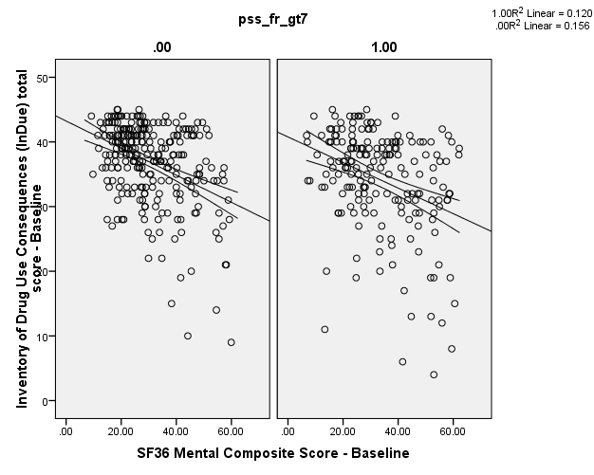

This is an effects plot in R using the effects package – at varying levels of PSS-FR

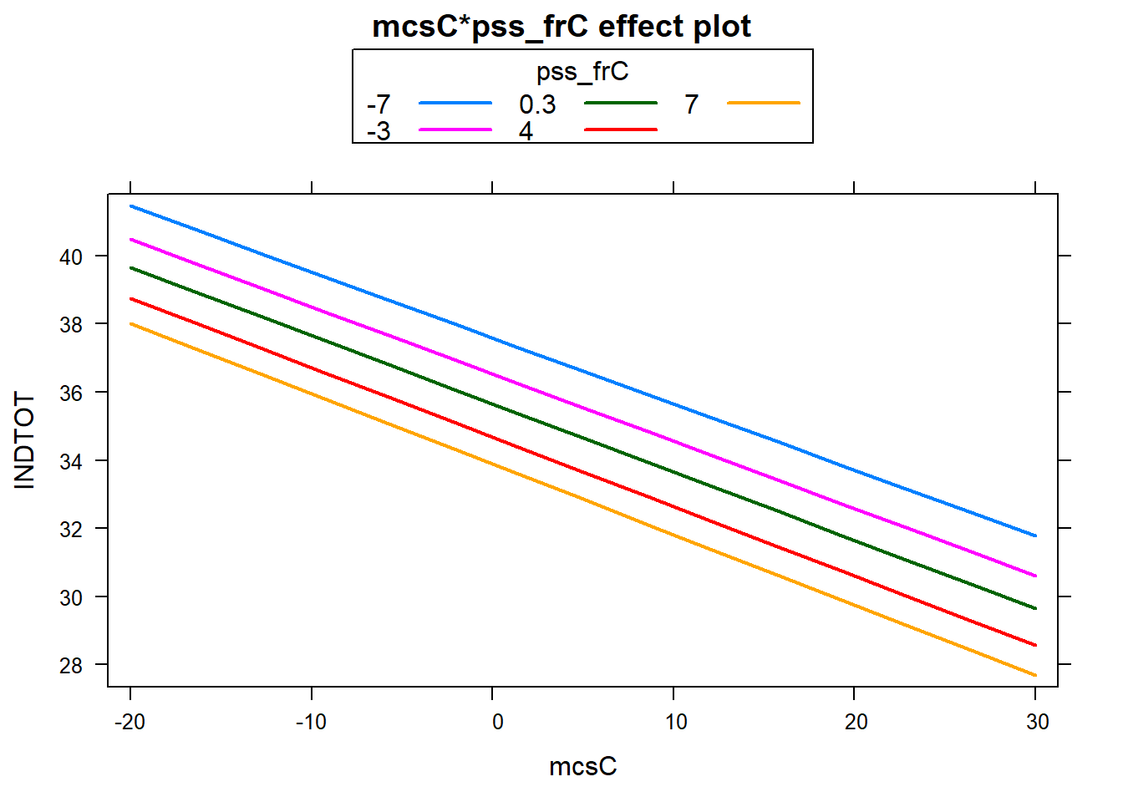

And another Effects Plot from SAS – at varying levels of PSS-FR

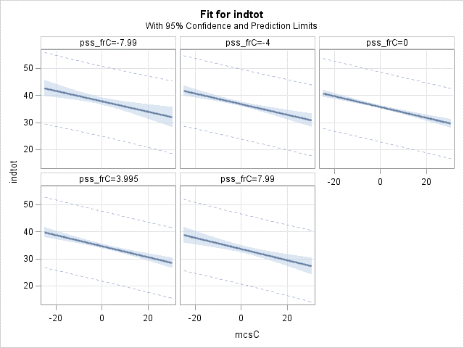

1. ANCOVA of the Inventory of Drug Use (INDTOT) by the SF36 Mental Composite Score (MCS) “adjusting for” gender (FEMALE). The table below is basically the regression model results showing the model results after each variable is added to the model. I added the first few columns to also include the model summary stats and the change in R2 after each variable is added to the model.

|  |  |  |  |  |  |  |  |  |  |  |  |
| --- | --- | --- | --- | --- | --- | --- | --- | --- | --- | --- | --- |
|  | Model Step | Adj R2 | F(df1, df2)  p-value | Change  in R2 | B | SEB | β | t | p-value | 95% CI LB | 95% CI UB |
| 1 | (Constant) | 0.143 | F(1,451)=76.407  p<.001 |  | 35.728 | .311 |  | 114.849 | <.001 | 35.117 | 36.340 |
| MCS* |  |  | 0.145  p<.001 | -.212 | .024 | -.381 | -8.741 | <.001 | -.260 | -.164 |
|  |  |  |  |  |  |  |  |  |  |  |  |
| 2 | (Constant) | 0.237 | F(2,450)=71.067  p<.001 |  | 36.963 | .337 |  | 109.843 | <.001 | 36.301 | 37.624 |
| MCS* |  |  |  | -.233 | .023 | -.418 | -10.088 | <.001 | -.278 | -.187 |
| Female |  |  | 0.095  p<.001 | -5.226 | .696 | -.311 | -7.507 | <.001 | -6.594 | -3.858 |
|  |  |  |  |  |  |  |  |  |  |  |  |
| 3 | (Constant) | 0.243 | F(3,449)=49.314  p<.001 |  | 36.940 | .335 |  | 110.168 | <.001 | 36.281 | 37.599 |
| MCS* |  |  |  | -.206 | .026 | -.370 | -7.916 | <.001 | -.257 | -.155 |
| Female |  |  |  | -5.457 | .702 | -.324 | -7.778 | <.001 | -6.836 | -4.078 |
| MCS* - x - Female |  |  | 0.008  p=.031 | -.119 | .055 | -.102 | -2.158 | .031 | -.228 | -.011 |

* MCS was mean centered at31.677; Female was coded 1=female and 0=male

Since the interaction term is significant (p=.031), we cannot assume that the homogeneity of slopes assumption has been met. So, in this case we should include the interaction term and we can conclude that gender does MODERATE the association between the mental composite score and the inventory of drug use scores.

**Effect Plots – first from SPSS**

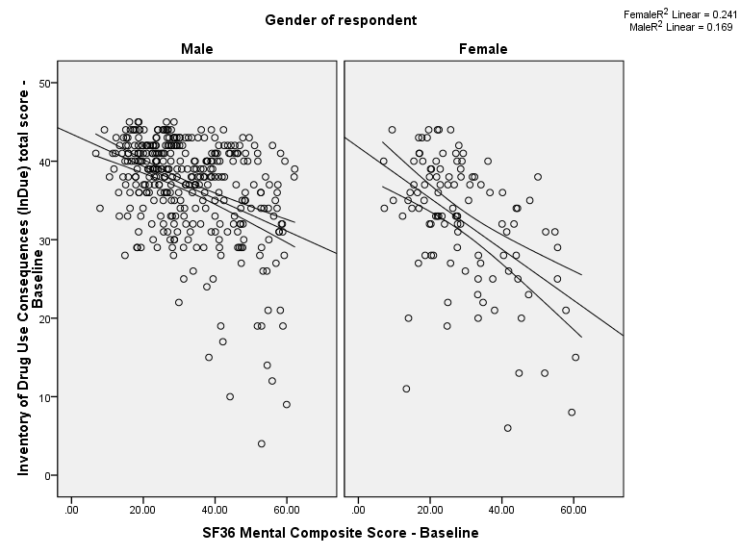

From R – using the sjPlot package

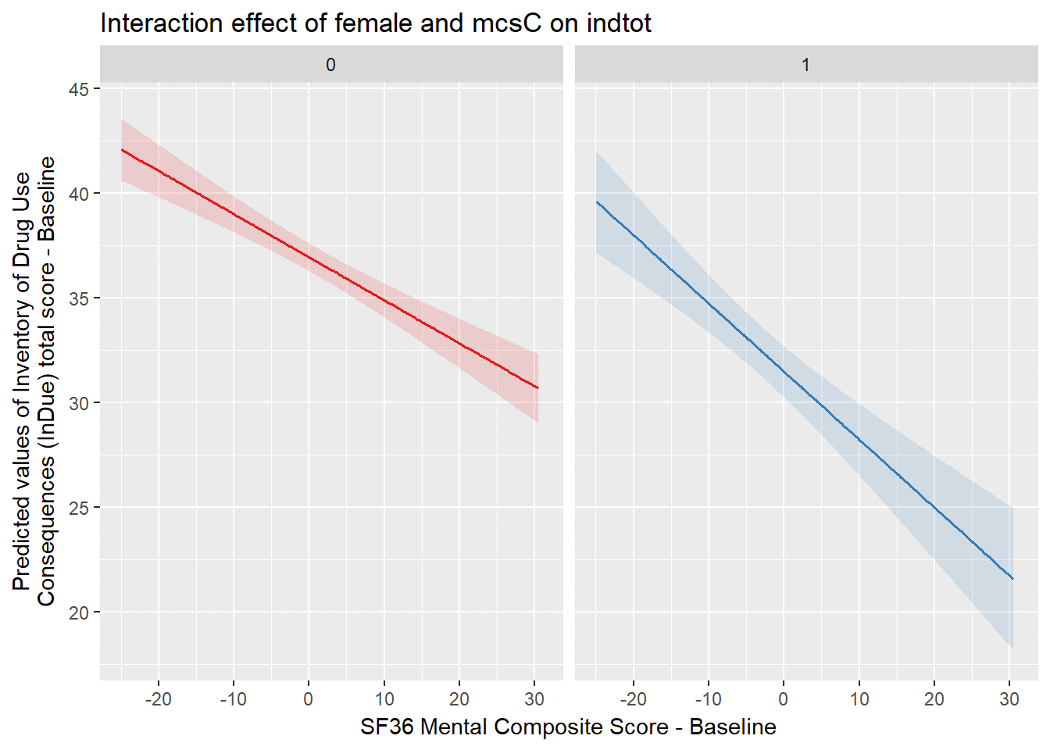

From SAS

